Weight Vs Colony Size Results with instar as numeric

Ruth Sharpe

04 August, 2017

### Leg length against colony size

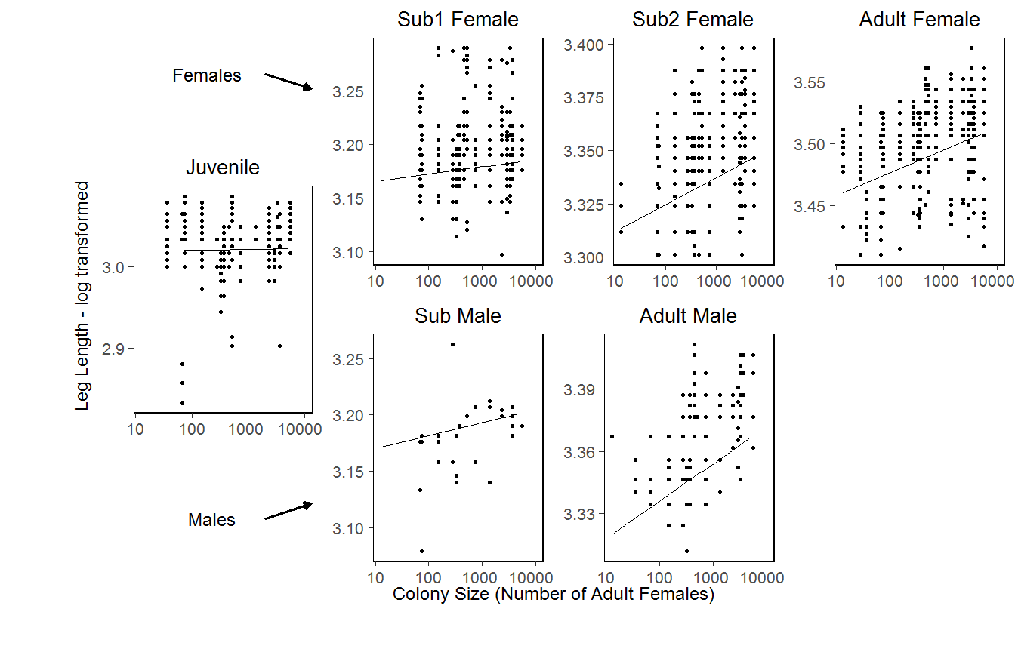

[1] "(figure 3.1)"

*FIGURE: Leg length (tiba plus patella) as a function of colony size with the full linear model, which contains a significant interaction with colony size, superimposed. Overall, leg length increased with colony size (p = < 0.001 *** ), but with a significant interaction between colony size and instar,. When tested individually, only the older instars exhibited a significant relationship. n= 19 colonies.*

### Individual condition against colony size

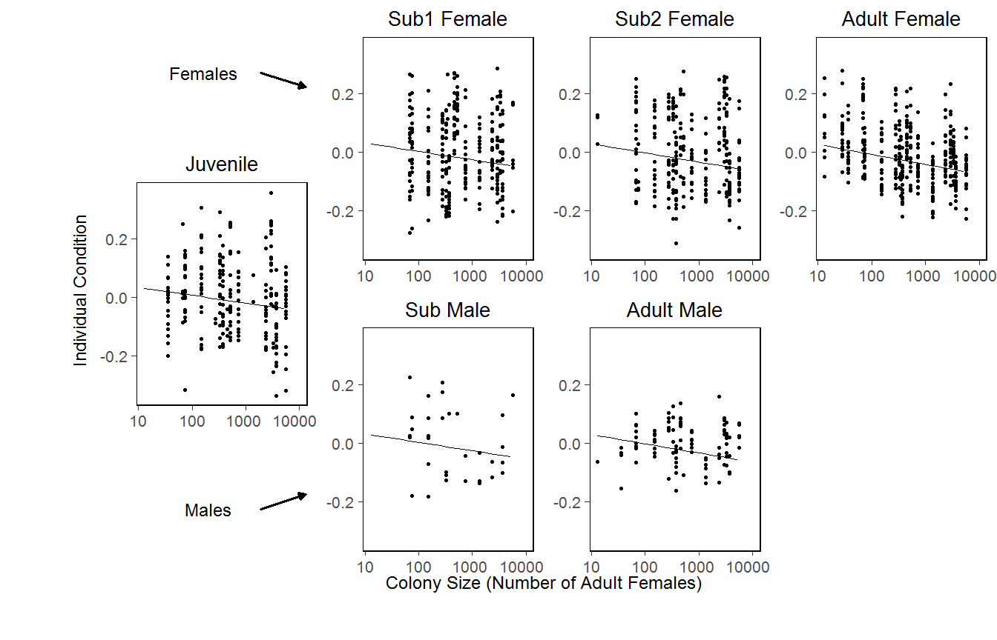

[1] "(figure 3.2)"

*FIGURE : Individual condition against colony size, with the linear model superimposed. Overall condition decreases with colony size (p = 0.004 ** ), with a significant interaction with instar age (p = < 0.001 *** ), but not instar sex. Gradient increases from juv4 to adult.*