Weight Vs Nest Size Results

Ruth Sharpe

17 August, 2016

## Leg Vs. Nest Size

The model with the lowest AIC included nest size, instar and instar x nest size interaction. Using this as the full model we found that leg length increases as nest size increases (lmer; 28 ,14= 36.62, p = < 0.001 *** ).

Leg length is significantly correlated with instar, but that is not surprising (lmer; 24 ,14= 4405.96, p = < 0.001 *** ).

There is a significant interaction between instar and nest size (lmer; 29,14 = 27.91, p = < 0.001 *** ).

Testing each instar separately, the only juvenile stage 4 and subadult stage 1 spiders did not show a significant decrease in leg length with nest size (table 1).

|  |  |  |
| --- | --- | --- |
| Instar | 2 | p value |
| Adult | 8.54 | 0.003 ** |
| Sub2 | 10.66 | < 0.001 *** |
| Sub1 | 0.29 | 0.588 |
| Juv4 | 1.48 | 0.224 |
| Adult Male | 11.8 | < 0.001 *** |
| Sub Male | 6.7 | 0.01 ** |

Table 1: Statistical results of leg length against nest size for each instar tested individually

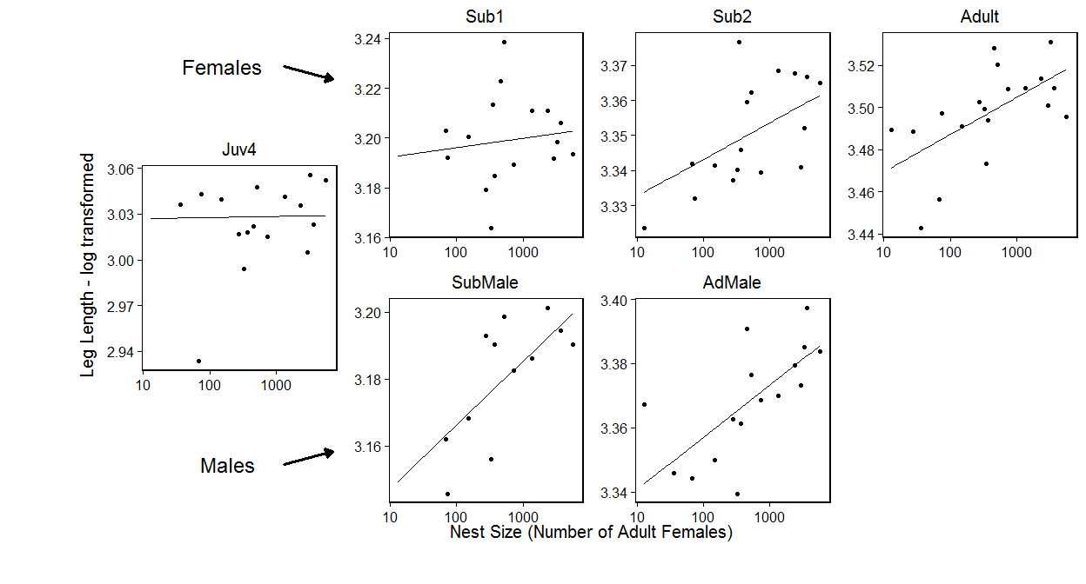

Figure 1: Leg length against nest size. The overlaid model is logLeg ~ logCtFm + Instar + logCtFm:Instar + (1 | NestID). Overall leg length decreases with nest size (p = < 0.001 *** ) and there is a significant interaction with instar(p = < 0.001 *** ).

## Condition Vs. Nest Size

Again the model with the lowest AIC included nest size, instar and instar x nest size interaction. Condition decreases as nest size increases (lmer; 28 ,14= 19.53, p = 0.003 ** ).

Condition is significantly correlated with instar (lmer; 24 ,14= 720.56, p = < 0.001 *** ).

Again there is a significant interaction between instar and nest size (lmer; 29,14 = 13.5, p = 0.019 ** ). When performing ad-hoc tests on the instars individually we find that only adult condition decreases with nest size (lmer; 23,4 = 9.48, p = 0.002 ** ).

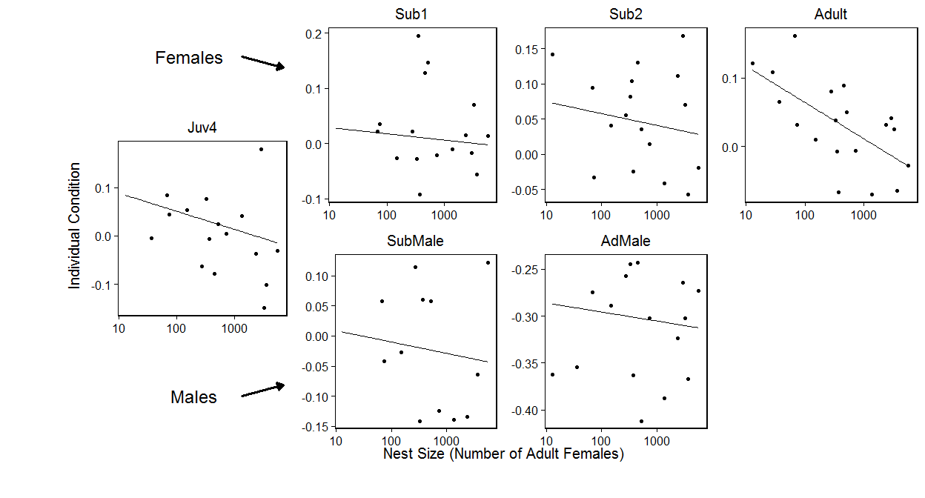

Figure 2: Individual condition against nest size. The overlaid model is condResiduals ~ logCtFm + Instar + logCtFm:Instar + (1 | NestID). Overall leg length decreases with nest size (p = 0.003 ** ) and there is a significant interaction with instar(p = < 0.001 *** ).

## Within Nest Variance Vs. Nest Size

### Condition Variance

The model with the lowest AIC value only included nest size and instar as explantory factors. Instar was significant (lmer; 29 ,14= 23.27, p = 0.01 ** ), however nest size was not (lmer; 28 ,14= 4.76, p = 0.575 ).

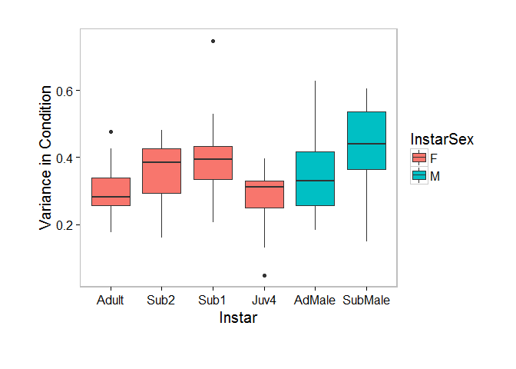

Figure 3. Condition variance within nests by instar. I am not sure yet whether this is a real results and/or intereseting to the story

Variance in leg length was not significant for any factors.

## Original Nest Vs Propagule

Leg length is larger in propagules compared to the source nest (lmer; 24,5= 3.9, p = 0.048 ** ).

Individuals in propagules have greater conditions compared to those in the original nests (lmer; 24,5= 9.06, p = 0.003 ** ).

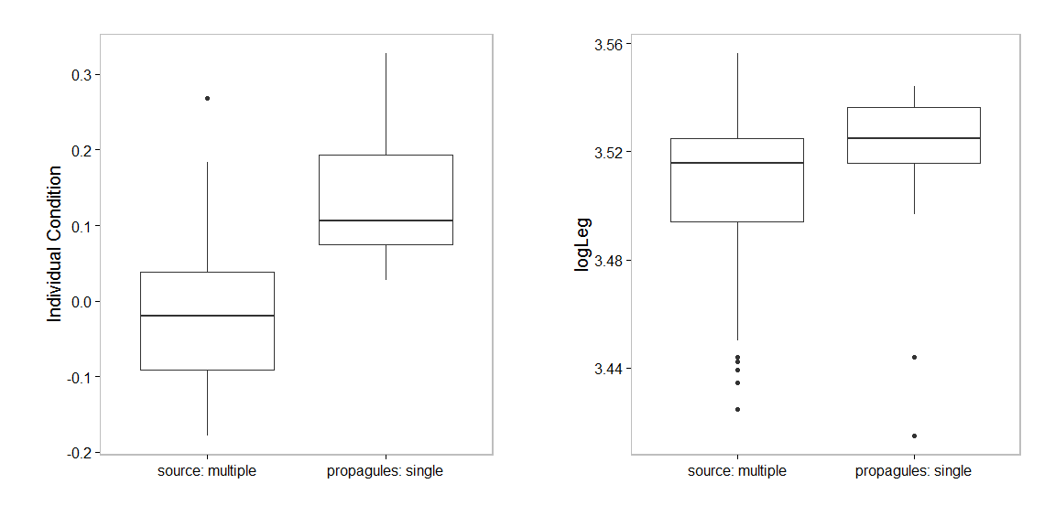

Figure 4: Condition and leg length of adult females in propagues and their source nest

## Propagule survival

We found that nests with single females spiders had a very low survival rate (figure 5).

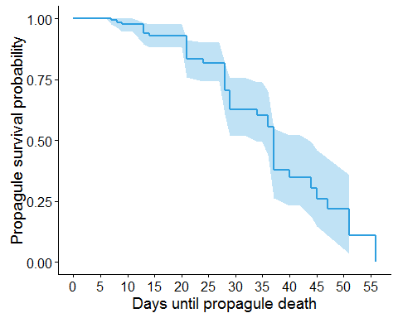

Figure 5: The survival function of 40 propagules from 10 source nests.