Weight Vs Colony Size Results with instar as numeric

Ruth Sharpe

05 September, 2016

## Leg Vs. Colony Size

The model with the lowest AIC was (logLeg ~ logCtFm + logCtFm:InstarNumber:InstarSex + logCtFm:InstarNumber + InstarSex:InstarNumber + InstarNumber + InstarSex + (1 | NestID)). Using this as the full model we found that leg length increases as colony size increases (lmer; 26 ,9= 36.23, p = < 0.001 *** ).

Leg length was significantly correlated with instar age, but that is not surprising due to their different physiology (lmer; 25 ,9= 4365.62, p = < 0.001 *** ).

In addition, leg length was significantly correlated with instar sex, but (lmer; 25 ,9= 4365.62, p = < 0.001 *** ).

The three way interaction was not significant (lmer; 28,9 = 2.66, p = 0.103 ).

However the instar age x nest size interaction was significant (lmer; 25,9 = 4365.62, p = < 0.001 *** ).

As the effect of colony size on spider size was absent in the youngest instars (Table 1); it was first detectable in subadult males and females.

Testing each instar separately, the only juvenile stage 4 and subadult stage 1 spiders did not show a significant decrease in leg length with colony size (table 1).

|  |  |  |
| --- | --- | --- |
| Instar | 2 | p value |
| Juv4 | 1.48 | 0.224 |
| Sub1 | 0.29 | 0.588 |
| Sub2 | 10.66 | < 0.001 *** |
| Adult | 8.54 | 0.003 ** |
| Sub Male | 6.7 | 0.01 ** |
| Adult Male | 11.8 | < 0.001 *** |

Table 1: Statistical results of leg length against colony size for each instar tested individually

Note: If line on graph is blue R could not plot the lmer, plotting a simple lm instead

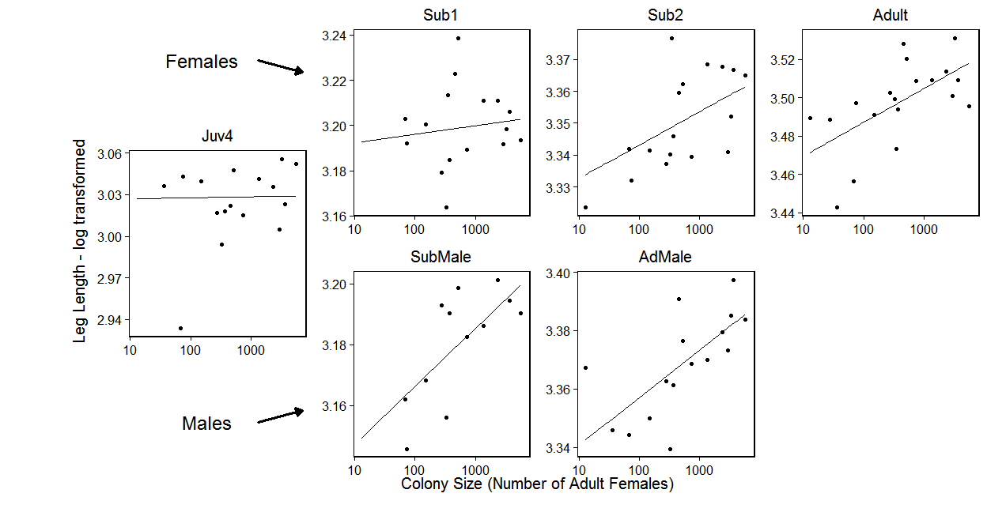

1. Figure: Leg length against colony size. The overlaid model is logLeg ~ logCtFm + Instar + logCtFm:Instar + (1 | NestID). Overall leg length decreases with colony size (p = < 0.001 *** ) and there was a significant interaction with instar (p = < 0.001 *** ).

## Condition Vs. Colony Size

Again the model with the lowest AIC included colony size, instar and instar x colony size interaction. Condition decreases as colony size increases (lmer; 28 ,14= 17.13, p = 0.009 ** ).

Condition was significantly correlated with instar (lmer; 24 ,14= 20.45, p = 0.025 * ).

Again there was a significant interaction between instar and colony size (lmer; 29,14 = 12.32, p = 0.031 * ). When performing ad-hoc tests on the instars individually we find that only adult condition decreases with colony size (lmer; 23,4 = 7.64, p = 0.006 ** ).

Note: If line on graph is blue R could not plot the lmer, plotting a simple lm instead

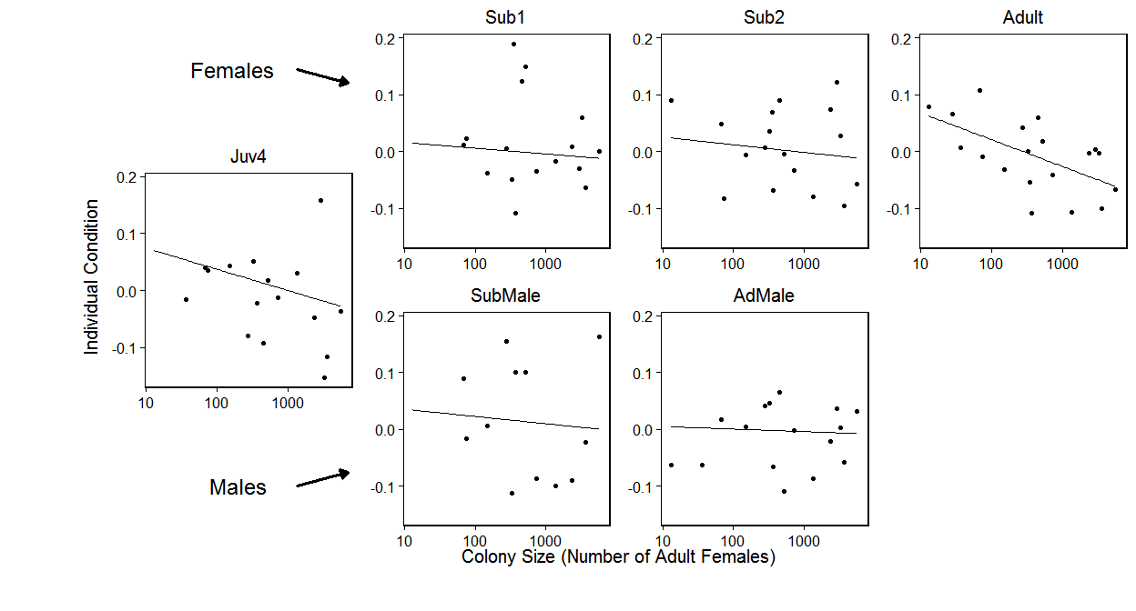

1. Figure : Individual condition against colony size. The overlaid model is condResiduals ~ logCtFm + Instar + logCtFm:Instar + (1 | NestID). Overall leg length decreases with colony size (p = 0.009 ** ) and there was a significant interaction with instar(p = 0.025 * ).

## Within Colony Variance Vs. colony size

### Condition Variance

The model with the lowest AIC value only included colony size and instar as explanatory factors. Instar was significant (lmer; 29 ,9= 21.9, p = < 0.001 *** ), however colony size was not (lmer; 28 ,9= 1.32, p = 0.25 ).

Note: If line on graph is blue R could not plot the lmer, plotting a simple lm instead

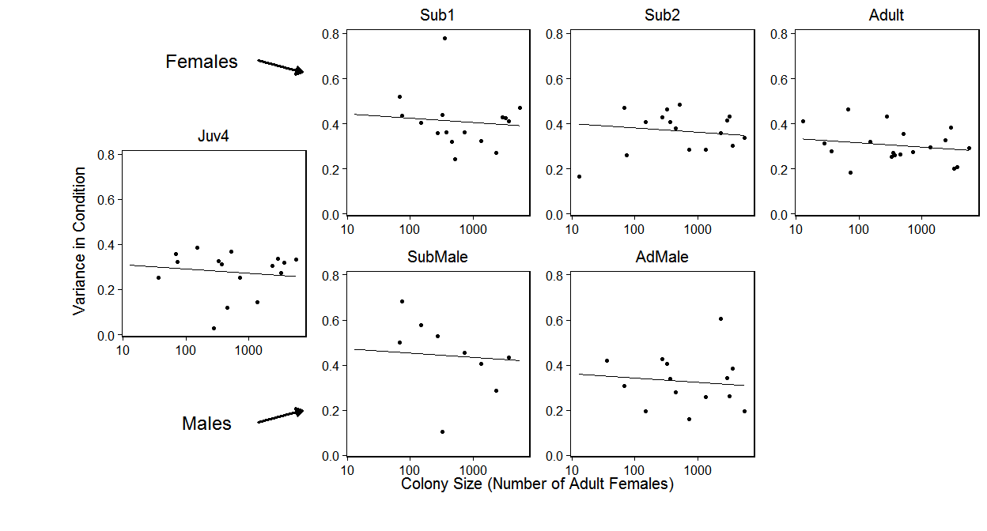

1. Figure : Variance in condition against colony size

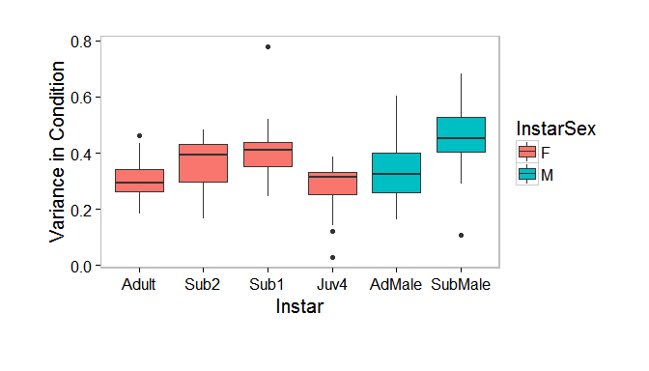

1. Figure :Condition variance within colonies by instar. I am not sure yet whether this is a real results and/or intereseting to the story

### Leg Length Variance

The model with the lowest AIC value only included colony size and instar as explantory factors. Instar was not significant (lmer; 29 ,9= 8.57, p = 0.127 ), neither was colony size (lmer; 28 ,9= 0.23, p = 0.631 ).

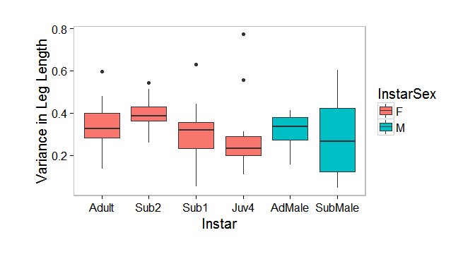

1. Figure :Leg length variance within colonies by instar. I am not sure yet whether this is a real results and/or intereseting to the story

# Biomass per capita vs colony size

Again the model with the lowest AIC included colony size, instar and instar x colony size interaction. Condition decreases as colony size increases (lmer; 24 ,5= 5.86, p = 0.015 * ).

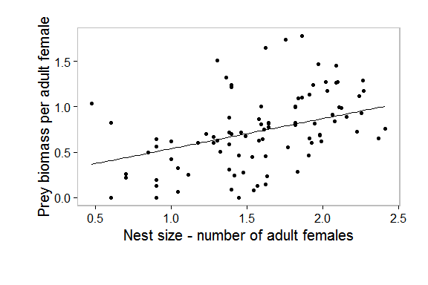

1. Figure : Variance in condition against colony size

## Original Colony Vs Propagule

Leg length was larger in propagules compared to the source colony (lmer; 24,5= 3.9, p = 0.048 * ).

Individuals in propagules have better condition compared to those in the original nests (lmer; 24,5= 9.45, p = 0.002 ** ).

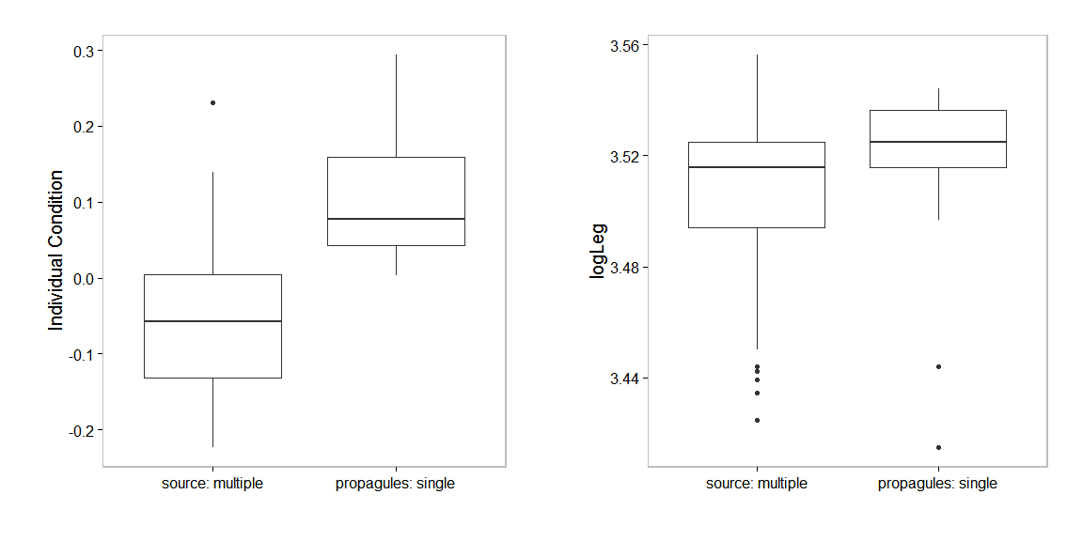

1. Figure: Condition and leg length of adult females in propagues and their source nest

## Propagule survival

We found that nests with single females spiders had a very low survival rate (figure 5).

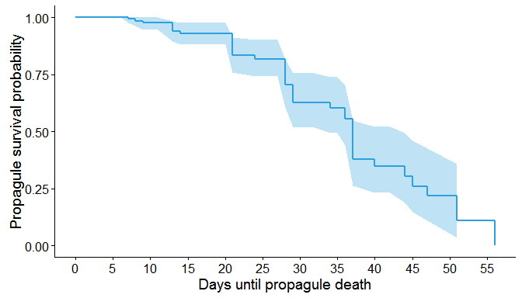

1. Figure: The survival function of 40 propagules from 10 source nests.