Leg Length vs Nest Size

Ruth Sharpe

16 August, 2016

# AIC Values of all possible models with instar always included

|  |  |  |  |
| --- | --- | --- | --- |
| AIC_Diff | AIC | model | num.predictors |
| 0 | -5303 | logLeg ~ logCtFm + logCtFm:Instar + I(logCtFm^2) + I(logCtFm^2):Instar + Instar + (1|NestID) | 20 |
| 22.24 | -5281 | logLeg ~ logCtFm + logCtFm:Instar + Instar + (1|NestID) | 14 |
| 24.03 | -5279 | logLeg ~ logCtFm + logCtFm:Instar + I(logCtFm^2) + Instar + (1|NestID) | 15 |
| 28.42 | -5274 | logLeg ~ I(logCtFm^2) + I(logCtFm^2):Instar + Instar + (1|NestID) | 14 |
| 30.39 | -5272 | logLeg ~ logCtFm + I(logCtFm^2) + I(logCtFm^2):Instar + Instar + (1|NestID) | 15 |
| 40.14 | -5263 | logLeg ~ logCtFm + Instar + (1|NestID) | 9 |
| 40.51 | -5262 | logLeg ~ I(logCtFm^2) + Instar + (1|NestID) | 9 |
| 42.12 | -5261 | logLeg ~ logCtFm + I(logCtFm^2) + Instar + (1|NestID) | 10 |

# Graph with lowest AIC model superimposed

Model:  
logLeg ~ I(logCtFm^2) + logCtFm + Instar + logCtFm:Instar + I(logCtFm^2):Instar + (1 | NestID)

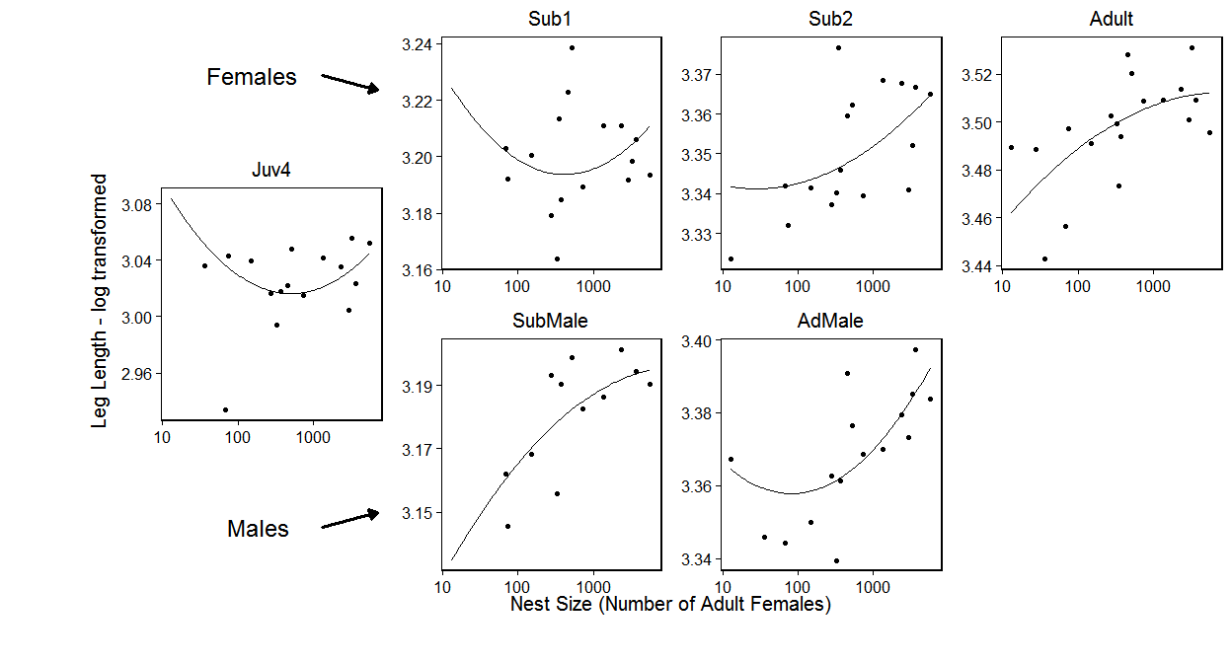

# Graph with model without squared values of nest size

Model:  
logLeg ~ logCtFm + Instar + logCtFm:Instar + (1 | NestID)

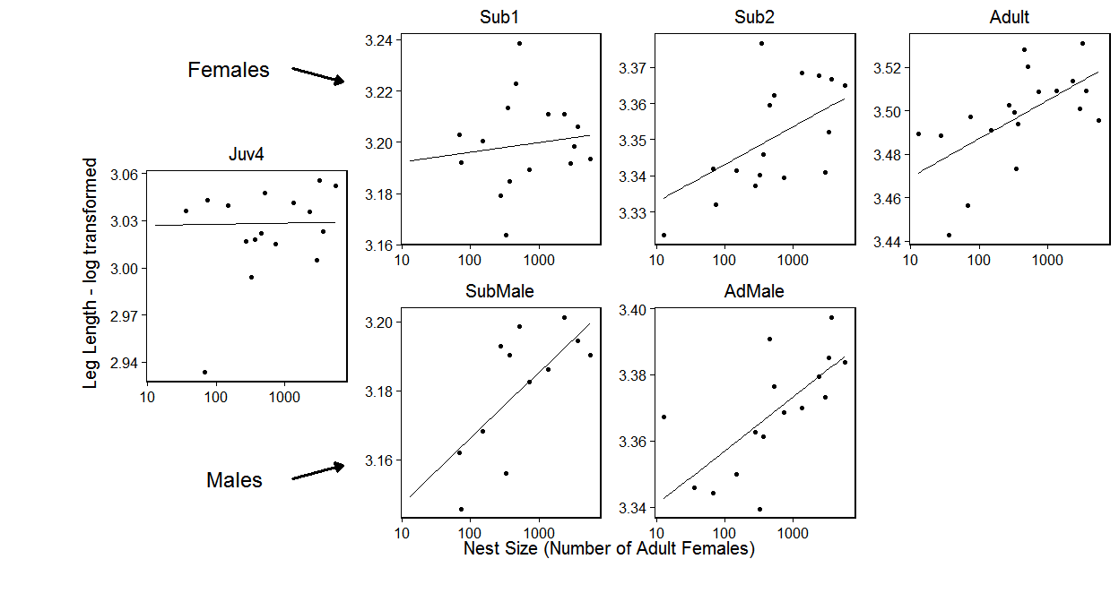

# Statistics using model without squared values as the full model

(seems too complicated to include the squared vaules, esp as the patter is not clear)

Anova of full model alone

-Model: logLeg ~ logCtFm + Instar + logCtFm:Instar + (1 | NestID)

---Testing Individual Variables, (Anova of full vs reduced model)---

Testing Nest Size

-Full Model: logLeg ~ logCtFm + Instar + logCtFm:Instar + (1 | NestID)

-Reduced Model: logLeg ~ Instar + (1 | NestID)

Testing Instar Term

-Full Model: logLeg ~ logCtFm + Instar + logCtFm:Instar + (1 | NestID)

-Reduced Model: logLeg ~ logCtFm + (1 | NestID)

Testing Interaction Term

-Full Model: logLeg ~ logCtFm + Instar + logCtFm:Instar + (1 | NestID)

-Reduced Model: logLeg ~ logCtFm + Instar + (1 | NestID)

# Testing Individual Instars

### As the interaction is significant testing instar individually

note: pops up saying 'refitting model(s) with ML (instead of REML)' but if make anova refit = FALSE results don't make sense

Adult

|  |  |  |  |  |  |  |  |  |
| --- | --- | --- | --- | --- | --- | --- | --- | --- |
|  | Df | AIC | BIC | logLik | deviance | Chisq | Chi Df | Pr(>Chisq) |
| ..1 | 3 | -1496.660 | -1484.952 | 751.3299 | -1502.660 | NA | NA | NA |
| object | 4 | -1503.201 | -1487.591 | 755.6007 | -1511.201 | 8.541558 | 1 | 0.0034713 |

Sub2

|  |  |  |  |  |  |  |  |  |
| --- | --- | --- | --- | --- | --- | --- | --- | --- |
|  | Df | AIC | BIC | logLik | deviance | Chisq | Chi Df | Pr(>Chisq) |
| ..1 | 3 | -1228.262 | -1217.709 | 617.1308 | -1234.262 | NA | NA | NA |
| object | 4 | -1236.919 | -1222.849 | 622.4595 | -1244.919 | 10.65751 | 1 | 0.0010962 |

Sub1

|  |  |  |  |  |  |  |  |  |
| --- | --- | --- | --- | --- | --- | --- | --- | --- |
|  | Df | AIC | BIC | logLik | deviance | Chisq | Chi Df | Pr(>Chisq) |
| ..1 | 3 | -1112.989 | -1102.042 | 559.4943 | -1118.989 | NA | NA | NA |
| object | 4 | -1111.281 | -1096.685 | 559.6407 | -1119.281 | 0.2927162 | 1 | 0.5884852 |

Juv4

|  |  |  |  |  |  |  |  |  |
| --- | --- | --- | --- | --- | --- | --- | --- | --- |
|  | Df | AIC | BIC | logLik | deviance | Chisq | Chi Df | Pr(>Chisq) |
| ..1 | 3 | -922.1183 | -911.7652 | 464.0592 | -928.1183 | NA | NA | NA |
| object | 4 | -921.5977 | -907.7935 | 464.7988 | -929.5977 | 1.47934 | 1 | 0.2238779 |

AdMale

|  |  |  |  |  |  |  |  |  |
| --- | --- | --- | --- | --- | --- | --- | --- | --- |
|  | Df | AIC | BIC | logLik | deviance | Chisq | Chi Df | Pr(>Chisq) |
| ..1 | 3 | -547.1792 | -539.1889 | 276.5896 | -553.1792 | NA | NA | NA |
| object | 4 | -556.9807 | -546.3269 | 282.4903 | -564.9807 | 11.80143 | 1 | 0.0005919 |

SubMale

|  |  |  |  |  |  |  |  |  |
| --- | --- | --- | --- | --- | --- | --- | --- | --- |
|  | Df | AIC | BIC | logLik | deviance | Chisq | Chi Df | Pr(>Chisq) |
| ..1 | 3 | -125.0124 | -120.6152 | 65.50620 | -131.0124 | NA | NA | NA |
| object | 4 | -129.7154 | -123.8524 | 68.85769 | -137.7154 | 6.702965 | 1 | 0.0096253 |