Variance in Leg vs Nest Size Instar As Number

Ruth Sharpe

Run on 12 September, 2016

## AIC Values of all possible models with instar included and sample size as weight

Rows removed with 2 or fewer data points

[1] "Using a standardized sample size as weight in model"

|  |  |  |  |
| --- | --- | --- | --- |
| AIC_Diff | AIC | model | num.predictors |
| 0 | -119.6 | relativeVar ~ logCtFm + InstarNumber + InstarNumber:InstarSex + logCtFm:InstarNumber + I(InstarNumber^2) + (1|NestID) | 8 |
| 0 | -119.6 | relativeVar ~ logCtFm + InstarNumber + logCtFm:InstarNumber + I(InstarNumber^2) + I(InstarNumber^2):InstarSex + (1|NestID) | 8 |
| 0.08 | -119.5 | relativeVar ~ logCtFm + logCtFm:InstarNumber + I(InstarNumber^2) + (1|NestID) | 6 |
| 0.13 | -119.5 | relativeVar ~ logCtFm + logCtFm:InstarNumber + I(InstarNumber^2) + I(InstarNumber^2):InstarSex:logCtFm + (1|NestID) | 8 |
| 0.14 | -119.5 | relativeVar ~ logCtFm + InstarNumber + logCtFm:InstarNumber + logCtFm:InstarNumber:InstarSex + I(InstarNumber^2) + (1|NestID) | 8 |
| 0.15 | -119.5 | relativeVar ~ logCtFm + InstarNumber + logCtFm:InstarNumber + I(InstarNumber^2) + (1|NestID) | 7 |
| 0.18 | -119.5 | relativeVar ~ logCtFm + InstarNumber + logCtFm:InstarNumber + I(InstarNumber^2):InstarSex:logCtFm + (1|NestID) | 8 |
| 0.19 | -119.4 | relativeVar ~ logCtFm + logCtFm:InstarNumber + I(InstarNumber^2):InstarSex:logCtFm + (1|NestID) | 7 |
| 0.29 | -119.3 | relativeVar ~ logCtFm + InstarNumber + I(InstarNumber^2) + I(InstarNumber^2):InstarSex:logCtFm + (1|NestID) | 8 |
| 1.17 | -118.5 | relativeVar ~ logCtFm + logCtFm:InstarNumber + I(InstarNumber^2) + I(InstarNumber^2):InstarSex + (1|NestID) | 7 |
| 1.22 | -118.4 | relativeVar ~ logCtFm + logCtFm:InstarNumber + logCtFm:InstarNumber:InstarSex + I(InstarNumber^2) + (1|NestID) | 7 |
| 1.88 | -117.8 | relativeVar ~ logCtFm + InstarNumber + logCtFm:InstarNumber + (1|NestID) | 6 |
| 1.88 | -117.8 | relativeVar ~ logCtFm + logCtFm:InstarNumber + (1|NestID) | 5 |
| 2 | -117.6 | relativeVar ~ logCtFm + InstarNumber + InstarNumber:InstarSex + logCtFm:InstarNumber + logCtFm:InstarNumber:InstarSex + I(InstarNumber^2) + (1|NestID) | 9 |
| 2 | -117.6 | relativeVar ~ logCtFm + InstarNumber:InstarSex + logCtFm:InstarNumber + logCtFm:InstarNumber:InstarSex + I(InstarNumber^2) + (1|NestID) | 9 |
| 2 | -117.6 | relativeVar ~ logCtFm + InstarNumber + InstarNumber:InstarSex + logCtFm:InstarNumber + I(InstarNumber^2) + I(InstarNumber^2):InstarSex + (1|NestID) | 9 |
| 2 | -117.6 | relativeVar ~ logCtFm + InstarNumber + logCtFm:InstarNumber + logCtFm:InstarNumber:InstarSex + I(InstarNumber^2) + I(InstarNumber^2):InstarSex + (1|NestID) | 9 |
| 2.06 | -117.6 | relativeVar ~ logCtFm + InstarNumber + I(InstarNumber^2) + I(InstarNumber^2):InstarSex + I(InstarNumber^2):InstarSex:logCtFm + (1|NestID) | 9 |
| 2.06 | -117.6 | relativeVar ~ logCtFm + InstarNumber + InstarNumber:InstarSex + I(InstarNumber^2) + I(InstarNumber^2):InstarSex:logCtFm + (1|NestID) | 9 |
| 2.06 | -117.6 | relativeVar ~ logCtFm + logCtFm:InstarNumber + I(InstarNumber^2) + I(InstarNumber^2):InstarSex + I(InstarNumber^2):InstarSex:logCtFm + (1|NestID) | 9 |
| 2.09 | -117.5 | relativeVar ~ logCtFm + logCtFm:InstarNumber + logCtFm:InstarNumber:InstarSex + I(InstarNumber^2) + I(InstarNumber^2):InstarSex:logCtFm + (1|NestID) | 9 |
| 2.1 | -117.5 | relativeVar ~ logCtFm + InstarNumber + logCtFm:InstarNumber + I(InstarNumber^2) + I(InstarNumber^2):InstarSex:logCtFm + (1|NestID) | 9 |
| 2.13 | -117.5 | relativeVar ~ logCtFm + InstarNumber + InstarNumber:InstarSex + logCtFm:InstarNumber + I(InstarNumber^2):InstarSex:logCtFm + (1|NestID) | 9 |
| 2.14 | -117.5 | relativeVar ~ logCtFm + InstarNumber + logCtFm:InstarNumber + logCtFm:InstarNumber:InstarSex + I(InstarNumber^2):InstarSex:logCtFm + (1|NestID) | 9 |
| 2.16 | -117.5 | relativeVar ~ logCtFm + logCtFm:InstarNumber + logCtFm:InstarNumber:InstarSex + I(InstarNumber^2):InstarSex:logCtFm + (1|NestID) | 8 |
| 2.41 | -117.2 | relativeVar ~ logCtFm + InstarNumber + I(InstarNumber^2) + (1|NestID) | 6 |
| 2.47 | -117.2 | relativeVar ~ logCtFm + InstarNumber + I(InstarNumber^2) + I(InstarNumber^2):InstarSex + (1|NestID) | 7 |
| 2.48 | -117.2 | relativeVar ~ logCtFm + InstarNumber + InstarNumber:InstarSex + I(InstarNumber^2) + (1|NestID) | 7 |
| 3.17 | -116.5 | relativeVar ~ logCtFm + logCtFm:InstarNumber + logCtFm:InstarNumber:InstarSex + I(InstarNumber^2) + I(InstarNumber^2):InstarSex + (1|NestID) | 8 |
| 3.34 | -116.3 | relativeVar ~ logCtFm + InstarNumber + InstarNumber:InstarSex + logCtFm:InstarNumber + (1|NestID) | 7 |
| 3.37 | -116.3 | relativeVar ~ logCtFm + InstarNumber + logCtFm:InstarNumber + logCtFm:InstarNumber:InstarSex + (1|NestID) | 7 |
| 3.43 | -116.2 | relativeVar ~ logCtFm + logCtFm:InstarNumber + logCtFm:InstarNumber:InstarSex + (1|NestID) | 6 |
| 3.98 | -115.7 | relativeVar ~ logCtFm + InstarNumber + logCtFm:InstarNumber + I(InstarNumber^2) + I(InstarNumber^2):InstarSex + I(InstarNumber^2):InstarSex:logCtFm + (1|NestID) | 10 |
| 3.98 | -115.7 | relativeVar ~ logCtFm + InstarNumber + InstarNumber:InstarSex + logCtFm:InstarNumber + I(InstarNumber^2) + I(InstarNumber^2):InstarSex:logCtFm + (1|NestID) | 10 |
| 4 | -115.6 | relativeVar ~ logCtFm + InstarNumber + InstarNumber:InstarSex + logCtFm:InstarNumber + logCtFm:InstarNumber:InstarSex + I(InstarNumber^2) + I(InstarNumber^2):InstarSex + (1|NestID) | 10 |
| 4.03 | -115.6 | relativeVar ~ logCtFm + logCtFm:InstarNumber + logCtFm:InstarNumber:InstarSex + I(InstarNumber^2) + I(InstarNumber^2):InstarSex + I(InstarNumber^2):InstarSex:logCtFm + (1|NestID) | 10 |
| 4.05 | -115.6 | relativeVar ~ logCtFm + InstarNumber + InstarNumber:InstarSex + I(InstarNumber^2) + I(InstarNumber^2):InstarSex + I(InstarNumber^2):InstarSex:logCtFm + (1|NestID) | 10 |
| 4.05 | -115.6 | relativeVar ~ logCtFm + InstarNumber + logCtFm:InstarNumber + logCtFm:InstarNumber:InstarSex + I(InstarNumber^2) + I(InstarNumber^2):InstarSex:logCtFm + (1|NestID) | 10 |
| 4.11 | -115.5 | relativeVar ~ logCtFm + InstarNumber + InstarNumber:InstarSex + logCtFm:InstarNumber + logCtFm:InstarNumber:InstarSex + I(InstarNumber^2):InstarSex:logCtFm + (1|NestID) | 10 |
| 4.24 | -115.4 | relativeVar ~ logCtFm + InstarNumber + (1|NestID) | 5 |
| 4.45 | -115.2 | relativeVar ~ logCtFm + I(InstarNumber^2) + I(InstarNumber^2):InstarSex:logCtFm + (1|NestID) | 7 |
| 4.47 | -115.2 | relativeVar ~ logCtFm + InstarNumber + InstarNumber:InstarSex + I(InstarNumber^2) + I(InstarNumber^2):InstarSex + (1|NestID) | 8 |
| 4.51 | -115.1 | relativeVar ~ logCtFm + I(InstarNumber^2):InstarSex:logCtFm + (1|NestID) | 6 |
| 5.03 | -114.6 | relativeVar ~ logCtFm + I(InstarNumber^2) + (1|NestID) | 5 |
| 5.34 | -114.3 | relativeVar ~ logCtFm + InstarNumber + InstarNumber:InstarSex + logCtFm:InstarNumber + logCtFm:InstarNumber:InstarSex + (1|NestID) | 8 |
| 5.82 | -113.8 | relativeVar ~ logCtFm + InstarNumber + InstarNumber:InstarSex + (1|NestID) | 6 |
| 5.94 | -113.7 | relativeVar ~ logCtFm + InstarNumber + logCtFm:InstarNumber + logCtFm:InstarNumber:InstarSex + I(InstarNumber^2) + I(InstarNumber^2):InstarSex + I(InstarNumber^2):InstarSex:logCtFm + (1|NestID) | 11 |
| 5.97 | -113.7 | relativeVar ~ logCtFm + InstarNumber + InstarNumber:InstarSex + logCtFm:InstarNumber + logCtFm:InstarNumber:InstarSex + I(InstarNumber^2) + I(InstarNumber^2):InstarSex:logCtFm + (1|NestID) | 11 |
| 5.98 | -113.7 | relativeVar ~ logCtFm + InstarNumber + InstarNumber:InstarSex + logCtFm:InstarNumber + I(InstarNumber^2) + I(InstarNumber^2):InstarSex + I(InstarNumber^2):InstarSex:logCtFm + (1|NestID) | 11 |
| 6.11 | -113.5 | relativeVar ~ logCtFm + InstarNumber + I(InstarNumber^2):InstarSex:logCtFm + (1|NestID) | 7 |
| 6.4 | -113.2 | relativeVar ~ logCtFm + I(InstarNumber^2) + I(InstarNumber^2):InstarSex + I(InstarNumber^2):InstarSex:logCtFm + (1|NestID) | 8 |
| 6.69 | -112.9 | relativeVar ~ logCtFm + I(InstarNumber^2) + I(InstarNumber^2):InstarSex + (1|NestID) | 6 |
| 7.59 | -112 | relativeVar ~ logCtFm + InstarNumber + InstarNumber:InstarSex + logCtFm:InstarNumber + logCtFm:InstarNumber:InstarSex + I(InstarNumber^2) + I(InstarNumber^2):InstarSex + I(InstarNumber^2):InstarSex:logCtFm + (1|NestID) | 12 |
| 8.08 | -111.5 | relativeVar ~ logCtFm + InstarNumber + InstarNumber:InstarSex + I(InstarNumber^2):InstarSex:logCtFm + (1|NestID) | 8 |

## Checking full model fit

[1] "relativeVar ~ logCtFm + InstarNumber + InstarNumber:InstarSex + logCtFm:InstarNumber + I(InstarNumber^2) + (1 | NestID)"

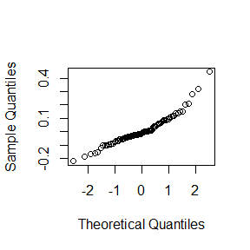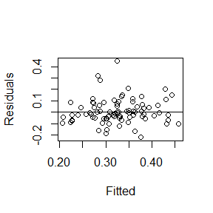

# Graph

note: blue line just lm model

Note: If line on graph is blue R could not plot the lmer, plotting a simple lm instead

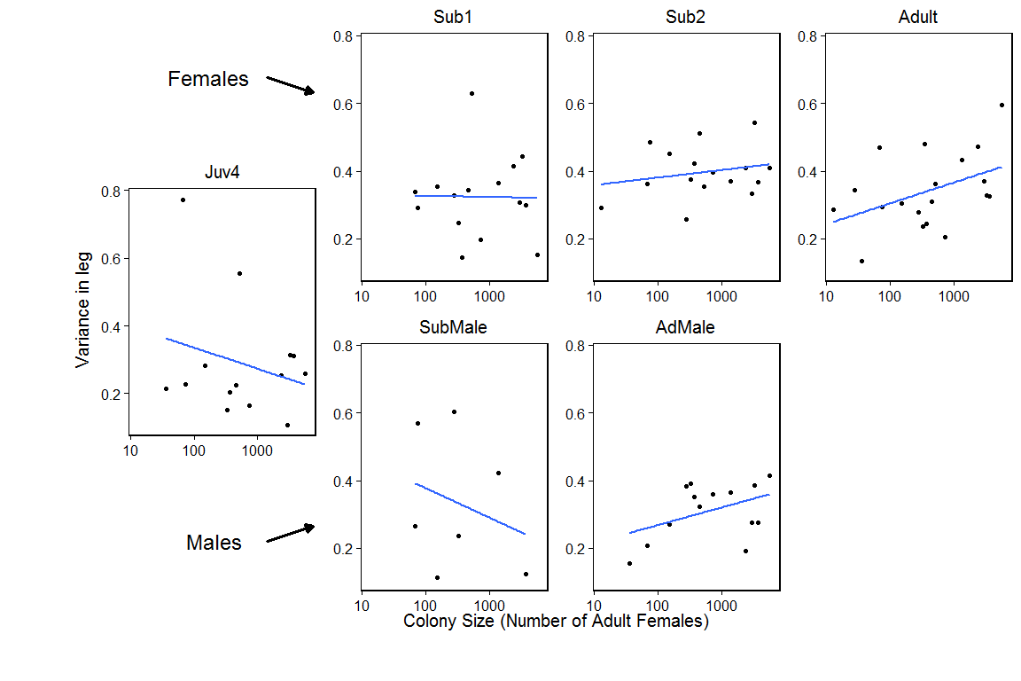

# Statistics using model with the almost lowest AIC as full model

# Graph of leg variance against instar

