Weight Vs Nest Size Results

Ruth Sharpe

16 August, 2016

# RCommonmark

H2O is a liquid. 210 is 1024.

The intercept was estimated as $\hat{α}$ = 4

chisqured: 2

Averages like ( {x} ) write: $\overline{x}$ Fractions like ( ) write: $\frac{a}{b}$ Big parentheses like ( () ) write: $\left(\frac{a}{b}\right)$

## Leg Vs. Nest Size

Leg length increases as nest size increases (lmer; 28 ,14= 36.62, p = < 0.001 *** ).

Leg length is significantly correlated with instar, but that is not surprising (lmer; 24 ,14= 4405.96, p = < 0.001 *** ).

There is a significant interaction between instar and nest size (lmer; 29,14 = 27.91, p = < 0.001 *** ).

Testing each instar separately, the only juvenile stage 4 and subadult stage 1 spiders did not show a significant decrease in leg length with nest size (table 1).

|  |  |  |
| --- | --- | --- |
| Instar | 2 | p value |
| Adult | 8.54 | 0.003 ** |
| Sub2 | 10.66 | < 0.001 *** |
| Sub1 | 0.29 | 0.588 |
| Juv4 | 1.48 | 0.224 |
| Adult Male | 11.8 | < 0.001 *** |
| Sub Male | 6.7 | 0.01 ** |

Table 1: Statistical results of leg length against nest size for each instar tested individually

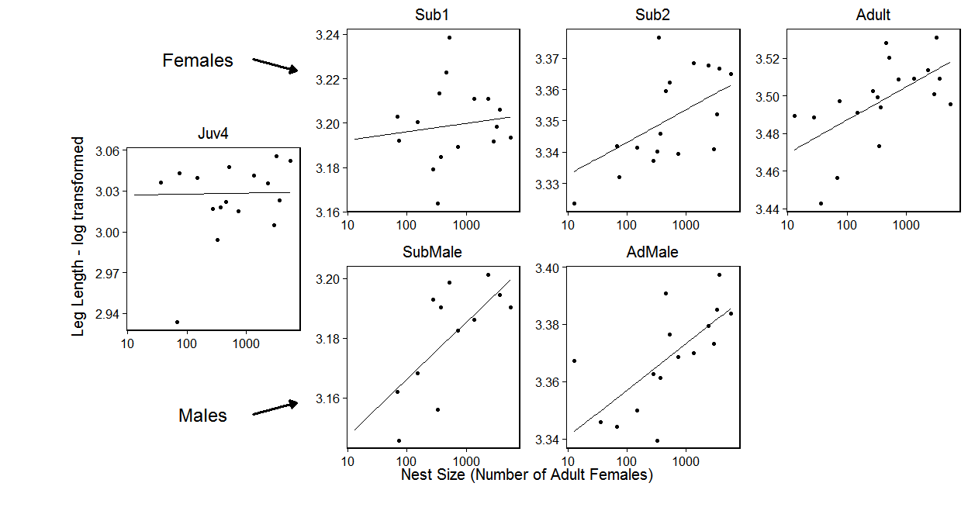

Figure 1: Leg length against nest size. The overlaid model is logLeg ~ logCtFm + Instar + logCtFm:Instar + (1 | NestID) Overall leg length decreases with nest size (p = < 0.001 *** ) and there is a significant interaction with instar(p = < 0.001 *** ).

## Condition Vs. Nest Size

Condition decreases as nest size increases (lmer; 28 ,14= 19.53, p = 0.003 ** ).

Condition is significantly correlated with instar (lmer; 24 ,14= 720.56, p = < 0.001 *** ).

Again there is a significant interaction between instar and nest size (lmer; 29,14 = 13.5, p = 0.019 ** ). When performing ad-hoc tests on the instars individually we find that only adult condition decreases with nest size (lmer; 23,4 = 9.48, p = 0.002 ** ).

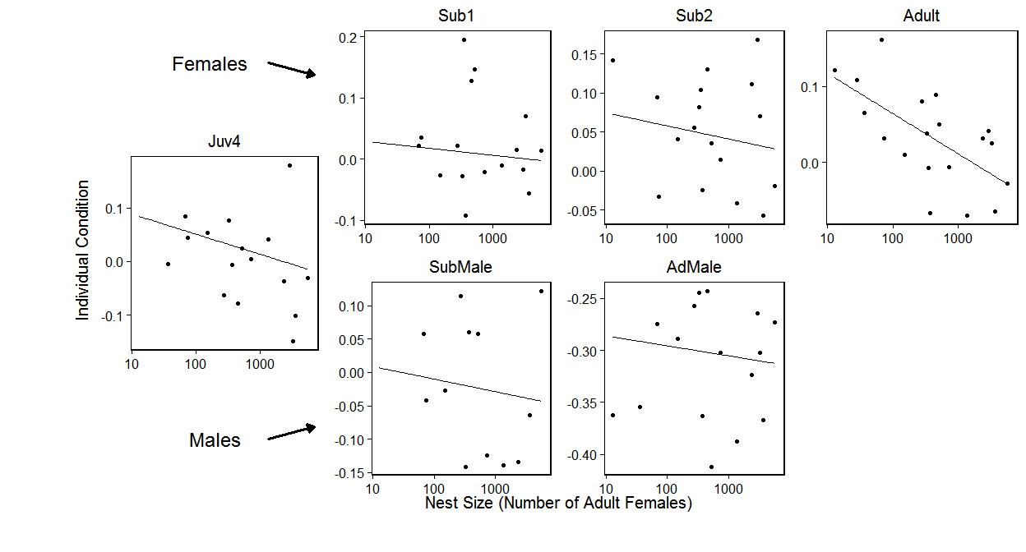 Figure 2: Individual condition against nest size. The overlaid model is condResiduals ~ logCtFm + Instar + logCtFm:Instar + (1 | NestID) Overall leg length decreases with nest size (p = 0.003 ** ) and there is a significant interaction with instar(p = < 0.001 *** ).