**Asymmetric allocation of food resources in a social spider**

**Introduction**

It has been shown that different individuals within a colony of *Anelosimus eximius* there is a degree of monopolisation of food resources (refs •••) although it has also been suggested that there is no correlation between the time females spent hunting and the time they spend feeding (Vollrath and Rohde-Arndt 1982).

**Aims and Methods**

1. The larger the colony the more asymmetry there is in resource allocation. This is because there is less food per capita in large colonies and as the prey items captured are larger and thus can be guarded more effectively by dominant/large individuals.

*Methods:*

* 1. Weight, leg (tibia plus patella length) and total body length of randomly picked individuals from colonies. How much of a variance in weight and size is there within instars against colony size?
  2. Feeding trial data (see below); Number individuals that are seen feeding on consecutive days

1. Are smaller (weight and size) spiders less likely to feed on prey items compared to larger spiders?

*Methods:* Feeding trial; weight and size of spiders compared to the number of days they are seen feeding during the feeding trial.

1. Do younger instars feed less frequently than larger instars?

*Methods:* Feeding trail: Count the number of each instar that is seen feeding on the introduced prey item and compare to the proportion of each instar within the nest.

*Feeding trial method*

Wait until prey is starting to be consumed. 10 minutes after the prey is being consumed paint all individuals feeding at that time and record the instars that are feeding. Return one and two hours later and record how many of each instar is feeding on the prey and paint the spiders that are feeding. Repeat for three/five(?) days, using different colour paint for each day. After end of trail capture some of the painted spiders (or all if we have to cut the nest and make a count of the spiders). Weight and measure (body length and tibia plus patella) them and compare to unpainted spiders.

**Potential results**

*Resource allocation and colony size*

Colony size increasing →

Variance in size

Sub 2

Adults

Figure 1: The variance in individual spider size with increasing colony size by simply measuring the size of spiders randomly chosen nests. As the colony size increases the variance in spider size within instars increases (assuming that I am not doing this on any very small colonies). It could be a unimodal curve to reflect the unimodal fitness function related to group size

Colony size increasing →

Number of individuals seen on at least 4 days

Figure 2: As the colony size increases individuals are more likely to monopolize the food resources. ***Potential problem****: the confounding effect of colony size, as the colony size increases there will simply be more individuals thus by chance I am less likely to see the same individual again, perhaps need to think more carefully about what should be on the y-axis.*

*Resource monopolization: Are smaller individuals less likely to feed?*

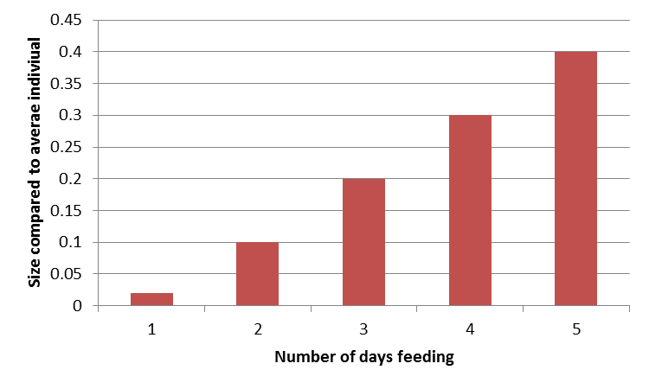

Figure 3: The size of individuals seen feeding on consecutive days compared to the average size of their instar within their colony. Individual that are larger in size are more able to monopolise scare resources. I might want further split this graph to distinguish between instars.

*Resource monopolization: Are smaller instars less likely to feed?*

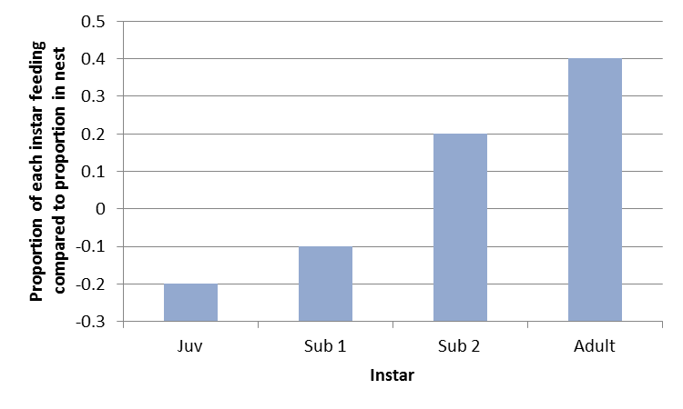

Figure 4: The proportion of each instar that is seen feeding compared to the proportion of instars within the nest. Adults are large so are more easily able to manipulate the resources, potentially preventing smaller instars from getting enough food

**Discussion**

* As the colony size increases large adults are more able to monopolize the scarcer food resources, thus preventing lower instars from growing fast enough to replace them
* Larger individuals are more able to monopolize food resources. This has the potential to produce positive feedback loop where initially small individual difference are magnified over time.

**Potential problems with experiment**

* Might have to cut the nest and count all individuals in each colony once the trial has ended?
* Large colonies may have fewer individuals returning to feed again simply because the colony is so large and there are more spiders. Perhaps I need to do more trails in a day on large colonies?
* The average size of prey that lands in nests is correlated with colony size. Perhaps I have to use larger prey for larger colony sizes