

Ruth Vacas Miñana

1DAM

Sistemas informaticos

ACTIVITIES 3 -5

1. Capture the execution of the following commands:
   1. To see the amount of RAM installed on our computer and see how much is occupied and how much free: $ free

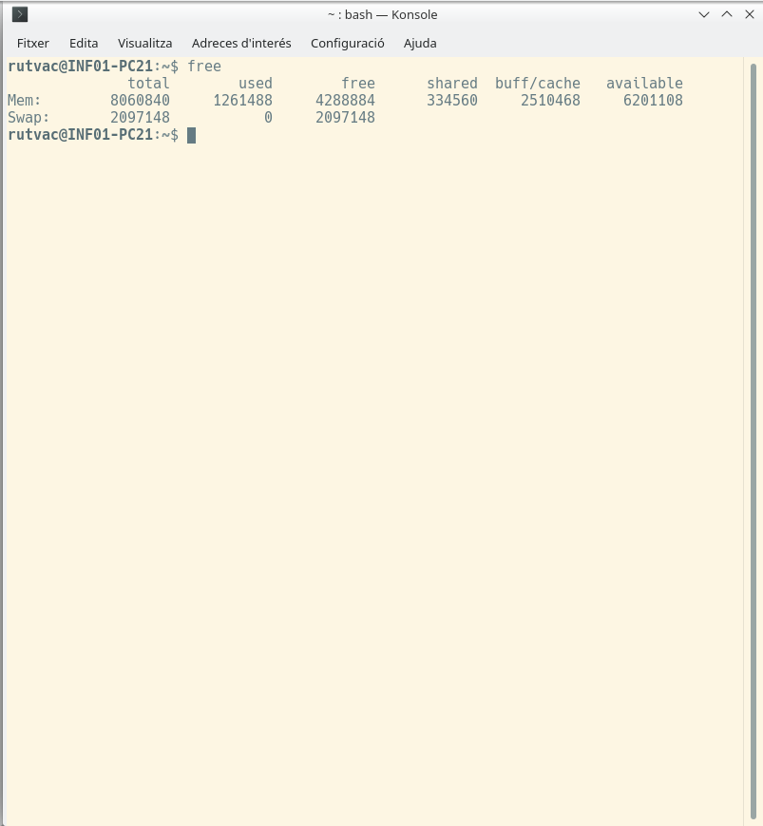

* 1. Memory information without the need to install additional software. $ cat /proc/meminfo

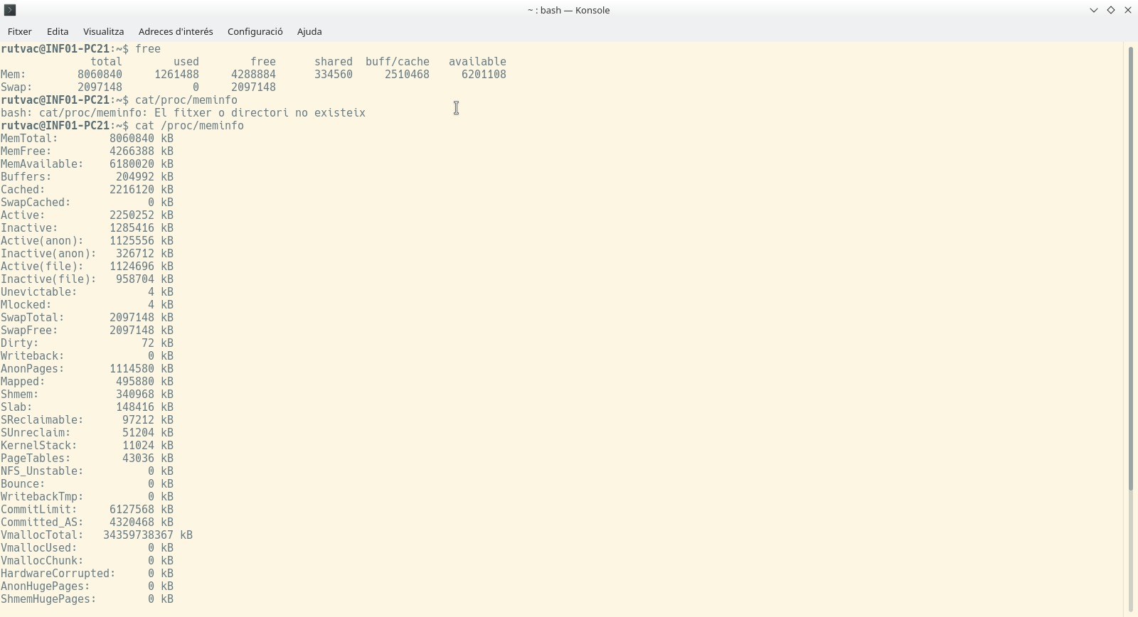

* 1. To view information of computer components (filtering by memory) (may be required to install. $sudo apt-get install lshw):

$ sudo lshw –short

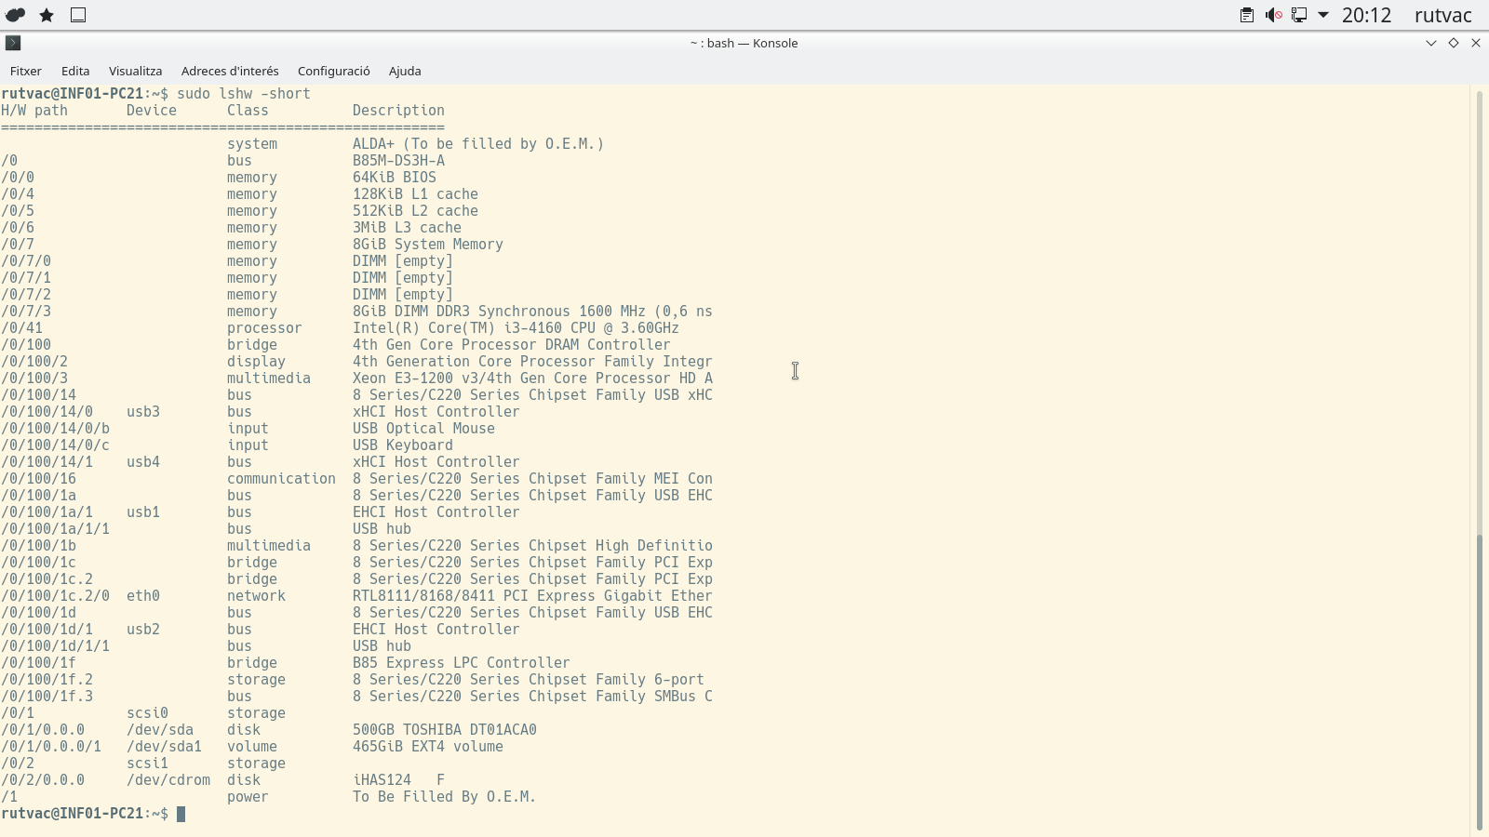

$ sudo lshw -C memory

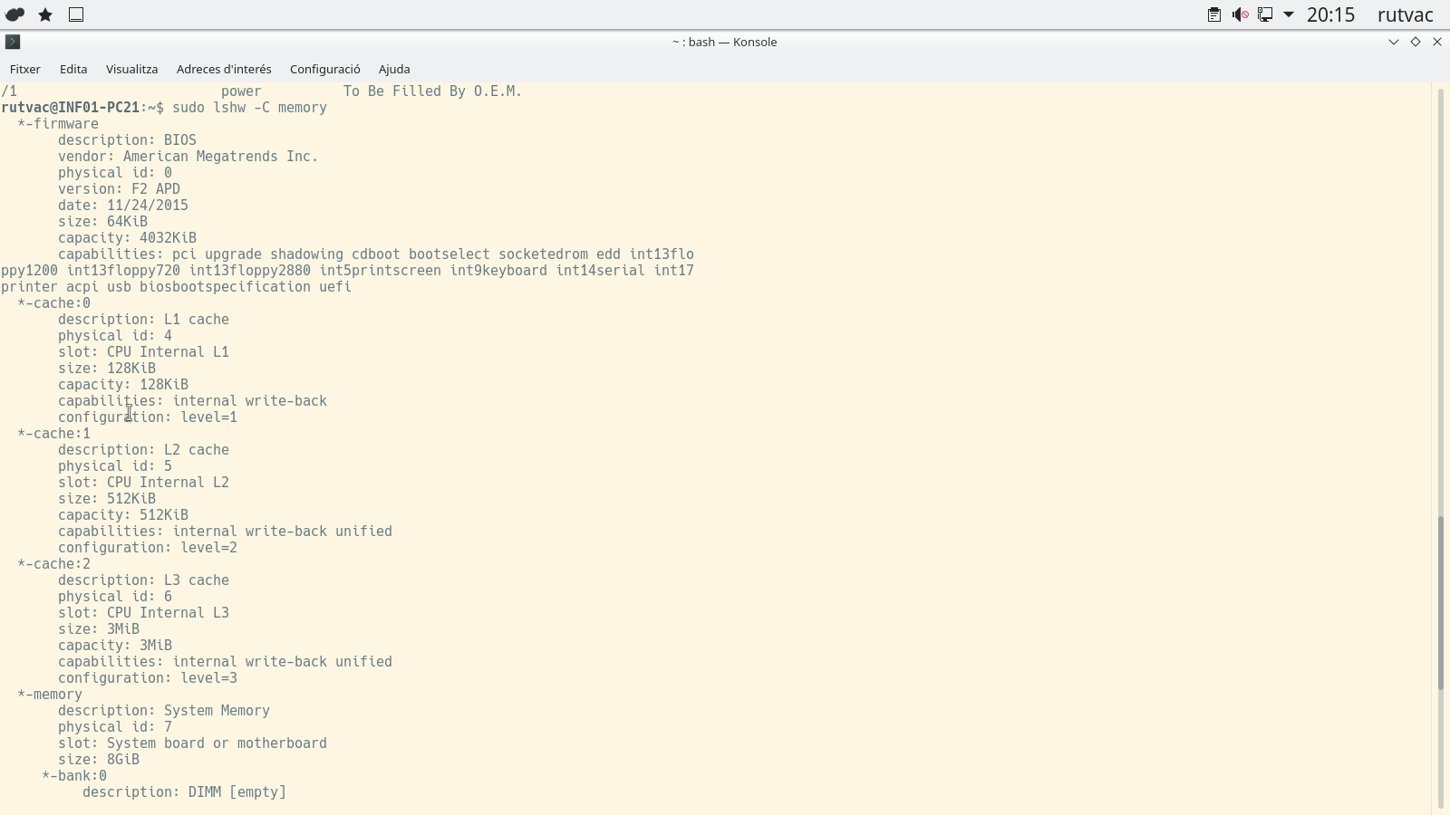

$ sudo lshw -C processor

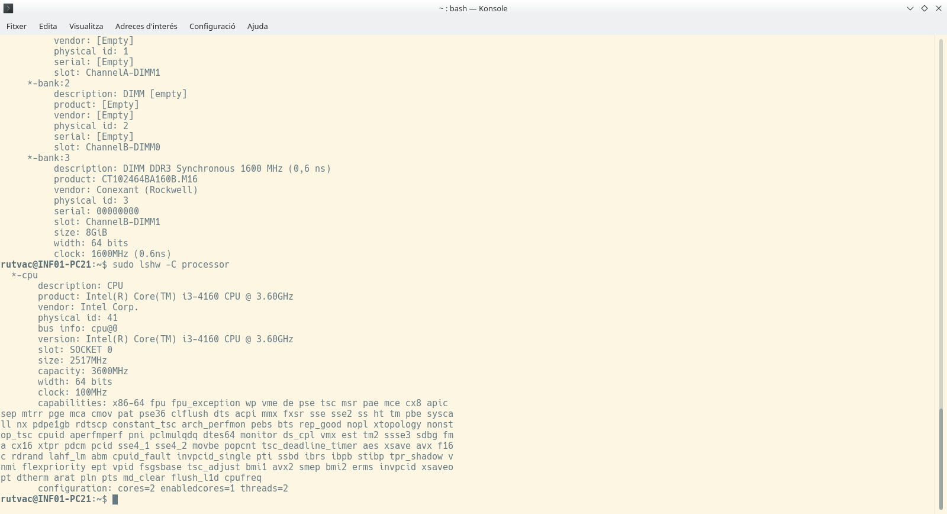

…

$ sudo lshw -class network

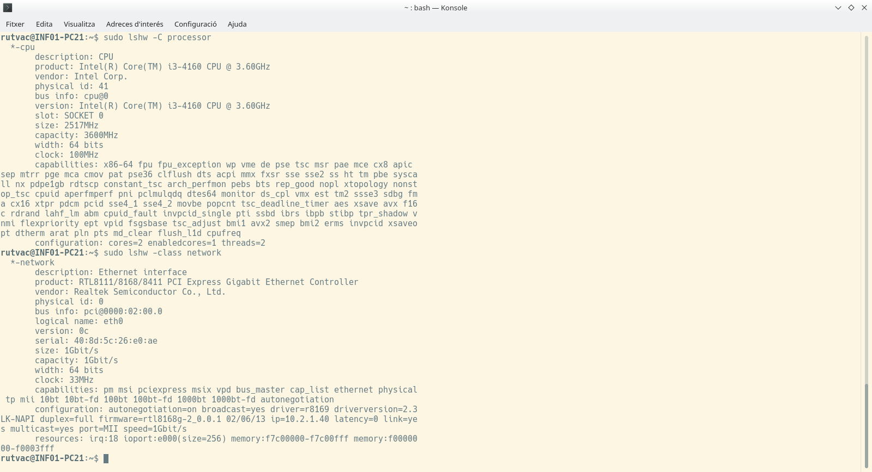

$ sudo lshw -html > hardware.html

| **id:** | inf01-pc21 |
| --- | --- |
| **description:** | Desktop Computer |
| **product:** | ALDA+ (To be filled by O.E.M.) |
| **vendor:** | APD |
| **version:** | ALDA+C |
| **serial:** | 3552036BN15770 |
| **width:** | 64 bits |
| **capabilities:** | smbios-2.7 dmi-2.7 smp vsyscall32 |
| **configuration:**   |  |  |  | | --- | --- | --- | | administrator_password | = | disabled | | boot | = | normal | | chassis | = | desktop | | family | = | To be filled by O.E.M. | | frontpanel_password | = | disabled | | keyboard_password | = | disabled | | power-on_password | = | disabled | | sku | = | To be filled by O.E.M. | | uuid | = | 40028D03-5C04-2605-E006-AE0700080009 | |  |

| **id:** | core |
| --- | --- |
| **description:** | Motherboard |
| **product:** | B85M-DS3H-A |
| **vendor:** | Gigabyte Technology Co., Ltd. |
| **physical id:** | 0 |
| **version:** | To be filled by O.E.M. |
| **serial:** | To be filled by O.E.M. |
| **slot:** | To be filled by O.E.M. |

| **id:** | firmware |
| --- | --- |
| **description:** | BIOS |
| **vendor:** | American Megatrends Inc. |
| **physical id:** | 0 |
| **version:** | F2 APD |
| **date:** | 11/24/2015 |
| **size:** | 64KiB |
| **capacity:** | 4032KiB |
| **capabilities:** | pci upgrade shadowing cdboot bootselect socketedrom edd int13floppy1200 int13floppy720 int13floppy2880 int5printscreen int9keyboard int14serial int17printer acpi usb biosbootspecification uefi |

| **id:** | cache:0 |
| --- | --- |
| **description:** | L1 cache |
| **physical id:** | 4 |
| **slot:** | CPU Internal L1 |
| **size:** | 128KiB |
| **capacity:** | 128KiB |
| **capabilities:** | internal write-back |
| **configuration:**   |  |  |  | | --- | --- | --- | | level | = | 1 | |  |

| **id:** | cache:1 |
| --- | --- |
| **description:** | L2 cache |
| **physical id:** | 5 |
| **slot:** | CPU Internal L2 |
| **size:** | 512KiB |
| **capacity:** | 512KiB |
| **capabilities:** | internal write-back unified |
| **configuration:**   |  |  |  | | --- | --- | --- | | level | = | 2 | |  |

| **id:** | cache:2 |
| --- | --- |
| **description:** | L3 cache |
| **physical id:** | 6 |
| **slot:** | CPU Internal L3 |
| **size:** | 3MiB |
| **capacity:** | 3MiB |
| **capabilities:** | internal write-back unified |
| **configuration:**   |  |  |  | | --- | --- | --- | | level | = | 3 | |  |

| **id:** | memory |
| --- | --- |
| **description:** | System Memory |
| **physical id:** | 7 |
| **slot:** | System board or motherboard |
| **size:** | 8GiB |

| **id:** | bank:0 |
| --- | --- |
| **description:** | DIMM [empty] |
| **product:** | [Empty] |
| **vendor:** | [Empty] |
| **physical id:** | 0 |
| **serial:** | [Empty] |
| **slot:** | ChannelA-DIMM0 |

| **id:** | bank:1 |
| --- | --- |
| **description:** | DIMM [empty] |
| **product:** | [Empty] |
| **vendor:** | [Empty] |
| **physical id:** | 1 |
| **serial:** | [Empty] |
| **slot:** | ChannelA-DIMM1 |

| **id:** | bank:2 |
| --- | --- |
| **description:** | DIMM [empty] |
| **product:** | [Empty] |
| **vendor:** | [Empty] |
| **physical id:** | 2 |
| **serial:** | [Empty] |
| **slot:** | ChannelB-DIMM0 |

| **id:** | bank:3 |
| --- | --- |
| **description:** | DIMM DDR3 Synchronous 1600 MHz (0,6 ns) |
| **product:** | CT102464BA160B.M16 |
| **vendor:** | Conexant (Rockwell) |
| **physical id:** | 3 |
| **serial:** | 00000000 |
| **slot:** | ChannelB-DIMM1 |
| **size:** | 8GiB |
| **width:** | 64 bits |
| **clock:** | 1600MHz (0.6ns) |

| **id:** | cpu |
| --- | --- |
| **description:** | CPU |
| **product:** | Intel(R) Core(TM) i3-4160 CPU @ 3.60GHz |
| **vendor:** | Intel Corp. |
| **physical id:** | 41 |
| **bus info:** | cpu@0 |
| **version:** | Intel(R) Core(TM) i3-4160 CPU @ 3.60GHz |
| **slot:** | SOCKET 0 |
| **size:** | 2504MHz |
| **capacity:** | 3600MHz |
| **width:** | 64 bits |
| **clock:** | 100MHz |
| **capabilities:** | x86-64 fpu fpu_exception wp vme de pse tsc msr pae mce cx8 apic sep mtrr pge mca cmov pat pse36 clflush dts acpi mmx fxsr sse sse2 ss ht tm pbe syscall nx pdpe1gb rdtscp constant_tsc arch_perfmon pebs bts rep_good nopl xtopology nonstop_tsc cpuid aperfmperf pni pclmulqdq dtes64 monitor ds_cpl vmx est tm2 ssse3 sdbg fma cx16 xtpr pdcm pcid sse4_1 sse4_2 movbe popcnt tsc_deadline_timer aes xsave avx f16c rdrand lahf_lm abm cpuid_fault invpcid_single pti ssbd ibrs ibpb stibp tpr_shadow vnmi flexpriority ept vpid fsgsbase tsc_adjust bmi1 avx2 smep bmi2 erms invpcid xsaveopt dtherm arat pln pts md_clear flush_l1d cpufreq |
| **configuration:**   |  |  |  | | --- | --- | --- | | cores | = | 2 | | enabledcores | = | 1 | | threads | = | 2 | |  |

| **id:** | pci |
| --- | --- |
| **description:** | Host bridge |
| **product:** | 4th Gen Core Processor DRAM Controller |
| **vendor:** | Intel Corporation |
| **physical id:** | 100 |
| **bus info:** | pci@0000:00:00.0 |
| **version:** | 06 |
| **width:** | 32 bits |
| **clock:** | 33MHz |
| **configuration:**   |  |  |  | | --- | --- | --- | | driver | = | hsw_uncore | |  |
| **resources:**   |  |  |  | | --- | --- | --- | | irq | : | 0 | |  |

| **id:** | display |
| --- | --- |
| **description:** | VGA compatible controller |
| **product:** | 4th Generation Core Processor Family Integrated Graphics Controller |
| **vendor:** | Intel Corporation |
| **physical id:** | 2 |
| **bus info:** | pci@0000:00:02.0 |
| **version:** | 06 |
| **width:** | 64 bits |
| **clock:** | 33MHz |
| **capabilities:** | msi pm vga_controller bus_master cap_list rom |
| **configuration:**   |  |  |  | | --- | --- | --- | | driver | = | i915 | | latency | = | 0 | |  |
| **resources:**   |  |  |  | | --- | --- | --- | | irq | : | 27 | | memory | : | f7800000-f7bfffff | | memory | : | e0000000-efffffff | | ioport | : | f000(size=64) | | memory | : | c0000-dffff | |  |

| **id:** | multimedia:0 |
| --- | --- |
| **description:** | Audio device |
| **product:** | Xeon E3-1200 v3/4th Gen Core Processor HD Audio Controller |
| **vendor:** | Intel Corporation |
| **physical id:** | 3 |
| **bus info:** | pci@0000:00:03.0 |
| **version:** | 06 |
| **width:** | 64 bits |
| **clock:** | 33MHz |
| **capabilities:** | pm msi pciexpress bus_master cap_list |
| **configuration:**   |  |  |  | | --- | --- | --- | | driver | = | snd_hda_intel | | latency | = | 0 | |  |
| **resources:**   |  |  |  | | --- | --- | --- | | irq | : | 30 | | memory | : | f7d14000-f7d17fff | |  |

| **id:** | usb:0 |
| --- | --- |
| **description:** | USB controller |
| **product:** | 8 Series/C220 Series Chipset Family USB xHCI |
| **vendor:** | Intel Corporation |
| **physical id:** | 14 |
| **bus info:** | pci@0000:00:14.0 |
| **version:** | 05 |
| **width:** | 64 bits |
| **clock:** | 33MHz |
| **capabilities:** | pm msi xhci bus_master cap_list |
| **configuration:**   |  |  |  | | --- | --- | --- | | driver | = | xhci_hcd | | latency | = | 0 | |  |
| **resources:**   |  |  |  | | --- | --- | --- | | irq | : | 24 | | memory | : | f7d00000-f7d0ffff | |  |

| **id:** | usbhost:0 |
| --- | --- |
| **product:** | xHCI Host Controller |
| **vendor:** | Linux 4.15.0-151-generic xhci-hcd |
| **physical id:** | 0 |
| **bus info:** | usb@3 |
| **logical name:** | usb3 |
| **version:** | 4.15 |
| **capabilities:** | usb-2.00 |
| **configuration:**   |  |  |  | | --- | --- | --- | | driver | = | hub | | slots | = | 12 | | speed | = | 480Mbit/s | |  |

| **id:** | usb:0 |
| --- | --- |
| **description:** | Mouse |
| **product:** | USB Optical Mouse |
| **vendor:** | Logitech |
| **physical id:** | b |
| **bus info:** | usb@3:b |
| **version:** | 72.00 |
| **capabilities:** | usb-2.00 |
| **configuration:**   |  |  |  | | --- | --- | --- | | driver | = | usbhid | | maxpower | = | 100mA | | speed | = | 1Mbit/s | |  |

| **id:** | usb:1 |
| --- | --- |
| **description:** | Keyboard |
| **product:** | USB Keyboard |
| **vendor:** | SIGMACHIP |
| **physical id:** | c |
| **bus info:** | usb@3:c |
| **version:** | 1.10 |
| **capabilities:** | usb-1.10 |
| **configuration:**   |  |  |  | | --- | --- | --- | | driver | = | usbhid | | maxpower | = | 98mA | | speed | = | 1Mbit/s | |  |

| **id:** | usbhost:1 |
| --- | --- |
| **product:** | xHCI Host Controller |
| **vendor:** | Linux 4.15.0-151-generic xhci-hcd |
| **physical id:** | 1 |
| **bus info:** | usb@4 |
| **logical name:** | usb4 |
| **version:** | 4.15 |
| **capabilities:** | usb-3.00 |
| **configuration:**   |  |  |  | | --- | --- | --- | | driver | = | hub | | slots | = | 6 | | speed | = | 5000Mbit/s | |  |

| **id:** | communication |
| --- | --- |
| **description:** | Communication controller |
| **product:** | 8 Series/C220 Series Chipset Family MEI Controller #1 |
| **vendor:** | Intel Corporation |
| **physical id:** | 16 |
| **bus info:** | pci@0000:00:16.0 |
| **version:** | 04 |
| **width:** | 64 bits |
| **clock:** | 33MHz |
| **capabilities:** | pm msi bus_master cap_list |
| **configuration:**   |  |  |  | | --- | --- | --- | | driver | = | mei_me | | latency | = | 0 | |  |
| **resources:**   |  |  |  | | --- | --- | --- | | irq | : | 28 | | memory | : | f7d1e000-f7d1e00f | |  |

| **id:** | usb:1 |
| --- | --- |
| **description:** | USB controller |
| **product:** | 8 Series/C220 Series Chipset Family USB EHCI #2 |
| **vendor:** | Intel Corporation |
| **physical id:** | 1a |
| **bus info:** | pci@0000:00:1a.0 |
| **version:** | 05 |
| **width:** | 32 bits |
| **clock:** | 33MHz |
| **capabilities:** | pm debug ehci bus_master cap_list |
| **configuration:**   |  |  |  | | --- | --- | --- | | driver | = | ehci-pci | | latency | = | 0 | |  |
| **resources:**   |  |  |  | | --- | --- | --- | | irq | : | 16 | | memory | : | f7d1c000-f7d1c3ff | |  |

| **id:** | usbhost |
| --- | --- |
| **product:** | EHCI Host Controller |
| **vendor:** | Linux 4.15.0-151-generic ehci_hcd |
| **physical id:** | 1 |
| **bus info:** | usb@1 |
| **logical name:** | usb1 |
| **version:** | 4.15 |
| **capabilities:** | usb-2.00 |
| **configuration:**   |  |  |  | | --- | --- | --- | | driver | = | hub | | slots | = | 2 | | speed | = | 480Mbit/s | |  |

| **id:** | usb |
| --- | --- |
| **description:** | USB hub |
| **vendor:** | Intel Corp. |
| **physical id:** | 1 |
| **bus info:** | usb@1:1 |
| **version:** | 0.05 |
| **capabilities:** | usb-2.00 |
| **configuration:**   |  |  |  | | --- | --- | --- | | driver | = | hub | | slots | = | 6 | | speed | = | 480Mbit/s | |  |

| **id:** | multimedia:1 |
| --- | --- |
| **description:** | Audio device |
| **product:** | 8 Series/C220 Series Chipset High Definition Audio Controller |
| **vendor:** | Intel Corporation |
| **physical id:** | 1b |
| **bus info:** | pci@0000:00:1b.0 |
| **version:** | 05 |
| **width:** | 64 bits |
| **clock:** | 33MHz |
| **capabilities:** | pm msi pciexpress bus_master cap_list |
| **configuration:**   |  |  |  | | --- | --- | --- | | driver | = | snd_hda_intel | | latency | = | 0 | |  |
| **resources:**   |  |  |  | | --- | --- | --- | | irq | : | 29 | | memory | : | f7d10000-f7d13fff | |  |

| **id:** | pci:0 |
| --- | --- |
| **description:** | PCI bridge |
| **product:** | 8 Series/C220 Series Chipset Family PCI Express Root Port #1 |
| **vendor:** | Intel Corporation |
| **physical id:** | 1c |
| **bus info:** | pci@0000:00:1c.0 |
| **version:** | d5 |
| **width:** | 32 bits |
| **clock:** | 33MHz |
| **capabilities:** | pci pciexpress msi pm normal_decode bus_master cap_list |
| **configuration:**   |  |  |  | | --- | --- | --- | | driver | = | pcieport | |  |
| **resources:**   |  |  |  | | --- | --- | --- | | irq | : | 16 | |  |

| **id:** | pci:1 |
| --- | --- |
| **description:** | PCI bridge |
| **product:** | 8 Series/C220 Series Chipset Family PCI Express Root Port #3 |
| **vendor:** | Intel Corporation |
| **physical id:** | 1c.2 |
| **bus info:** | pci@0000:00:1c.2 |
| **version:** | d5 |
| **width:** | 32 bits |
| **clock:** | 33MHz |
| **capabilities:** | pci pciexpress msi pm normal_decode bus_master cap_list |
| **configuration:**   |  |  |  | | --- | --- | --- | | driver | = | pcieport | |  |
| **resources:**   |  |  |  | | --- | --- | --- | | irq | : | 18 | | ioport | : | e000(size=4096) | | memory | : | f7c00000-f7cfffff | | ioport | : | f0000000(size=1048576) | |  |

| **id:** | network |
| --- | --- |
| **description:** | Ethernet interface |
| **product:** | RTL8111/8168/8411 PCI Express Gigabit Ethernet Controller |
| **vendor:** | Realtek Semiconductor Co., Ltd. |
| **physical id:** | 0 |
| **bus info:** | pci@0000:02:00.0 |
| **logical name:** | eth0 |
| **version:** | 0c |
| **serial:** | 40:8d:5c:26:e0:ae |
| **size:** | 1Gbit/s |
| **capacity:** | 1Gbit/s |
| **width:** | 64 bits |
| **clock:** | 33MHz |
| **capabilities:** | pm msi pciexpress msix vpd bus_master cap_list ethernet physical tp mii 10bt 10bt-fd 100bt 100bt-fd 1000bt 1000bt-fd autonegotiation |
| **configuration:**   |  |  |  | | --- | --- | --- | | autonegotiation | = | on | | broadcast | = | yes | | driver | = | r8169 | | driverversion | = | 2.3LK-NAPI | | duplex | = | full | | firmware | = | rtl8168g-2_0.0.1 02/06/13 | | ip | = | 10.2.1.40 | | latency | = | 0 | | link | = | yes | | multicast | = | yes | | port | = | MII | | speed | = | 1Gbit/s | |  |
| **resources:**   |  |  |  | | --- | --- | --- | | irq | : | 18 | | ioport | : | e000(size=256) | | memory | : | f7c00000-f7c00fff | | memory | : | f0000000-f0003fff | |  |

| **id:** | usb:2 |
| --- | --- |
| **description:** | USB controller |
| **product:** | 8 Series/C220 Series Chipset Family USB EHCI #1 |
| **vendor:** | Intel Corporation |
| **physical id:** | 1d |
| **bus info:** | pci@0000:00:1d.0 |
| **version:** | 05 |
| **width:** | 32 bits |
| **clock:** | 33MHz |
| **capabilities:** | pm debug ehci bus_master cap_list |
| **configuration:**   |  |  |  | | --- | --- | --- | | driver | = | ehci-pci | | latency | = | 0 | |  |
| **resources:**   |  |  |  | | --- | --- | --- | | irq | : | 23 | | memory | : | f7d1b000-f7d1b3ff | |  |

| **id:** | usbhost |
| --- | --- |
| **product:** | EHCI Host Controller |
| **vendor:** | Linux 4.15.0-151-generic ehci_hcd |
| **physical id:** | 1 |
| **bus info:** | usb@2 |
| **logical name:** | usb2 |
| **version:** | 4.15 |
| **capabilities:** | usb-2.00 |
| **configuration:**   |  |  |  | | --- | --- | --- | | driver | = | hub | | slots | = | 2 | | speed | = | 480Mbit/s | |  |

| **id:** | usb |
| --- | --- |
| **description:** | USB hub |
| **vendor:** | Intel Corp. |
| **physical id:** | 1 |
| **bus info:** | usb@2:1 |
| **version:** | 0.05 |
| **capabilities:** | usb-2.00 |
| **configuration:**   |  |  |  | | --- | --- | --- | | driver | = | hub | | slots | = | 6 | | speed | = | 480Mbit/s | |  |

| **id:** | isa |
| --- | --- |
| **description:** | ISA bridge |
| **product:** | B85 Express LPC Controller |
| **vendor:** | Intel Corporation |
| **physical id:** | 1f |
| **bus info:** | pci@0000:00:1f.0 |
| **version:** | 05 |
| **width:** | 32 bits |
| **clock:** | 33MHz |
| **capabilities:** | isa bus_master cap_list |
| **configuration:**   |  |  |  | | --- | --- | --- | | driver | = | lpc_ich | | latency | = | 0 | |  |
| **resources:**   |  |  |  | | --- | --- | --- | | irq | : | 0 | |  |

| **id:** | storage |
| --- | --- |
| **description:** | SATA controller |
| **product:** | 8 Series/C220 Series Chipset Family 6-port SATA Controller 1 [AHCI mode] |
| **vendor:** | Intel Corporation |
| **physical id:** | 1f.2 |
| **bus info:** | pci@0000:00:1f.2 |
| **version:** | 05 |
| **width:** | 32 bits |
| **clock:** | 66MHz |
| **capabilities:** | storage msi pm ahci_1.0 bus_master cap_list |
| **configuration:**   |  |  |  | | --- | --- | --- | | driver | = | ahci | | latency | = | 0 | |  |
| **resources:**   |  |  |  | | --- | --- | --- | | irq | : | 25 | | ioport | : | f0b0(size=8) | | ioport | : | f0a0(size=4) | | ioport | : | f090(size=8) | | ioport | : | f080(size=4) | | ioport | : | f060(size=32) | | memory | : | f7d1a000-f7d1a7ff | |  |

| **id:** | serial |
| --- | --- |
| **description:** | SMBus |
| **product:** | 8 Series/C220 Series Chipset Family SMBus Controller |
| **vendor:** | Intel Corporation |
| **physical id:** | 1f.3 |
| **bus info:** | pci@0000:00:1f.3 |
| **version:** | 05 |
| **width:** | 64 bits |
| **clock:** | 33MHz |
| **configuration:**   |  |  |  | | --- | --- | --- | | latency | = | 0 | |  |
| **resources:**   |  |  |  | | --- | --- | --- | | memory | : | f7d19000-f7d190ff | | ioport | : | f040(size=32) | |  |

| **id:** | scsi:0 |
| --- | --- |
| **physical id:** | 1 |
| **logical name:** | scsi0 |
| **capabilities:** | emulated |

| **id:** | disk |
| --- | --- |
| **description:** | ATA Disk |
| **product:** | TOSHIBA DT01ACA0 |
| **vendor:** | Toshiba |
| **physical id:** | 0.0.0 |
| **bus info:** | scsi@0:0.0.0 |
| **logical name:** | /dev/sda |
| **version:** | A750 |
| **serial:** | Y55NAAXHS |
| **size:** | 465GiB (500GB) |
| **capabilities:** | partitioned partitioned:dos |
| **configuration:**   |  |  |  | | --- | --- | --- | | ansiversion | = | 5 | | logicalsectorsize | = | 512 | | sectorsize | = | 4096 | | signature | = | 668854fc | |  |

| **id:** | volume |
| --- | --- |
| **description:** | EXT4 volume |
| **vendor:** | Linux |
| **physical id:** | 1 |
| **bus info:** | scsi@0:0.0.0,1 |
| **logical name:** | /dev/sda1 |
| **logical name:** | / |
| **version:** | 1.0 |
| **serial:** | 985cd788-7836-4ace-ad71-f15dd02ae340 |
| **size:** | 465GiB |
| **capacity:** | 465GiB |
| **capabilities:** | primary bootable journaled extended_attributes large_files huge_files dir_nlink recover 64bit extents ext4 ext2 initialized |
| **configuration:**   |  |  |  | | --- | --- | --- | | created | = | 2019-10-24 10:29:04 | | filesystem | = | ext4 | | lastmountpoint | = | /root | | modified | = | 2022-10-18 16:10:06 | | mount.fstype | = | ext4 | | mount.options | = | rw,relatime,errors=remount-ro,data=ordered | | mounted | = | 2022-10-18 16:10:06 | | state | = | mounted | |  |

| **id:** | scsi:1 |
| --- | --- |
| **physical id:** | 2 |
| **logical name:** | scsi1 |
| **capabilities:** | emulated |

| **id:** | cdrom |
| --- | --- |
| **description:** | DVD-RAM writer |
| **product:** | iHAS124 F |
| **vendor:** | ATAPI |
| **physical id:** | 0.0.0 |
| **bus info:** | scsi@1:0.0.0 |
| **logical name:** | /dev/cdrom |
| **logical name:** | /dev/cdrw |
| **logical name:** | /dev/dvd |
| **logical name:** | /dev/dvdrw |
| **logical name:** | /dev/sr0 |
| **version:** | CL08 |
| **capabilities:** | removable audio cd-r cd-rw dvd dvd-r dvd-ram |
| **configuration:**   |  |  |  | | --- | --- | --- | | ansiversion | = | 5 | | status | = | nodisc | |  |

| **id:** | power |
| --- | --- |
| **description:** | To Be Filled By O.E.M. |
| **product:** | To Be Filled By O.E.M. |
| **vendor:** | To Be Filled By O.E.M. |
| **physical id:** | 1 |
| **version:** | To Be Filled By O.E.M. |
| **serial:** | To Be Filled By O.E.M. |
| **capacity:** | 32768mWh |

1. Install a benchmark on your computer (hardinfo, CPU-X on Ubuntu or CPU-Z on Windows) and prepare a Report with the information you can get from the tests. Including all the relevant information you can get: processor, cache, RAM, BIOS,...

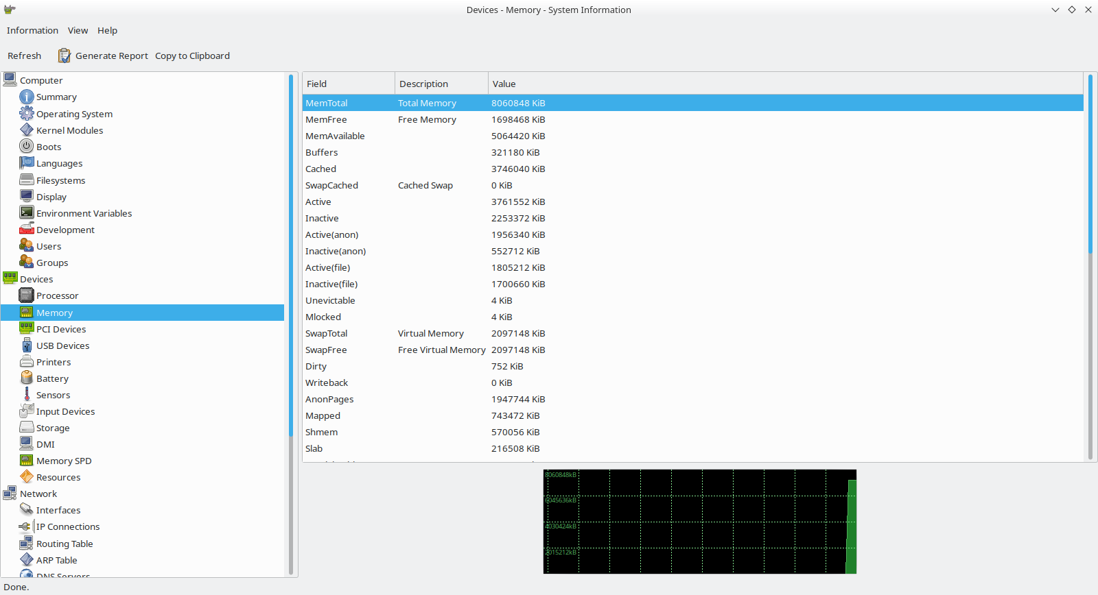

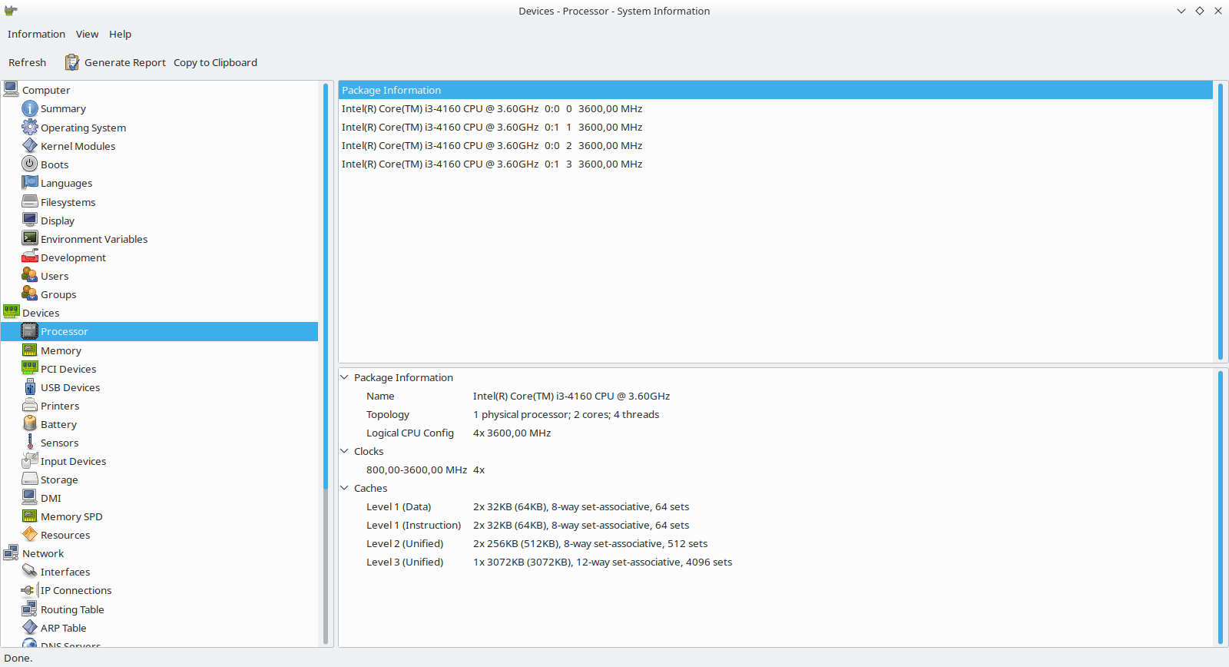

1. 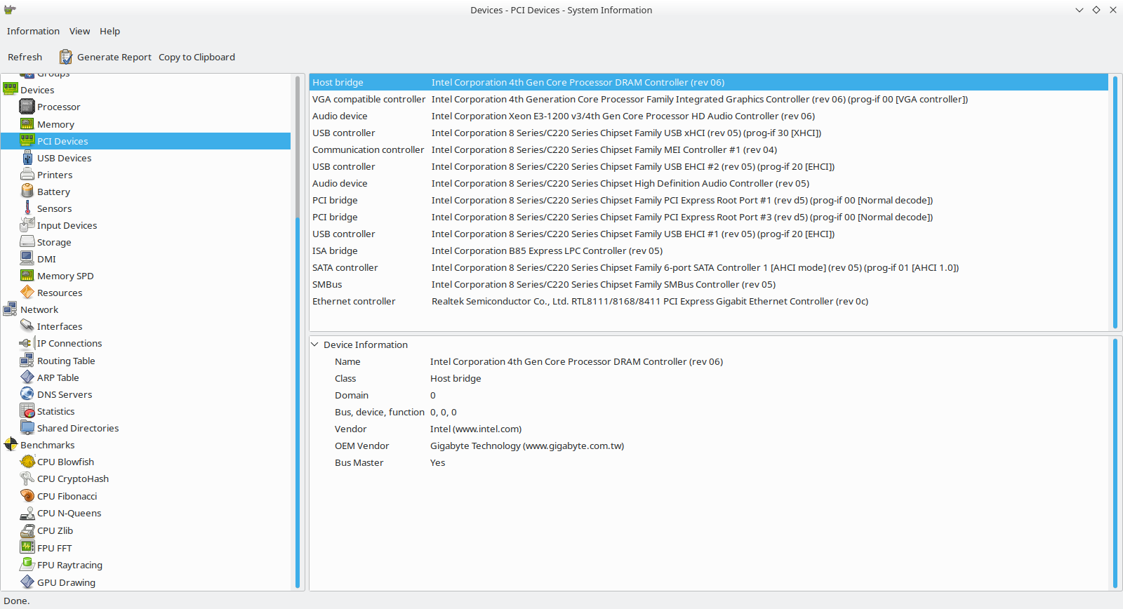According to the previous results, do you 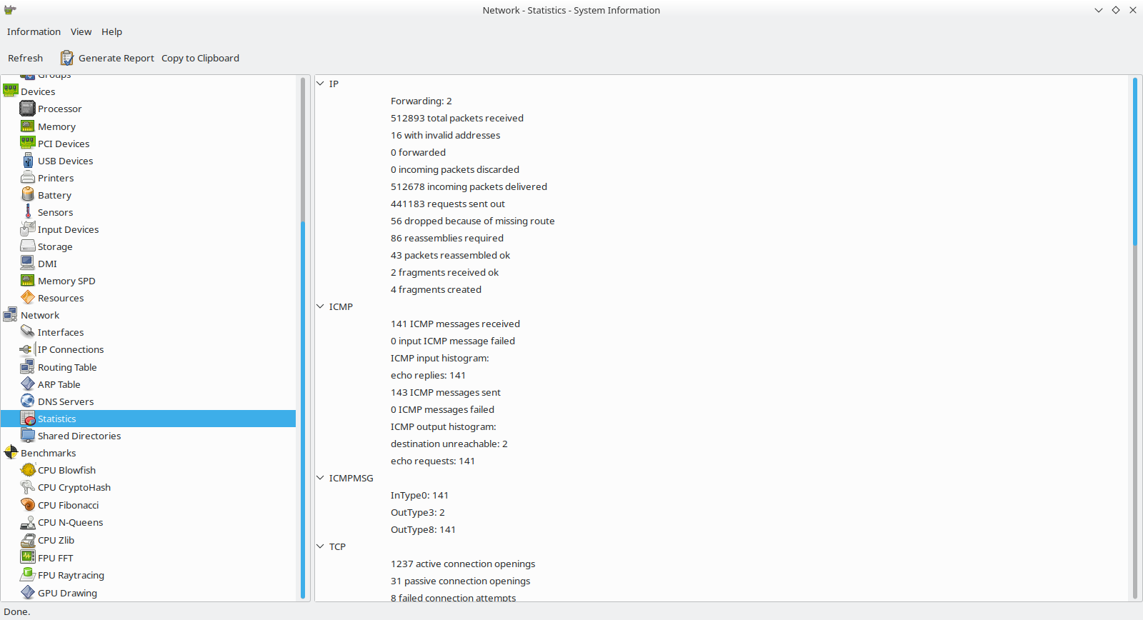think you need to change any components or add on your computer to increase its performance?. Talk to a classmate an write some sentences in english to explain the reasons for that change to the rest of the class