BA64036_Assignment1

Ruthvick Bulagakula

2023-09-29

## Introduction

The purpose of this assignment is to set up and use the tools for this course.

## Instructions

1. Install the ISLR library using the install.packages() command. Call the library using the library(ISLR) command to ensure that the library is correctly installed (10% of total points)

**Calling Installed Library**

# If i use install.packages() command rmd file is failing to knit.   
# so, i've removed install.packages() command  
  
library(ISLR) # Using Library to call installed ISLR library

1. Create a new R-Notebook (.Rmd) file. In the first code chunk, call the ISLR library and then print the summary of the Carseats dataset. How many observations (rows) this dataset contains? (15% of total points)

**Using Careseats Dataset**

summary(Carseats) # Using Summary function to get descriptive statistics of Carseats dataset

## Sales CompPrice Income Advertising   
## Min. : 0.000 Min. : 77 Min. : 21.00 Min. : 0.000   
## 1st Qu.: 5.390 1st Qu.:115 1st Qu.: 42.75 1st Qu.: 0.000   
## Median : 7.490 Median :125 Median : 69.00 Median : 5.000   
## Mean : 7.496 Mean :125 Mean : 68.66 Mean : 6.635   
## 3rd Qu.: 9.320 3rd Qu.:135 3rd Qu.: 91.00 3rd Qu.:12.000   
## Max. :16.270 Max. :175 Max. :120.00 Max. :29.000   
## Population Price ShelveLoc Age Education   
## Min. : 10.0 Min. : 24.0 Bad : 96 Min. :25.00 Min. :10.0   
## 1st Qu.:139.0 1st Qu.:100.0 Good : 85 1st Qu.:39.75 1st Qu.:12.0   
## Median :272.0 Median :117.0 Medium:219 Median :54.50 Median :14.0   
## Mean :264.8 Mean :115.8 Mean :53.32 Mean :13.9   
## 3rd Qu.:398.5 3rd Qu.:131.0 3rd Qu.:66.00 3rd Qu.:16.0   
## Max. :509.0 Max. :191.0 Max. :80.00 Max. :18.0   
## Urban US   
## No :118 No :142   
## Yes:282 Yes:258   
##   
##   
##   
##

**No.of Observations in carseats dataset**

nrow(Carseats) # Using nrow function to get no of rows in Carsearts dataset

## [1] 400

1. Using the summary statistics shown above, what is maximum value of the advertising attribute? (15% of total points)

**Maximum Values of the advertising**

max(Carseats$Advertising) # Using max function to get maximum value of advertising

## [1] 29

1. Calculate the IQR of the Price attribute. (15% of total points)

**IQR for Price**

IQR(Carseats$Price) # Using IQR function to get Interquartile Range for Price

## [1] 31

1. Plot the Sales against Price. What do you see in there? Calculate the correlation of the two attributes. What does the sign of the correlation coefficient suggest? (15% of total points)

**Plotting Sales againt Price**

# Using plot function to get scatterplot for Price againt Sales  
plot(Carseats$Price, Carseats$Sales, xlab = "Price", ylab = "Sales", main = "Price VS Sales", col = "Blue")

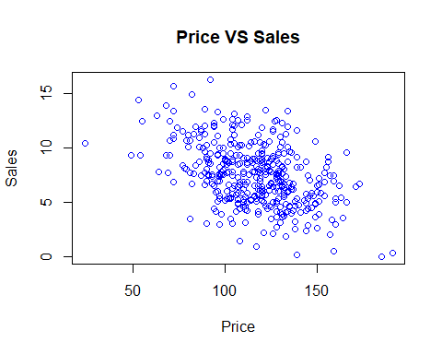

**Correlation coefficient for price and sales**

cor(Carseats$Price, Carseats$Sales) # Using cor function to Price and Sales correlation

## [1] -0.4449507