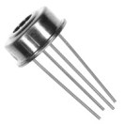

MLX90614 is a cheap and popular infrared thermometer from Melexis. This device is made in different versions for different purposes.  
You can get a generic purpose version with 0.5accuracy or for medical purposes with accuracy up to 0.2.

Also, you can choose the voltage you needed: 3.3v or 5v versions are available.  
With MLX90614 you can distantly measure the temperature of the objects, even the temperature of the sky.