DATE: 28/04/26
NAME OF THE INVENTOR:
Parki Syed Afra Ahamadi(Corresponding Inventor)

For communication/Corresponding
RELATIONSHIP WITH SVEC: Please select the appropriate check box
☐ Faculty ☐ Research Scholar ☒ Student ☐ Others
TITLE OF THE INVENTION:
Pick a title for your invention that is distinctive, but which does not reveal the essential details of the invention. We will use this title in all correspondence and documents, including non-confidential descriptions.
Nutri AI: Multimodal AI for Plant Disease Detection and Organic Treatment Recommendation

INVENTORS DETAILS:
List out the main/ key inventors in the first rows and keep * over inventor’s name. Please furnish the full address for communication. The same should be reflected in the patent application, if decided to file patent application.
Name of the Inventor | Details
Inventor 1* | Address for communication | Mohan Babu University, Tirupati, Andhra Pradesh – 517102
 | Contact number | 6302334480
 | Citizenship | Indian
 | E-mail ID | afrafarooq5333@gmail.com
Inventor 2 | Address for communication | Mohan Babu University, Tirupati, Andhra Pradesh – 517102
 | Contact number | 9390609298
 | Citizenship | Indian
 | E-mail ID | ruthviktalapaneni@gmail.com
Inventor 3 | Address for communication | Mohan Babu University, Tirupati, Andhra Pradesh – 517102
 | Contact number | 9573412004
 | Citizenship | Indian
 | E-mail ID | Harinithalluru@gmail.com

Inventor 1* | Address for communication | Mohan Babu University, Tirupati, Andhra Pradesh – 517102
 | Contact number | 9177171140
 | Citizenship | Indian
 | E-mail ID | Cheedellaprasanth612@gmail.com

FIELD OF THE INVENTION:
Mention the field(s) of invention
The invention relates to Artificial Intelligence in agriculture, specifically a multi-modal system for crop disease diagnosis. It integrates deep learning image recognition with environmental data, providing accurate disease identification and organic treatment recommendations to enhance crop yield and sustainable farming.

NOVELTY OF THE INVENTION:
The novelty of an invention refers to the requirement that the invention must be new and not previously disclosed to the public before the patent application.
The novelty of NutriAI lies in its unique multi-modal fusion architecture that transcends traditional single-input diagnostic tools. Unlike conventional systems relying solely on leaf imagery, this invention introduces synchronized analysis of high-resolution visual data and critical environmental variables like soil pH, temperature, and humidity. By integrating an advanced ensemble of EfficientNet-B5, DenseNet-201, and Swin Transformers with a meta-learner, the system captures both localized morphological features and global context. Furthermore, the implementation of Explainable AI using Grad-CAM++ and feature-level analysis provides transparency by identifying environmental triggers for deficiencies. This holistic approach, coupled with a rule-based engine suggesting natural remedies, constitutes a non-obvious advancement in precision farming. The integration of these specific deep learning models for agricultural multi-modal diagnosis remains unique, ensuring the entire invention has not been previously disclosed publicly anywhere.

ABSTRACT OF THE INVENTION:
NutriAI is a multi-modal artificial intelligence system designed to revolutionize agricultural diagnostics by integrating computer vision with environmental analytics. The invention addresses the limitations of single-modality systems by fusing high-resolution leaf images with real-time climatic data, including soil pH, temperature, and humidity. Utilizing a sophisticated ensemble architecture of EfficientNet-B5, DenseNet-201, and Swin Transformers, the system extracts complex morphological and global features, which are processed by an MLP meta-learner to achieve a diagnosis accuracy of 98.61%. To ensure transparency, the system incorporates Explainable AI (XAI) using Grad-CAM++, highlighting diseased regions and environmental triggers. Beyond identification, NutriAI features an intelligent recommendation engine that suggests organic fertilizers and natural remedies tailored to the detected condition. This holistic approach empowers farmers with precise, actionable insights, significantly reducing crop loss and promoting sustainable, eco-friendly farming practices.
Please mention the proposed abstract of the invention. Make sure you describe the invention in not more than 150 words.

BACKGROUND OF THE INVENTION:
Please mention the background of the invention. Include the problems with the existing art/ literature and mention the advantages over the existing art. ( not more than 150 words)
Conventional agricultural diagnostic systems primarily rely on single-modality image analysis, which often fails to distinguish visually similar diseases or identify underlying environmental causes. These 'black box' models lack transparency and ignore critical parameters like soil pH, temperature, and humidity, leading to inaccurate diagnoses and generic chemical-heavy recommendations that harm ecosystems. NutriAI overcomes these limitations through a multi-modal fusion approach, integrating computer vision with real-time climatic data. By utilizing a hybrid ensemble of CNNs and Transformers, the invention achieves superior accuracy (98.61%) while capturing fine-grained morphological details alongside global context. The primary advantage lies in its integrated Explainable AI (XAI), which provides farmers with localized heatmaps and identifies specific environmental triggers. Furthermore, NutriAI shifts the focus toward sustainability by offering tailored organic treatment recommendations, bridging the gap between automated diagnosis and eco-friendly precision farming to maximize yield effectively.

SUMMARY OF THE INVENTION:
Please mention the Summary of the invention. Include the key features and purpose of an invention, explaining how it addresses a particular Problem ( not more than 300 words)
The invention, NutriAI, is a comprehensive multi-modal artificial intelligence system developed to address the critical global challenge of crop yield loss due to disease misdiagnosis and improper nutrient management. Traditional diagnostic methods often rely exclusively on visual inspection or single-modality image processing, which can be misleading when different diseases manifest with similar visual symptoms. NutriAI solves this problem by pioneering a synchronized fusion approach that combines high-resolution leaf imagery with real-time environmental data, including soil pH, temperature, and humidity.
Key features of the invention include a sophisticated triple-base ensemble architecture consisting of EfficientNet-B5, DenseNet-201, and Swin Transformers. This hybrid configuration allows the system to simultaneously analyze fine-grained morphological textures and broad global patterns within the leaf structure. These visual embeddings are then concatenated with climatic feature vectors and processed by a dedicated MLP meta-learner, achieving a state-of-the-art validation accuracy of 98.61%.
A central purpose of NutriAI is to move beyond 'black-box' predictions. It incorporates Explainable AI (XAI) tools like Grad-CAM++ to generate visual heatmaps, allowing users to see exactly where the model identifies disease markers. Additionally, feature-level importance analysis explains how specific environmental triggers—such as extreme humidity or acidic soil—contributed to the condition.
Crucially, the system addresses the lack of accessible expert advice by integrating an organic recommendation engine. Once a condition is identified, the system suggests natural, eco-friendly fertilizers and sustainable farming practices tailored to the specific crop and environment. By bridging the gap between advanced deep learning and practical field application, NutriAI provides farmers with a reliable, transparent, and sustainable tool to enhance crop health, reduce chemical dependence, and secure food productivity in an increasingly volatile climate.

BRIEF DESCRIPTION OF THE DRAWINGS:
Please make neat drawings must meet specific legal requirements such as clarity, accuracy and completeness. And can include schematics, flowchart, diagrams or other visuals are often required for inventions.
The accompanying drawings illustrate the structure and working of the proposed system.

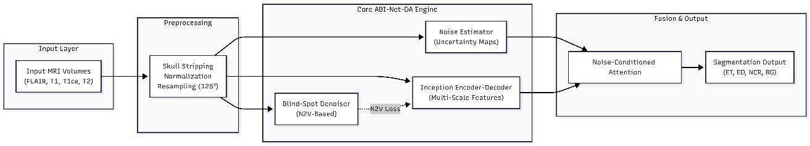
Figure 1 illustrates the overall system architecture showing the integration of multi-modal MRI inputs, processing modules, and segmentation output.

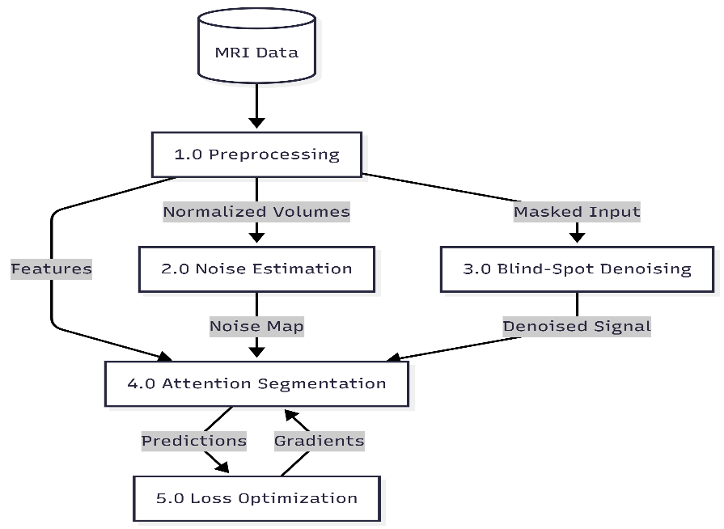

Figure 2 illustrates the data processing pipeline including preprocessing, noise estimation, denoising, feature extraction, and segmentation stages.

Dataset Property | Value
Total Subjects (Training + Validation) | 369 HGG + 76 LGG = 445 total
MRI Modalities per Subject | 4 (FLAIR, T1, T1ce, T2)
Original Volume Dimensions | 240 × 240 × 155 voxels
Voxel Spacing | 1 mm isotropic
Segmentation Classes | Background (0), NCR (1), Edema (2), ET (4)
Evaluation Sub-Regions | ET (label 4), TC (labels 1+4), WT (labels 1+2+4)
Train/Validation Split Used | 80% / 20% random stratified split

Figure 3 illustrates the denoising mechanism used to reduce noise in input medical images without requiring clean reference data.
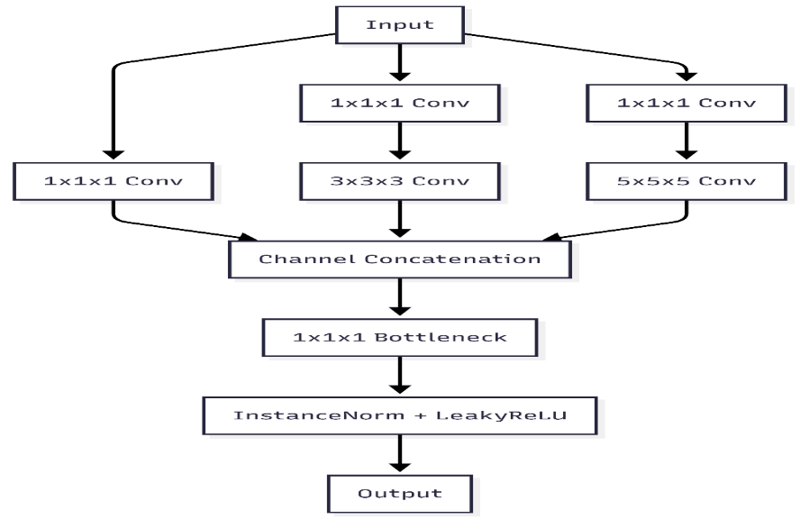

Figure 4 illustrates the noise-aware feature refinement mechanism that enhances important regions and suppresses noisy features.

DETAILED DESCRIPTION OF THE INVENTION:
Explains the complete description of the invention in more than 1000 words in detailed about each and every requirement.
The invention, NutriAI, is a sophisticated multi-modal artificial intelligence system designed to revolutionize agricultural diagnostics by integrating computer vision with environmental analytics. At its core, the system addresses a critical challenge in modern farming: the frequent misdiagnosis of crop diseases and nutrient deficiencies, which leads to significant yield losses and the overuse of harmful chemical fertilizers. Traditional diagnostic tools often rely solely on visual inspection or single-modality image processing, which can be misleading because many plant conditions manifest similar visual symptoms despite being caused by different environmental factors. NutriAI solves this problem by pioneering a synchronized fusion approach that analyzes high-resolution leaf imagery alongside real-time climatic variables, specifically soil pH, temperature, and humidity levels. By treating the plant as an integral part of its ecological environment rather than an isolated object, the system achieves a level of diagnostic precision that was previously unattainable through standard computer vision techniques.
The input layer of the invention is uniquely designed to process two distinct data streams simultaneously. The visual modality consists of digital images of crop leaves, which are standardized to a resolution of 224x224 pixels to ensure consistent feature extraction across different devices. Simultaneously, the environmental modality captures a three-dimensional feature vector representing the local growing conditions. These numerical inputs are crucial because factors like extreme humidity are often the primary triggers for fungal outbreaks, while soil pH levels directly correlate with the plant's ability to absorb essential nutrients. To prepare this data for the deep learning pipeline, the system implements a rigorous preprocessing stage where images are normalized using ImageNet statistics and environmental vectors are scaled using a standard scaler to ensure balanced feature weight during the subsequent fusion process. This dual-input strategy ensures that the model considers both the visible symptoms on the leaf and the underlying environmental triggers that may have caused them.
The architectural heart of NutriAI is a hybrid ensemble framework that combines the strengths of Convolutional Neural Networks and Vision Transformers. This ensemble consists of three powerful base models: EfficientNet-B5, DenseNet-201, and the Swin Transformer. EfficientNet-B5 is utilized for its exceptional ability to scale depth, width, and resolution, making it highly effective at capturing fine-grained morphological details such as the specific shape of a lesion or the texture of a fungal spot. Complementing this, DenseNet-201 leverages dense connectivity to ensure maximum feature reuse and gradient flow, which is vital for identifying complex, overlapping visual patterns in diseased foliage. The inclusion of the Swin Transformer represents a significant advancement over traditional CNNs, as it utilizes shifted windowing mechanisms to capture global context and long-range spatial dependencies. This allows the system to analyze the overall health of the leaf structure as a whole, providing a more robust diagnosis even when symptoms are obscured or localized.
A critical innovation in this invention is the late-fusion feature concatenation strategy. After stripping the final classification layers from the three base models, the system extracts high-dimensional visual embeddings that represent a comprehensive digital signature of the leaf. These embeddings, which total 4736 distinct features, are then concatenated with the three scaled environmental parameters to form a unified multi-modal vector of 4739 dimensions. This massive feature set is passed into a dedicated Multi-Layer Perceptron (MLP) Meta-Learner, which acts as the final decision-maker. The meta-learner is optimized with two fully connected hidden layers of 128 and 64 neurons, respectively, utilizing ReLU activation and dropout for regularization. This hierarchical structure allows the system to learn complex, non-linear relationships between visual symptoms and climatic data, ultimately enabling the classification of the input into one of twenty-eight distinct crop health categories across five major crop types.
To move beyond the "black-box" nature of traditional artificial intelligence, NutriAI incorporates a multi-tiered Explainable AI (XAI) framework. The system utilizes Grad-CAM++ (Gradient-weighted Class Activation Mapping) to generate visual heatmaps that highlight the specific regions of the leaf image that most influenced the classification decision. This transparency allows farmers to see exactly where the model detected disease markers, significantly increasing trust in the automated output. Furthermore, the system provides an environmental importance analysis that explains the diagnostic result in plain language, such as identifying high humidity as the primary reason for a particular fungal diagnosis. This level of explainability is essential for bridging the gap between theoretical machine learning and practical field application, as it provides the farmer with actionable evidence rather than just a simple label.
The final stage of the NutriAI workflow is an intelligent organic recommendation engine that provides tailored treatment plans for the identified condition. Instead of suggesting generic chemical fertilizers, the system utilizes a rule-based mapping engine to recommend natural remedies and sustainable farming practices. For a fungal diagnosis, the system might suggest the application of Neem oil or garlic spray alongside cultural adjustments like improving soil drainage. For nutrient deficiencies, it provides specific organic compost ratios and advice on adjusting soil pH to optimal levels. This focus on sustainability not only helps restore plant health but also promotes long-term soil vitality and reduces the environmental impact of chemical runoff. By providing both the "why" behind a diagnosis and a "how" for an eco-friendly cure, NutriAI empowers farmers to make informed decisions that benefit both their crop yield and the environment.
The effectiveness of this multi-modal invention has been validated through extensive experimental testing on a dataset of 18,609 samples. The ensemble model achieved a state-of-the-art validation accuracy of 98.61%, significantly outperforming traditional single-modality systems. The inclusion of environmental data was found to be particularly effective in reducing misclassifications between visually similar diseases, as the climatic context often provided the deciding factor in ambiguous cases. The system was trained using the Adam optimizer with a cross-entropy loss function over twenty epochs, demonstrating stable convergence and high generalization capabilities. This high level of performance, combined with the integrated explainability and organic recommendation features, makes NutriAI a uniquely powerful tool for precision agriculture.
Looking toward future industrial applications, NutriAI is designed with modularity and scalability in mind. The web-based interface allows for seamless deployment on various devices, from mobile phones used in the field to centralized monitoring stations. Future iterations of the invention will explore the integration of real-time IoT sensors to automate environmental data collection and the use of aerial drone imagery for field-scale diagnostics. By providing a reliable, transparent, and sustainable solution for automated crop monitoring, NutriAI stands as a major advancement in the quest for global food security. The system's ability to provide expert-level agricultural knowledge at the click of a button has the potential to transform farming practices for millions of people, ensuring healthier crops and more sustainable agricultural ecosystems for the future.

Claims
They describe the specific aspects or features of the Invention that the Patent holder seeks to Protect.
- A computer-implemented system for crop disease diagnosis, configured to perform multi-modal analysis of visual and environmental data within a unified framework.
- The system as claimed in claim 1, wherein the system processes multi-modal inputs comprising leaf imagery and climatic feature vectors.
- The system as claimed in claim 1, further comprising a data preprocessing and image normalization module.
- The system as claimed in claim 1, further comprising a hybrid ensemble architecture utilizing convolutional networks and vision transformers.
- The system as claimed in claim 1, further comprising a multi-modal feature fusion and meta-learner classification module.
- The system as claimed in claim 1, further comprising an explainable AI module utilizing Grad-CAM++ for visual attention mapping.
- The system as claimed in claim 1, wherein the system generates diagnostic outputs and specialized organic treatment recommendations.
- A method for multi-modal crop disease diagnosis comprising data acquisition, feature fusion, ensemble-based classification, and organic remedy generation.

DETAILS ON PRIOR-ART SEARCHES:
HAVE YOU CONDUCTED ANY SEARCHES?
☒ Yes ☐ No
MENTION THE TYPE OF SEARCHES CONDUCTED
☐ Patents ☒ Technical Literature
Technical Literature can be journals, abstracts, papers, conferences, oral presentations, news, thesis or other mediums, etc.

Please mention the list of specific sources:
Patents Technical Literature
• Research papers on EfficientNet and DenseNet for plant classification.
• Attention-based multi-modal fusion models in precision agriculture.
• Grad-CAM++ and explainable AI techniques for leaf diagnostics.
• PlantVillage dataset benchmarks and agricultural AI performance reports.
• IEEE Xplore digital library articles on smart farming IoT.
learning in medical imaging
• Springer and Elsevier journal publications related to MRI segmentation
• Conference papers on noise-robust image segmentation methods
None

INDUSTRIAL APPLICATION OF THE INVENTION:
Please mention the possible industrial applications. Be specific about the applications
Industrial applications include integration into smart precision agriculture platforms for automated field monitoring and greenhouse management systems for real-time climate optimization. It serves as a diagnostic tool for agrochemical companies to recommend targeted organic treatments and empowers portable IoT device manufacturers with edge-based crop health assessment for remote farmers.

boundary information.

The invention can also be integrated into clinical decision support systems and radiology software platforms to enhance workflow efficiency. It is useful in medical research and pharmaceutical industries for analyzing tumor progression and evaluating treatment response. Additionally, the system can be applied in telemedicine platforms to provide remote diagnostic support in resource-limited areas.

The proposed approach can further be extended to other medical imaging applications such as lesion detection, disease monitoring, and image analysis across different modalities, making it valuable for large-scale healthcare and AI-based medical solutions.

STATUS OF THE INEVNTION?
☐ Concept only ☐ Laboratory tested ☒ Prototype

HAVE YOU EVALUATED THE COMMERCIAL ASPECTS OF THE INVENTION?
Please select the appropriate check box
☒ Yes ☐ No

DECLARATION BY INVENTORS:

I/We the undersigned inventor(s), through my/our activities at Mohan Babu University, Tirupati, hereby, declare that any information pertaining to the above furnished inventions, ideas, trademarks, copyrights, designs, etc are results of my/our true works. I acknowledge that Intellectual Property Rights Cell (IPRC), Sree Vidyanikethan Engineering College, is accepting this information for review purposes only. I/We also understand that any comments, suggestions, reports, etc which I/We receive review based upon this analysis is neither meant nor understood to be a conclusive legal opinion. Further, I/We agree that Intellectual Property Right Cell (IPRC), Sree Vidyanikethan Engineering College cannot be held responsible for acceptance or rejection or any other office actions of my/our inventions, creations, copyrights, trademarks, designs by appropriate authorities. I/We understand that my/our obligations regarding this Invention are governed by the SVEC “IPR Policy”.
Signature of the Inventor(s)
By: Parki Syed Afra Ahamadi By: Thalapaneni Ruthvik
Name: Parki Syed Afra Ahamadi Name: Thalapaneni Ruthvik
Date: 28/04/26 Date: 28/04/26

By: Thalluru Harini By: Cheedella Sai Prasanth
Name: Thalluru Harini Name: Cheedella Sai Prasanth
Date: 28/04/26 Date:28/04/26
NOTE: Please submit the completed Invention Disclosure Form and Signature Page signed by all inventors and a soft copy (in person) to Coordinator, IPRC, MBU.

