DATE: 27/04/26
NAME OF THE INVENTOR:
M. Bhagya Sri (Corresponding Inventor)

For communication/Corresponding
RELATIONSHIP WITH SVEC: Please select the appropriate check box
☐ Faculty ☐ Research Scholar ☒ Student ☐ Others
TITLE OF THE INVENTION:
Pick a title for your invention that is distinctive, but which does not reveal the essential details of the invention. We will use this title in all correspondence and documents, including non-confidential descriptions.
A System and Method for Noise-Aware Medical Image Analysis

INVENTORS DETAILS:
List out the main/ key inventors in the first rows and keep * over inventor’s name. Please furnish the full address for communication. The same should be reflected in the patent application, if decided to file patent application.
Name of the Inventor | Details
Inventor 1* | Address for communication | Mohan Babu University, Tirupati, Andhra Pradesh – 517102
 | Contact number | 7989454728
 | Citizenship | Indian
 | E-mail ID | maddisettybhagyasri@gmail.com
Inventor 2 | Address for communication | Mohan Babu University, Tirupati, Andhra Pradesh – 517102
 | Contact number | 8639500097
 | Citizenship | Indian
 | E-mail ID | harshithkompala00@gmail.com
Inventor 3 | Address for communication | Mohan Babu University, Tirupati, Andhra Pradesh – 517102
 | Contact number | 7093584812
 | Citizenship | Indian
 | E-mail ID | gowthamreddynandyala@gmail.com

Inventor 1* | Address for communication | Mohan Babu University, Tirupati, Andhra Pradesh – 517102
 | Contact number | 9059059699
 | Citizenship | Indian
 | E-mail ID | vadlaveeravenkatapunithroyal@gmail.com

FIELD OF THE INVENTION:
Mention the field(s) of invention
The present invention relates to the field of Artificial Intelligence and Medical Image Processing. More particularly, it pertains to deep learning-based systems for medical image analysis, specifically for brain tumor segmentation using multi-modal MRI images with integrated noise-aware processing techniques.

NOVELTY OF THE INVENTION:
The novelty of an invention refers to the requirement that the invention must be new and not previously disclosed to the public before the patent application.
The present invention introduces a novel deep learning-based system that integrates noise handling and medical image analysis within a single unified framework. Unlike existing methods that perform noise reduction as a separate preprocessing step, the proposed system incorporates noise estimation, self-supervised denoising, and adaptive feature refinement directly into the analysis process.

The invention further provides a mechanism to identify and suppress unreliable image regions while enhancing clinically relevant features, thereby improving accuracy and robustness under varying noise conditions. This integrated, noise-aware approach enables the system to operate effectively on real-world medical images without requiring clean reference data.

Such a combination of unified processing, noise-aware learning, and adaptive feature enhancement has not been previously disclosed, making the invention distinct from conventional medical image segmentation and analysis techniques.

ABSTRACT OF THE INVENTION:
The present invention relates to a system and method for noise-aware medical image analysis, particularly for brain tumor segmentation from multi-modal MRI images. The system integrates noise estimation, self-supervised denoising, and segmentation within a unified deep learning framework, eliminating the need for separate preprocessing steps. A noise estimation mechanism identifies unreliable regions, while a denoising process reconstructs image quality without requiring clean reference data. An adaptive feature enhancement mechanism selectively emphasizes important tumor regions and suppresses noise-affected areas. The system processes multiple MRI modalities to generate accurate segmentation outputs for clinical use. By incorporating noise-aware learning, the invention improves segmentation accuracy, boundary detection, and robustness under varying imaging conditions. The proposed approach enables efficient and reliable medical image analysis, making it suitable for real-world clinical environments where imaging noise and variability are common challenges in diagnostic and treatment workflows.
Please mention the proposed abstract of the invention. Make sure you describe the invention in not more than 150 words.

BACKGROUND OF THE INVENTION:
Please mention the background of the invention. Include the problems with the existing art/ literature and mention the advantages over the existing art. ( not more than 150 words)
Brain tumor segmentation from medical images plays a crucial role in diagnosis, treatment planning, and disease monitoring. Conventional approaches rely on manual analysis or traditional image processing methods, which are time-consuming and prone to variability. Recent deep learning techniques have improved segmentation performance; however, most existing methods assume that input images are free from noise. In practical clinical settings, medical images, particularly MRI scans, are often affected by noise, artifacts, and variations in acquisition conditions, leading to reduced accuracy and unreliable results. Existing solutions typically apply noise reduction as a separate preprocessing step, which limits the ability of the model to adapt to varying noise levels. The present invention addresses these limitations by integrating noise handling and image analysis within a unified framework, enabling improved accuracy, robustness, and adaptability in real-world medical imaging applications.

SUMMARY OF THE INVENTION:
Please mention the Summary of the invention. Include the key features and purpose of an invention, explaining how it addresses a particular Problem ( not more than 300 words)
The present invention provides a system and method for noise-aware medical image analysis, particularly for accurate brain tumor segmentation using multi-modal MRI images. The invention addresses the limitations of existing approaches that rely on separate preprocessing steps for noise reduction and assume clean input data, which leads to reduced performance in real-world clinical conditions.
The proposed system integrates noise estimation, denoising, and image segmentation within a unified deep learning framework. A noise estimation mechanism is employed to identify and quantify noise present in different regions of the input images. A self-supervised denoising process is incorporated to reconstruct image quality without requiring clean reference data. Additionally, an adaptive feature enhancement mechanism is used to emphasize relevant tumor regions while suppressing noise-affected areas.
The system processes multiple MRI modalities to capture comprehensive tumor characteristics and generate accurate segmentation outputs. The integrated design allows the model to learn noise-aware features, improving robustness, boundary detection, and segmentation accuracy under varying imaging conditions.
By eliminating the need for separate denoising pipelines and enabling end-to-end learning, the invention provides a more efficient and reliable solution for medical image analysis. The proposed approach is suitable for clinical applications where imaging data may be affected by noise, artifacts, and variability, thereby enhancing diagnostic accuracy and supporting better treatment planning.

BRIEF DESCRIPTION OF THE DRAWINGS:
Please make neat drawings must meet specific legal requirements such as clarity, accuracy and completeness. And can include schematics, flowchart, diagrams or other visuals are often required for inventions.
The accompanying drawings illustrate the structure and working of the proposed system.

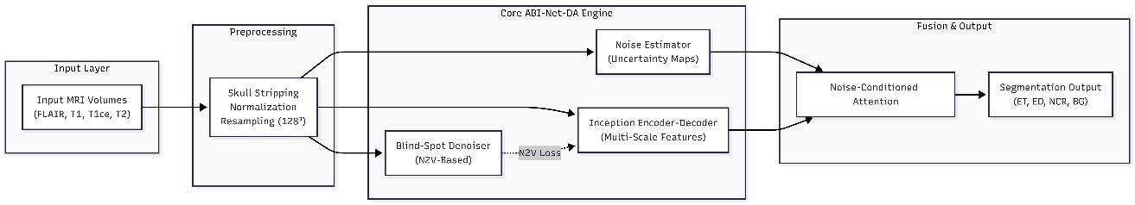
Figure 1 illustrates the overall system architecture showing the integration of multi-modal MRI inputs, processing modules, and segmentation output.

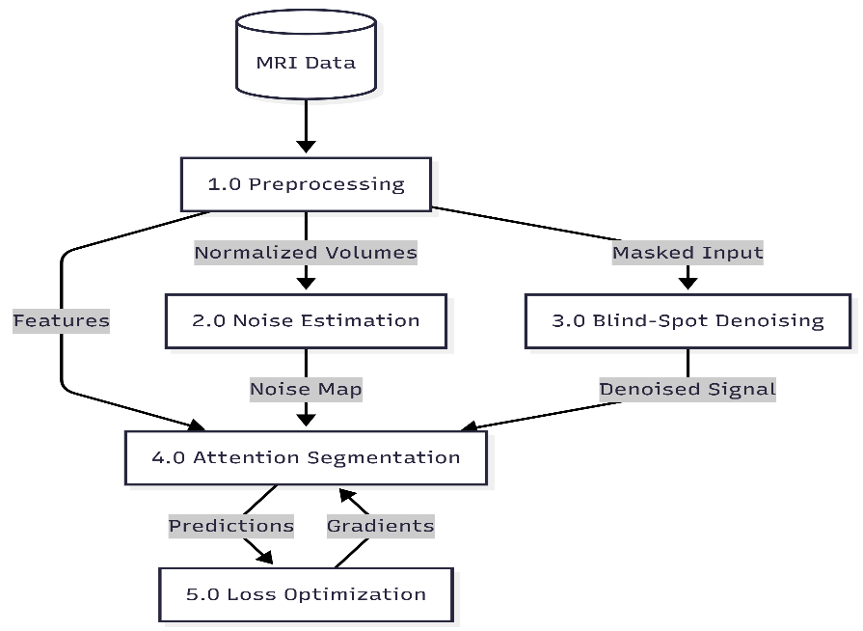

Figure 2 illustrates the data processing pipeline including preprocessing, noise estimation, denoising, feature extraction, and segmentation stages.

Dataset Property | Value
Total Subjects (Training + Validation) | 369 HGG + 76 LGG = 445 total
MRI Modalities per Subject | 4 (FLAIR, T1, T1ce, T2)
Original Volume Dimensions | 240 × 240 × 155 voxels
Voxel Spacing | 1 mm isotropic
Segmentation Classes | Background (0), NCR (1), Edema (2), ET (4)
Evaluation Sub-Regions | ET (label 4), TC (labels 1+4), WT (labels 1+2+4)
Train/Validation Split Used | 80% / 20% random stratified split

Figure 3 illustrates the denoising mechanism used to reduce noise in input medical images without requiring clean reference data.
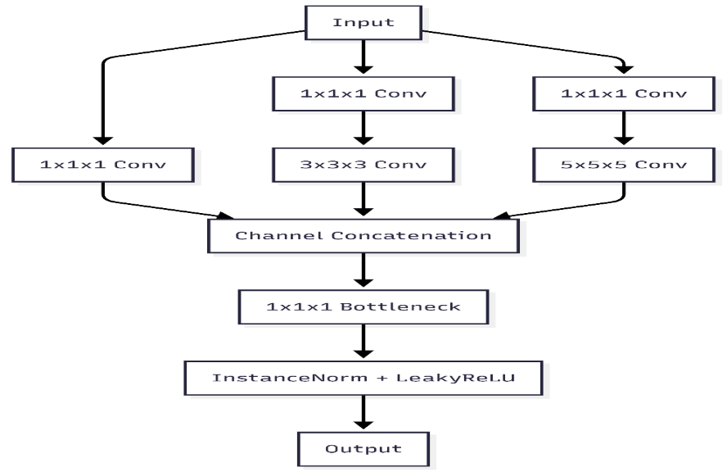

Figure 4 illustrates the noise-aware feature refinement mechanism that enhances important regions and suppresses noisy features.

DETAILED DESCRIPTION OF THE INVENTION:
Explains the complete description of the invention in more than 1000 words in detailed about each and every requirement.
The present invention relates to a system and method for noise-aware medical image analysis, specifically designed for accurate brain tumor segmentation using multi-modal magnetic resonance imaging (MRI) data. The invention addresses the limitations of existing medical image analysis techniques that assume clean input data and rely on separate preprocessing steps for noise reduction.

In real-world clinical environments, MRI images are often affected by noise, artifacts, and variations in acquisition conditions. These factors reduce the performance of conventional segmentation models and lead to inaccurate or unreliable results. The present invention overcomes these challenges by integrating noise estimation, denoising, and segmentation within a unified deep learning framework, enabling improved robustness and accuracy.

The system accepts multi-modal MRI images as input, including FLAIR, T1-weighted, T1-contrast enhanced, and T2-weighted modalities. These modalities provide complementary information about tumor structure, intensity, and surrounding tissues. The input images are first subjected to preprocessing steps, which include normalization, resizing, and alignment to ensure consistency across different data sources. This step helps in reducing variations in intensity and spatial resolution.

Following preprocessing, the images are processed through a feature extraction module. This module is designed to capture both spatial and contextual information from the input data. It learns hierarchical representations of image features, enabling the system to identify complex patterns associated with tumor regions. The extracted features are then forwarded to subsequent processing stages.

A key component of the invention is the noise estimation mechanism. This module analyzes the input data and generates a noise map that represents the level of noise or uncertainty present in different regions of the image. The noise map is used to guide further processing and ensures that the system is aware of unreliable regions.

The invention further incorporates a denoising mechanism that operates without requiring clean reference images. This self-supervised approach reconstructs the image by predicting missing or corrupted values using surrounding contextual information. The denoising process is applied both at the input stage and during intermediate feature processing, allowing the system to reduce noise while preserving important structural details.

Another important component is the adaptive feature refinement mechanism. This module uses the noise information to adjust the importance of different features. Regions with high noise are suppressed, while regions containing relevant tumor information are enhanced. This selective emphasis improves the model’s ability to focus on meaningful patterns and reduces false detections.

The refined features are then passed to the segmentation module, which generates output maps representing different tumor regions. These regions include enhancing tumor, tumor core, and whole tumor areas. The segmentation process ensures accurate boundary detection and spatial localization of tumor structures.

The system is trained using a combination of optimization techniques to ensure accurate predictions. The learning process is designed to balance segmentation accuracy and noise robustness. By incorporating noise-aware learning, the model adapts to different levels of image quality and maintains performance under challenging conditions.

The output of the system consists of segmented images along with evaluation metrics that can be used for clinical analysis. The results demonstrate improved performance compared to traditional methods, particularly in noisy environments.

The invention provides several advantages over existing approaches. It eliminates the need for separate denoising steps, reduces computational redundancy, and improves overall efficiency. The integrated design enables end-to-end learning, allowing the system to adapt to real-world data conditions. Furthermore, the approach enhances segmentation accuracy, boundary precision, and robustness.

The proposed system can be applied in various clinical and research settings, including tumor diagnosis, treatment planning, and disease monitoring. It can also be extended to other medical imaging tasks, making it a versatile solution in the field of healthcare technology.

In conclusion, the present invention introduces a novel and efficient approach for medical image analysis by combining noise handling and segmentation within a single framework. This integration leads to improved performance, reliability, and applicability in real-world scenarios, making it a significant advancement in medical imaging technology.

Claims
They describe the specific aspects or features of the Invention that the Patent holder seeks to Protect.
1. A computer-implemented system for medical image analysis, configured to perform noise-aware image segmentation within a unified framework.

2. The system as claimed in claim 1, wherein the system processes multi-modal medical images.

3. The system as claimed in claim 1, further comprising a preprocessing module.

4. The system as claimed in claim 1, further comprising a noise estimation module.

5. The system as claimed in claim 1, further comprising a denoising module.

6. The system as claimed in claim 1, further comprising a feature refinement mechanism.

7. The system as claimed in claim 1, wherein the system generates segmented outputs.

8. A method for medical image analysis comprising preprocessing, noise estimation, denoising, and segmentation.

DETAILS ON PRIOR-ART SEARCHES:
HAVE YOU CONDUCTED ANY SEARCHES?
☒ Yes ☐ No
MENTION THE TYPE OF SEARCHES CONDUCTED
☐ Patents ☒ Technical Literature
Technical Literature can be journals, abstracts, papers, conferences, oral presentations, news, thesis or other mediums, etc.

Please mention the list of specific sources:
Patents Technical Literature
• Research papers on U-Net and 3D U-Net for medical image segmentation
• Attention-based segmentation models in medical imaging
• Noise2Void and self-supervised denoising techniques
• Brain Tumor Segmentation (BraTS) Challenge publications and reports
• IEEE Xplore digital library articles on deep learning in medical imaging
• Springer and Elsevier journal publications related to MRI segmentation
• Conference papers on noise-robust image segmentation methods
None

INDUSTRIAL APPLICATION OF THE INVENTION:
Please mention the possible industrial applications. Be specific about the applications
The present invention has significant applications in the healthcare and medical imaging industry. It can be used in hospitals and diagnostic centers for automated brain tumor detection and segmentation from MRI scans, supporting radiologists in accurate and efficient diagnosis. The system can assist in treatment planning, including radiation therapy and surgical decision-making, by providing precise tumor boundary information.

The invention can also be integrated into clinical decision support systems and radiology software platforms to enhance workflow efficiency. It is useful in medical research and pharmaceutical industries for analyzing tumor progression and evaluating treatment response. Additionally, the system can be applied in telemedicine platforms to provide remote diagnostic support in resource-limited areas.

The proposed approach can further be extended to other medical imaging applications such as lesion detection, disease monitoring, and image analysis across different modalities, making it valuable for large-scale healthcare and AI-based medical solutions.

STATUS OF THE INEVNTION?
☐ Concept only ☐ Laboratory tested ☒ Prototype

HAVE YOU EVALUATED THE COMMERCIAL ASPECTS OF THE INVENTION?
Please select the appropriate check box
☒ Yes ☐ No

DECLARATION BY INVENTORS:

I/We the undersigned inventor(s), through my/our activities at Mohan Babu University, Tirupati, hereby, declare that any information pertaining to the above furnished inventions, ideas, trademarks, copyrights, designs, etc are results of my/our true works. I acknowledge that Intellectual Property Rights Cell (IPRC), Sree Vidyanikethan Engineering College, is accepting this information for review purposes only. I/We also understand that any comments, suggestions, reports, etc which I/We receive review based upon this analysis is neither meant nor understood to be a conclusive legal opinion. Further, I/We agree that Intellectual Property Right Cell (IPRC), Sree Vidyanikethan Engineering College cannot be held responsible for acceptance or rejection or any other office actions of my/our inventions, creations, copyrights, trademarks, designs by appropriate authorities. I/We understand that my/our obligations regarding this Invention are governed by the SVEC “IPR Policy”.
Signature of the Inventor(s)
By: M. Bhagya Sri By: K. Harshith
Name: M. Bhagya Sri Name: K. Harshith
Date: 27/04/26 Date: 27/04/26

By: N. Gowtham Reddy By: V. Venkata Punith
Name: N. Gowtham Reddy Name: V. Venkata Punith
Date: 27/04/26 Date:27/04/26
NOTE: Please submit the completed Invention Disclosure Form and Signature Page signed by all inventors and a soft copy (in person) to Coordinator, IPRC, MBU.

