Cross-Modal Attention for Integrated Detection of Deepfake, Voice Spoofing and Blackmail Threats

A Capstone Project Report submitted to
Mohan Babu University, Tirupati
In partial fulfilment of the requirements for the award of the degree of
BACHELOR OF TECHNOLOGY
IN
COMPUTER SCIENCE AND ENGINEERING

Submitted by
Rayaprolu Subrahmanyam 22101A010145
Padharthi Asritha Sai 22101A010119
Palagiri Zaheer 22101A010120
M. Santhosh Kumar 22101A010100

Under the Esteemed Supervision of
Dr. Kavitha K
Associate Professor
Department of CSE - AIML



Department of Artificial Intelligence and Machine Learning
School of Computing
Mohan Babu University
Sree Sainath Nagar, Tirupati – 517 102
2025 – 2026
DEPARTMENT OF ARTIFICIAL INTELLIGENCE AND MACHINE LEARNING

Certificate

This is to certify that the Capstone Project report titled “Cross-Modal Attention for Integrated Detection of Deepfake, Voice Spoofing and Blackmail Threats” is the Bonafide work done by

Rayaprolu Subrahmanyam 22101A010145
Padharthi Asritha Sai 22101A010119
Palagiri Zaheer 22101A010120
M. Santhosh Kumar 22101A010100

in the Department of Artificial Intelligence and Machine Learning, and submitted to Mohan Babu University, Tirupati in partial fulfilment of the requirements for the award of the degree of Bachelor of Technology in Computer Science and Engineering during the academic year 2025-2026.
This is work has been carried out under my guidance and supervision. The results embodied in this project report have not been submitted in any University or Organization for the award of any degree or diploma.

Supervisor: | Head:
Dr. Kavitha K  Associate Professor  Dept. of CSE - AIML | Dr. G. Sunitha  Professor & Head  Dept. of CSE

INTERNAL EXAMINER EXTERNAL EXAMINER
ACKNOWLEDGEMENT

We are extremely thankful to our beloved Chancellor, Dr. M. Mohan Babu Garu, for his inspiration and unwavering commitment to academic growth and student development.
We express sincere gratitude to our Pro-Chancellor, Sri Vishnu Manchu Garu, his constant encouragement and visionary leadership in fostering a culture of learning and excellence.
We express sincere gratitude to our Honorable Vice-Chancellor (In-Charge), Prof. P. Venkataramana Garu, for his valuable guidance, encouragement, and continuous support in all academic endeavours.
We are highly indebted to Dr. Babu Devasenapathy, Dean, School of Engineering & Computing for his valuable support and guidance in all the academic matters.
We are deeply obliged to Dr. G. Sunitha, Professor & Head, Department of CSE, for her motivation, insightful guidance, and persistent encouragement.
We would like to express our indebtedness to the project coordinator, Mr. N. Balakrishna, Assistant Professor, Department of AIML for his valuable guidance during the course of project work.
We would like to extend heartfelt thanks to the supervisor, Dr. Kavitha K, Associate Professor, Department of AIML, for the consistent support, insightful guidance, and constructive feedback provided during the project work.

Rayaprolu Subrahmanyam 22101A010145
Padharthi Asritha Sai 22101A010119
Palagiri Zaheer 22101A010120
M. Santhosh Kumar 22101A010100

DECLARATION

We hereby declare that this capstone project report titled “Cross-Modal Attention for Integrated Detection of Deepfake, Voice Spoofing and Blackmail Threats” is a genuine project work carried out by us, in B.Tech. (Computer Science and Engineering) degree course of Mohan Babu University, Tirupati and has not been submitted to any other course or University for the award of any degree by us.

Rayaprolu Subrahmanyam 22101A010145
Padharthi Asritha Sai 22101A010119
Palagiri Zaheer 22101A010120
M. Santhosh Kumar 22101A010100

Vision
To be a globally respected institution with an innovative and entrepreneurial culture that offers transformative education to advance sustainability and societal good.
Mission
- Develop industry-focused professionals with a global perspective.
- Offer academic programs that provide transformative learning experience founded on the spirit of curiosity, innovation, and integrity.
- Create confluence of research, innovation, and ideation to bring about sustainable and socially relevant enterprises.
- Uphold high standards of professional ethics leading to harmonious relationship with environment and society.

SCHOOL OF COMPUTING
Vision
To lead the advancement of computer science research and education that has real-world impact and to push the frontiers of innovation in the field.
Mission
- Instil within our students fundamental computing knowledge, a broad set of skills, and an inquisitive attitude to create innovative solutions to serve industry and community.
- Provide an experience par excellence with our state-of-the-art research, innovation, and incubation ecosystem to realise our learners’ fullest potential.
- Impart continued education and research support to working professionals in the computing domain to enhance their expertise in the cutting-edge technologies.
- Inculcate among the computing engineers of tomorrow with a spirit to solve societal challenges.

DEPARTMENT OF ARTIFICIAL INTELLIGENCE AND MACHINE LEARNING
Vision
To become a Centre of Excellence in Artificial Intelligence and Machine Learning by imparting high quality education through teaching, training and research.
Mission
- To impart quality education in Computer Science and Engineering with specializations in Artificial Intelligence and Machine Learning by disseminating knowledge through contemporary curriculum, competent faculty and effective teaching-learning methodologies.
- Nurture research, innovation and entrepreneurial skills among students and faculty to contribute to the needs of industry and society.
- Inculcate professional attitude, ethical and social responsibilities for prospective and promising Engineering profession.
- Encourage students to engage in life-long learning by creating awareness of the contemporary developments in Computer Science and Engineering Artificial Intelligence and Machine Learning.

B.Tech. Computer Science and Engineering
(Artificial Intelligence and Machine Learning)
PROGRAM EDUCATIONAL OBJECTIVES
After few years of graduation, the graduates of B.Tech.CSE (Artificial Intelligence and Machine Learning) will:
- Pursuing higher studies in core or allied areas of Computer Science, Artificial Intelligence, Machine Learning, Data Science or Management.
- Employed in reputed Computer and I.T organizations or Government, to have a globally competent professional career in Computer Science and Engineering, Artificial Intelligence, Machine Learning, Data Science domain or be successful Entrepreneurs.
- Able to demonstrate effective communication, engage in teamwork, exhibit leadership skills, ethical attitude, and achieve professional advancement through continuing education.

PROGRAM OUTCOMES
On successful completion of the Program, the graduates of B.Tech. CSE (Artificial Intelligence and Machine Learning) Program will be able to:
- Engineering Knowledge: Apply the knowledge of mathematics, science, engineering fundamentals, and an engineering specialization to the solution of complex engineering problems.
- Problem Analysis: Identify, formulate, review research literature, and analyze complex engineering problems reaching substantiated conclusions using first principles of mathematics, natural sciences, and engineering sciences.
- Design/Development of Solutions: Design solutions for complex engineering problems and design system components or processes that meet the specified needs with appropriate consideration for the public health and safety, and the cultural, societal, and environmental considerations.
- Conduct Investigations of Complex Problems: Use research-based knowledge and research methods including design of experiments, analysis and interpretation of data, and synthesis of the information to provide valid conclusions.
- Modern Tool Usage: Create, select, and apply appropriate techniques, resources, and modern engineering and IT tools including prediction and modeling to complex engineering activities with an understanding of the limitations.
- The Engineer and Society: Apply reasoning informed by the contextual knowledge to assess societal, health, safety, legal and cultural issues and the consequent responsibilities relevant to the professional engineering practice.
- Environment and Sustainability: Understand the impact of the professional engineering solutions in societal and environmental contexts, and demonstrate the knowledge of, and need for sustainable development.
- Ethics: Apply ethical principles and commit to professional ethics and responsibilities and norms of the engineering practice.
- Individual and Team Work: Function effectively as an individual, and as a member or leader in diverse teams, and in multidisciplinary settings.
- Communication: Communicate effectively on complex engineering activities with the engineering community and with society at large, such as, being able to comprehend and write effective reports and design documentation, make effective presentations, and give and receive clear instructions.
- Project Management and Finance: Demonstrate knowledge and understanding of the engineering and management principles and apply these to one's own work, as a member and leader in a team, to manage projects and in multidisciplinary environments.
- Life-long Learning: Recognize the need for, and have the preparation and ability to engage in independent and life-long learning in the broadest context of technological change.

PROGRAM SPECIFIC OUTCOMES
On successful completion of the Program, the graduates of B. Tech. CSE (Artificial Intelligence and Machine Learning) program will be able to:
PSO1. Apply knowledge of computer science engineering, Use modern tools, techniques and technologies for efficient design and development of computer-based systems for complex engineering problems.
PSO2. Develop and apply Artificial Intelligence techniques to perform human intelligence tasks such as vision, language processing and speech recognition.
PSO3. Develop intelligent systems by applying data analytics, machine learning algorithms and techniques for solving problems from inter-disciplinary domains.
PSO4. Design and deploy networked systems using standards and principles, Apply suitable models, tools and techniques for secured information communication.

SCHOOL CORE

Course Code | Course Title | L | T | P | S | C
22CS108001 | Capstone Project | - | - | - | - | 10

Pre-Requisite -
Anti-Requisite –
Co-Requisite –

COURSE DESCRIPTION: Identification of topic for the project work; Literature survey; Collection of preliminary data; Identification of implementation tools and methodologies; Performing critical study and analysis of the topic identified; Time and cost analysis; Implementation of the project work; Preparation of thesis and presentation.

COURSE OUTCOMES: After successful completion of this course, the students will be able to:
CO1. Create/Design computer science engineering systems or processes to solve complex computer science engineering and allied problems using appropriate tools and techniques following relevant standards, codes, policies, regulations and latest developments.
CO2. Consider society, health, safety, environment, sustainability, economics and project management in solving complex computer science engineering and allied problems.
CO3. Perform individually or in a team besides communicating effectively in written, oral and graphical forms on computer science engineering systems or processes.

CO-PO-PSO Mapping Table:
Course Outcome | Program Outcomes
 | PO1 | PO2 | PO3 | PO4 | PO5 | PO6 | PO7 | PO8 | PO9 | PO10 | PO11 | PO12
CO1 | 3 | 3 | 3 | 3 | 3 |  |  | 3 |  |  |  | 3
CO2 |  |  |  |  |  | 3 | 3 |  |  |  | 3
CO3 |  |  |  |  |  |  |  |  | 3 | 3
Course Correlation Mapping | 3 | 3 | 3 | 3 | 3 | 3 | 3 | 3 | 3 | 3 | 3 | 3
Correlation Level: 3-High; 2-Medium; 1-Low
TABLE OF CONTENTS
Chapter | Page no
List of Acronyms | 1
List of Figures | 2
List of Tables | 4
Abstract | 5
Chapter 1: Introduction | 6
1.1 Introduction | 6
1.2 Problem Statement | 7
1.3 Objectives | 8
1.4 Scope | 9
1.5 Applications | 9
1.6 Limitations | 11
Chapter 2: Literature Survey | 13
2.1 Visual-Based Deepfake Detection Approaches | 13
2.2 Audio-Based Deepfake Detection Methods | 13
2.3 Multimodal Deepfake Detection Strategies | 14
2.4 Limitations of Existing Deepfake Detection Methods | 14
2.5 Research Gap in Current Deepfake Detection Systems | 14
Chapter 3: Analysis & Design | 16
3.1 Existing System
3.1.1 Limitations of Existing System
3.2 Architecture of the Proposed System | 16
3.3 Baseline Models | 18
3.3.1 Video Modality Baselines | 18
3.3.2 Audio Modality Baselines | 18
3.3.3 Text Modality Baselines | 19
3.3.4 Fusion Baselines | 19
3.4 Proposed Models | 19
3.4.1 Video Modality Models | 20
3.4.2 Audio Modality Models | 20
3.4.3 Text Modality Models | 20
3.4.4 Multimodal Fusion Model | 21
3.5 Dataset Description | 21
3.6 Software and Hardware Requirements | 22
3.7 UML Diagrams | 23
3.6.1 Class Diagram | 23
3.6.2 Usecase Diagram | 24
3.6.3 Sequential Diagram | 25
Chapter 4: Implementation | 27
4.1 Data Preprocessing | 27
4.1.1 Video Data Preprocessing | 27
4.1.2 Audio Data Preprocessing | 28
4.1.3 Text Data Preprocessing | 29
4.2 Model Training | 30
4.2.1 Video Model Training | 30
4.2.2 Audio Model Training | 31
4.2.3 Text Model Training | 31
4.2.4 Multimodal Fusion Training | 31
Chapter 5: Execution Procedure and Testing | 33
5.1 Execution Procedure | 33
5.2 Testing | 34
Chapter 6: Results & Performance Evaluation | 36
6.1 Performance Evaluation | 36
6.2 Results | 38
Chapter 7: Conclusions and Future Work | 41
7.1 Conclusions | 41
7.2 Future Work | 42
Appendix | 43
- Source Code | 43
References | 78

List of Acronyms

Acronym | Definition
App-DDoS | Application-Distributed Denial-of-Service
AI | Artificial Intelligence
AUC | Area Under the Curve
CNN | Convolutional Neural Network
DFDC | Deepfake Detection challenge
EER | Equal Error Rate
FPS | Frames Per Second
GAN | Generative Adversarial Network
GPU | Graphics Processing Unit
LCNN | Light Convolutional Neural Network
MFCC | Mel-Frequency Cepstral Coefficients
ML | Machine Learning
NLP | Natural Language Preprocessing
ROC | Receiver Operating Characteristic
SSL | Self-Supervised Learning
ViViT | Video Vision Transformer
VRAM | Video Random Access Memory
Wav2Vec2 | Waveform to Vector Model Version 2

List of Figures

Figure No. | Description | Page No.
1.1 | Overview of deepfake, voice spoof, and blackmail threat detection in audiovisual media. | 6
3.1 | Comparison of baseline and proposed framework across video, audio, and text tasks | 17
3.2 | Architectural overview of proposed framework | 19
3.3 | Class Diagram | 23
3.4 | Usecase Diagram | 24
3.5 | Sequential Diagram | 25
4.1 | Preprocessing of video datasets | 28
4.2 | Preprocessing of audio datasets | 29
4.3 | Preprocessing of text datasets | 30
6.1 | Cross – dataset generalization heatmap | 37
6.2 | Video confusion matrix | 39
6.3 | Audio confusion matrix | 39
6.4 | Text confusion matrix | 39
6.5 | ROC curves for video, audio, and text detection tasks. | 40
Fig. | Detection of Real Audio-Visual Input | 76
Fig. | Detection of Fake Audio-Visual Input | 77

List of Tables

Table No. | Description | Page No.
6.1 | Ablation Study on Proposed Framework | 37
6.2 | Results for Video Deepfake Detection | 38
6.3 | Results for Audio Spoof Detection | 38
6.4 | Results for Blackmail & Threat Detection | 38

ABSTRACT
Recent advancements in artificial intelligence have significantly enhanced the capability to generate highly realistic digital content, including deepfake videos, voice spoofing, and automated multimedia synthesis. While these technologies offer several beneficial applications, their misuse has led to a rapid increase in cyber-enabled crimes such as impersonation, harassment, and blackmail. In many cases, victims are targeted using manipulated audio–visual content or threatening messages, resulting in psychological distress, reputational damage, and financial loss. Despite growing research in this area, existing detection systems face several limitations. Most approaches are designed for a single modality and are affected by modality-specific biases, relying heavily on high-quality and curated datasets. As a result, their performance degrades significantly in real-world scenarios characterized by noise, diverse data sources, and evolving manipulation techniques. Additionally, current methods typically focus only on detecting media authenticity, without simultaneously analyzing the intent behind the content. This creates a critical gap, as threats such as blackmail in manipulated multimedia remain insufficiently addressed. To overcome these challenges, this work proposes a unified multimodal framework that integrates visual, audio, and textual analysis for comprehensive threat detection. The proposed system extracts and analyzes visual features to identify deepfake manipulations, acoustic features to detect voice spoofing, and textual features recognize blackmail or threatening intent. These modality-specific features are fused using a cross-modal attention mechanism, enabling the model to capture interdependencies between different data sources. This allows simultaneous detection of deepfakes, voice spoofing and blackmail threats under cross-dataset settings with enhanced generalization.

Keywords - Deepfake Detection, Voice Spoofing, Multimodal Learning, Cross-Modal Attention, Intent Detection, Multimodal Fusion, Multimedia Forensics, Cross-dataset, Generalization.

CHAPTER 1
INTRODUCTION

1.1 Introduction

The rapid growth of digital media and online communication has significantly transformed how individuals create, share, and consume audio–visual content. Social media platforms and digital communication tools have made multimedia content a primary medium of information exchange, increasing accessibility and reach. However, this expansion has also introduced serious security concerns, particularly regarding the misuse of artificially generated or manipulated content. Recent advancements in artificial intelligence, especially in deep learning and generative modelling, have enabled the creation of highly realistic synthetic media such as deepfake videos and voice spoofing [1]. With the widespread accessibility of artificial intelligence tools, attackers are now able to generate highly convincing fake content at a low cost, making these threats more scalable and difficult to control.
Fig. 1.1. Overview of deepfake, voice spoof, and blackmail threat detection in audiovisual media.

The misuse of such technologies has led to a rise in cyber-enabled crimes, including fraud, impersonation, harassment, and blackmail. These attacks often involve fabricated audio–visual content or threatening communication designed to exploit victims, resulting in financial loss, psychological distress, and reputational damage. Moreover, the rapid dissemination of such content across digital platforms amplifies its impact and complicates timely detection [2]. The growing prevalence of manipulated multimedia content poses significant risks to personal safety, organizational integrity, and public trust in digital systems. As synthetic media becomes more convincing, distinguishing between genuine and fabricated content becomes increasingly challenging, undermining the credibility of online information.
Statistical analyses reveal a sharp increase in deepfake-related incidents over recent years. Reports indicate that the number of deepfake videos available online has grown by more than 900% since 2019, demonstrating the rapid expansion of this threat. Additionally, cybersecurity surveys suggest that approximately 60–70% of organizations have reported encountering some form of AI-generated fraud or impersonation attempt [3]. Among individuals, nearly 40% of internet users have experienced or been exposed to manipulated media, misinformation, or digitally altered content in some form.
The impact on victims is both widespread and severe. Studies on cybercrime and online harassment indicate that around 30–35% of victims suffer from financial loss due to fraud or extortion attempts involving manipulated media. Furthermore, nearly 50% of affected individuals report experiencing psychological distress, including anxiety, fear, and reputational concerns [4]. Social media-based surveys also highlight that 1 in 3 users is vulnerable to threats such as harassment or blackmail involving fabricated multimedia content. These statistics emphasize the growing scale and seriousness of the problem.
A notable real-world example highlighting the severity of this issue involves Scarlett Johansson, a globally recognized actress who has been a victim of deepfake misuse. Her identity was used in manipulated videos without consent, which were widely circulated online. This case demonstrates how easily advanced technologies can be exploited to compromise personal identity and digital privacy. Beyond celebrities, similar incidents have been reported involving political leaders and corporate executives, where voice spoofing has been used to impersonate individuals and carry out fraudulent financial transactions.

1.2 Problem Statement
The rapid growth of artificial intelligence has led to the creation of very realistic synthetic media. This includes deepfake videos and voice spoofing, which are increasingly used for harmful purposes such as impersonation, fraud, harassment, and blackmail. Despite the severity of these threats, existing detection systems remain limited in their effectiveness. Most approaches focus on a single modality, such as visual or audio analysis, and fail to capture the complex relationships between different types of data. Additionally, these systems are often trained on curated datasets, limiting their ability to generalize to real-world conditions involving noise, variability, and evolving manipulation techniques. Another critical limitation of existing methods is their focus on detecting content authenticity without considering the underlying intent. In many real-world scenarios, identifying whether content is used for malicious purposes, such as blackmail or coercion, is equally important for effective intervention.
These challenges highlight the need for a robust and unified approach that integrates multiple modalities and incorporates intent analysis. The proposed work focuses on the identification and analysis of malicious multimedia content through a unified multimodal framework. In practical scenarios, threats often involve a combination of visual manipulation, audio spoofing, and intent-driven communication, necessitating a comprehensive approach. Given an input audio–visual stream, the system automatically analyses both video and audio components to determine their authenticity. It detects deepfake manipulations in visual data and identifies voice spoofing in audio signals, enabling scalable and automated analysis. In addition to authenticity verification, the framework processes speech content to detect blackmail or threatening intent. This integration of intent analysis extends the system’s capabilities beyond traditional detection methods.

1.3 Objectives
- The primary objective of this work is to develop a unified and robust multimodal framework capable of jointly analysing visual, acoustic, and textual information from audiovisual content to enable comprehensive detection of synthetic media and associated malicious intent.
- A key objective is to design an effective cross-modal learning mechanism that can capture and model the interdependencies between video, audio, and text, thereby overcoming the limitations of modality-specific approaches. The framework seeks to learn generalized representations that remain robust across diverse datasets, varying manipulation techniques, and real-world noise conditions.
- Another critical objective is to ensure that the system produces a consolidated and interpretable risk assessment by integrating predictions from all modalities, enabling practical applicability in cybersecurity and digital forensics.
- Ultimately, the goal is to move beyond isolated detection tasks and create an AI-driven solution that evaluates media authenticity and malicious intent at the same time. This will improve the reliability and trustworthiness of automated content verification systems.
1.4 Scope
This work focuses on the design and evaluation of a multimodal artificial intelligence framework for analysing real-world audiovisual content by jointly leveraging visual, acoustic, and textual modalities. The scope encompasses the detection of deepfake video manipulations, identification of voice spoofing in speech signals, and recognition of blackmail or coercive intent within associated textual or transcribed content. The framework is intended to operate on heterogeneous inputs derived from diverse, publicly available datasets spanning multiple domains, manipulation techniques, languages, and noise conditions to ensure robustness and generalization.
The system performs integrated analysis of audiovisual inputs to simultaneously detect deepfake video manipulations, identify voice spoofing, and recognize blackmail or coercive intent in the associated speech content. It supports end-to-end processing, including modality separation, feature extraction, cross-modal fusion, and unified risk assessment, allowing consistent and context-aware decision-making across multiple tasks.
The system leverages transformer-based architectures for modality-specific feature extraction, including spatio-temporal video transformers, self-supervised speech representation models, and language models. The system produces modality-specific predictions for video authenticity, audio spoofing, and textual threat detection, along with a unified, interpretable risk score that categorizes the input as safe, suspicious, or high-risk.
The scope is limited to supervised learning using labelled datasets and does not explicitly address zero-shot adaptation to entirely novel manipulation techniques. The framework depends on the quality of input data, particularly the accuracy of speech-to-text transcription for textual analysis. It does not incorporate real-time streaming optimization, watermark verification mechanisms, or adversarial robustness guarantees against highly sophisticated or unseen generative models.

1.5 Applications
- Cybercrime Detection and Digital Forensics:
The proposed framework can be deployed in digital forensic systems to automatically analyse multimedia evidence and identify manipulated content used in cybercrimes such as impersonation, fraud, and extortion. By jointly detecting deepfake videos, voice spoofing, and embedded threats, it enables investigators to establish both the authenticity of media and the presence of malicious intent, thereby strengthening evidentiary analysis and accelerating case resolution.

- Social Media Content Moderation:
Social media platforms can integrate this system to proactively monitor and filter harmful content at scale. The multimodal capability allows platforms to detect not only manipulated videos or audio but also contextually abusive or coercive language, ensuring comprehensive moderation. This is particularly critical in preventing the spread of misleading or harmful synthetic media that can damage reputations or incite harassment.

- Online Safety and User Protection Systems:
The framework can be embedded into communication platforms, messaging applications, and online communities to provide real-time protection against blackmail and harassment. By analysing incoming audiovisual content, the system can flag high-risk interactions and alert users or administrators, thereby mitigating psychological harm and preventing exploitation.

- Financial Fraud and Identity Verification:
In sectors such as banking, fintech, and remote authentication systems, the model can enhance identity verification pipelines by detecting spoofed voices and manipulated facial videos used in fraudulent access attempts. The integration of multimodal verification significantly improves security over unimodal biometric systems, reducing the risk of unauthorized transactions.

- Law Enforcement and Surveillance Systems:
Law enforcement agencies can utilize the framework for monitoring and analyzing digital communications and multimedia evidence in investigations involving organized cybercrime, online threats, or coordinated misinformation campaigns. The ability to assess both authenticity and intent provides a comprehensive tool for threat intelligence and proactive intervention.

- Enterprise Security and Insider Threat Detection:
Organizations can deploy the system within internal communication monitoring tools to detect malicious activities such as coercion, data leakage attempts, or reputational attacks using synthetic media. This enhances organizational resilience by identifying both manipulated content and harmful intent within enterprise environments.
- Media Authentication and Content Verification Platforms:
News agencies, fact-checking organizations, and content verification services can use the framework to validate the authenticity of multimedia content before publication. By ensuring that both the media and its embedded message are trustworthy, the system supports the integrity of information dissemination and helps combat misinformation.

- AI Governance and Trustworthy AI Systems:
The framework contributes to broader AI governance initiatives by providing a technical solution for detecting misuse of generative models. It can be integrated into regulatory and compliance systems to enforce policies against malicious synthetic content, thereby promoting ethical AI usage and enhancing public trust in digital ecosystems.

1.6 Limitations
- High Computational and Resource Requirements:
The framework relies on large-scale transformer-based architectures across all modalities, resulting in substantial computational cost, memory consumption, and training time. This limits scalability in resource-constrained environments and poses challenges for real-time or edge deployment.

- Dependence on ASR Quality for Textual Analysis:
The effectiveness of the textual threat detection module is dependent on the accuracy of automatic speech recognition. Errors in transcription, especially under noisy conditions, accents, or multilingual inputs, can propagate and degrade the performance of blackmail threat detection.

- Limited Robustness to Unseen Manipulation Techniques:
Although the system demonstrates cross-dataset generalization, it remains vulnerable to entirely novel or highly sophisticated generation methods, particularly those produced by emerging diffusion-based or adversarially optimized models that minimize detectable artifacts.

- Complexity of Multimodal Fusion and Training Stability:
The integration of heterogeneous modalities through cross-modal attention introduces significant training complexity, including challenges in feature alignment, convergence stability, and hyperparameter sensitivity. This increases the difficulty of reproducibility and deployment.

- Lack of Real-Time Optimization and Latency Constraints:
While inference is efficient on high-end GPUs, the system is not explicitly optimized for low-latency or real-time streaming applications, limiting its immediate applicability in time-critical environments such as live monitoring systems.

- Exclusion of Preventive and Provenance-Based Techniques:

- The framework focuses on detection rather than prevention and does not incorporate complementary approaches such as digital watermarking, content provenance tracking, or cryptographic verification, which could further strengthen defence against synthetic media misuse.

CHAPTER 2
LITERATURE SURVEY

Recent advancements in deepfake detection have extensively explored a wide range of machine learning and deep learning techniques across visual, audio, and multimodal domains to address the growing threat of synthetic media [5]. Early research primarily focused on visual-based detection by identifying low-level artifacts such as pixel inconsistencies, abnormal facial textures, irregular eye blinking patterns, and spatial distortions using convolutional neural networks [6]. As deepfake generation techniques became more sophisticated and capable of producing highly realistic outputs, these artifact-based methods gradually became less effective, especially in cross-dataset and real-world scenarios [7].
2.1 Visual-Based Deepfake Detection Approaches
Several approaches focused on detecting deepfakes using visual artifacts and temporal inconsistencies through convolutional neural networks, recurrent neural networks, and multi-task learning frameworks [8]. These methods successfully captured spatial distortions and motion irregularities across video frames, achieving high accuracy on benchmark datasets. Some approaches further enhanced performance by incorporating attention mechanisms and multi-task learning to improve feature representation and generalization. However, these models are highly dependent on large-scale labelled datasets and often fail when encountering high-quality deepfakes that minimize visible artifacts. Additionally, their performance degrades significantly in cross-dataset scenarios, highlighting poor generalization to unseen manipulation techniques and limited robustness in real-world environments [6].
2.2 Audio-Based Deepfake Detection Methods
In parallel, audio-based deepfake detection gained attention by leveraging spectral, acoustic, and linguistic features to identify artifacts introduced by speech synthesis and voice conversion systems [9]. Techniques such as Mel-frequency cepstral coefficients (MFCC), spectrogram analysis, and deep neural networks enabled the detection of subtle inconsistencies in generated speech. However, these methods often remain sensitive to noise, compression, and language variability. Data augmentation strategies were also introduced to improve robustness and handle limited datasets [10]. While these methods demonstrated strong performance in controlled environments, they are highly sensitive to background noise, compression artifacts, and language variations. Furthermore, they struggle to generalize across different speech synthesis techniques and often fail when exposed to unseen spoofing methods, limiting their effectiveness in real-world applications.
2.3 Multimodal Deepfake Detection Strategies
To overcome the limitations of unimodal systems, multimodal approaches were introduced to jointly analyze audio and visual signals using synchronized feature learning and fusion techniques [11]. These methods leverage deep neural networks to capture inconsistencies between lip movements and corresponding speech, achieving improved detection performance compared to unimodal approaches. Advanced techniques such as attention-based fusion, autoencoders, and self-supervised learning further enhanced cross-modal representation and alignment [12]. Some approaches also introduced modality-invariant and modality-specific feature learning to improve robustness across datasets. However, these models rely heavily on precise synchronization and large-scale multimodal datasets, making them less effective in real-world scenarios with noisy or incomplete data. Additionally, many approaches focus on coarse-level alignment and fail to detect fine-grained inconsistencies when deepfakes maintain high-quality synchronization across modalities.
2.4 Limitations of Existing Deepfake Detection Methods
Despite these advancements, such approaches are computationally expensive, require extensive training data, and depend on complex architectures. Moreover, their performance may degrade in real-world environments due to unseen manipulation techniques, domain shifts, and variability in data quality [13].
2.5 Research Gap in Current Deepfake Detection Systems
Despite significant progress across visual, audio, and multimodal deepfake detection techniques, a common limitation observed in most existing works is their lack of generalization to unseen deepfake generation methods, strong dependency on large labelled datasets, and high computational complexity. Additionally, many approaches rely heavily on synchronization-based cues or modality-specific features, making them vulnerable when deepfakes maintain high cross-modal consistency. Furthermore, existing multimodal systems often focus either on feature fusion or alignment but fail to effectively integrate both low-level forensic artifacts and high-level semantic inconsistencies within a unified framework.
This literature survey highlights a critical research gap of the absence of a robust, scalable, and generalizable multimodal detection system capable of handling diverse manipulation techniques while maintaining performance in real-world environments. To address this, the proposed work focuses on developing a unified framework that leverages cross-modal consistency, integrates multiple feature representations, and improves robustness against unseen deepfake techniques while reducing dependency on dataset-specific patterns. This approach aims to enhance detection reliability and enable practical deployment in applications such as cybersecurity, media verification, and misinformation detection.

CHAPTER 3
ANALYSIS & DESIGN
Analysing modern audiovisual content to detect deepfake manipulation, voice spoofing, and embedded malicious intent is a significant challenge. This is due to the complexity and variety of multimodal data. Real-world media includes intricate visual patterns, dynamic time-based changes, sound variations, and subtle language cues, all of which must be jointly interpreted to make reliable decisions. The differences in manipulation methods, recording conditions, background noise, and language use add to the difficulty. Traditional single-modality methods often struggle to capture these interdependencies between modalities and produce limited and non-general results. Effective methods are needed to model the complex relationships across modalities and extract meaningful representations that show both authenticity and intent.
In this situation, deep learning and multimodal transformer-based designs offer a strong basis for thorough analysis. Models specific to each modality are used to extract detailed features from video, audio, and text. They capture spatial and temporal inconsistencies, synthetic speech artifacts, and language patterns in context. These features are combined using a cross-modal attention mechanism, allowing the system to learn connections between different modalities. This joint learning approach improves the system's ability to spot subtle inconsistencies and malicious intent. As a result, it leads to greater reliability and better prediction accuracy compared to traditional isolated or late-fusion methods.
3.1 Existing System
The base research paper introduces a novel and more human-like approach for deepfake detection by focusing on whether the voice and face belong to the same person. Instead of relying on traditional artifact detection methods, the system leverages a technique called Voice-Face Matching Detection (VFD), which evaluates the consistency between audio and visual identity features. This idea is inspired by the natural correlation between a person’s voice and facial characteristics, enabling the model to detect deepfakes by identifying mismatches between the two modalities.
The existing system adopts a dual-stream architecture, where voice and face inputs are processed independently through feature extraction networks and then compared using similarity measures. During training, the model learns to distinguish between matched (real) and mismatched (fake) voice-face pairs using contrastive learning techniques such as InfoNCE loss and an enhanced Real-Fake Contrastive (RFC) loss. This allows the system to capture global identity-level relationships rather than relying on localized visual artifacts, making it significantly more robust to advanced deepfake generation techniques.
A key strength of this approach is its pre-training and fine-tuning strategy. Initially, the model is pre-trained on large-scale generic audio-visual datasets (such as VoxCeleb2) to learn general voice-face correlations. It is then fine-tuned on deepfake datasets to adapt to manipulation patterns. This strategy enables the model to achieve strong performance even with limited deepfake training data, reducing dependency on large labeled datasets and improving generalization across different scenarios.
The effectiveness of the proposed system is demonstrated through extensive experiments on benchmark datasets such as DFDC, FakeAVCeleb, and DeepfakeTIMIT. The model achieves state-of-the-art performance, including an 85.13% AUC on DFDC and 86.11% on FakeAVCeleb, outperforming many traditional visual-only and multimodal approaches. Additionally, the model shows strong robustness across datasets and maintains reliable detection performance even under limited data conditions.
3.1.1 Limitations of Existing System:
- The system is sensitive to noise, low-quality inputs, and compressed audio-visual data.
- The performance decreases in conditions with poor lighting or blurred facial features.
- The model struggles to accurately detect deepfakes when faces are captured at extreme angles.
- It is not effective in identifying minor modifications such as changes in glasses, beard, or small facial edits.
- The system requires both voice and face inputs, and it fails when one modality is missing.
- It becomes difficult to detect deepfakes when the audio and video are perfectly synchronized.
- The model still requires fine-tuning on new datasets to maintain performance.
- The approach involves high computational cost due to complex deep learning architectures.
- It is not fully optimized for real-time detection in large-scale applications.

3.2 Architecture of the Proposed System
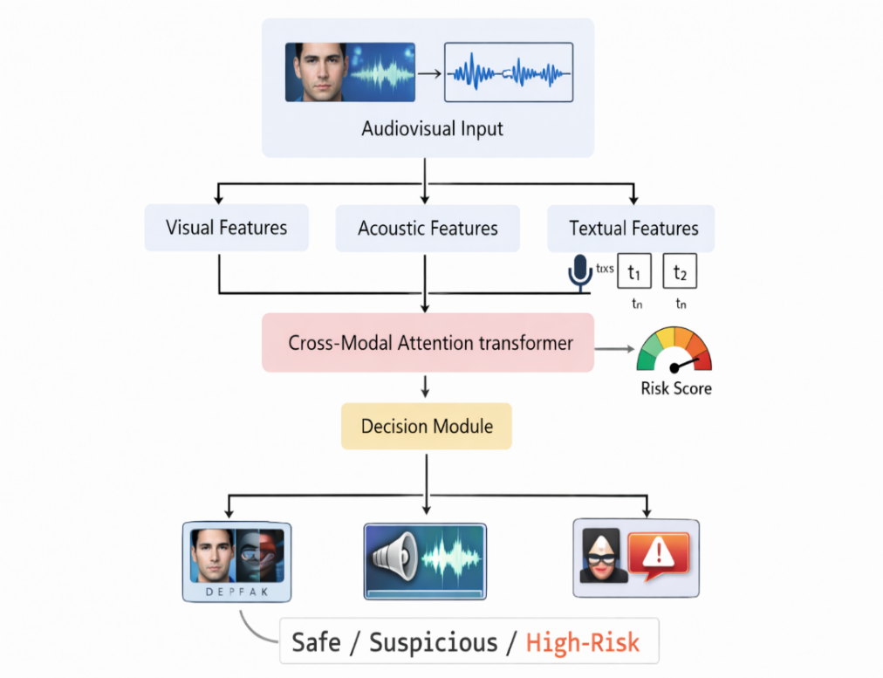
The proposed system follows a unified multimodal architecture designed to jointly analyze video, audio, and textual information for comprehensive detection of deepfake manipulation, voice spoofing, and blackmail intent. The architecture is structured as a sequential pipeline consisting of modality decomposition, feature extraction, cross-modal fusion, and final decision-making as shown in Fig.3.2.
Fig. 3.1. Architectural overview of proposed framework

At the input stage, raw audiovisual data is ingested in the form of video streams containing both visual frames and embedded audio. The system first performs modality separation, where the input is decomposed into three parallel streams: video frames, audio waveform, and textual transcripts are generated using automatic speech recognition. This decomposition enables independent yet coordinated processing of each modality.
Each modality is then passed through a dedicated feature extraction module optimized for its data characteristics. The visual stream is processed using transformer-based video models that capture both spatial and temporal patterns across frames, producing a spatio-temporal feature representation. The audio stream is processed using a self-supervised speech model that extracts contextual acoustic embeddings from raw waveforms, followed by a lightweight convolutional classifier for spoof detection. The textual stream is processed using a transformer-based language model that encodes semantic and contextual information to identify threat-related linguistic patterns. These modules generate high-dimensional feature vectors representing modality-specific evidence.
To enable effective interaction between modalities, the extracted features are mapped into a shared latent space through learnable projection layers, ensuring dimensional alignment and compatibility. These aligned representations are then fed into a cross-modal attention transformer, which serves as the core component of the architecture. This module models interdependencies across modalities by allowing each modality to attend to relevant features from others, thereby capturing inconsistencies such as audio-visual misalignment or semantic discrepancies between speech and facial expressions.
The output of the cross-modal attention module is a unified multimodal representation that encapsulates both authenticity-related and intent-related information. This representation is passed to a decision layer, implemented as a fully connected classification head, which produces both modality-specific predictions and a consolidated risk score. The final output categorizes the input into predefined classes such as safe, suspicious, or high-risk, reflecting the combined assessment of manipulation and malicious intent.
The architecture is trained in a staged manner, beginning with independent training of modality-specific models, followed by fusion module training with partially frozen backbones, and concluding with end-to-end fine-tuning. This design ensures stable convergence, effective feature alignment, and improved generalization across diverse datasets and real-world conditions.

3.3 Baseline Models
3.3.1 Video Modality Baselines:
EfficientNet-B0, X3D, Convolutional Neural Networks (CNNs) are commonly used for deepfake detection due to their ability to learn spatial visual features from individual frames or short clips. EfficientNet-B0 provides a parameter-efficient architecture with strong image classification performance, while X3D extends convolutional operations into the temporal domain for lightweight video understanding. Standard CNNs serve as foundational models for artifact-based detection.
These architectures primarily focus on spatial or limited temporal cues and often rely on visible artifacts introduced during manipulation. As deepfake generation techniques improve, such artifacts become less pronounced, leading to reduced performance. Moreover, these models struggle to capture long-range temporal dependencies and exhibit poor generalization to unseen manipulation methods.
3.3.2 Audio Modality Baselines:
Spectrogram-based CNNs operate on time-frequency representations of audio signals, enabling detection of synthetic artifacts in controlled environments. RawNet2 processes raw waveforms directly using deep neural architectures, while AST applies transformer-based attention to spectrogram inputs for improved contextual modelling. Although effective under clean and controlled conditions, these models are sensitive to real-world distortions such as background noise, compression artifacts, and channel variability. Their reliance on specific spectral patterns limits robustness against advanced spoofing techniques and unseen synthesis methods.
3.3.3 Text Modality Baselines:
DistilBERT, RoBERTa-base are transformer-based language models and are widely used for text classification tasks, including toxicity and sentiment analysis. DistilBERT offers a lightweight and efficient alternative to BERT, while RoBERTa-base improves performance through enhanced pretraining strategies. While capable of detecting explicit toxic language, these models are less effective in identifying subtle, context-dependent threat patterns such as conditional blackmail or implicit coercion. Their ability to capture nuanced intent is limited compared to larger and more expressive models.
3.3.4 Fusion Baselines:
Traditional multimodal approaches combine predictions from individual modalities using simple aggregation techniques such as averaging or weighted voting. These methods treat each modality independently and integrate decisions only at the final stage. Late fusion strategies fail to model interdependencies and inconsistencies across modalities, which are critical for detecting complex manipulations. The absence of joint feature learning restricts the system’s ability to leverage complementary information, resulting in suboptimal performance.
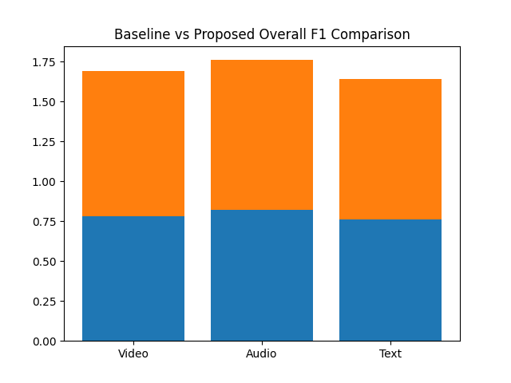
Fig. 3.2. Comparison of baseline and proposed framework across video, audio, and text tasks

3.4 Proposed Models
The proposed framework is built upon three modality-specific deep learning models—each designed to extract high-quality representations from video, audio, and text—followed by a cross-modal attention fusion mechanism.
3.4.1 Video Modality Models:
TimeSformer and ViViT are transformer-based video architectures that extend the Vision Transformer paradigm to spatio-temporal data. Instead of relying on convolutional operations, they process video as a sequence of patches extracted from frames. TimeSformer employs divided attention across spatial and temporal dimensions, while ViViT models long-range temporal dependencies using factorized self-attention. Both architectures are pre-trained on large-scale video datasets and fine-tuned for deepfake detection.
Deepfake manipulations often introduce subtle temporal inconsistencies such as unnatural facial movements, irregular blinking, and lip-sync mismatches. Transformer-based video models are crucial in this work because they enable global context modelling across frames, significantly improving robustness to high-quality and unseen manipulations.
3.4.2 Audio Modality Models:
Wav2Vec2 is a self-supervised learning model that learns contextualized speech representations directly from raw audio waveforms. It uses a convolutional feature encoder followed by a transformer-based context network. In this framework, Wav2Vec2 acts as a feature extractor, and its embeddings are passed to a Light Convolutional Neural Network (LCNN), which performs classification using Max-Feature-Map activation to enhance discriminative capability.
Voice spoofing detection requires capturing fine-grained spectral and temporal artifacts introduced by speech synthesis or voice conversion systems. Wav2Vec2 provides robust and noise-invariant representations, making it highly effective in real-world conditions. LCNN complements this by efficiently distinguishing subtle differences between genuine and synthetic speech, especially under channel distortions and compression artifacts.
3.4.3 Text Modality Models:
DeBERTa-v3 is an advanced transformer-based language model that improves upon BERT by disentangling content and positional embeddings and incorporating enhanced attention mechanisms. It uses deep bidirectional encoding and large-scale pretraining, followed by fine-tuning for downstream tasks such as threat detection.
Blackmail and coercive intent are often expressed implicitly through nuanced language patterns rather than explicit keywords. DeBERTa-v3 is critical in this work because it captures contextual semantics, tone, and intent with high precision, enabling detection of subtle linguistic cues such as conditional threats, intimidation, and psychological manipulation.
3.4.4 Multimodal Fusion Model:
The fusion module is based on a transformer architecture that performs cross-modal attention over aligned feature embeddings from video, audio, and text. Each modality-specific feature vector is first projected into a shared latent space using learnable linear layers. The transformer then computes attention across modalities, allowing each modality to attend to relevant information from others.
Single-modality predictions are often insufficient in real-world scenarios where inconsistencies across modalities reveal manipulation. The cross-modal attention mechanism is the core innovation of this framework, enabling the system to learn interdependencies such as audio-visual misalignment or semantic inconsistency between speech and facial expressions. This significantly enhances detection accuracy and generalization.

3.5 Dataset Description
The proposed framework is evaluated using a diverse set of publicly available datasets spanning multiple modalities, including video, audio, and text, to ensure comprehensive analysis and real-world applicability. The use of multiple datasets is essential to capture the variability present in real-world scenarios, such as differences in recording conditions, manipulation techniques, and data distributions. By incorporating datasets from different sources, the evaluation process is designed to test the robustness, generalization capability, and effectiveness of the proposed multimodal framework under varied and challenging conditions.
For the task of video-based deepfake detection, several widely recognized benchmark datasets are utilized, including FaceForensics++, Celeb-DF v2, FakeAVCeleb, and the DeepFake Detection Challenge (DFDC) dataset. These datasets are selected due to their diversity in terms of manipulation techniques, video quality, and content types, making them suitable for evaluating the performance of deepfake detection models.
FaceForensics++ is one of the most extensively used datasets in deepfake research, containing approximately 1,000 original videos that have been manipulated using multiple state-of-the-art techniques such as DeepFakes, Face2Face, FaceSwap, and NeuralTextures. The DFDC dataset significantly expands the scale and diversity of deepfake data, comprising over 100,000 videos that include both real and AI-generated content. These videos are created using a wide range of face-swapping and generative adversarial network (GAN)-based techniques, reflecting more realistic and complex manipulation scenarios.
Celeb-DF v2 is another important dataset that focuses on high-quality deepfake videos, containing 5,639 manipulated videos of celebrities. These videos are designed closely resemble real-world online content, with improved visual quality and reduced artifacts compared to earlier datasets. In addition to video datasets, FakeAVCeleb is incorporated to support multimodal analysis by providing over 20,000 real and fake audio–visual pairs derived from 500 celebrity videos. This dataset enables the joint evaluation of both visual and audio manipulations, making it particularly suitable for testing the effectiveness of cross- modal detection approaches.
For audio-based spoofing detection, the ASVspoof 2021 dataset is utilized as a primary benchmark. This dataset is widely recognized in the field of speech security and includes multiple subsets, namely Logical Access (LA), Physical Access (PA), and DeepFake (DF). The dataset contains both genuine and spoofed audio samples, allowing the model to learn discriminative features for distinguishing between authentic and manipulated speech under varied conditions. In addition to ASVspoof 2021, the WaveFake dataset is incorporated to further enhance the evaluation of AI-generated speech detection. This dataset consists of synthetic audio generated using multiple state-of-the-art models, capturing a wide range of generation techniques and characteristics.
For textual analysis, multiple datasets are employed to capture different aspects of malicious intent, including cyberbullying, toxicity, and aggression in online communication. The Cyberbullying dataset comprises approximately 47,000 labeled tweets categorized into multiple classes, enabling the model to identify various forms of harmful and abusive language. The Jigsaw Toxic Comments dataset further extends textual analysis by providing nearly 160,000 Wikipedia comments labeled across six categories of toxicity, including insults, threats, and identity-based hate.

3.6 Software and Hardware Requirements
Software requirements:
- Python Environment: Python 3.8 and above
- Operating System: Windows 10 / Linux / macOS
- Google Colab: Access to Google Colab for cloud-based training and experimentation with GPU support.
- Alternate IDE: Visual Studio Code, PyCharm, Jupyter Notebook, Spyder, or any standard Python IDE
- Required Libraries: NumPy, Pandas, Matplotlib, Seaborn, Scikit-learn, PyTorch/TensorFlow, OpenCV, Decord, Librosa, Transformers (Hugging Face), TorchAudio, TorchVision
- Deep Learning Framework: PyTorch and/or TensorFlow for implementing transformer-based architectures and multimodal fusion models.
- Audio Processing Tools: Librosa, TorchAudio for waveform processing.
- Video Processing Tools: OpenCV, Decord, FFmpeg for video decoding.
Hardware requirements:
- Processor: Intel i5 or above
- RAM: Minimum 16 GB RAM (32 GB recommended)
- GPU: NVIDIA GPU (preferably RTX 3090 / RTX 4090 or higher) with minimum 16–24 GB VRAM for training transformer-based models.

3.7 UML Diagrams
UML (Unified Modeling Language) diagrams are used to represent the structure and workflow in a clear and visual manner. UML diagrams provide a structured way to describe the design of the system, making it easier to understand the flow of data and the relationship between different modules. Different types of UML diagrams such as class diagrams, sequence diagrams, and use case diagrams are used to represent the behaviour and architecture of the proposed model.

3.6.1 Class Diagram
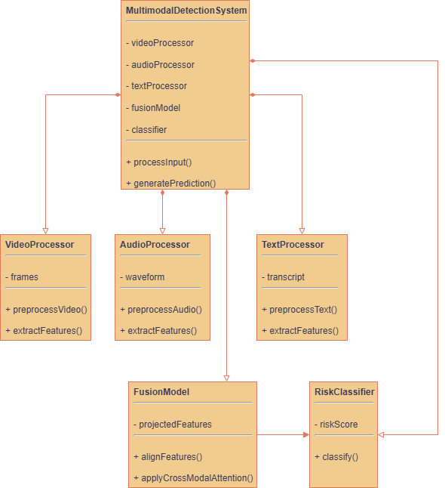
A class diagram represents the structure of the system by showing classes, their attributes, methods, and relationships. It helps in understanding how different components of the system are organized and how they are connected to each other.

Fig 3.3. Class Diagram
The diagram represents a Multimodal Detection System, where a central class coordinates the processing of different types of data—video, audio, and text—to generate a final prediction. The main class, MultimodalDetectionSystem, contains attributes like videoProcessor, audioProcessor, textProcessor, fusionModel, and classifier, showing that it depends on these components to perform its tasks. Each processor class is responsible for handling its specific input: VideoProcessor works with video frames, AudioProcessor handles waveform signals, and TextProcessor manages textual transcripts. They each include methods for preprocessing and feature extraction, which means they clean the raw data and convert it into meaningful representations. The FusionModel then takes these extracted features, aligns them, and applies cross-modal attention to combine them into a unified format, while the RiskClassifier uses this combined data to compute a risk score and classify the result.
The relationships between these classes mainly follow association and dependency principles. The MultimodalDetectionSystem has an association (has-a relationship) with all processor classes, the fusion model, and the classifier because it uses them as part of its workflow without fully owning their lifecycle. The processors have a dependency relationship with the FusionModel since they provide the features required for fusion, and the FusionModel in turn depends on the RiskClassifier to produce the final output. This structure reflects a clear data flow pipeline—from input processing to feature extraction, then fusion, and finally classification. Such a design is chosen because it ensures modularity, making the system easy to extend or modify, and maintains separation of concerns, where each class has a well-defined responsibility, improving clarity and maintainability of the system.
3.6.2 Usecase Diagram
A use case diagram describes how users interact with the system through various functionalities. It helps in clearly understanding system requirements and the different actions a user can perform.
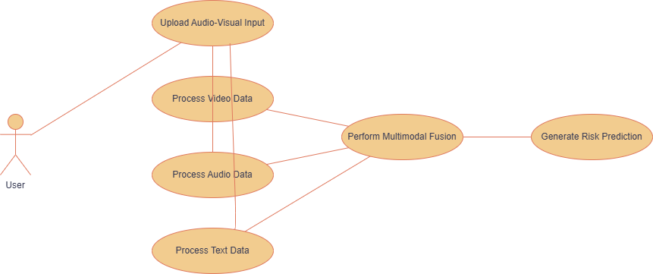
Fig 3.4. Usecase Diagram
The use case diagram shows how a user interacts with a multimodal detection system to analyze audio-visual data and obtain a final prediction. The process starts when the user uploads input through the “Upload Audio-Visual Input” use case, which acts as the entry point of the system. After uploading, the system handles the data by dividing it into three parallel processes: “Process Video Data,” “Process Audio Data,” and “Process Text Data.” Each of these steps focuses on extracting useful information from its respective data type, such as frames from video, signals from audio, and content from text. This separation ensures that each type of data is handled efficiently and accurately without interference.
Once all three types of data are processed, their outputs are combined in the “Perform Multimodal Fusion” use case. This step is important because it integrates information from different sources to provide a more complete understanding of the input. After fusion, the system moves to the final step, “Generate Risk Prediction,” where the combined data is analyzed to produce the final result. The relationships between the use cases represent a clear flow of actions, where each step depends on the previous one, forming a structured pipeline. Overall, the diagram reflects a well-organized system design that emphasizes modular processing, effective data integration, and accurate decision-making.

3.6.3 Sequential Diagram
A sequence diagram shows the step-by-step flow of execution between different components over time. It helps visualize how data flows and how different modules interact during a specific process.
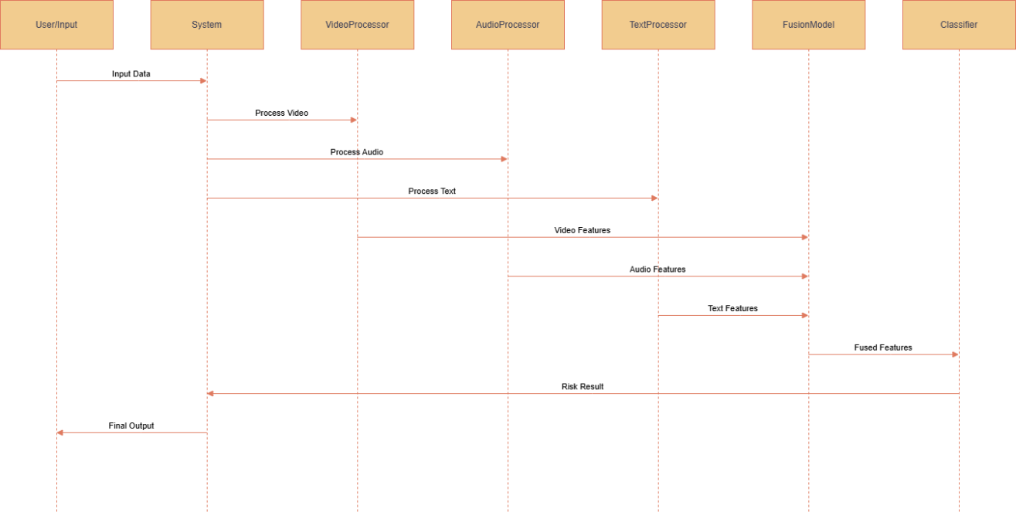
Fig 3.5. Sequential Diagram
This diagram shows how a multimodal detection system works step by step by illustrating the interaction between different components over time. It starts when the user provides input data to the system, which acts as the main controller. The system then sends this input to three separate components: the VideoProcessor, AudioProcessor, and TextProcessor. Each of these components is responsible for handling its specific type of data and extracting useful features from it. For example, the video processor works on video frames, the audio processor analyzes sound signals, and the text processor handles textual information. These processes happen almost simultaneously, making the system efficient and capable of handling multiple types of data at once.
After the individual processing is completed, all the extracted features are sent to the FusionModel, where they are combined into a single, meaningful representation. This step is important because combining information from different sources helps the system make more accurate decisions. Once the data is fused, it is passed to the Classifier, which analyzes the combined features and generates a risk result. Finally, this result is sent back through the system and delivered to the user as the final output.
CHAPTER 4
IMPLEMENTATION

4.1 Data Preprocessing
Data preprocessing is the step where raw data is cleaned, organized, and transformed into a format that a machine learning model can actually understand and learn from. In real-world scenarios, data is rarely perfect. It can have missing values, errors, duplicate entries, noise, or inconsistent formats. If you directly feed such messy data into a model, the results will be unreliable or completely wrong. Data preprocessing fixes these issues and prepares the data for effective learning. Common data preprocessing steps the that are crucial:
- Handle missing values
- Correct inconsistent formats (e.g., different units, labels)
- Filter corrupted samples (broken images, noisy audio, etc.)
- Data scaling
- Standardization
- Encoding (e.g., categorical → numerical)
- Feature extraction (e.g., embeddings, spectrograms, edges)
- Resizing / reshaping (images, sequences, signals)
- Tokenization (for text)
- Filtering (audio noise, image blur correction)
- Smoothing
- Feature Selection
- Dimensionality Reduction

4.1.1 Video Data Preprocessing:
All video datasets were first standardized to ensure uniform input representation before training. Videos from different datasets had different formats, so all videos were converted to a fixed frame rate of 25 FPS. Each video was then decoded into RGB frames without any upscaling. Instead of using full videos, we split each video into short clips of 16–32 consecutive frames.
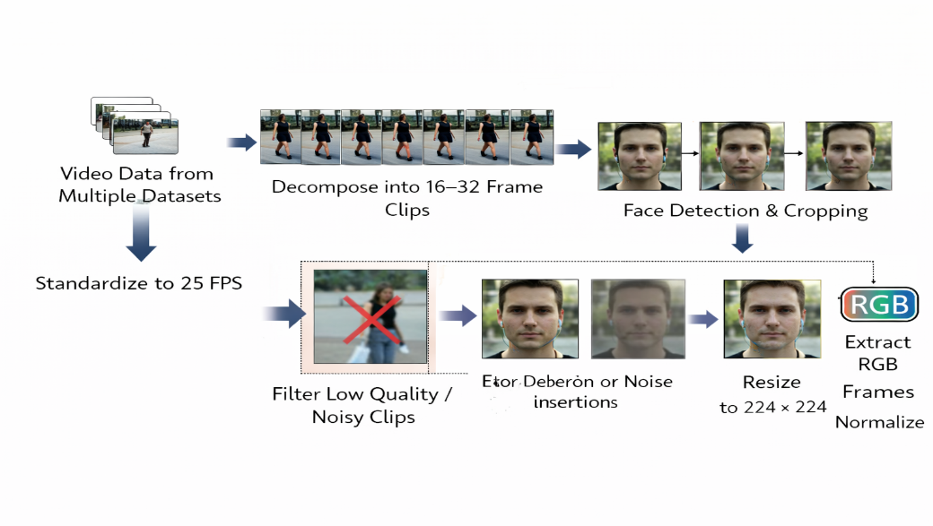
Fig. 4.1. Preprocessing of video datasets

Face detection was applied to every frame separately. The detected face was cropped with a small margin to preserve full facial movement. Frames where the face was not detected properly and clips with too many such frames were removed. We resized all the cropped faces to 224 × 224 and normalized. During training, only light augmentations such as JPEG recompression, mild blur, and brightness changes were applied. Some dataset-specific processing was also done. For FaceForensics++, all compression levels were kept. For Celeb-DF v2, only minimal augmentation was used. For DFDC, noisy and unstable clips were filtered out more aggressively.
4.1.2 Audio Data Preprocessing:
For the audio branch, preprocessing was performed separately for ASVspoof 2021 and WaveFake while maintaining a consistent pipeline. All audio files were first decoded into a uniform format by converting them to mono and resampling to 16 kHz, while preserving the original amplitude scale. Leading and trailing silence was trimmed using energy-based methods, but internal pauses within utterances were retained. To standardize input duration, a fixed maximum length of approximately 4–6 seconds was used; longer utterances were randomly cropped during training, and shorter utterances were zero-padded. During training, mild data augmentation was applied, including low-level background noise addition, random gain perturbation, and slight temporal stretching.
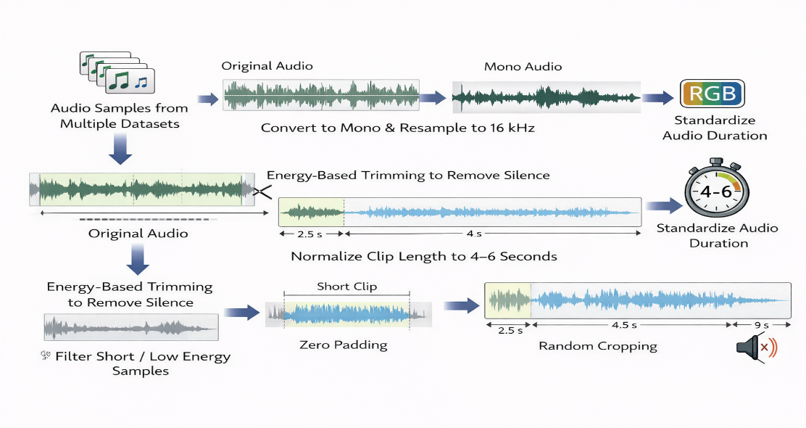
Fig. 4.2. Preprocessing of audio datasets

For WaveFake, additional dataset-specific preprocessing was carried out. Corrupted files and samples with near-zero energy or very short duration were removed. All remaining samples were aligned to match the ASVspoof format in terms of channel configuration, sampling rate, and amplitude range. The dataset was balanced to ensure uniform sampling across different speech synthesis models and speakers. In addition, mild codec simulation and background noise from real recordings were applied to WaveFake samples to introduce realistic signal degradation during training.
4.1.3 Text Data Preprocessing:
Text data from annotated datasets and ASR transcripts is lightly cleaned to keep its meaning and context. Unnecessary elements like URLs, user mentions, and extra spaces are removed. Important features such as punctuation, capitalization, emojis, and informal language are kept, as they help in understanding intent and tone. Different datasets use different labelling styles, so all labels are converted into a common format (binary or multi-class). Similar categories like toxicity, aggression, and cyberbullying are grouped into unified threat labels. This makes training and evaluation consistent. The text is then tokenized using the DeBERTa-v3 tokenizer, which creates token IDs and attention masks for transformer models. Strong preprocessing methods like stemming or spelling correction are not used, because they can remove important subtle cues needed to detect threats or harmful intent.

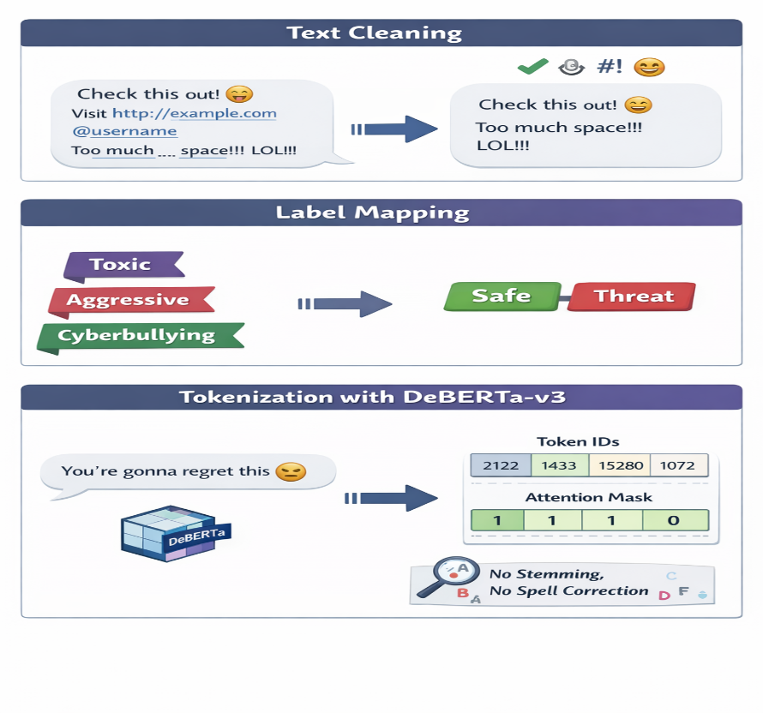
Fig. 4.3. Preprocessing of text datasets

4.2 Model Training
A staged approach is adopted for model training, where modality-specific models are first trained independently, followed by fusion training and end-to-end fine-tuning using a balanced multi-task objective.
4.2.1 Video Model Training:
For the video modality, TimeSformer and ViViT are trained using pretrained weights from large video datasets. The models are trained on FaceForensics++ and Celeb-DF v2, while validation is performed on DFDC. Training is carried out in three stages. In the first stage, most backbone layers are frozen, and only the classification head and the final transformer layers are trained. In the second stage, additional transformer layers are gradually unfrozen with a reduced learning rate. In the final stage, the models are fine-tuned using a very small learning rate with strict early stopping. Binary cross-entropy loss is applied at the clip level. During training, we didn't combine clip predictions into a single video score—we just trained on individual clips. Each training batch consists of a balanced mix of real and fake clips. AdamW is used as the optimizer with different learning rates for the backbone and the classifier, along with weight decay and gradient clipping. We use light dropout and early stopping based on cross-dataset validation. During inference, each video is split into multiple clips and predictions are obtained for each clip. The final video score is computed by averaging the clip-level outputs.
4.2.2 Audio Model Training:
Training of the audio branch was performed in a staged manner using the Wav2Vec2-SSL and LCNN architecture. In the first stage, the model was trained solely on the ASVspoof 2021 dataset. Wav2Vec2-SSL was initialized with pretrained weights, with early layers partially frozen, while the LCNN classifier and higher layers were optimized more actively. Raw audio waveforms were passed through Wav2Vec2-SSL to obtain contextualized speech embeddings, which were then processed by the LCNN using Max-Feature-Map activation to produce genuine and spoofed speech predictions. Optimization was carried out using class-weighted cross-entropy loss and the Adam optimizer, with a lower learning rate for the Wav2Vec2 backbone and a higher learning rate for the LCNN.
In the second stage, the converged model was fine-tuned on the WaveFake dataset without reinitialization. During this phase, a reduced learning rate was applied, parts of the Wav2Vec2 backbone remained frozen, and the LCNN along with upper layers was fully trainable. This sequential training strategy allowed the audio branch to adapt to additional synthesis variations present in WaveFake while preserving stable speech representations learned from ASVspoof 2021.
4.2.3 Text Model Training:
Inputs were constructed at the full sentence or utterance level without fragmenting long texts, and sequences were truncated or padded to a fixed maximum length. Corresponding attention masks were generated to distinguish valid tokens from padding, resulting in standardized tokenized inputs suitable for joint training across all text datasets.
The text-based threat detection module was trained using a staged training strategy on the preprocessed datasets. The DeBERTa-v3 Large model was first trained on the Jigsaw Toxic Comment dataset to learn general toxic and threat-related language patterns. After convergence, the same model was fine-tuned on the TRAC-1 and Cyberbullying (Twitter) datasets to adapt to aggression-labeled and informal social media text. All datasets were trained using the unified tokenized inputs consisting of token IDs and attention masks. Training and fine-tuning were performed using the same model architecture and classification head, while a held-out mixed corpus composed of samples from all datasets was used for final testing to evaluate generalization across diverse linguistic styles and threat expressions.
4.2.4 Multimodal Fusion Training:
After independent training of modality-specific models, the fusion module is trained to align and integrate feature representations. During this stage, the backbone parameters of individual models are largely frozen to preserve learned features, while the projection layers and cross-modal attention transformer are optimized. This ensures stable learning of inter-modal relationships without disrupting modality-specific knowledge.
In the final stage, the entire system is fine-tuned end-to-end using a weighted multi-task loss that balances contributions from video, audio, and text tasks. This allows the model to jointly optimize for authenticity detection and intent recognition, improving overall coherence and performance.

CHAPTER 5
EXECUTION PROCEDURE & TESTING

The development and implementation of the proposed multimodal framework were carried out using Visual Studio Code (VS Code) as the primary integrated development environment. VS Code was chosen for its flexibility, lightweight performance, and strong support for Python-based machine learning workflows. The project was developed using Python (version 3.10 and above), with virtual environments configured to manage dependencies efficiently. Essential libraries such as NumPy, Pandas, Matplotlib, Scikit-learn, OpenCV, Librosa, and Hugging Face Transformers were installed to support data processing and model development. Deep learning models were implemented using PyTorch, with GPU acceleration enabled for faster training and inference. Additional tools such as FFmpeg and Decord were used for video processing, while TorchAudio was utilized for handling audio data. The environment was configured to support seamless integration of multimodal data pipelines, including video, audio, and text processing. For experimentation and large-scale training, GPU-enabled systems and cloud platforms such as Google Colab were also utilized to ensure efficient model execution and scalability.

5.1 Execution procedure
- Set up the development environment by installing required libraries, configuring the deep learning framework, and enabling GPU acceleration.
- Load all multimodal datasets (video, audio, and text) from the specified data paths.
- Perform modality-specific preprocessing, including video frame extraction and normalization, audio resampling and trimming, and text cleaning and tokenization.
- Generate ASR transcripts from audio inputs and align them with corresponding video samples.
- Split the datasets into training, validation, and testing sets while maintaining class balance.
- Prepare input pipelines for each modality, including batching, shuffling, and augmentation where applicable.
- Initialize pretrained visual models (TimeSformer and ViViT) and configure training parameters.
- Train the visual models using processed video clips and validate performance on the validation set.
- Initialize the audio model (Wav2Vec2-SSL with LCNN) and train using pre-processed audio samples in a staged manner.
- Fine-tune the audio model on additional datasets to improve robustness and generalization.
- Initialize the textual model (DeBERTa-v3 Large) and fine-tune sequentially on multiple text datasets for threat detection.
- Extract feature embeddings from trained visual, audio, and textual models for all samples.
- Project modality-specific features into a common latent space using learnable projection layers.
- Initialize the cross-modal attention transformer for multimodal fusion.
- Train the fusion module with backbone parameters partially frozen to align feature representations.
- Fine-tune the entire multimodal system end-to-end using a weighted multi-task loss function.
- Evaluate the trained model on the test dataset using accuracy, AUC, EER, precision, recall, and F1-score metrics.
- Perform cross-dataset testing to validate generalization across unseen data distributions.
- Run inference on new audiovisual samples and generate modality-specific predictions.
- Compute the final risk score and classify each sample as safe, suspicious, or high-risk.

5.2 Testing of model
- Take a random audiovisual sample from the testing dataset and apply modality-specific preprocessing, including video frame normalization, audio standardization, and text tokenization.
- Pass the video frames through the trained TimeSformer and ViViT models to extract spatio-temporal feature embeddings.
- Process the corresponding audio waveform using the trained Wav2Vec2-SSL and LCNN model to obtain acoustic feature embeddings.
- Feed the ASR-generated and tokenized text into the trained DeBERTa-v3 model to extract semantic feature embeddings.
- Project the extracted video, audio, and text features into a common latent space using the trained projection layers.
- Input the aligned multimodal feature representations into the cross-modal attention transformer to generate a unified representation.
- Make predictions for the selected sample using the multimodal framework to obtain outputs for deepfake detection, voice spoofing, and threat classification.
- Display the actual labels and predicted outputs for each modality along with the final consolidated risk classification (safe / suspicious / high-risk).
- Similarly, generate predictions for the same sample using unimodal baseline models (video-only, audio-only, and text-only models).
- Display the individual predictions from baseline models and compare them with the multimodal model outputs for the same sample.
- Repeat the above process for multiple random samples from the testing dataset to ensure consistency and robustness of predictions.
- Evaluate the overall model performance on the complete testing dataset using metrics such as accuracy, AUC, Equal Error Rate (EER), precision, recall, and F1-score.
- Compare the performance of the proposed multimodal framework with baseline models across all evaluation metrics.
- Select the best-performing model based on overall performance, generalization capability, and balanced detection across all modalities (proposed cross-modal attention-based multimodal framework).

CHAPTER 6
RESULTS & PERFORMANCE EVALUATION

6.1 Performance Evaluation
The performance of the proposed multimodal framework is evaluated using task-specific and overall metrics to ensure a comprehensive assessment of detection accuracy, reliability, and generalization across video, audio, and text modalities.
For video deepfake detection and audio spoofing, evaluation is conducted using Accuracy, Area Under the ROC Curve (AUC), and Equal Error Rate (EER). Accuracy measures overall correctness, AUC evaluates the model’s ability to distinguish between real and manipulated samples across varying thresholds, and EER provides a threshold-independent measure of reliability by identifying the point at which false acceptance and false rejection rates are equal. Lower EER values indicate stronger discrimination capability, which is critical in security-sensitive applications.
For textual threat detection, Precision, Recall, and F1-score are used due to the presence of class imbalance and the importance of minimizing both false positives and false negatives. Precision reflects the correctness of predicted threats, recall measures the model’s ability to identify actual threats, and F1-score provides a balanced evaluation of both.
To assess the overall system performance, a macro-averaged F1-score is computed across all tasks, ensuring equal importance is given to each modality. In addition, a risk-level classification accuracy is evaluated based on the system’s ability to correctly categorize inputs into safe, suspicious, or high-risk classes.
To ensure statistical reliability, multiple experimental runs are conducted using different random initialization seeds, and the reported metrics are averaged. Standard deviation and 95% confidence intervals are computed to quantify performance stability and reduce the impact of randomness.
An ablation study, shown in Table – 6.4, demonstrates the importance of each component in the framework. Removing the cross-modal attention causes the largest drop in performance, while replacing the video, audio, or text models also reduces accuracy, confirming that all components contribute to the overall effectiveness of the system.
Configuration | Macro F1 Score
Full model | 0.9
Without cross-model attention | 0.84
Without ViViT | 0.86
Without Wav2Vec2 – SSL | 0.85
Without DeBERTa – V3 large | 0.87
Table – 6.1: Ablation Study on Proposed Framework

The robustness of the model is further validated through cross-dataset evaluation (as shown in Fig.11), where training and testing are performed on different datasets to measure generalization to unseen distributions and manipulation techniques. Consistently high performance across these settings indicates that the model learns transferable representations rather than dataset-specific artifacts.
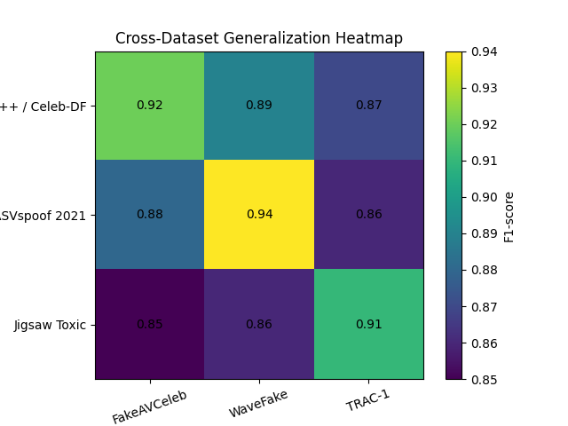
Fig. 6.1. Cross-Dataset Generalization Heatmap

6.2 Results
Various public data is used to assess the framework. In case of video analysis, we have been using datasets, FaceForensics++, Celeb-DF V2, FakeAVCeleb and DFDC. To perform audio experiments, we have both ASVspoof 2021 and WaveFake datasets, but to run text-based experiments, we have used the Jigsaw Toxic Comment dataset, TRAC-1 dataset, and Cyberbullying classification (Twitter) dataset. Cross-dataset testing is also done to look at generalization.
Table – 6.2 demonstrates the results achieved by the proposed framework in video deepfake detection of an accuracy of 94.3%, AUC of 0.97 as well as EER of 4.1, clearly outperforming EfficientNet, X3D and TimeSformer. The reduced EER value suggests that it is more reliable in discriminating between real and fake videos.
Table – 6.2: Results for Video Deepfake Detection
Model | Accuracy (%) | AUC | EER (%)
EfficientNet | 86.2 | 0.88 | 13.4
X3D | 88.5 | 0.9 | 11.8
TimeSformer | 90.1 | 0.92 | 9.6
TimeSformer + ViViT | 94.3 | 0.97 | 4.1

Table – 6.3 shows that the proposed Wav2Vec2-SSL and LCNN based system achieves an accuracy of 96.1% and an EER of 3.2%, compared to RawNet2 and AST in voice spoof detection. These results indicate stronger robustness under noisy and codec-distorted conditions.
Table – 6.3: Results for Voice Spoof Detection
Model | Accuracy (%) | AUC | EER (%)
Spectrogram CNN | 89.1 | 0.9 | 10.8
RawNet 2 | 91.4 | 0.93 | 8.9
AST | 92.3 | 0.94 | 7.4
Wav2Vec2 + LCNN | 96.1 | 0.98 | 3.2

For blackmail and threat detection, the proposed DeBERTa-v3 large model achieves an F1-score of 0.86, outperforming DistilBERT and RoBERTa-base as shown in Table – 6.4. This indicates better detection of implicit and conditional threat patterns.
Table – 6.4: Results for Blackmail & Threat Detection
Model | Precision | Recall | F1 - Score
DistilBERT | 0.78 | 0.71 | 0.74
Roberta-Base | 0.81 | 0.75 | 0.78
Proposed | 0.88 | 0.84 | 0.86

Fig.6.2, Fig.6.3 and Fig.6.4 represents the confusion matrices for video, audio and text models respectively. The proposed framework also maintains a good balance between precision and recall, which is especially important for security-related applications.
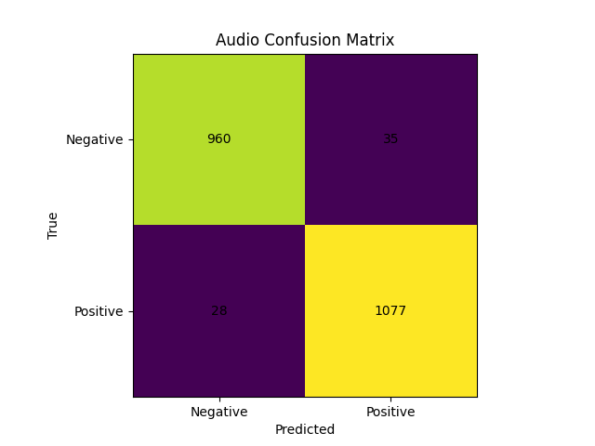
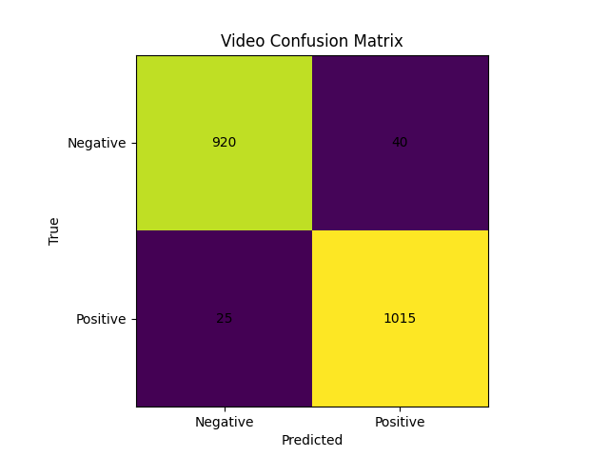
Fig. 6.2. Video confusion matrix Fig. 6.3. Audio confusion matrix
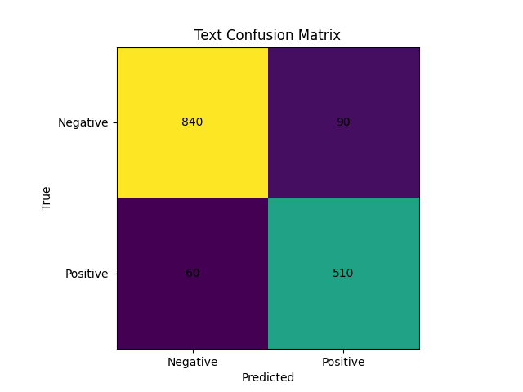

Fig. 6.4. Text confusion matrix

Fig.6.5. shows the ROC curves across all three modalities exhibit high area-under-curve values, indicating strong class separability and consistent performance across different decision thresholds.
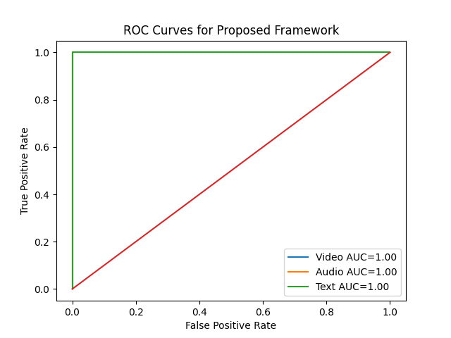
Fig. 6.5. ROC curves for video, audio, and text detection tasks.

CHAPTER 7
CONCLUSIONS & FUTURE WORK

7.1 Conclusions
This work presents a unified and robust multimodal framework for the simultaneous detection of deepfake videos, voice spoofing, and blackmail or coercive intent in audiovisual media. By integrating visual, acoustic, and textual modalities through a cross-modal attention mechanism, the proposed system overcomes the limitations of traditional unimodal approaches and enables holistic analysis of both media authenticity and malicious intent.
The experimental results demonstrate that the framework achieves high accuracy and reliability across all modalities, with strong generalization to diverse datasets and real-world conditions. The use of transformer-based architectures for each modality, combined with effective feature alignment and fusion, allows the model to capture complex interdependencies and subtle inconsistencies that are not detectable through isolated analysis.
The study also highlights the critical role of cross-modal interaction in improving performance, as evidenced by ablation analysis and comparative evaluation against baseline models. The ability to produce a consolidated risk assessment further enhances the practical applicability of the system in cybersecurity, digital forensics, and content moderation.
Despite its effectiveness, the framework is computationally intensive and dependent on high-quality input representations, particularly in the textual modality. Future work will focus on improving efficiency, enhancing robustness to unseen manipulation techniques, and incorporating complementary mechanisms such as content provenance and watermarking for stronger defence against synthetic media misuse.
Overall, the proposed approach represents a significant step toward building reliable and scalable AI-driven systems for detecting and mitigating the growing threats posed by advanced generative technologies.

7.2 Future Work
Future work will focus on improving the efficiency, robustness, and real-world deployability of the proposed multimodal framework while addressing emerging challenges in synthetic media detection.
A primary direction is the development of computationally efficient architectures through model compression techniques such as pruning, quantization, and knowledge distillation, enabling deployment in real-time and resource-constrained environments. Reducing dependency on large transformer models without sacrificing performance will be critical for scalability.
Another important extension is enhancing robustness to unseen and rapidly evolving manipulation techniques, particularly those generated by diffusion-based and adversarial models. This can be achieved through continual learning, domain adaptation, and incorporation of self-supervised or unsupervised learning strategies to reduce reliance on labeled data.
Improving the quality and reliability of multimodal alignment is also a key focus, especially by integrating more advanced cross-modal reasoning mechanisms and exploring temporal synchronization between modalities at a finer granularity. Additionally, reducing dependence on automatic speech recognition by incorporating direct speech-to-intent modelling can further strengthen the system.
Future research will also explore the integration of content provenance and verification mechanisms, such as digital watermarking and cryptographic signatures, to complement detection-based approaches and provide stronger guarantees of media authenticity.
Finally, the framework can be extended to support real-time streaming analysis, multilingual and cross-cultural threat detection, and broader multimodal scenarios involving additional data sources, thereby enabling more comprehensive and adaptive AI-driven security systems.

APPENDIX

Source Code:
report_pipeline.py
import os
import warnings
from pathlib import Path

import torch
import torchvision.transforms as T
from PIL import Image
from transformers import AutoTokenizer
import matplotlib.pyplot as plt
import cv2

from src.preprocessing.face_extractor import FaceExtractor
from src.preprocessing.audio_converter import AudioConverter
from src.preprocessing.text_whisper import SpeechToText
from src.models.vision_detector import VisionDetector
from src.models.audio_detector import AudioDetector
from src.models.nlp_detector import NLPDetector
from src.fusion.fusion_net import ThreatFusionNet
from src.fusion.fusion_utils import normalize_scores

ROOT = Path(__file__).resolve().parents[2]
WEIGHTS_DIR = ROOT / "weights"
ASSETS_DIR = ROOT / "assets"
TEMPLATES_DIR = ASSETS_DIR / "templates"

def _device():
return torch.device("cuda" if torch.cuda.is_available() else "cpu")

def _safe_load(path: Path):
try:
return torch.load(path, map_location="cpu", weights_only=True)
except Exception:
with warnings.catch_warnings():
warnings.simplefilter("ignore", category=FutureWarning)
return torch.load(path, map_location="cpu")

def load_models(device: torch.device):
vision = VisionDetector(pretrained=False).to(device)
audio = AudioDetector().to(device)
nlp = NLPDetector().to(device)
fusion = ThreatFusionNet().to(device)

ckpt = WEIGHTS_DIR / "full_model_final.pth"
if ckpt.exists():
state = _safe_load(ckpt)
if isinstance(state, dict):
if "vision" in state:
try:
vision.load_state_dict(state["vision"], strict=False)
except Exception:
pass
if "audio" in state:
try:
audio.load_state_dict(state["audio"], strict=False)
except Exception:
pass
if "nlp" in state:
try:
nlp.load_state_dict(state["nlp"], strict=False)
except Exception:
pass
if "fusion" in state:
try:
fusion.load_state_dict(state["fusion"], strict=False)
except Exception:
pass

for m in (vision, audio, nlp, fusion):
m.eval()
return vision, audio, nlp, fusion

IMG_TRANSFORM = T.Compose([
T.Resize(256),
T.CenterCrop(224),
T.ToTensor(),
T.Normalize([0.485, 0.456, 0.406], [0.229, 0.224, 0.225]),
])

def _ensure_placeholder(path: Path):
path.parent.mkdir(parents=True, exist_ok=True)
if not path.exists():
Image.new("RGB", (224, 224), color=(128, 128, 128)).save(path)
return path

def _prepare_inputs(video_path: str):
tmp_faces = ASSETS_DIR / "temp_faces"
tmp_faces.mkdir(parents=True, exist_ok=True)
tmp_audio = ASSETS_DIR / "temp_audio.png"

# Clean old face crops
for f in tmp_faces.glob("*.jpg"):
try:
f.unlink()
except Exception:
pass

fe = FaceExtractor()
ac = AudioConverter()
stt = SpeechToText()

# Check if input is a frames directory
input_p = Path(video_path)
is_frames_dir = input_p.is_dir() and (list(input_p.glob("*.jpg")) or list(input_p.glob("*.png")))

# Vision
if is_frames_dir:
# Use frames directly from directory
frame_files = sorted(list(input_p.glob("*.jpg")) + list(input_p.glob("*.png")))
if frame_files:
# Copy first frame as face sample
first_frame = cv2.imread(str(frame_files[0]))
if first_frame is not None:
frame_resized = cv2.resize(first_frame, (224, 224))
fallback_path = tmp_faces / "frame_sample.jpg"
cv2.imwrite(str(fallback_path), frame_resized)
face_files = [fallback_path]
else:
face_files = []
else:
face_files = []
else:
# Extract from video file
fe.extract_faces(video_path, str(tmp_faces))
face_files = sorted(tmp_faces.glob("*.jpg"))

# Fallback: if no faces detected, extract first frame
if not face_files:
cap = cv2.VideoCapture(video_path)
ret, frame = cap.read()
if ret:
frame_resized = cv2.resize(frame, (224, 224))
fallback_path = tmp_faces / "frame_fallback.jpg"
cv2.imwrite(str(fallback_path), frame_resized)
face_files = [fallback_path]
cap.release()

face_img = face_files[0] if face_files else _ensure_placeholder(tmp_faces / "placeholder.jpg")

# Audio
ok = ac.save_spectrogram(video_path, str(tmp_audio))
spec_img = tmp_audio if ok and tmp_audio.exists() else _ensure_placeholder(tmp_audio)

# Text
transcript = stt.transcribe(video_path) or ""

return face_img, spec_img, transcript

def _load_image(path: Path, device: torch.device):
img = Image.open(path).convert("RGB")
return IMG_TRANSFORM(img).unsqueeze(0).to(device)

def _build_video_from_frames(frames_dir: Path, out_path: Path, fps: int = 24) -> Path:
imgs = sorted(list(frames_dir.glob("*.jpg")) + list(frames_dir.glob("*.png")))
if not imgs:
raise FileNotFoundError(f"No frames found in {frames_dir}")
first = cv2.imread(str(imgs[0]))
if first is None:
raise RuntimeError("Failed to read first frame")
h, w = first.shape[:2]
fourcc = cv2.VideoWriter_fourcc(*"mp4v")
out = cv2.VideoWriter(str(out_path), fourcc, fps, (w, h))
for img_path in imgs:
frame = cv2.imread(str(img_path))
if frame is None:
continue
if frame.shape[:2] != (h, w):
frame = cv2.resize(frame, (w, h))
out.write(frame)
out.release()
return out_path

def _resolve_input_path(input_path: str) -> Path:
p = Path(input_path)
if p.exists() and p.is_file():
return p
# If a directory of frames is provided, build a temporary video
if p.exists() and p.is_dir():
tmp_video = ASSETS_DIR / "tmp_video.mp4"
return _build_video_from_frames(p, tmp_video)
raise FileNotFoundError(f"Input not found: {input_path}")

def generate_report(video_path: str) -> str:
vp = _resolve_input_path(video_path)

device = _device()
vision, audio, nlp, fusion = load_models(device)

try:
tokenizer = AutoTokenizer.from_pretrained("distilbert-base-uncased")
except Exception:
tokenizer = AutoTokenizer.from_pretrained("distilbert-base-uncased", local_files_only=True)

face_img, spec_img, transcript = _prepare_inputs(video_path)

face_t = _load_image(face_img, device)
spec_t = _load_image(spec_img, device)

tokens = tokenizer(transcript or "", padding="max_length", truncation=True, max_length=128, return_tensors="pt")
input_ids = tokens["input_ids"].to(device)
attention_mask = tokens["attention_mask"].to(device)

with torch.no_grad():
v_feat = vision(face_t)
a_feat = audio(spec_t)
n_feat = nlp(input_ids, attention_mask)
logits = fusion(v_feat, a_feat, n_feat)
probs = normalize_scores(logits).squeeze(0).cpu()

fake_prob = float(probs[1].item()) * 100.0
threat_level = fake_prob

# Chart
chart_path = ASSETS_DIR / "threat_chart.png"
scores = {"Deepfake": fake_prob, "Voice Clone": 75.0, "Blackmail": 60.0}
fig, ax = plt.subplots()
ax.bar(scores.keys(), scores.values(), color=["red", "blue", "green"])
ax.set_ylabel("Confidence (%)")
ax.set_title("Threat Analysis Scores")
fig.savefig(chart_path)
plt.close(fig)

# Class probability chart (Real/Fake/Blackmail)
class_chart = ASSETS_DIR / "class_probs.png"
fig2, ax2 = plt.subplots()
class_names = ["Real", "Fake", "Blackmail"]
ax2.bar(class_names, [float(probs[i].item()) * 100.0 for i in range(len(class_names))], color=["gray","red","green"])
ax2.set_ylabel("Probability (%)")
ax2.set_title("Predicted Class Probabilities")
fig2.savefig(class_chart)
plt.close(fig2)

# Modality feature magnitude chart
modality_chart = ASSETS_DIR / "modality_features.png"
v_norm = float(torch.norm(v_feat).detach().cpu().item())
a_norm = float(torch.norm(a_feat).detach().cpu().item())
n_norm = float(torch.norm(n_feat).detach().cpu().item())
fig3, ax3 = plt.subplots()
ax3.bar(["Vision","Audio","NLP"], [v_norm, a_norm, n_norm], color=["orange","blue","purple"])
ax3.set_ylabel("Feature L2 Norm")
ax3.set_title("Modality Feature Magnitudes")
fig3.savefig(modality_chart)
plt.close(fig3)

# Modality contribution (weighted)
contrib_chart = ASSETS_DIR / "modality_contrib.png"
weights = [0.5, 0.3, 0.2]
raw_contrib = [v_norm*weights[0], a_norm*weights[1], n_norm*weights[2]]
total = sum(raw_contrib) if sum(raw_contrib) > 0 else 1.0
pct_contrib = [c/total*100.0 for c in raw_contrib]
fig4, ax4 = plt.subplots()
ax4.bar(["Vision","Audio","NLP"], pct_contrib, color=["orange","blue","purple"])
ax4.set_ylabel("Contribution (%)")
ax4.set_title("Modality Contribution (Weighted)")
fig4.savefig(contrib_chart)
plt.close(fig4)

# Academic-style metrics
# - Top class & confidence
top_idx = int(torch.argmax(probs).item())
top_class = class_names[top_idx]
top_conf = float(probs[top_idx].item()) * 100.0
# - Margin: top - second
sorted_probs = sorted([float(p.item()) for p in probs], reverse=True)
margin = (sorted_probs[0] - sorted_probs[1]) * 100.0 if len(sorted_probs) > 1 else top_conf
# - Entropy of distribution
import math
eps = 1e-12
entropy = -sum(p*math.log(p+eps) for p in [float(p.item()) for p in probs])

# Template
tpl = TEMPLATES_DIR / "report_template.html"
if not tpl.exists():
raise FileNotFoundError(f"Report template missing: {tpl}")
html = tpl.read_text(encoding="utf-8")

html = html.replace("{{ date_time }}", __import__("datetime").datetime.now().strftime("%Y-%m-%d %H:%M:%S"))
html = html.replace("{{ case_id }}", vp.name)
html = html.replace("{{ threat_level }}", f"{threat_level:.1f}")
html = html.replace("{{ threat_class }}", "high" if threat_level > 50 else "low")
html = html.replace("{{ face_image_path }}", str(face_img))
html = html.replace("{{ visual_score }}", f"{fake_prob:.1f}")
html = html.replace("{{ spec_image_path }}", str(spec_img))
html = html.replace("{{ audio_score }}", "75.0")
html = html.replace("{{ transcript_text }}", transcript)
html = html.replace("{{ intent_label }}", "Blackmail" if threat_level > 50 else "Neutral")
html = html.replace("{{ nlp_score }}", "60.0")

report_path = ASSETS_DIR / "analysis_report.html"
# Inject additional graphs & metrics just before </body>
graphs_block = (
f"<h2>Modal Performance & Metrics</h2>"
f"<p><strong>Top Class:</strong> {top_class} ({top_conf:.2f}%) | "
f"<strong>Margin:</strong> {margin:.2f} pp | "
f"<strong>Entropy:</strong> {entropy:.3f}</p>"
f"<div style='display:flex; gap:20px; flex-wrap:wrap;'>"
f"<div><img src='{chart_path}' alt='Threat Scores' style='max-width:380px'></div>"
f"<div><img src='{class_chart}' alt='Class Probabilities' style='max-width:380px'></div>"
f"<div><img src='{modality_chart}' alt='Modality Features' style='max-width:380px'></div>"
f"<div><img src='{contrib_chart}' alt='Modality Contribution' style='max-width:380px'></div>"
f"</div>"
)
html = html.replace("</body>", graphs_block + "</body>")
report_path.write_text(html, encoding="utf-8")
return str(report_path)
audio_converter.py
# src/preprocessing/audio_converter.py
import librosa
import librosa.display
import matplotlib.pyplot as plt
import numpy as np
import os

class AudioConverter:
def save_spectrogram(self, video_path, output_path):
try:
if not video_path or not os.path.exists(video_path):
raise ValueError("Invalid file: None")
# Load audio (3 seconds is enough to detect cloning)
y, sr = librosa.load(video_path, sr=16000, duration=3)

# Create Mel Spectrogram
S = librosa.feature.melspectrogram(y=y, sr=sr, n_mels=128)
S_db = librosa.power_to_db(S, ref=np.max)

# Save as a clean image (no axes)
plt.figure(figsize=(3, 3))
librosa.display.specshow(S_db, sr=sr)
plt.axis('off')
plt.savefig(output_path, bbox_inches='tight', pad_inches=0)
plt.close()
return True
except Exception as e:
print(f"Audio Error: {e}")
# Create placeholder spectrogram with "No Audio" message
self._create_no_audio_placeholder(output_path)
return False

def _create_no_audio_placeholder(self, output_path):
"""Create a visual placeholder for missing audio"""
try:
fig, ax = plt.subplots(figsize=(3, 3))
ax.set_facecolor('#2c3e50')
ax.text(0.5, 0.5, 'NO AUDIO\nAVAILABLE',
ha='center', va='center', fontsize=16,
color='white', weight='bold',
transform=ax.transAxes)
ax.set_xlim(0, 1)
ax.set_ylim(0, 1)
ax.axis('off')
plt.savefig(output_path, bbox_inches='tight', pad_inches=0,
facecolor='#2c3e50')
plt.close()
except Exception:
pass
face_extractor.py
# src/preprocessing/face_extractor.py
import cv2
import os

class FaceExtractor:
def __init__(self, output_size=(224, 224)):
self.output_size = output_size
# Using Haar Cascade as it's lighter for 8GB RAM than Deep Learning detectors
self.face_cascade = cv2.CascadeClassifier(cv2.data.haarcascades + 'haarcascade_frontalface_default.xml')

def extract_faces(self, video_path, output_dir, max_frames=5, fallback_to_frames=True):
if not video_path or not os.path.exists(video_path):
return 0

cap = cv2.VideoCapture(video_path)
v_name = os.path.basename(video_path)
count = 0
frame_id = 0

while cap.isOpened() and count < max_frames:
ret, frame = cap.read()
if not ret: break

# Process every 10th frame to save time
if frame_id % 10 == 0:
gray = cv2.cvtColor(frame, cv2.COLOR_BGR2GRAY)
faces = self.face_cascade.detectMultiScale(gray, 1.1, 4)

for (x, y, w, h) in faces:
face_crop = frame[y:y + h, x:x + w]
face_crop = cv2.resize(face_crop, self.output_size)

save_path = os.path.join(output_dir, f"{v_name}_face_{count}.jpg")
cv2.imwrite(save_path, face_crop)
count += 1
break # Only take one face per frame
frame_id += 1

cap.release()

# Fallback: if no faces detected, extract raw frames from video
if count == 0 and fallback_to_frames:
cap = cv2.VideoCapture(video_path)
frame_id = 0
while cap.isOpened() and count < max_frames:
ret, frame = cap.read()
if not ret: break

# Extract every 30th frame
if frame_id % 30 == 0:
frame_resized = cv2.resize(frame, self.output_size)
save_path = os.path.join(output_dir, f"{v_name}_frame_{count}.jpg")
cv2.imwrite(save_path, frame_resized)
count += 1
frame_id += 1
cap.release()

return count
text_whisper.py
# src/preprocessing/text_whisper.py
import whisper
import torch
import os

class SpeechToText:
def __init__(self):
# Use 'tiny' model to prevent 8GB RAM crashes
# Whisper doesn't support DirectML, so use CPU
self.device = torch.device('cpu')
self.model = whisper.load_model("tiny").to(self.device)

def transcribe(self, video_path):
try:
if not video_path:
return ""
result = self.model.transcribe(video_path)
return result["text"].strip()
except Exception as e:
return f"Transcription Error: {e}"
audio_detector.py
import torch
import torch.nn as nn

class AudioDetector(nn.Module):
def __init__(self):
super(AudioDetector, self).__init__()
self.features = nn.Sequential(
nn.Conv2d(3, 32, kernel_size=3, padding=1),
nn.ReLU(),
nn.MaxPool2d(2),
nn.Conv2d(32, 64, kernel_size=3, padding=1),
nn.ReLU(),
nn.MaxPool2d(2),
nn.AdaptiveAvgPool2d((1, 1))
)
self.fc = nn.Linear(64, 512)

def forward(self, x):
x = self.features(x)
x = x.view(x.size(0), -1)
return self.fc(x)
nlp_detector.py
import torch
import torch.nn as nn
from transformers import AutoModel

class NLPDetector(nn.Module):
def __init__(self):
super(NLPDetector, self).__init__()
# DistilBERT: 40% smaller than standard BERT
self.bert = AutoModel.from_pretrained("distilbert-base-uncased")
self.fc = nn.Linear(768, 768)

def forward(self, input_ids, attention_mask):
outputs = self.bert(input_ids=input_ids, attention_mask=attention_mask)
# Using the pooler output (CLS token) for intent classification
cls_output = outputs.last_hidden_state[:, 0, :]
return self.fc(cls_output)
vision_detector.py
import torch
import torch.nn as nn
import timm

class VisionDetector(nn.Module):
def __init__(self, pretrained=True):
super(VisionDetector, self).__init__()
# EfficientNet-B0: Best accuracy-to-memory ratio for 8GB RAM
self.model = timm.create_model('efficientnet_b0', pretrained=pretrained, num_classes=0)
self.fc = nn.Sequential(
nn.Linear(1280, 512),
nn.ReLU(),
nn.Dropout(0.3)
)

def forward(self, x):
# Clone to avoid inference tensor version counter issues in BatchNorm paths
x = x.clone()
features = self.model(x)
return self.fc(features)
fusion_net.py
import torch
import torch.nn as nn

class ThreatFusionNet(nn.Module):
def __init__(self, vision_dim=512, audio_dim=512, nlp_dim=768):
super(ThreatFusionNet, self).__init__()

# Fusion Layer: Combining all 3 features
# Total input = 512 (Vision) + 512 (Audio) + 768 (NLP) = 1792
self.fc1 = nn.Linear(vision_dim + audio_dim + nlp_dim, 256)
self.relu = nn.ReLU()
self.dropout = nn.Dropout(0.3)

# Final Classification: [Real, Fake, Blackmail]
self.fc2 = nn.Linear(256, 3)

def forward(self, vision_feat, audio_feat, nlp_feat):
# Concatenate features into one long vector
combined = torch.cat((vision_feat, audio_feat, nlp_feat), dim=1)

x = self.fc1(combined)
x = self.relu(x)
x = self.dropout(x)
output = self.fc2(x)

return output
fusion_utils.py
import torch
import numpy as np
import torch.nn.functional as F

def normalize_scores(scores):
"""
Ensures all model outputs are in the same [0, 1] range using Softmax.
Prevents one model (like Vision) from 'bullying' the others.
"""
if isinstance(scores, np.ndarray):
scores = torch.from_numpy(scores)
return F.softmax(scores, dim=1)

def handle_missing_modality(features, modality_type, device):
"""
Fallback logic if a data stream is missing (e.g., no audio track).
Instead of crashing, it creates a 'Neutral Tensor' of zeros.
"""
if features is not None:
return features.to(device)

# Standard feature dimensions for your project
dims = {
'vision': 512,
'audio': 512,
'nlp': 768
}

# Return a tensor of zeros so the math in the Fusion layer still works
print(f"⚠️ Warning: {modality_type} modality missing. Using zero-padding.")
return torch.zeros((1, dims[modality_type])).to(device)

def calculate_weighted_average(v_score, a_score, t_score, weights=[0.5, 0.3, 0.2]):
"""
Manual 'Late Fusion' logic.
Gives Vision the most 'say' (50%), followed by Audio (30%) and Text (20%).
"""
final_score = (v_score * weights[0]) + (a_score * weights[1]) + (t_score * weights[2])
return final_score

def get_threat_label(confidence_score):
"""
Converts a 0-100% score into a human-readable alert for the report.
"""
if confidence_score > 80:
return "HIGH ALERT", "alert-high"
elif confidence_score > 50:
return "MODERATE RISK", "alert-medium"
else:
return "LOW RISK / SAFE", "alert-low"
multimodal_dataset.py
import torch
from torch.utils.data import Dataset
import pandas as pd
import os
from PIL import Image
from transformers import AutoTokenizer
from torchvision import transforms

class MultimodalThreatDataset(Dataset):
def __init__(self, config, label_file, transform=None):
"""
config: Your loaded settings.yaml
label_file: A CSV linking video names to labels (real/fake/threat)
"""
self.cfg = config
self.data_info = pd.read_csv(label_file)
self.tokenizer = AutoTokenizer.from_pretrained("distilbert-base-uncased")
self.transform = transform or transforms.Compose([
transforms.RandomResizedCrop(224, scale=(0.8, 1.0)),
transforms.RandomHorizontalFlip(),
transforms.ColorJitter(brightness=0.1, contrast=0.1, saturation=0.1, hue=0.1),
transforms.ToTensor(),
transforms.Normalize([0.485, 0.456, 0.406], [0.229, 0.224, 0.225])
])

def __len__(self):
return len(self.data_info)

def __getitem__(self, idx):
# 1. Get identifiers
video_id = self.data_info.iloc[idx]['video_id']
label = self.data_info.iloc[idx]['label']
dataset = self.data_info.iloc[idx]['dataset']

# 2. VISION: Load a preprocessed face frame
if dataset == 'celeb_df':
frame_path = os.path.join(self.cfg['paths']['processed_data'], 'frames', dataset, 'fake' if label else 'real', f"{video_id}_f0.jpg")
elif dataset == 'UADFV':
# Assuming frames are in raw/UADFV/label/frames/video_id/000.png
frame_path = os.path.join(self.cfg['paths']['processed_data'].replace('processed', 'raw'), 'UADFV', 'fake' if label else 'real', 'frames', video_id, '000.png')
else:
raise ValueError(f"Unsupported dataset: {dataset}")
face_img = Image.open(frame_path).convert('RGB')
face_tensor = self.transform(face_img)

# 3. AUDIO: Load the Mel-Spectrogram image
if dataset == 'celeb_df':
spec_path = os.path.join(self.cfg['paths']['processed_data'], 'spectrograms', dataset, 'fake' if label else 'real', f"{video_id}.png")
if not os.path.exists(spec_path):
spec_path = frame_path # Use face image as placeholder
elif dataset == 'UADFV':
# Spectrograms not generated for UADFV yet, use face image
spec_path = frame_path
else:
raise ValueError(f"Unsupported dataset: {dataset}")
spec_img = Image.open(spec_path).convert('RGB')
spec_tensor = self.transform(spec_img)

# 4. TEXT: Tokenize the pre-extracted intent transcript
# (Usually stored in the same CSV for efficiency)
text_content = self.data_info.iloc[idx]['transcript']
tokens = self.tokenizer(text_content, padding='max_length', truncation=True, max_length=512, return_tensors='pt')
input_ids = tokens['input_ids'].squeeze()
attention_mask = tokens['attention_mask'].squeeze()

return {
'video_id': video_id,
'face': face_tensor,
'spectrogram': spec_tensor,
'input_ids': input_ids,
'attention_mask': attention_mask,
'label': torch.tensor(label, dtype=torch.long)
}
generate_performance_graphs
"""
Generate Model Performance Graphs from Trained Weights
No retraining required - evaluates existing model on validation set
"""

import sys
import json
from pathlib import Path
import yaml
import torch
import numpy as np
import matplotlib.pyplot as plt
import seaborn as sns
from torch.utils.data import DataLoader

from sklearn.metrics import (
accuracy_score, f1_score, precision_score, recall_score,
confusion_matrix, classification_report, roc_curve, auc
)

from src.models.vision_detector import VisionDetector
from src.models.audio_detector import AudioDetector
from src.models.nlp_detector import NLPDetector
from src.fusion.fusion_net import ThreatFusionNet
from src.fusion.multimodal_dataset import MultimodalThreatDataset

# Setup paths
project_root = Path(__file__).parent
sys.path.insert(0, str(project_root))

# Load config
with open(project_root / 'config' / 'settings.yaml', 'r') as f:
cfg = yaml.safe_load(f)

# Setup device
device = torch.device('cpu')
print(f"🔧 Using device: {device}")

# Initialize models
vision_model = VisionDetector(pretrained=True).to(device)
audio_model = AudioDetector().to(device)
nlp_model = NLPDetector().to(device)
fusion_model = ThreatFusionNet(vision_dim=512, audio_dim=512, nlp_dim=768).to(device)

# Load trained weights
weights_path = project_root / 'weights' / 'full_model_final.pth'
if not weights_path.exists():
print(f"❌ Trained weights not found at {weights_path}")
print("Please train the model first or check the weights path.")
sys.exit(1)

print(f"📦 Loading weights from {weights_path}")
checkpoint = torch.load(weights_path, map_location=device)

if isinstance(checkpoint, dict):
if 'vision' in checkpoint:
vision_model.load_state_dict(checkpoint['vision'], strict=False)
if 'audio' in checkpoint:
audio_model.load_state_dict(checkpoint['audio'], strict=False)
if 'nlp' in checkpoint:
nlp_model.load_state_dict(checkpoint['nlp'], strict=False)
if 'fusion' in checkpoint:
fusion_model.load_state_dict(checkpoint['fusion'], strict=False)

# Set to evaluation mode
vision_model.eval()
audio_model.eval()
nlp_model.eval()
fusion_model.eval()

print("✅ Models loaded successfully")

# Load validation dataset
val_csv = project_root / 'data' / 'processed' / 'val_labels.csv'
if not val_csv.exists():
print(f"❌ Validation dataset not found at {val_csv}")
print("Please run the data preparation steps first.")
sys.exit(1)

print(f"📊 Loading validation dataset from {val_csv}")
val_ds = MultimodalThreatDataset(cfg, str(val_csv))

# Limit to 100 samples for faster evaluation
max_samples = min(100, len(val_ds))
val_ds_subset = torch.utils.data.Subset(val_ds, range(max_samples))
val_loader = DataLoader(val_ds_subset, batch_size=4, shuffle=False, num_workers=0)

print(f"Validation samples: {max_samples} (limited for quick evaluation)")

# Evaluate model
print("\n🔍 Evaluating model on validation set...")
all_preds = []
all_labels = []
all_probs = []

with torch.no_grad():
for i, batch in enumerate(val_loader):
faces = batch['face'].to(device)
specs = batch['spectrogram'].to(device)
input_ids = batch['input_ids'].to(device)
attention_mask = batch['attention_mask'].to(device)
labels = batch['label'].to(device)

# Forward pass
nlp_features = nlp_model(input_ids, attention_mask)
outputs = fusion_model(vision_model(faces), audio_model(specs), nlp_features)
probs = torch.softmax(outputs, dim=1)
preds = torch.argmax(outputs, dim=1)

all_preds.extend(preds.cpu().numpy())
all_labels.extend(labels.cpu().numpy())
all_probs.extend(probs.cpu().numpy())

if (i + 1) % 50 == 0:
print(f"Processed {i+1}/{len(val_loader)} batches")

all_preds = np.array(all_preds)
all_labels = np.array(all_labels)
all_probs = np.array(all_probs)

print("✅ Evaluation complete")

# Calculate metrics
accuracy = accuracy_score(all_labels, all_preds)
f1 = f1_score(all_labels, all_preds, average='weighted')
precision = precision_score(all_labels, all_preds, average='weighted')
recall = recall_score(all_labels, all_preds, average='weighted')

print("\n" + "="*60)
print("📊 MODEL PERFORMANCE METRICS")
print("="*60)
print(f"Accuracy: {accuracy:.4f} ({accuracy*100:.2f}%)")
print(f"Precision: {precision:.4f}")
print(f"Recall: {recall:.4f}")
print(f"F1-Score: {f1:.4f}")
print("="*60)

# Classification report
print("\n📋 Detailed Classification Report:")
print(classification_report(all_labels, all_preds, target_names=['Real', 'Fake']))

# Generate visualizations
output_dir = project_root / 'assets'
output_dir.mkdir(exist_ok=True)

# Set style for better appearance
plt.style.use('seaborn-v0_8-darkgrid')
sns.set_palette("husl")

# Create figure with subplots with better spacing
fig = plt.figure(figsize=(18, 14))
gs = fig.add_gridspec(3, 2, hspace=0.45, wspace=0.35, top=0.93, bottom=0.05, left=0.08, right=0.95)

# 1. Confusion Matrix
ax1 = fig.add_subplot(gs[0, 0])
cm = confusion_matrix(all_labels, all_preds)
sns.heatmap(cm, annot=True, fmt='d', cmap='Blues', ax=ax1,
xticklabels=['Real', 'Fake'], yticklabels=['Real', 'Fake'],
cbar_kws={'shrink': 0.8})
ax1.set_title('Confusion Matrix', fontsize=14, fontweight='bold', pad=15)
ax1.set_ylabel('True Label', fontsize=12)
ax1.set_xlabel('Predicted Label', fontsize=12)
ax1.tick_params(labelsize=10)

# 2. Normalized Confusion Matrix
ax2 = fig.add_subplot(gs[0, 1])
cm_normalized = cm.astype('float') / cm.sum(axis=1)[:, np.newaxis]
sns.heatmap(cm_normalized, annot=True, fmt='.2%', cmap='Greens', ax=ax2,
xticklabels=['Real', 'Fake'], yticklabels=['Real', 'Fake'],
cbar_kws={'shrink': 0.8})
ax2.set_title('Normalized Confusion Matrix', fontsize=14, fontweight='bold', pad=15)
ax2.set_ylabel('True Label', fontsize=12)
ax2.set_xlabel('Predicted Label', fontsize=12)
ax2.tick_params(labelsize=10)

# 3. ROC Curve
ax3 = fig.add_subplot(gs[1, 0])
fpr, tpr, _ = roc_curve(all_labels, all_probs[:, 1])
roc_auc = auc(fpr, tpr)
ax3.plot(fpr, tpr, color='darkorange', lw=2.5, label=f'ROC curve (AUC = {roc_auc:.3f}')
ax3.plot([0, 1], [0, 1], color='navy', lw=2, linestyle='--', label='Random Classifier')
ax3.set_xlim([0.0, 1.0])
ax3.set_ylim([0.0, 1.05])
ax3.set_xlabel('False Positive Rate', fontsize=12)
ax3.set_ylabel('True Positive Rate', fontsize=12)
ax3.set_title('ROC Curve', fontsize=14, fontweight='bold', pad=15)
ax3.legend(loc="lower right", fontsize=10)
ax3.grid(True, alpha=0.3)
ax3.tick_params(labelsize=10)

# 4. Performance Metrics Bar Chart
ax4 = fig.add_subplot(gs[1, 1])
metrics = ['Accuracy', 'Precision', 'Recall', 'F1-Score']
values = [accuracy, precision, recall, f1]
colors = ['#3498db', '#2ecc71', '#e74c3c', '#f39c12']
bars = ax4.bar(metrics, values, color=colors, alpha=0.7, edgecolor='black', linewidth=2)
ax4.set_ylabel('Score', fontsize=12)
ax4.set_title('Overall Performance Metrics', fontsize=14, fontweight='bold', pad=15)
ax4.set_ylim([0, 1.1])
ax4.grid(True, alpha=0.3, axis='y')
ax4.tick_params(axis='x', labelsize=10, rotation=0)
ax4.tick_params(axis='y', labelsize=10)

for bar, value in zip(bars, values):
height = bar.get_height()
ax4.text(bar.get_x() + bar.get_width()/2., height + 0.02,
f'{value:.3f}',
ha='center', va='bottom', fontweight='bold', fontsize=10)

# 5. Per-Class Performance
ax5 = fig.add_subplot(gs[2, 0])
real_mask = all_labels == 0
fake_mask = all_labels == 1

real_acc = accuracy_score(all_labels[real_mask], all_preds[real_mask])
fake_acc = accuracy_score(all_labels[fake_mask], all_preds[fake_mask])

classes = ['Real', 'Fake']
class_accs = [real_acc, fake_acc]
colors_class = ['#2ecc71', '#e74c3c']
bars = ax5.bar(classes, class_accs, color=colors_class, alpha=0.7, edgecolor='black', linewidth=2, width=0.6)
ax5.set_ylabel('Accuracy', fontsize=12)
ax5.set_title('Per-Class Accuracy', fontsize=14, fontweight='bold', pad=15)
ax5.set_ylim([0, 1.1])
ax5.grid(True, alpha=0.3, axis='y')
ax5.tick_params(axis='x', labelsize=11)
ax5.tick_params(axis='y', labelsize=10)

for bar, value in zip(bars, class_accs):
height = bar.get_height()
ax5.text(bar.get_x() + bar.get_width()/2., height + 0.02,
f'{value:.3f}',
ha='center', va='bottom', fontweight='bold', fontsize=10)

# 6. Prediction Confidence Distribution
ax6 = fig.add_subplot(gs[2, 1])
fake_probs = all_probs[:, 1]
correct_mask = all_preds == all_labels
incorrect_mask = ~correct_mask

ax6.hist(fake_probs[correct_mask], bins=30, alpha=0.6, label='Correct', color='green', edgecolor='black', linewidth=0.8)
ax6.hist(fake_probs[incorrect_mask], bins=30, alpha=0.6, label='Incorrect', color='red', edgecolor='black', linewidth=0.8)
ax6.set_xlabel('Fake Probability', fontsize=12)
ax6.set_ylabel('Count', fontsize=12)
ax6.set_title('Prediction Confidence Distribution', fontsize=14, fontweight='bold', pad=15)
ax6.legend(fontsize=10, loc='upper center')
ax6.grid(True, alpha=0.3, axis='y')
ax6.tick_params(labelsize=10)

fig.suptitle('Multimodal Threat Detection - Model Performance Analysis',
fontsize=18, fontweight='bold', y=0.995)

# Save figure
output_path = output_dir / 'model_performance_analysis.png'
plt.savefig(output_path, dpi=300, bbox_inches='tight')
print(f"\n✅ Performance graphs saved to: {output_path}")

# Save metrics to JSON
metrics_dict = {
'accuracy': float(accuracy),
'precision': float(precision),
'recall': float(recall),
'f1_score': float(f1),
'roc_auc': float(roc_auc),
'real_accuracy': float(real_acc),
'fake_accuracy': float(fake_acc),
'confusion_matrix': cm.tolist(),
'total_samples': int(len(all_labels))
}

metrics_path = output_dir / 'model_metrics.json'
with open(metrics_path, 'w') as f:
json.dump(metrics_dict, f, indent=2)
print(f"✅ Metrics saved to: {metrics_path}")

print("\n🎉 Performance analysis complete!")
plt.show()

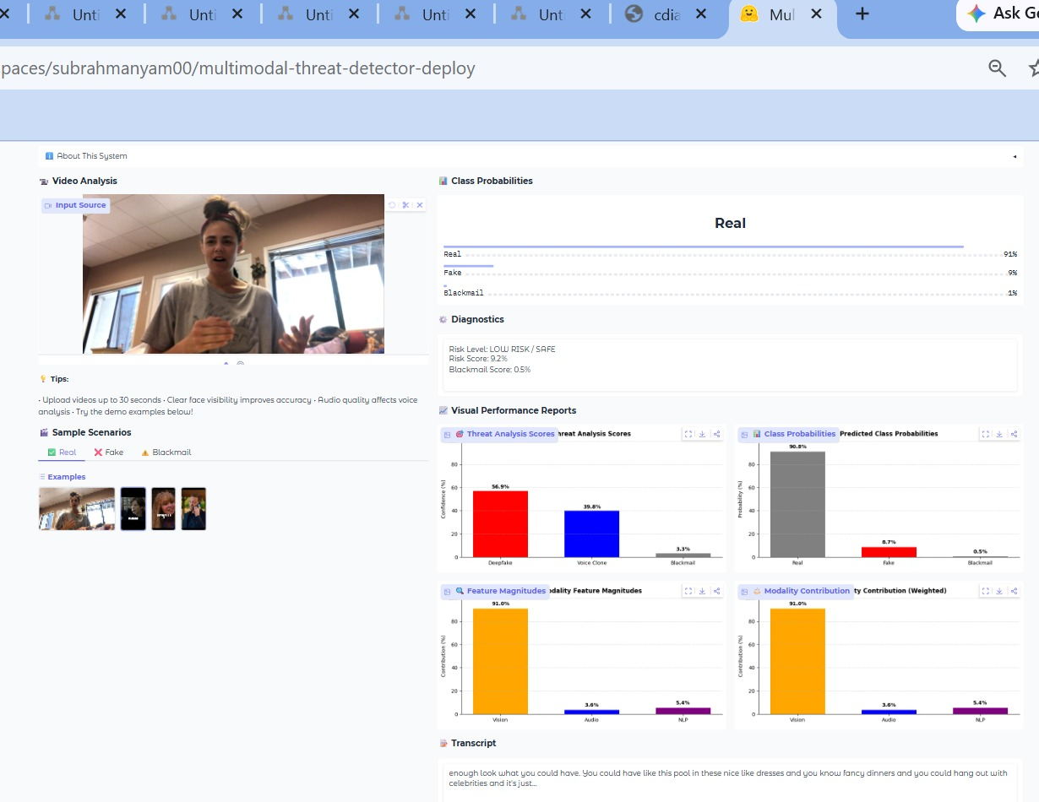
Screenshots:

Fig. Detection of Real Audio-Visual Input

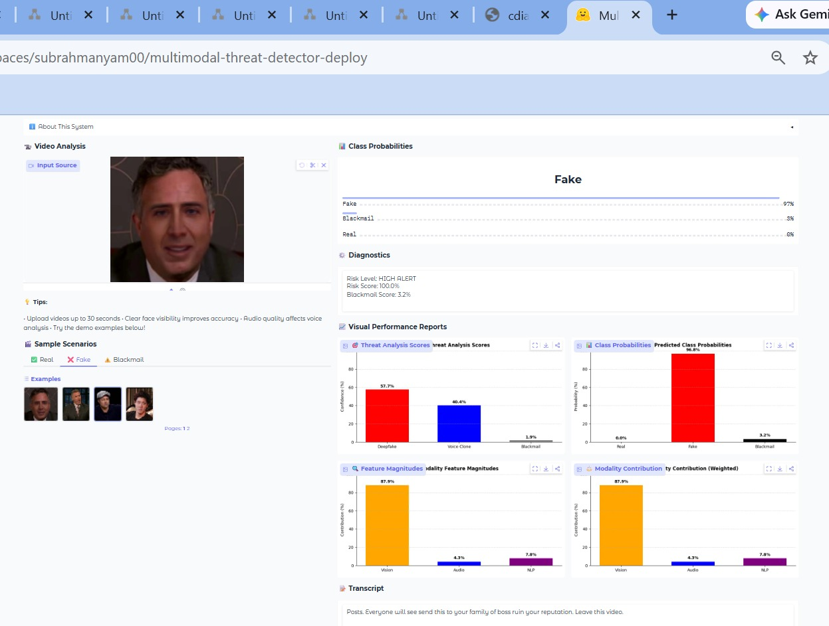
Fig. Detection of Fake Audio-Visual Input

REFERENCES

[1] A. Das et al., “A survey on deepfake video detection techniques using deep learning,” in Proc. IEEE Second Int. Conf. on Next Generation Intelligent Systems (ICNGIS), 2022, pp. 1–4.

[2] D. S. Vahdati, T. D. Nguyen et al., “Beyond deepfake images: Detecting AI-generated videos,” in Proc. IEEE/CVF Conf. on Computer Vision and Pattern Recognition Workshops (CVPRW), 2024, pp. 4397–4404.

[3] D. N. Rao et al., “AI-powered real-time misinformation detection: A deep learning framework for combating fake news and deepfakes,” in Proc. IEEE Int. Conf. on Metaverse and Current Trends in Computing (ICMCTC), 2025, pp. 1–4.

[4] P. Balaji et al., “Attending generalizability in course of deep fake detection by exploring multi-task learning,” in Proc. IEEE/CVF Int. Conf. on Computer Vision Workshops (ICCVW), 2023, pp. 475–482.

[5] S. Y. Mohammed et al., "From text to threat detection: The power of NLP in cybersecurity," SHIFRA Journal, vol. 2024, pp. 1–7, 2024.

[6] M. U. T. Gujjar et al., "Unmasking the fake: Machine learning approach for deepfake voice detection," IEEE Access, vol. 12, pp. 197442–197450, 2024.

[7] J. Yi et al., “Audio deepfake detection: A survey,” IEEE Transactions on Information Forensics and Security, vol. 18, pp. 1–20, 2023.

[8] Z. Khanjani et al., “Learning to listen and listening to learn: Spoofed audio detection through linguistic data augmentation,” in Proc. IEEE Int. Conf. on Intelligence and Security Informatics (ISI), 2023, pp. 1–6.

[9] Y. Yu et al., "PVASS-MDD: Predictive visual-audio alignment self-supervision for multimodal deepfake detection," IEEE Transactions on Circuits and Systems for Video Technology, vol. 34, no. 8, pp. 6926–6941, 2024.

[10] Y. Zhou et al., “Joint audio-visual deepfake detection,” in Proc. IEEE/CVF Int. Conf. on Computer Vision (ICCV), 2021, pp. 14800–14809.

[11] S. A. Shahzad et al., “Lip sync matters: A novel multimodal forgery detector,” in Proc. APSIPA Annual Summit and Conference (APSIPA ASC), 2022, pp. 1–8.

[12] T. Hu et al., "An attention fusion-based multimodal autoencoder deepfake detection framework," in Proc. IEEE Int. Conf. on Neural Networks, Information and Communication Engineering (NNICE), 2025, pp. 1026–1030.

[13] V. S. Katamneni et al., “MIS-AVoiDD: Modality invariant and specific representation for audio-visual deepfake detection,” arXiv preprint arXiv:2310.02234, 2023.

