**Week-2**

**SL4J**

**Exercise 1: Logging Error Messages and Warning Levels**

**Task:** Write a Java application that demonstrates logging error messages and warning levels using SLF4J.

**SLF4J** (Simple Logging Facade for Java): It's an interface that lets you plug in any logging framework (like Logback, Log4j).

**Logback**: It's the most common implementation used with SLF4J.

Instead of printing errors with System.out.println(), we use logger.error(), logger.warn() etc. for clean, controllable logging in production.

**Steps:**

**1.Create a Maven Project in Eclipse**  
Go to File → New → Project → Maven Project  
Choose maven-archetype-quickstart → Fill in GroupId (e.g., com.example) and ArtifactId (e.g., logging-demo) → Finish.

**2.Add SLF4J and Logback Dependencies**Open pom.xml and add the SLF4J API and Logback Classic dependencies inside the <dependencies> section**.**

**3.Create Java Class With Logger**

In src/main/java, create a class like LoggingExample.java and use:

private static final Logger logger = LoggerFactory.getLogger(ClassName.class);

**4.Log Messages and Run the App**

Use logger.error() and logger.warn() in your main() method, then run the program to see logs in the Console.

**LoggingExample.java**

//LoggingExample.java

package com.example;

import org.slf4j.Logger;

import org.slf4j.LoggerFactory;

public class LoggingExample {

private static final Logger logger = LoggerFactory.getLogger(LoggingExample.class);

public static void main(String[] args) {

logger.error("This is an error message");

logger.warn("This is a warning message");

}

} 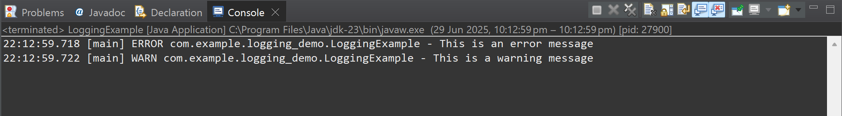

**Conclusion:**

This exercise demonstrated how to implement structured logging in Java using SLF4J with Logback.  
By replacing print statements with proper logging levels like error() and warn(), we gain better control, readability, and professionalism in our application's output.  
This approach is essential for debugging, monitoring, and maintaining production-level Java applications.

**-- THE END --**