**Week-7**

**React**

**Exercise 1: Create Cricket App**

**Folder Structure:**

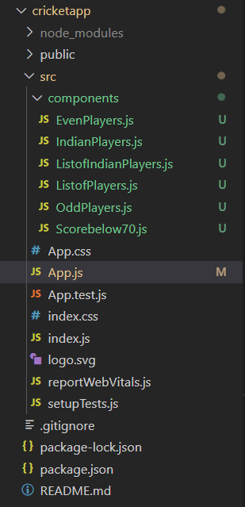

**App.js**

// App.js

import ListofPlayers from './components/ListofPlayers';

import Scorebelow70 from './components/Scorebelow70';

import { IndianPlayers } from './components/IndianPlayers';

import { OddPlayers } from './components/OddPlayers';

import { EvenPlayers } from './components/EvenPlayers';

import ListofIndianPlayers from './components/ListofIndianPlayers';

function App() {

const flag = false;

const players = [

{ name: 'Jack', score: 50 },

{ name: 'Michael', score: 70 },

{ name: 'John', score: 40 },

{ name: 'Ann', score: 61 },

{ name: 'Elisabeth', score: 61 },

{ name: 'Sachin', score: 95 },

{ name: 'Dhoni', score: 100 },

{ name: 'Virat', score: 84 },

{ name: 'Jadeja', score: 64 },

{ name: 'Raina', score: 75 },

{ name: 'Rohit', score: 80 },

];

const IndianTeam = ['Sachin1', 'Dhoni2', 'Virat3', 'Rohit4', 'Yuvaraj5', 'Raina6'];

if (flag) {

return (

<div className="App">

<h1>List of Players</h1>

<ListofPlayers players={players} />

<hr />

<h1>List of Players having Scores Less than 70</h1>

<Scorebelow70 players={players} />

</div>

);

} else {

return (

<div className="App">

<h1>Indian Team</h1>

<hr />

<h2>Odd Players</h2>

<OddPlayers players={IndianTeam} />

<hr />

<h2>Even Players</h2>

<EvenPlayers players={IndianTeam} />

<hr />

<h2>List of Indian Players Merged:</h2>

<ListofIndianPlayers players={IndianPlayers} />

</div>

);

}

}

export default App;

**ListofPlayers.js:**

function ListofPlayers({ players }) {

  return (

    <div>

      <ul>

        {players.map((player) => (

          <li key={player.name}>

            Mr. {player.name} <span>{player.score}</span>

          </li>

        ))}

      </ul>

    </div>

  );

}

export default ListofPlayers;

**Scorebelow70.js:**

function Scorebelow70({ players }) {

  const playersBelow70 = players.filter((player) => player.score <= 70);

  return (

    <div>

      <ul>

        {playersBelow70.map((player) => (

          <li key={player.name}>

            Mr. {player.name} <span>{player.score}</span>

          </li>

        ))}

      </ul>

    </div>

  );

}

export default Scorebelow70;

**IndianPlayers.js:**

const T20Players = ['First Player', 'Second Player', 'Third Player'];

const RanjiTrophyPlayers = ['Fourth Player', 'Fifth Player', 'Sixth Player'];

export const IndianPlayers = [...T20Players, ...RanjiTrophyPlayers];

**OddPlayers.js:**

export function OddPlayers({ players: [first, , third, , fifth] }) {

  return (

    <div>

      <ul>

        <li>First : {first}</li>

        <li>Third : {third}</li>

        <li>Fifth : {fifth}</li>

      </ul>

    </div>

  );

}

**EvenPlayers.js:**

export function EvenPlayers({ players: [, second, , fourth, , sixth] }) {

  return (

    <div>

      <ul>

        <li>Second : {second}</li>

        <li>Fourth : {fourth}</li>

        <li>Sixth : {sixth}</li>

      </ul>

    </div>

  );

}

**ListofIndianPlayers.js:**

function ListofIndianPlayers({ players }) {

  return (

    <div>

      <ul>

        {players.map((player) => (

          <li key={player}>Mr. {player}</li>

        ))}

      </ul>

    </div>

  );

}

export default ListofIndianPlayers;

**Output:**

When flag is false:

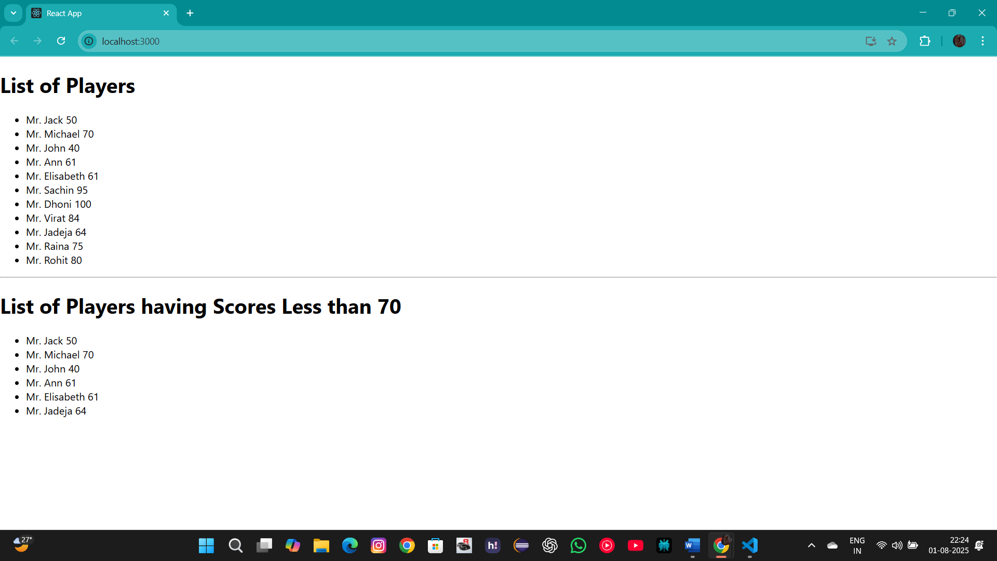

When flag is true: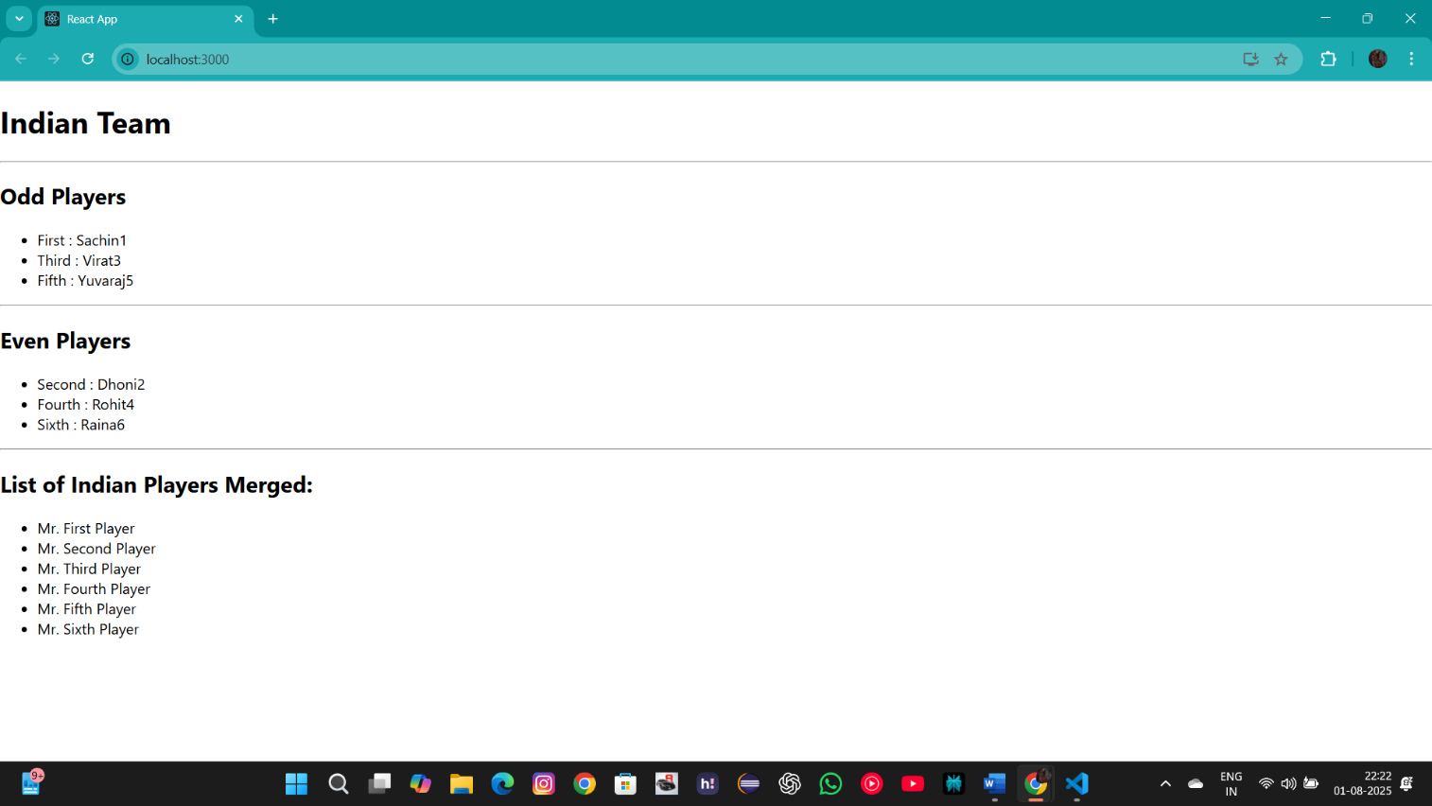

**Exercise 2: Office Space Rental App**

**Folder Structure:**

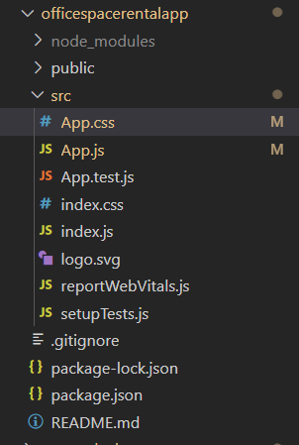

**App.js**

// App.js

import React from 'react';

import './App.css';

function App() {

  const heading = "Office Space";

  const imageUrl = "https://images.unsplash.com/photo-1556761175-5973dc0f32e7?w=500";

  const image = <img src={imageUrl} width="25%" height="25%" alt="Modern Office Space" />;

  const officeList = [

    { Name: 'DBS', Rent: 50000, Address: 'Chennai' },

    { Name: 'WeWork', Rent: 75000, Address: 'Bengaluru' },

    { Name: 'Regus', Rent: 80000, Address: 'Mumbai' },

    { Name: 'Cowrks', Rent: 55000, Address: 'Hyderabad' },

  ];

  return (

    <div className="App">

      <h1>{heading}, at Affordable Range</h1>

      {image}

      {officeList.map((office) => (

        <div key={office.Name} className="office-item">

          <h2>Name: {office.Name}</h2>

          <h3 className={office.Rent <= 60000 ? 'textRed' : 'textGreen'}>

            Rent: Rs. {office.Rent}

          </h3>

          <h3>Address: {office.Address}</h3>

        </div>

      ))}

    </div>

  );

}

export default App;

**App.css**

// App.css

.App {

  text-align: center;

  font-family: sans-serif;

}

.office-item {

  border: 1px solid #ccc;

  border-radius: 8px;

  padding: 15px;

  margin: 15px auto;

  max-width: 400px;

  box-shadow: 0 2px 4px rgba(0, 0, 0, 0.1);

}

.textRed {

  color: red;

}

.textGreen {

  color: green;

}

**Output:**

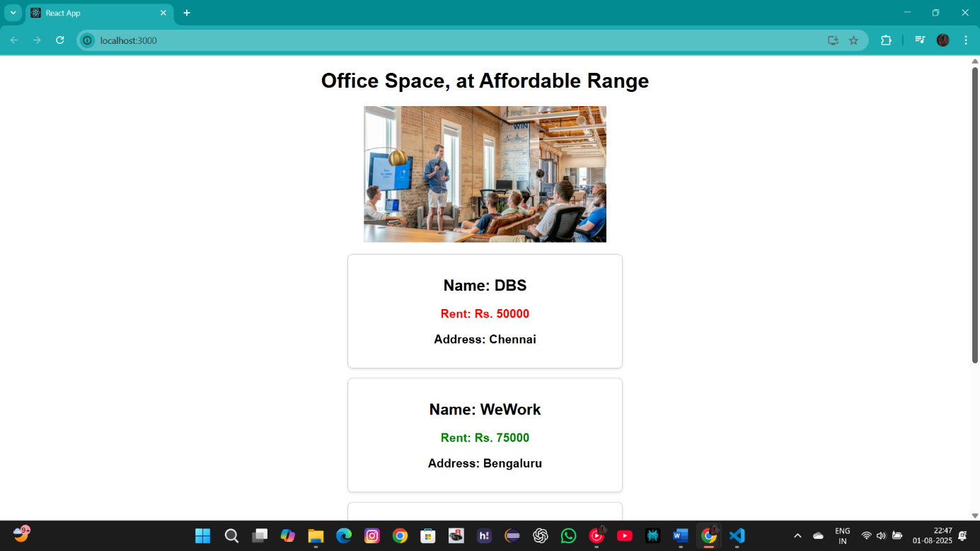

**Exercise 3: Event Example App**

**Folder Structure:**

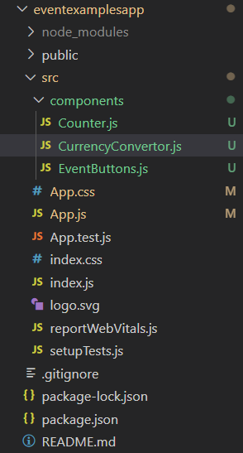

**App.js**

// App.js

import React from 'react';

import './App.css';

import Counter from './components/Counter';

import EventButtons from './components/EventButtons';

import CurrencyConvertor from './components/CurrencyConvertor';

function App() {

  return (

    <div className="container">

      <h1 className="header">Event Handling Examples</h1>

      <Counter />

      <EventButtons />

      <hr className="hr" />

      <CurrencyConvertor />

    </div>

  );

}

export default App;

**App.css:**

.container {

  font-family: Arial, sans-serif;

  text-align: center;

  padding: 20px;

  max-width: 600px;

  margin: 20px auto;

  border: 1px solid #d1d1d1;

  border-radius: 10px;

  box-shadow: 0 4px 8px rgba(0, 0, 0, 0.1);

  background-color: #f9f9f9;

}

.header {

  color: #333;

}

.section {

  margin-bottom: 25px;

  padding: 20px;

  border: 1px solid #eee;

  border-radius: 8px;

  background-color: #fff;

}

.button {

  background-color: #f0f0f0;

  border: 1px solid #ccc;

  padding: 10px 15px;

  margin: 5px;

  cursor: pointer;

  border-radius: 4px;

  font-size: 14px;

  transition: background-color 0.3s, box-shadow 0.3s;

}

.button:hover {

  background-color: #e0e0e0;

  box-shadow: 0 2px 4px rgba(0,0,0,0.1);

}

.hr {

  border: none;

  border-top: 1px solid #ddd;

  margin: 30px 0;

}

.formGroup {

  margin-bottom: 15px;

  text-align: left;

}

.label {

  display: block;

  margin-bottom: 5px;

  font-weight: bold;

  color: #555;

}

.input {

  width: calc(100% - 22px);

  padding: 10px;

  border: 1px solid #ccc;

  border-radius: 4px;

  font-size: 14px;

}

.currency-header {

  color: #006400;

}

**Counter.js:**

import React, { useState } from 'react';

function Counter() {

  const [count, setCount] = useState(0);

  const increment = () => {

    setCount(prevCount => prevCount + 1);

  };

  const decrement = () => {

    setCount(prevCount => prevCount - 1);

  };

  const sayHello = () => {

    alert('Hello! Member1');

  };

  const handleIncrementClick = () => {

    increment();

    sayHello();

  };

  return (

    <div className="section">

      <h2>Counter: {count}</h2>

      <button className="button" onClick={handleIncrementClick}>Increment</button>

      <button className="button" onClick={decrement}>Decrement</button>

    </div>

  );

}

export default Counter;

**EventButtons.js:**

import React from 'react';

function EventButtons() {

  const sayMessage = (message) => {

    alert(message);

  };

  const handlePress = (event) => {

    alert('I was clicked');

  };

  return (

    <div className="section">

      <button className="button" onClick={() => sayMessage('welcome')}>Say Welcome</button>

      <button className="button" onClick={handlePress}>Click on me (OnPress)</button>

    </div>

  );

}

export default EventButtons;

**CurrencyConvertor.js:**

import React, { useState } from 'react';

function CurrencyConvertor() {

  const [rupees, setRupees] = useState('');

  const [currencyType, setCurrencyType] = useState('Euro');

  const handleSubmit = (event) => {

    event.preventDefault();

    if (!rupees || isNaN(rupees)) {

      alert('Please enter a valid number for the amount.');

      return;

    }

    const conversionRate = 90;

    const convertedAmount = (parseFloat(rupees) / conversionRate).toFixed(2);

    alert(`Converting to Euro Amount is ${convertedAmount}`);

  };

  return (

    <div className="section">

      <h2 className="header currency-header">Currency Convertor!!!</h2>

      <form onSubmit={handleSubmit}>

        <div className="formGroup">

          <label className="label">Amount (INR):</label>

          <input

            type="text"

            value={rupees}

            onChange={(e) => setRupees(e.target.value)}

            className="input"

            placeholder="e.g., 5000"

          />

        </div>

        <div className="formGroup">

          <label className="label">Currency:</label>

          <input

            type="text"

            value={currencyType}

            onChange={(e) => setCurrencyType(e.target.value)}

            className="input"

            placeholder="e.g., Euro"

          />

        </div>

        <button type="submit" className="button">Convert</button>

      </form>

    </div>

  );

}

export default CurrencyConvertor;

**Output:**

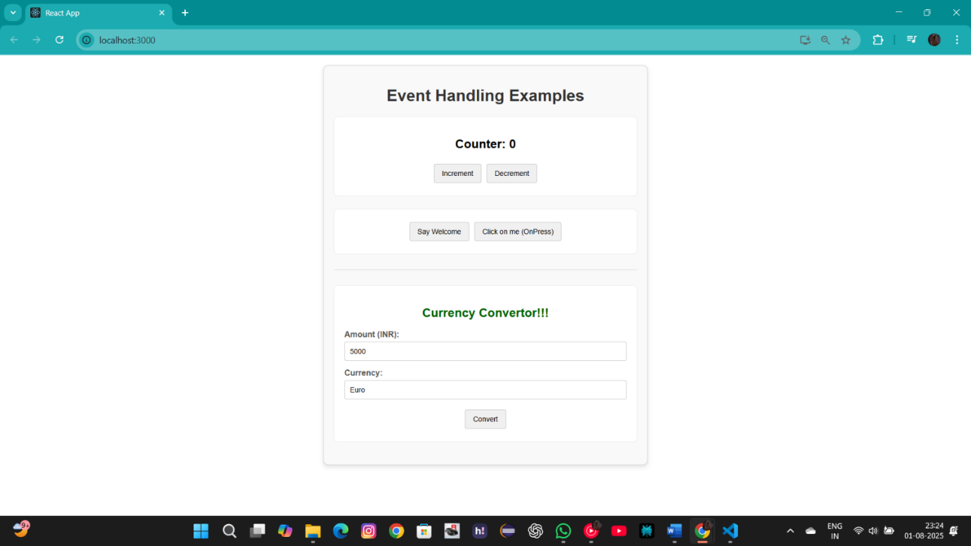

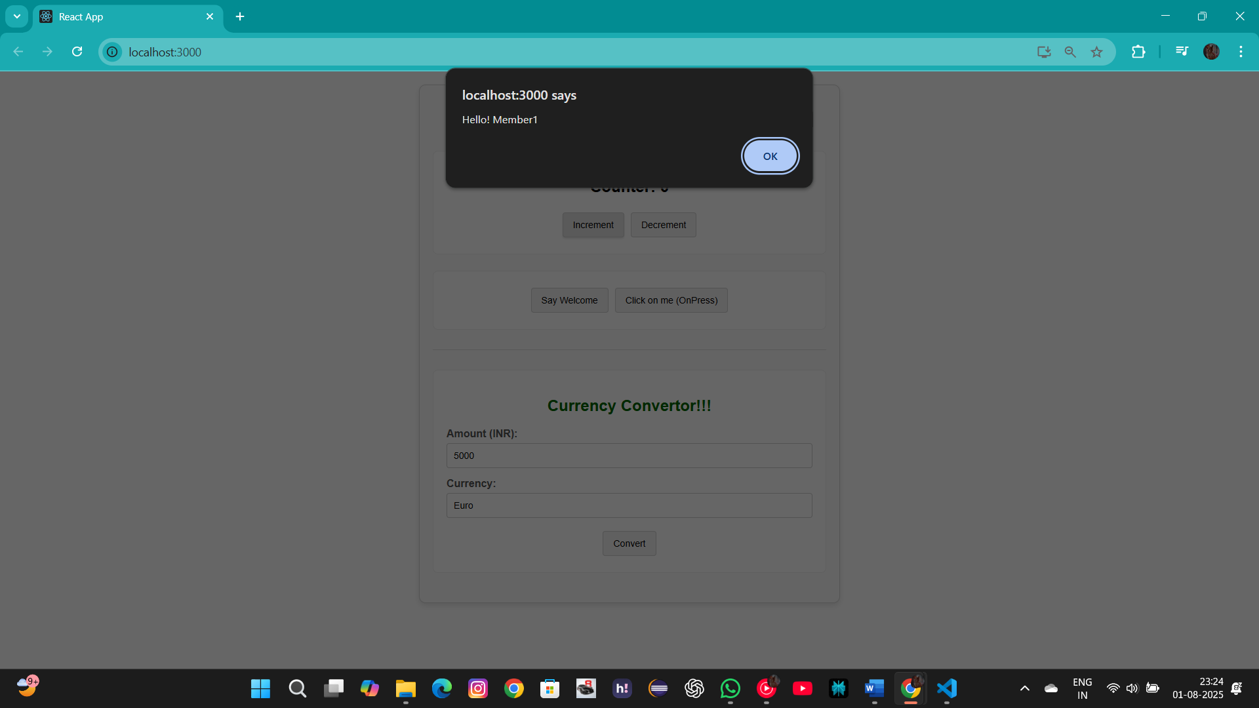

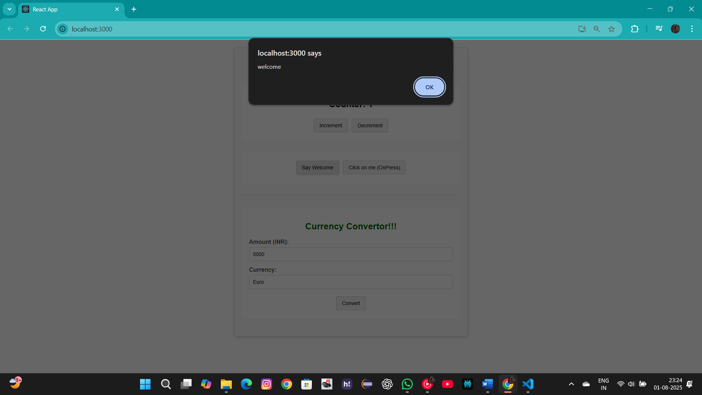

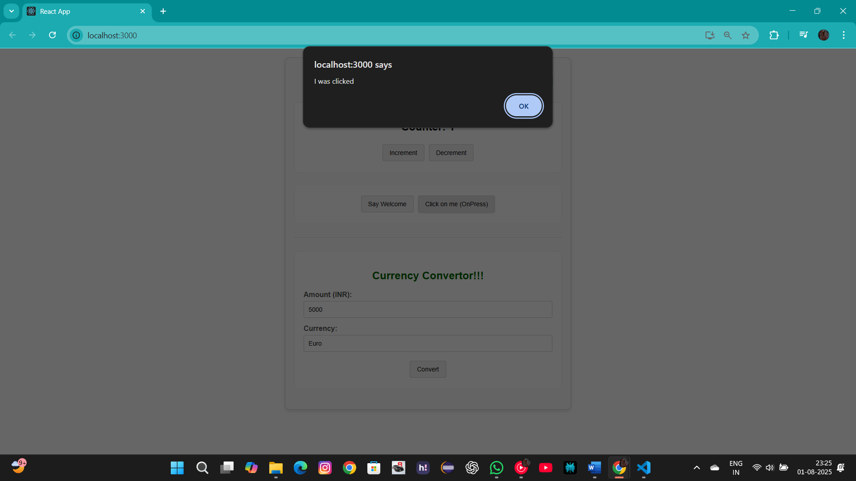

**Exercise 4: Ticket Booking App**

**Folder Structure:**

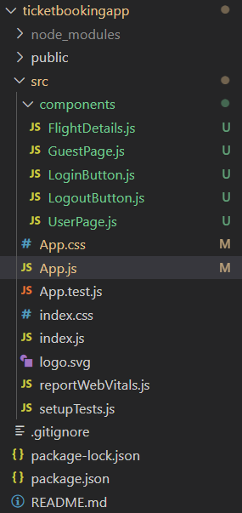

**App.js**

// App.js

import React, { useState } from 'react';

import './App.css';

import UserPage from './components/UserPage';

import GuestPage from './components/GuestPage';

import LoginButton from './components/LoginButton';

import LogoutButton from './components/LogoutButton';

function App() {

  const [isLoggedIn, setIsLoggedIn] = useState(false);

  const handleLoginClick = () => {

    setIsLoggedIn(true);

  };

  const handleLogoutClick = () => {

    setIsLoggedIn(false);

  };

  let button;

  let page;

  if (isLoggedIn) {

    button = <LogoutButton onClick={handleLogoutClick} />;

    page = <UserPage />;

  } else {

    button = <LoginButton onClick={handleLoginClick} />;

    page = <GuestPage />;

  }

  return (

    <div className="container">

      <div className="header">

        <h1 className="appName">FlightBook</h1>

        {button}

      </div>

      {page}

    </div>

  );

}

export default App;

**App.css:**

.container {

  font-family: Arial, sans-serif;

  max-width: 800px;

  margin: 0 auto;

  padding: 20px;

  background-color: #f4f7f6;

  border-radius: 8px;

  box-shadow: 0 4px 8px rgba(0,0,0,0.1);

}

.header {

  display: flex;

  justify-content: space-between;

  align-items: center;

  border-bottom: 2px solid #ddd;

  padding-bottom: 10px;

  margin-bottom: 20px;

}

.appName {

  color: #333;

}

.pageContainer {

  text-align: center;

}

.title {

  color: #0056b3;

}

.subtitle {

  color: #555;

  font-size: 1.1em;

}

.button {

  padding: 10px 20px;

  font-size: 16px;

  cursor: pointer;

  border: none;

  border-radius: 5px;

  background-color: #007BFF;

  color: white;

  transition: background-color 0.3s;

}

.flightList {

  margin-top: 30px;

  text-align: left;

}

.flightHeader {

  color: #333;

  border-bottom: 1px solid #eee;

  padding-bottom: 10px;

}

.flightItem {

  display: flex;

  justify-content: space-between;

  align-items: center;

  padding: 15px;

  margin: 10px 0;

  background-color: #fff;

  border-radius: 5px;

  box-shadow: 0 2px 4px rgba(0,0,0,0.05);

}

.flightPrice {

  font-weight: bold;

  color: #28a745;

}

.bookButton {

  padding: 8px 15px;

  font-size: 14px;

  cursor: pointer;

  border: none;

  border-radius: 5px;

  background-color: #28a745;

  color: white;

}

**LoginButton.js:**

import React from 'react';

function LoginButton(props) {

  return (

    <button className="button" onClick={props.onClick}>

      Login

    </button>

  );

}

export default LoginButton;

**LogoutButton.js:**

function LogoutButton(props) {

  return (

    <button className="button" onClick={props.onClick}>

      Logout

    </button>

  );

}

export default LogoutButton;

**FlightDetails.js:**

function FlightDetails({ canBook }) {

  const flights = [

    { id: 1, from: 'Delhi', to: 'Mumbai', price: '₹5,500' },

    { id: 2, from: 'Bengaluru', to: 'Chennai', price: '₹4,800' },

    { id: 3, from: 'Kolkata', to: 'Goa', price: '₹7,200' },

  ];

  return (

    <div className="flightList">

      <h2 className="flightHeader">Available Flights</h2>

      {flights.map(flight => (

        <div key={flight.id} className="flightItem">

          <span>{flight.from} → {flight.to}</span>

          <span className="flightPrice">{flight.price}</span>

          {canBook && <button className="bookButton">Book Now</button>}

        </div>

      ))}

    </div>

  );

}

export default FlightDetails;

**GuestPage.js :**

import React from 'react';

import FlightDetails from './FlightDetails';

function GuestPage(props) {

  return (

    <div className="pageContainer">

      <h1 className="title">Please sign up to book a flight.</h1>

      <p className="subtitle">Guests can browse available flights below.</p>

      <FlightDetails canBook={false} />

    </div>

  );

}

export default GuestPage;

**UserPage.js:**

import React from 'react';

import FlightDetails from './FlightDetails';

function UserPage(props) {

  return (

    <div className="pageContainer">

      <h1 className="title">Welcome back, Valued Customer!</h1>

      <p className="subtitle">You can now book your tickets.</p>

      <FlightDetails canBook={true} />

    </div>

  );

}

export default UserPage;

**Output:**

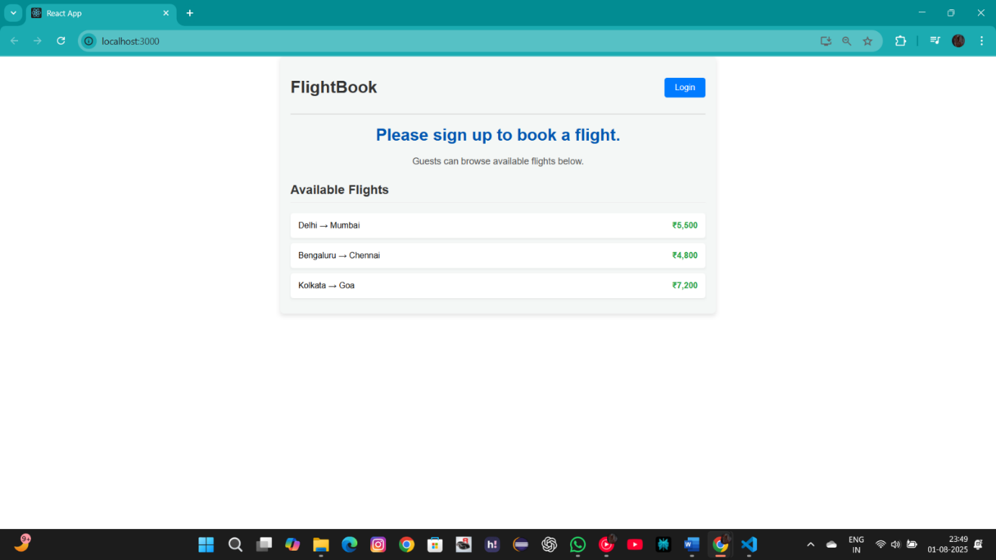



**Exercise 5: Blogger App**

**Folder Structure:**

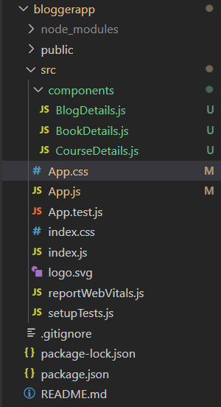

**App.js**

// App.js

import React, { useState } from 'react';

import './App.css';

import BookDetails from './components/BookDetails';

import BlogDetails from './components/BlogDetails';

import CourseDetails from './components/CourseDetails';

function App() {

  const [activeView, setActiveView] = useState('all');

  const renderViewWithIfElse = () => {

    if (activeView === 'books') {

      return <BookDetails />;

    } else if (activeView === 'blogs') {

      return <BlogDetails />;

    } else if (activeView === 'courses') {

      return <CourseDetails />;

    } else {

      return (

        <>

          <CourseDetails />

          <BookDetails />

          <BlogDetails />

        </>

      );

    }

  };

  return (

    <div className="app-container">

      <nav className="navigation">

        <button onClick={() => setActiveView('all')} className={activeView === 'all' ? 'nav-button active' : 'nav-button'}>All</button>

        <button onClick={() => setActiveView('books')} className={activeView === 'books' ? 'nav-button active' : 'nav-button'}>Books</button>

        <button onClick={() => setActiveView('blogs')} className={activeView === 'blogs' ? 'nav-button active' : 'nav-button'}>Blogs</button>

        <button onClick={() => setActiveView('courses')} className={activeView === 'courses' ? 'nav-button active' : 'nav-button'}>Courses</button>

      </nav>

      <div className="details-container">

        {renderViewWithIfElse()}

      </div>

    </div>

  );

}

export default App;

**App.css:**

body {

  font-family: Arial, sans-serif;

  background-color: #f9f9f9;

  margin: 0;

  padding: 20px;

}

.app-container {

  max-width: 1200px;

  margin: 0 auto;

}

.navigation {

  text-align: center;

  margin-bottom: 30px;

  padding: 15px;

  background-color: #fff;

  border-radius: 8px;

  box-shadow: 0 2px 5px rgba(0,0,0,0.1);

}

.nav-button {

  padding: 10px 20px;

  margin: 0 10px;

  font-size: 16px;

  cursor: pointer;

  border: 1px solid #007bff;

  background-color: #007bff;

  color: white;

  border-radius: 5px;

  transition: background-color 0.3s, color 0.3s;

}

.nav-button:hover {

  background-color: #0056b3;

}

.nav-button.active {

  background-color: #fff;

  color: #007bff;

}

.details-container {

  display: flex;

  justify-content: space-around;

  gap: 20px;

}

.details-card {

  flex: 1;

  padding: 20px;

  background-color: white;

  border-left: 5px solid #28a745;

  border-radius: 8px;

  box-shadow: 0 2px 5px rgba(0,0,0,0.1);

}

.details-card h1 {

  color: #333;

  margin-top: 0;

  border-bottom: 2px solid #eee;

  padding-bottom: 10px;

}

.item {

  margin-bottom: 15px;

}

.item h3 {

  margin: 0 0 5px 0;

  color: #0056b3;

}

.item h4, .item p {

  margin: 0;

  color: #555;

}

**BookDetails.js:**

import React from 'react';

const books = [

  { id: 101, bname: 'Master React', price: 670 },

  { id: 102, bname: 'Deep Dive into Angular 11', price: 800 },

  { id: 103, bname: 'Mongo Essentials', price: 450 },

];

function BookDetails() {

  return (

    <div className="details-card">

      <h1>Book Details</h1>

      {books.map((book) => (

        <div key={book.id} className="item">

          <h3>{book.bname}</h3>

          <h4>{book.price}</h4>

        </div>

      ))}

    </div>

  );

}

export default BookDetails;

**BlogDetails.js:**

import React from 'react';

const blogs = [

    { id: 1, title: 'React Learning', author: 'Stephen Biz', content: 'Welcome to learning React!' },

    { id: 2, title: 'Installation', author: 'Schewzdenier', content: 'You can install React from npm.' },

];

function BlogDetails() {

  return (

    <div className="details-card">

      <h1>Blog Details</h1>

      {blogs.map(blog => (

          <div key={blog.id} className="item">

              <h3>{blog.title}</h3>

              <h4>{blog.author}</h4>

              <p>{blog.content}</p>

          </div>

      ))}

    </div>

  );

}

export default BlogDetails;

**CourseDetails.js:**

import React from 'react';

const courses = [

    { id: 1, cname: 'Angular', date: '4/5/2021' },

    { id: 2, cname: 'React', date: '6/3/2021' },

];

function CourseDetails() {

  return (

    <div className="details-card">

      <h1>Course Details</h1>

      {courses.map(course => (

          <div key={course.id} className="item">

              <h3>{course.cname}</h3>

              <h4>{course.date}</h4>

          </div>

      ))}

    </div>

  );

}

export default CourseDetails;

**Output:** 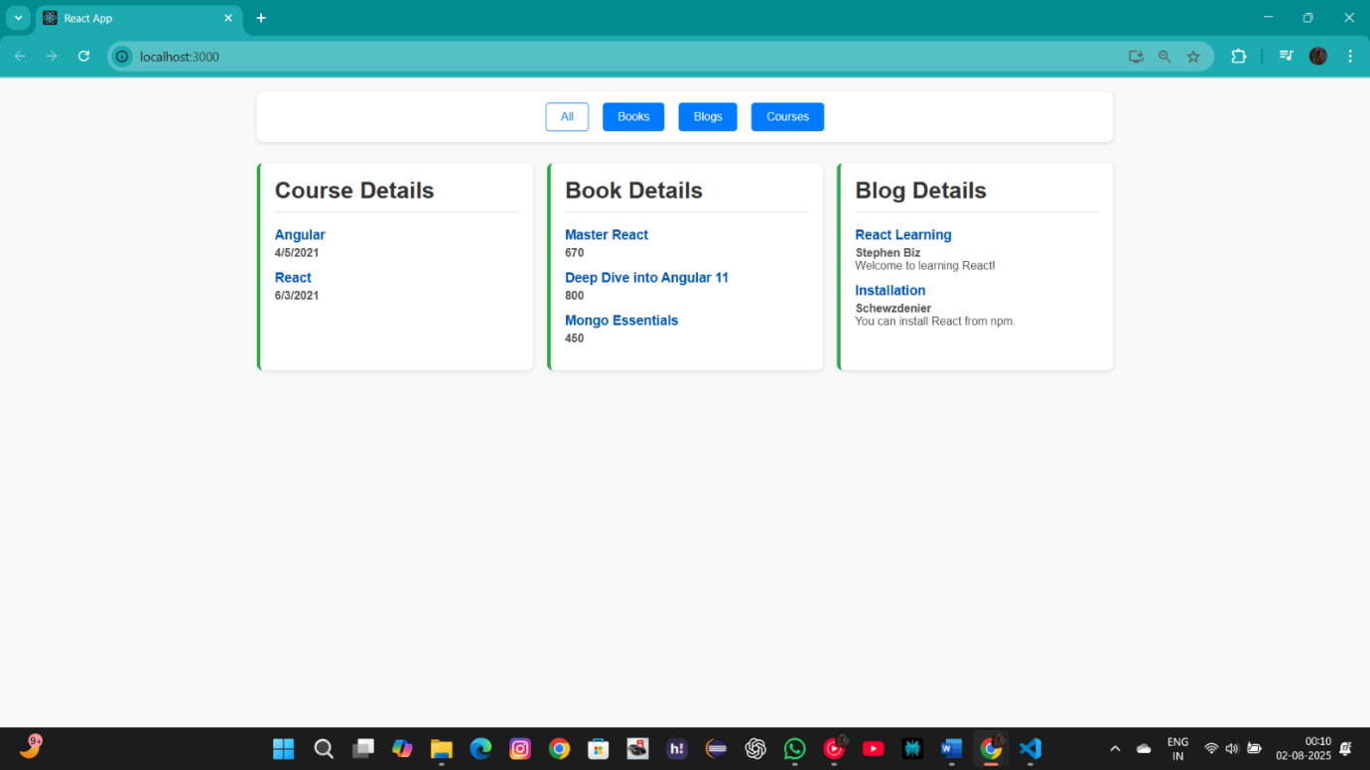

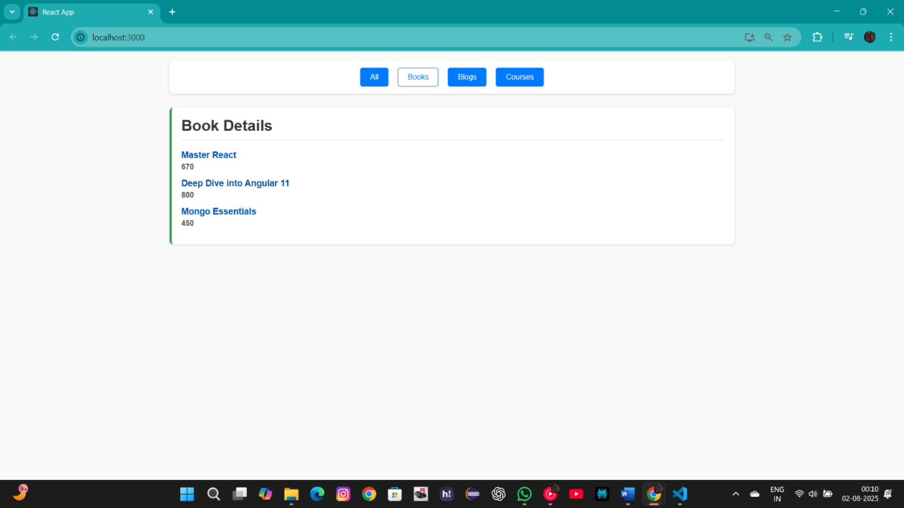

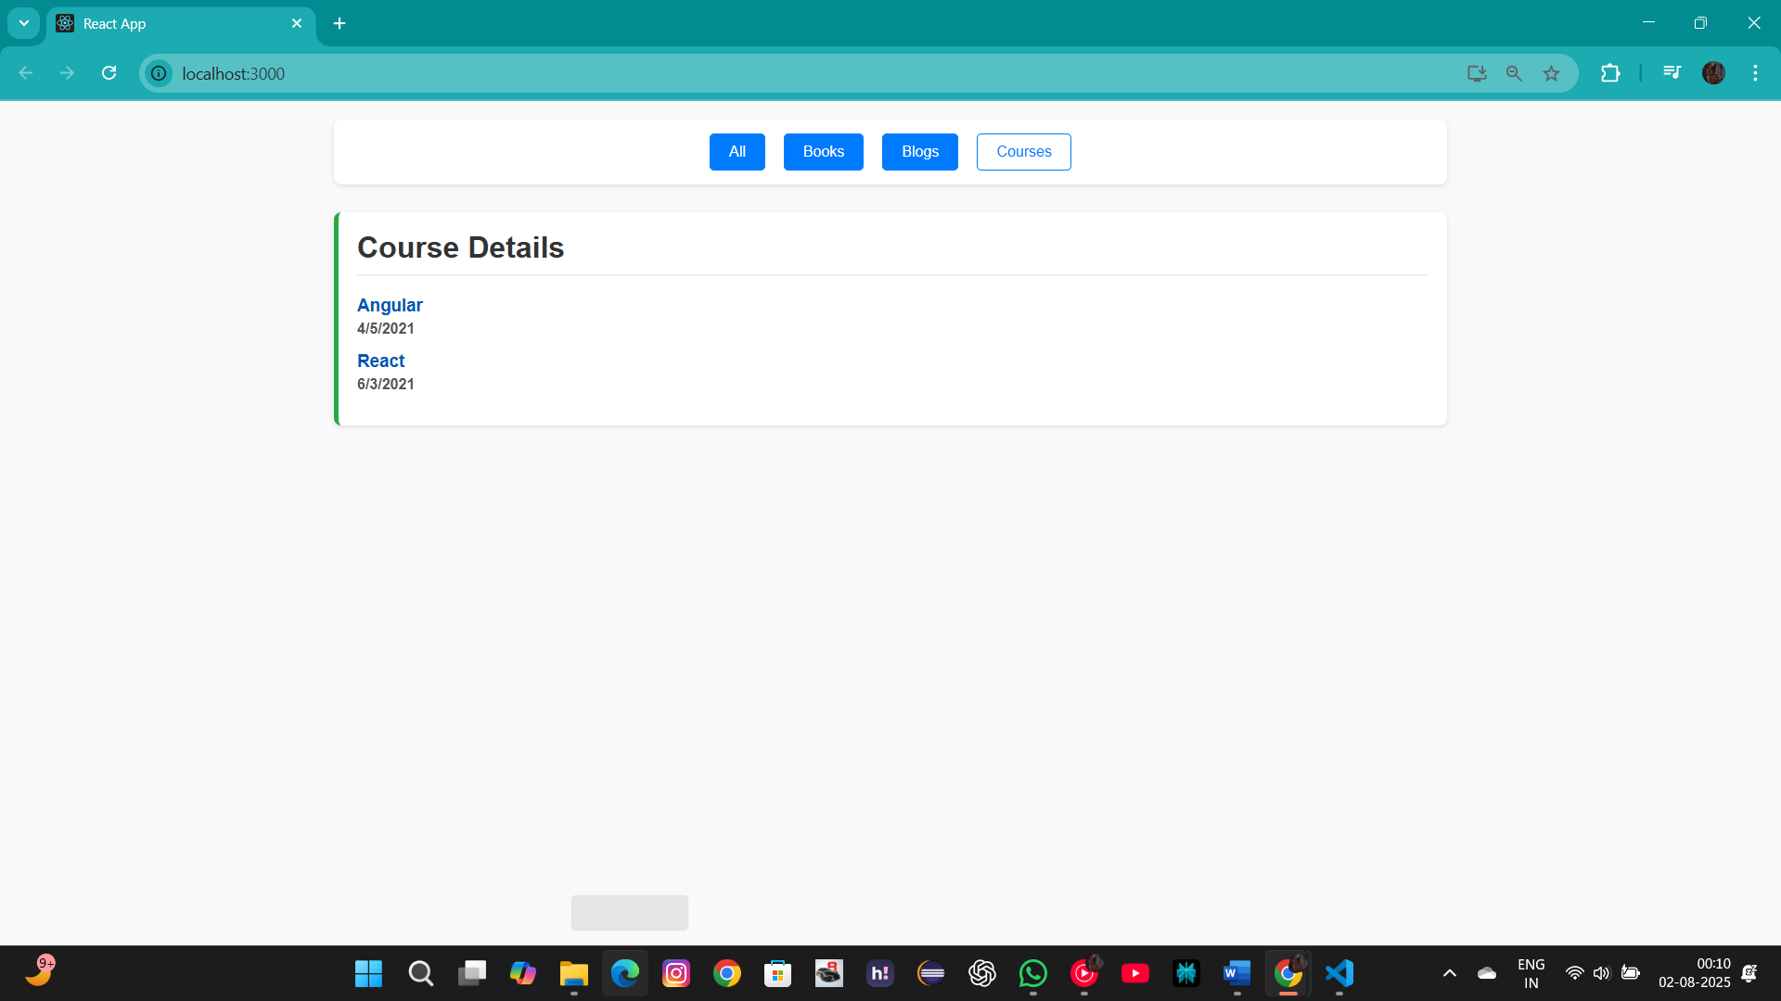

**-- THE END --**