Week 12: Creation of virtual machine for Ubuntu OS and Deploying the web application
- Evaluation of previous experiments
- Creating, running and scaling pods in minikube (eg. nginx)
- Running Nagios server and Understanding the Monitoring tool using Docker.
- Creation of virtual machine for Ubuntu OS and deploying an web server
(i.e. DEPLOYMENT of index.html using EC2 instance in AWS)
- Deploying an Maven web project application into cloud

- Creation of virtual machine
- Deploying the web application
- Accessing it publicly

Deploying an application into cloud

Steps for Deploying application into the cloud
- Create application and Push into github
- Create the virtual machine and connect to it.
- Clone the application from github, Write the Dockerfile
- Create the image
- Run the image and access it public ip of virtual machine

- Create Maven-web-java project in eclipse & push into github

- Create the virtual machine (EC2--instance) in aws and connect to
Using Amazon EC2 eliminates your need to invest in hardware up front, so you can develop and deploy applications faster.
Ex : Launch ubuntu instnace
Step 1: Login to AWS /canvas account

Step 2: Services -- EC2
Step 3: Choose region which is near ? 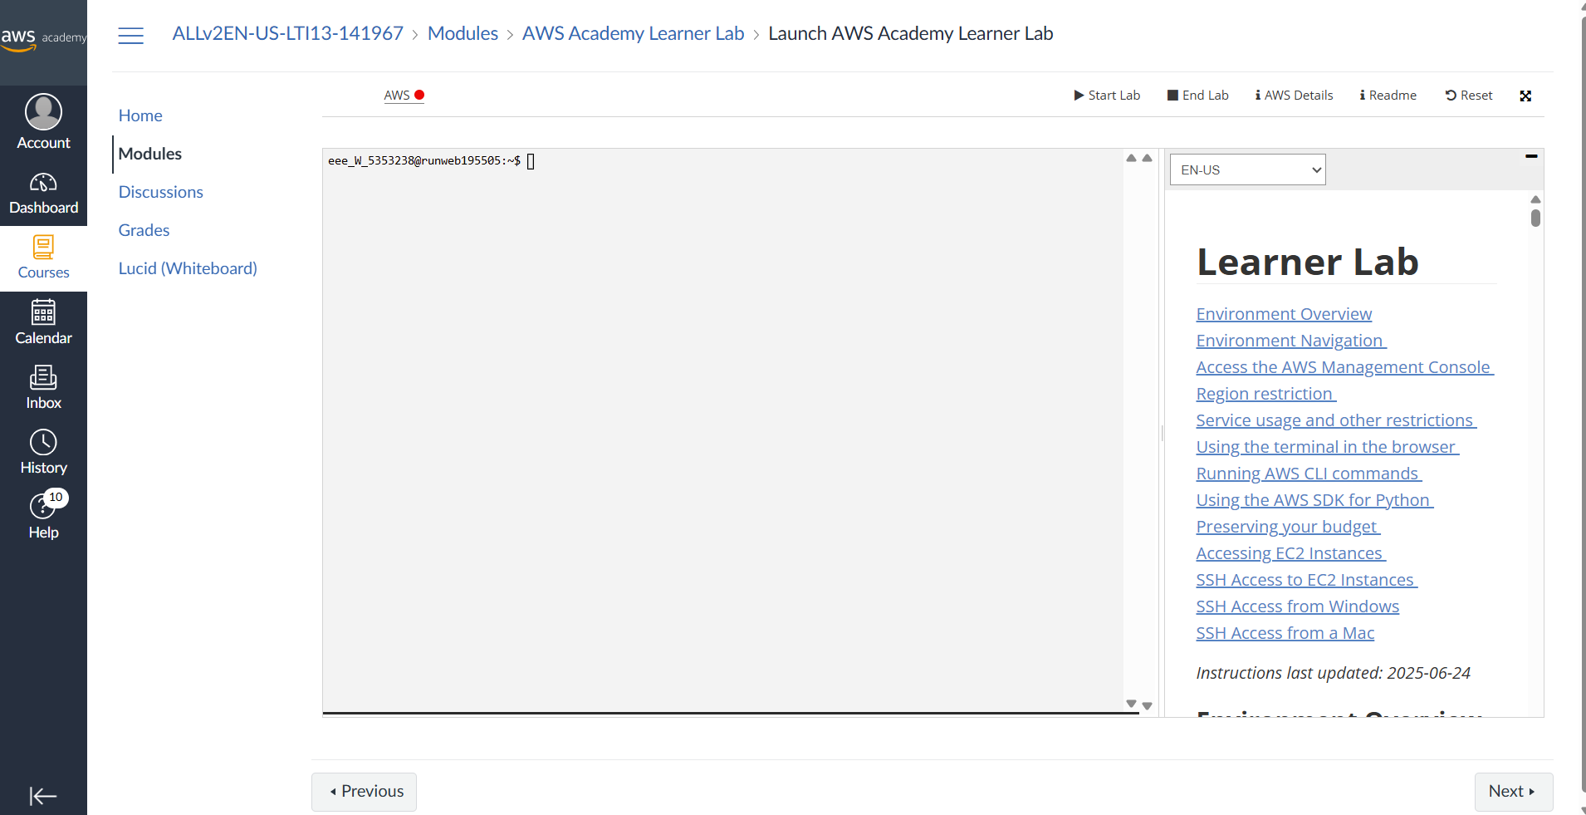
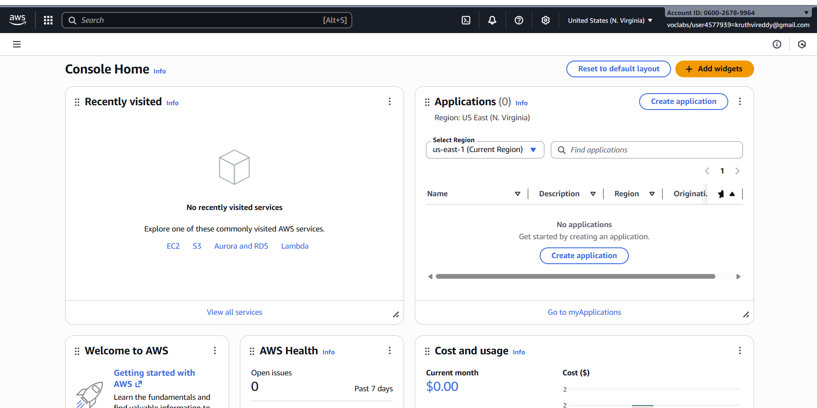 Services -- EC2 --- Launch Instance
Stage 1 --Name (Giving name to the machine) ubuntu
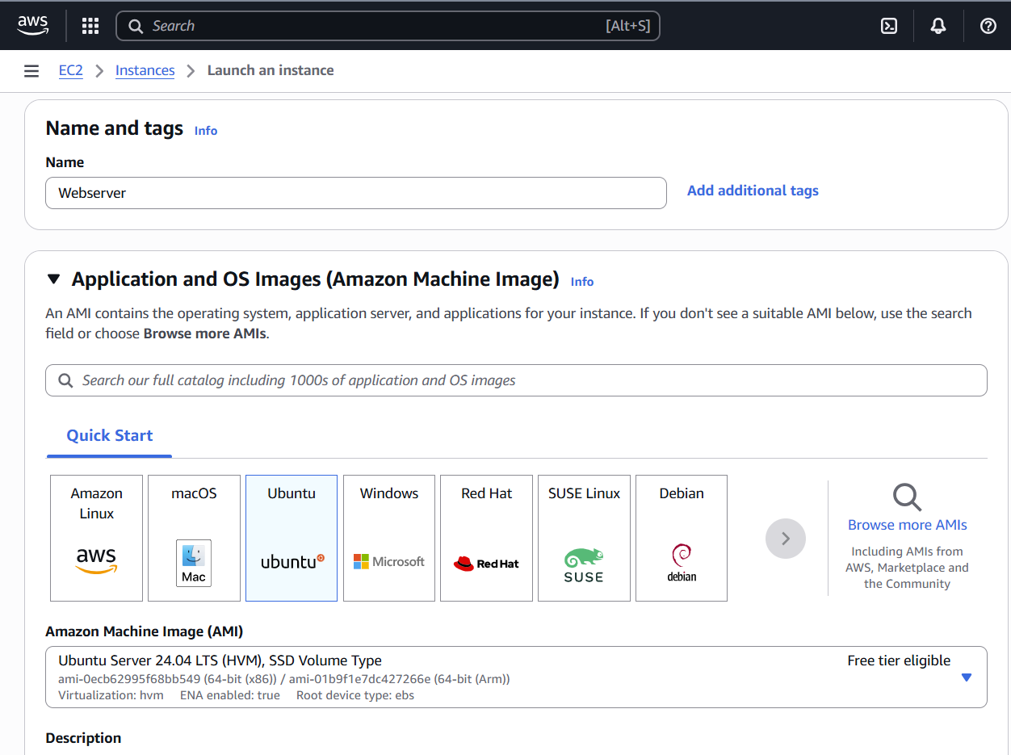
Stage 2 -- Select AMI ( Note: Select free tier eligible ) ubuntu server
Stage 3 -- Architecture as 64-bit
Stage 4 -- Instance type ---- t2.micro(default 1 CPU,1 GB RAM)
Stage 5 -- Create a new keypair---a keypair will downloaded with extension .pem
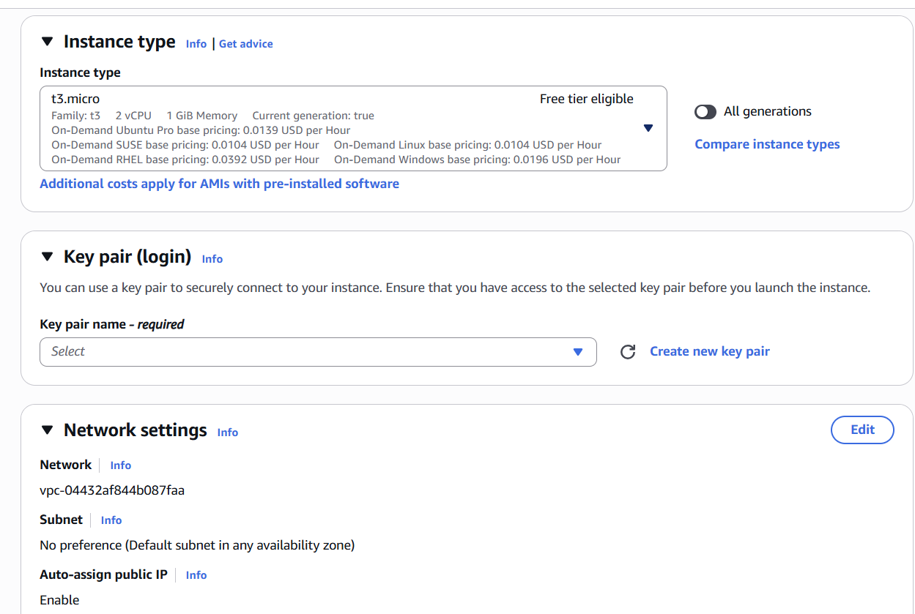
Store key in folder AWS
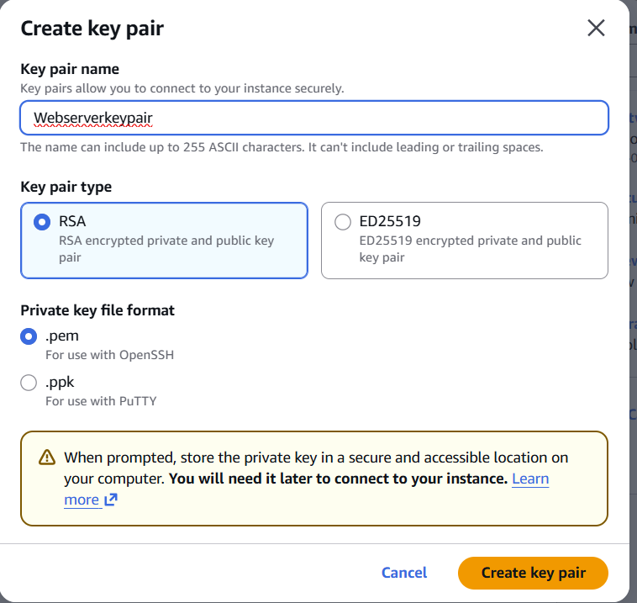
Stage 6 -- Network Setting ----Create Security group -- ( It deals with ports )
(Note for understanding We have 0 to 65535 ports. Every port is dedicated to special purpose)
Do this step : HERE select http and https
Stage 7 -- Storage - 8GB ( Observation - we have root - it is same as C Drive)
Stage 8 --- click on launch instance
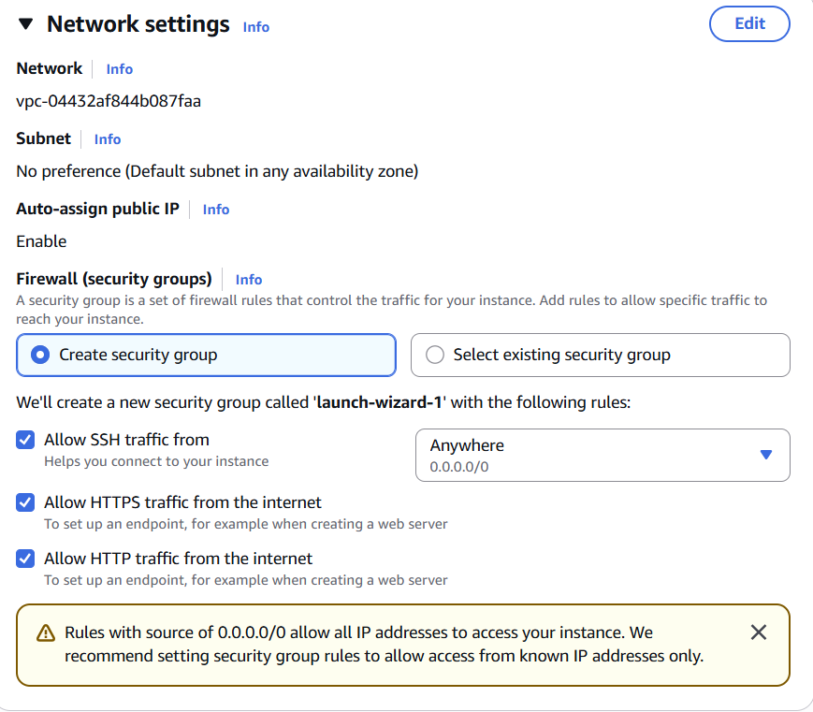
Stage 9: Number of instances ---1
+++++++++++++++++++++++++++++++
Observation - One machines created
Do this step:---once it is created select that instance and click on connect
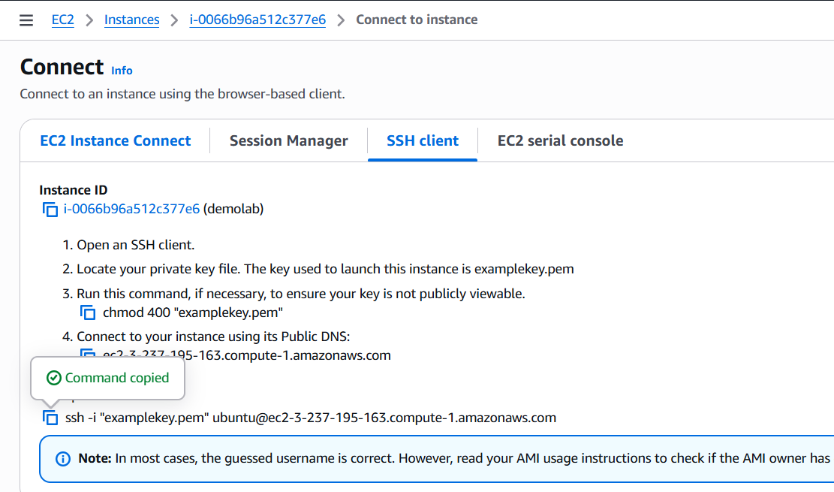
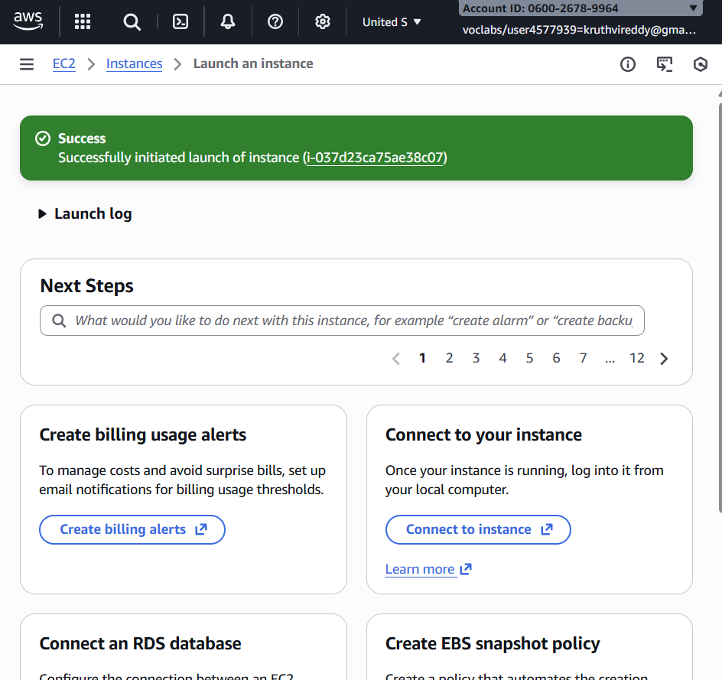
Here copy the ssh – i command from SSH client connect tab
We can use powershell /gitbash /webconsole , to connect to ubuntu machine.
NOTE:- cd path of AWS folder // change path
To connect to above terminals we need to go into the path of the keypair.and
paste the
ssh -i command from the aws console

IV .Clone the application from github, Write the Dockerfile
once connected to instance

Step 1:- install the docker
install docker ---apt-get update
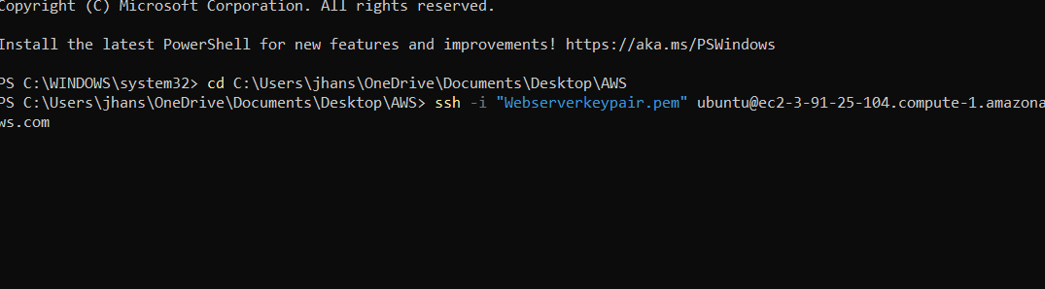
- apt-get install docker.io
- 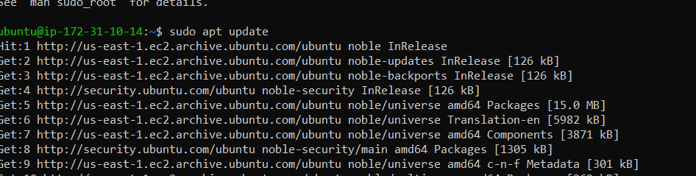

- 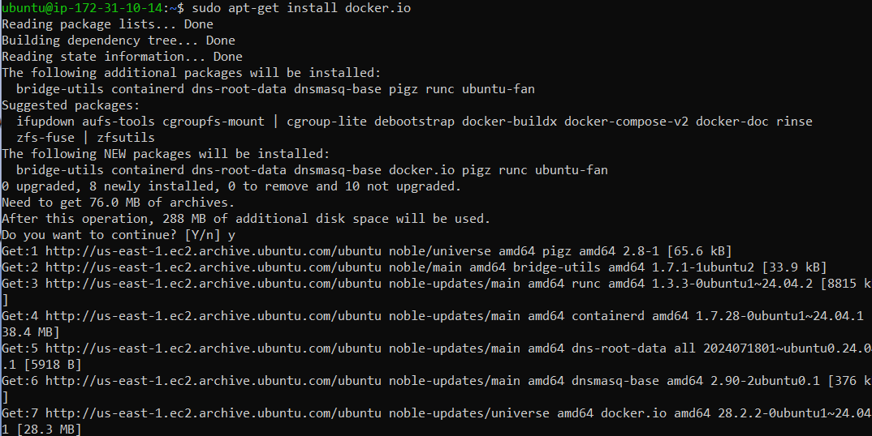
apt-get install nano
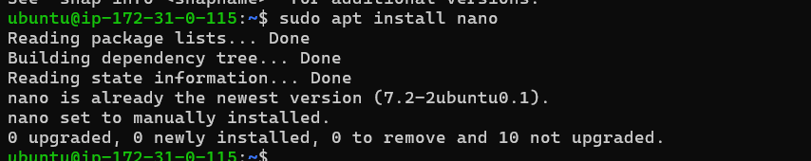

step 2:- git clone <paste the github link of maven-web-java project>
step 3:- navigate to the maven-web-java project

- Create the image

Step 4:- nano Dockerfile
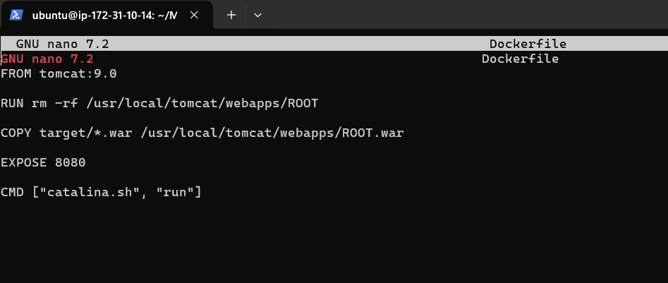

V. Run the image and access it with public ip of virtual machine

Step 1:- build your image
docker build –t <imagename> .(dot)
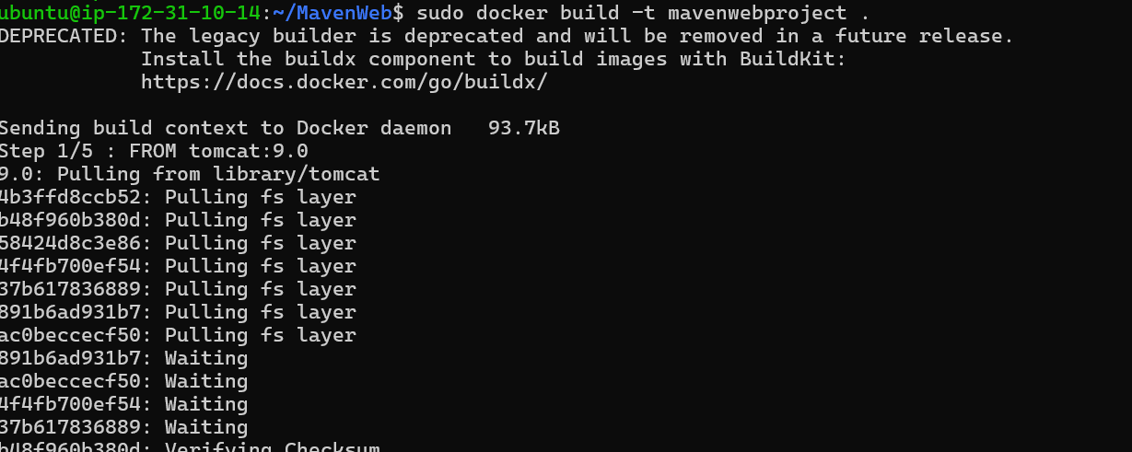
Step 2:- check for images
Step 3:- run image
docker run –d --name app-demo –p 6060:8080 <image name>

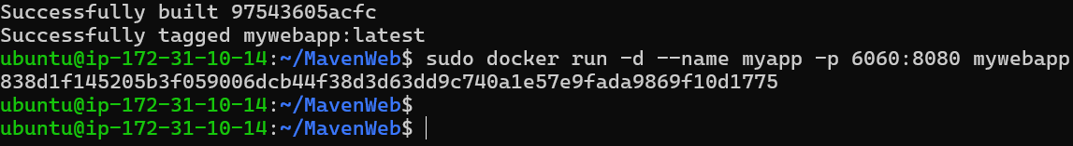

Step:-4 Accessing the app by public ip of virtual machine
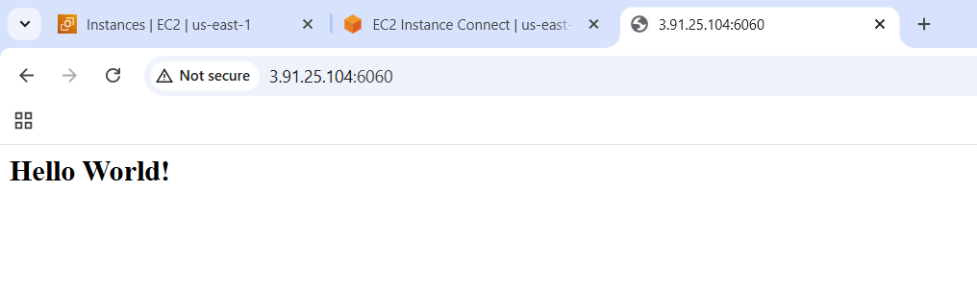
Note:-if your are not able to connect change the inbound rules..

