AIAC - Lab Assignment : 5.1 & 6
(Classes & Responsible AI)

Name : Ruthwick Reddy
Enrollment No : 2303A52484
Batch : 31

Task 1
Employee Data: Create Python code that defines a class named
Employee with the following attributes: _{empid} , _{empname} , designation , _{basic_salary} , and _{exp} . Implement a method display_details() to print all employee details. Implement another
method _{calculate_allowance()} to determine additional allowance based on experience:
If _{exp > 10 years} → allowance = 20% of basic_salary
If 5 _{≤ exp ≤ 10 years} → allowance = 10% of basic_salary
If _{exp < 5 years} → allowance = 5% of basic_salary
Finally, create at least one instance of the _{Employee} class, call the
display_details() method, and print the calculated allowance.
Code:
class

Employee
:

def
__init__
(
self
,
empid
,
empname
,
designation
,
basic_salar
y
,
exp
)
:

self
.
empid
=
empid

self
.
empname
=
empname

self
.
designation
=
designation
self.basic_salary = basic_salary self.exp = exp def calculate_salary(self): if self.exp > 10:
allowance = 0.2 * self.basic_salary elif 5<= self.exp <= 10:
allowance = 0.1 * self.basic_salary elif self.exp < 5:
allowance = 0.05 * self.basic_salary total_salary = self.basic_salary + allowance return total_salary #example usage
emp1 = Employee(101, "Alice", "Manager", 50000, 12 ) print(f"Total salary for {emp1.empname}: {emp1.calculate_sala ry()}") Output:

Task 2
Electricity Bill Calculation- Create Python code that defines a class named ElectricityBill with attributes: customer_id , name , and units_consumed . Implement a method display_details() to print
customer details, and a method calculate_bill() where:
Units ≤ 100 → ₹5 per unit
101 to 300 units → ₹7 per unit
More than 300 units → ₹10 per unit
Create a bill object, display details, and print the total bill amount.
Code:
class ElectricityBill:
def calculate_bill(self, customer_id, name, units_consume d, rate_per_unit):
self.customer_id = customer_id self.name = name self.units_consumed = units_consumed self.rate_per_unit = rate_per_unit
if self.units_consumed <= 100:
bill_amount = self.units_consumed * 5 elif 101 <= self.units_consumed <= 300:
bill_amount = (100 * 5) + ((self.units_consumed -
100) * 7) elif self.units_consumed > 300:
bill_amount = (100 * 5) + (200 * 7) + ((self.unit s_consumed - 300) * 10) return bill_amount customer1= ElectricityBill() customer1.calculate_bill(101, "Alice", 350, 0) print(f"Customer ID: {customer1.customer_id}") print(f"Customer Name: {customer1.name}") print(f"Units Consumed: {customer1.units_consumed}") print(f"Total Bill Amount: {customer1.calculate_bill(101, 'Al ice', 350, 0)}")
Output:
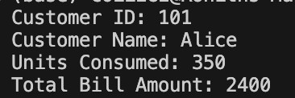

Task 3
Product Discount Calculation- Create Python code that defines a class named Product with attributes: product_id , product_name ,
price , and category . Implement a method display_details() to
print product details. Implement another method
_{calculate_discount()} where:
Electronics → 10% discount
Clothing → 15% discount
Grocery → 5% discount
Create at least one product object, display details, and print the final price after discount.
Code:
class

Product
:

def
__init__
(
self
,
product_id
,
product_name
,
price
,
categ
ory
)
:

self
.
product_id
=
product_id

self
.
name
=
product_name

self
.
price
=
price

self
.
category
=
category

def
calculate_discount
(
self
)
:

if
self
.
category
==

"Electronics"
:
return self.price * 0.90 # 10% discount elif self.category == "Clothing":
return self.price * 0.80 # 20% discount elif self.category == "Grocery": return self.price * 0.95 # 5% discount return self.price # No discount
# Creating object (outside the class) bill1 = Product(101, "Laptop", 1000, "Electronics")
discounted_price = bill1.calculate_discount() print(f"Product Name: {bill1.name}") print(f"Product ID: {bill1.product_id}") print(f"Product Category: {bill1.category}") print(f"Original Price: {bill1.price}") print(f"Price after Discount is {discounted_price}") Output:
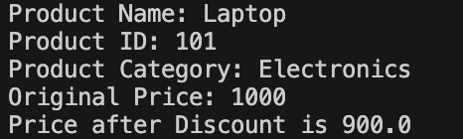

Task 4
Book Late Fee Calculation- Create Python code that defines a class named LibraryBook with attributes: book_id , title , author , _{borrower} , and _{days_late} . Implement a method display_details()
to print book details, and a method _{calculate_late_fee()} where:
Days late ≤ 5 → ₹5 per day
6 to 10 days late → ₹7 per day
More than 10 days late → ₹10 per day
Create a book object, display details, and print the late fee.
Code:
class

LibraryBook
:

def
__init__
(
self
,
book_id
,
title
,
author
,
borrower
,
days
_late
)
:

self
.
book_id
=
book_id

self
.
title
=
title

self
.
author
=
author

self
.
borrower
=
borrower

self
.
days_late
=
days_late

def
display_details
(
self
)
:

print
(
f
"Book ID: {self.book_id}"
)

print
(
f
"Title: {self.title}"
)

print
(
f
"Author: {self.author}"
)

print
(
f
"Borrower: {self.borrower}"
)

print
(
f
"Days Late: {self.days_late}"
)

def
calculate_late_fee
(
self
)
:

if
self
.
days_late
<=

5
:

return
self
.
days_late
*

5

elif self
.
days_late
<=

10
:

return
self
.
days_late
*

7

else
:

return
self
.
days_late
*

10
# Creating
object

(
outside the
class
)
book1
=

LibraryBook
(
201
,

"Python Programming"
,

"Guido van Ros
sum"
,

"Alice"
,

8
)
# Displaying details
book1
.
display_details
(
)
# Calculating and printing late fee
late_fee
=
book1
.
calculate_late_fee
(
)
print
(
f
"Late Fee: ₹{late_fee}"
)
Output:
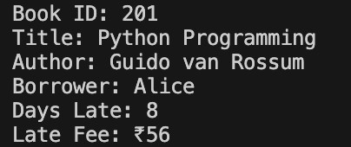
Task 5
Student Performance Report - Define a function student_report(student_data) that accepts a dictionary containing
student names and their marks. The function should:
Calculate the average score for each student
Determine pass/fail status (pass ≥ 40
Return a summary report as a list of dictionaries
Use Copilot suggestions as you build the function and format the output.
Code:
def
student_report
(
student_data
)
:

report
=

[
]

for
name
,
marks
in
student_data
.
items
(
)
:

# Handle marks given
as
list or dictionary

if

isinstance
(
marks
,
dict
)
:

scores
=
marks
.
values
(
)

else
:

scores
=
marks

average
=

sum
(
scores
)

/

len
(
scores
)

status
=

"Pass"

if
average
>=

40

else

"Fail"

report
.
append
(
{

"name"
:
name
,

"average_score"
:

round
(
average
,

2
)
,

"status"
:
status

}
)

return
report
# Example usage
students
=

{

"Alice"
:

[
45
,

50
,

40
]
,

"Bob"
:

[
30
,

35
,

38
]
,

"Charlie"
:

{
"Math"
:

60
,

"Science"
:

55
,

"English"
:

65
}
}
summary
=

student_report
(
students
)
for
student
in

summary
:

print
(
student
)
Output:
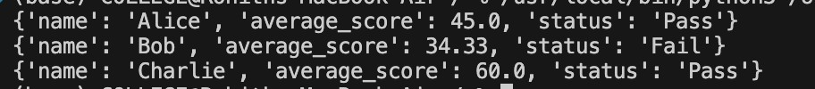
Task 6
Taxi Fare Calculation-Create Python code that defines a class named
TaxiRide with attributes: ride_id , driver_name , distance_km , and waiting_time_min . Implement a method display_details() to print ride details, and a method _{calculate_fare()} where:
₹15 per km for the first 10 km
₹12 per km for the next 20 km
₹10 per km above 30 km
Waiting charge: ₹2 per minute
Create a ride object, display details, and print the total fare.
Code:
class

TaxiRide
:

def
__init__
(
self
,
ride_id
,
driver_name
,
distance_km
,
wai
ting_time_min
)
:

self
.
ride_id
=
ride_id

self
.
driver_name
=
driver_name

self
.
distance_km
=
distance_km

self
.
waiting_time_min
=
waiting_time_min

def
display_details
(
self
)
:

print
(
f
"Ride ID: {self.ride_id}"
)

print
(
f
"Driver Name: {self.driver_name}"
)

print
(
f
"Distance Travelled: {self.distance_km} km"
)

print
(
f
"Waiting Time: {self.waiting_time_min} minute
s"
)

def
calculate_fare
(
self
)
:

fare
=

0

# Distance fare calculation

if
self
.
distance_km
<=

10
:

fare
+=
self
.
distance_km
*

15

elif self
.
distance_km
<=

30
:

fare
+=

10

*

15

fare
+=

(
self
.
distance_km
-

10
)

*

12

else
:

fare
+=

10

*

15

fare
+=

20

*

12

fare
+=

(
self
.
distance_km
-

30
)

*

10

# Waiting charge

fare
+=
self
.
waiting_time_min
*

2

return
fare
# Creating
object

(
outside the
class
)
ride1
=

TaxiRide
(
101
,

"Rahul"
,

35
,

10
)
# Displaying details
ride1
.
display_details
(
)
# Calculating and printing total fare
total_fare
=
ride1
.
calculate_fare
(
)
print
(
f
"Total Fare: ₹{total_fare}"
)
Output:
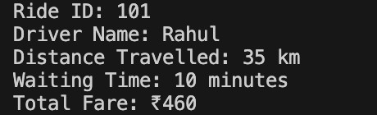
Task 7
Statistics Subject Performance - Create a Python function statistics_subject(scores_list) that accepts a list of 60 student scores
and computes key performance statistics. The function should return the following:
Highest score in the class
Lowest score in the class
Class average score
Number of students passed (score ≥ 40
Number of students failed (score < 40
Allow Copilot to assist with aggregations and logic Code:
def statistics_subject(scores_list): if len(scores_list) != 60:
print("Error: The list must contain exactly 60 studen t scores.") return None
highest_score = max(scores_list) lowest_score = min(scores_list) average_score = sum(scores_list) / len(scores_list)
passed_students = sum(1 for score in scores_list if score
>= 40) failed_students = sum(1 for score in scores_list if score
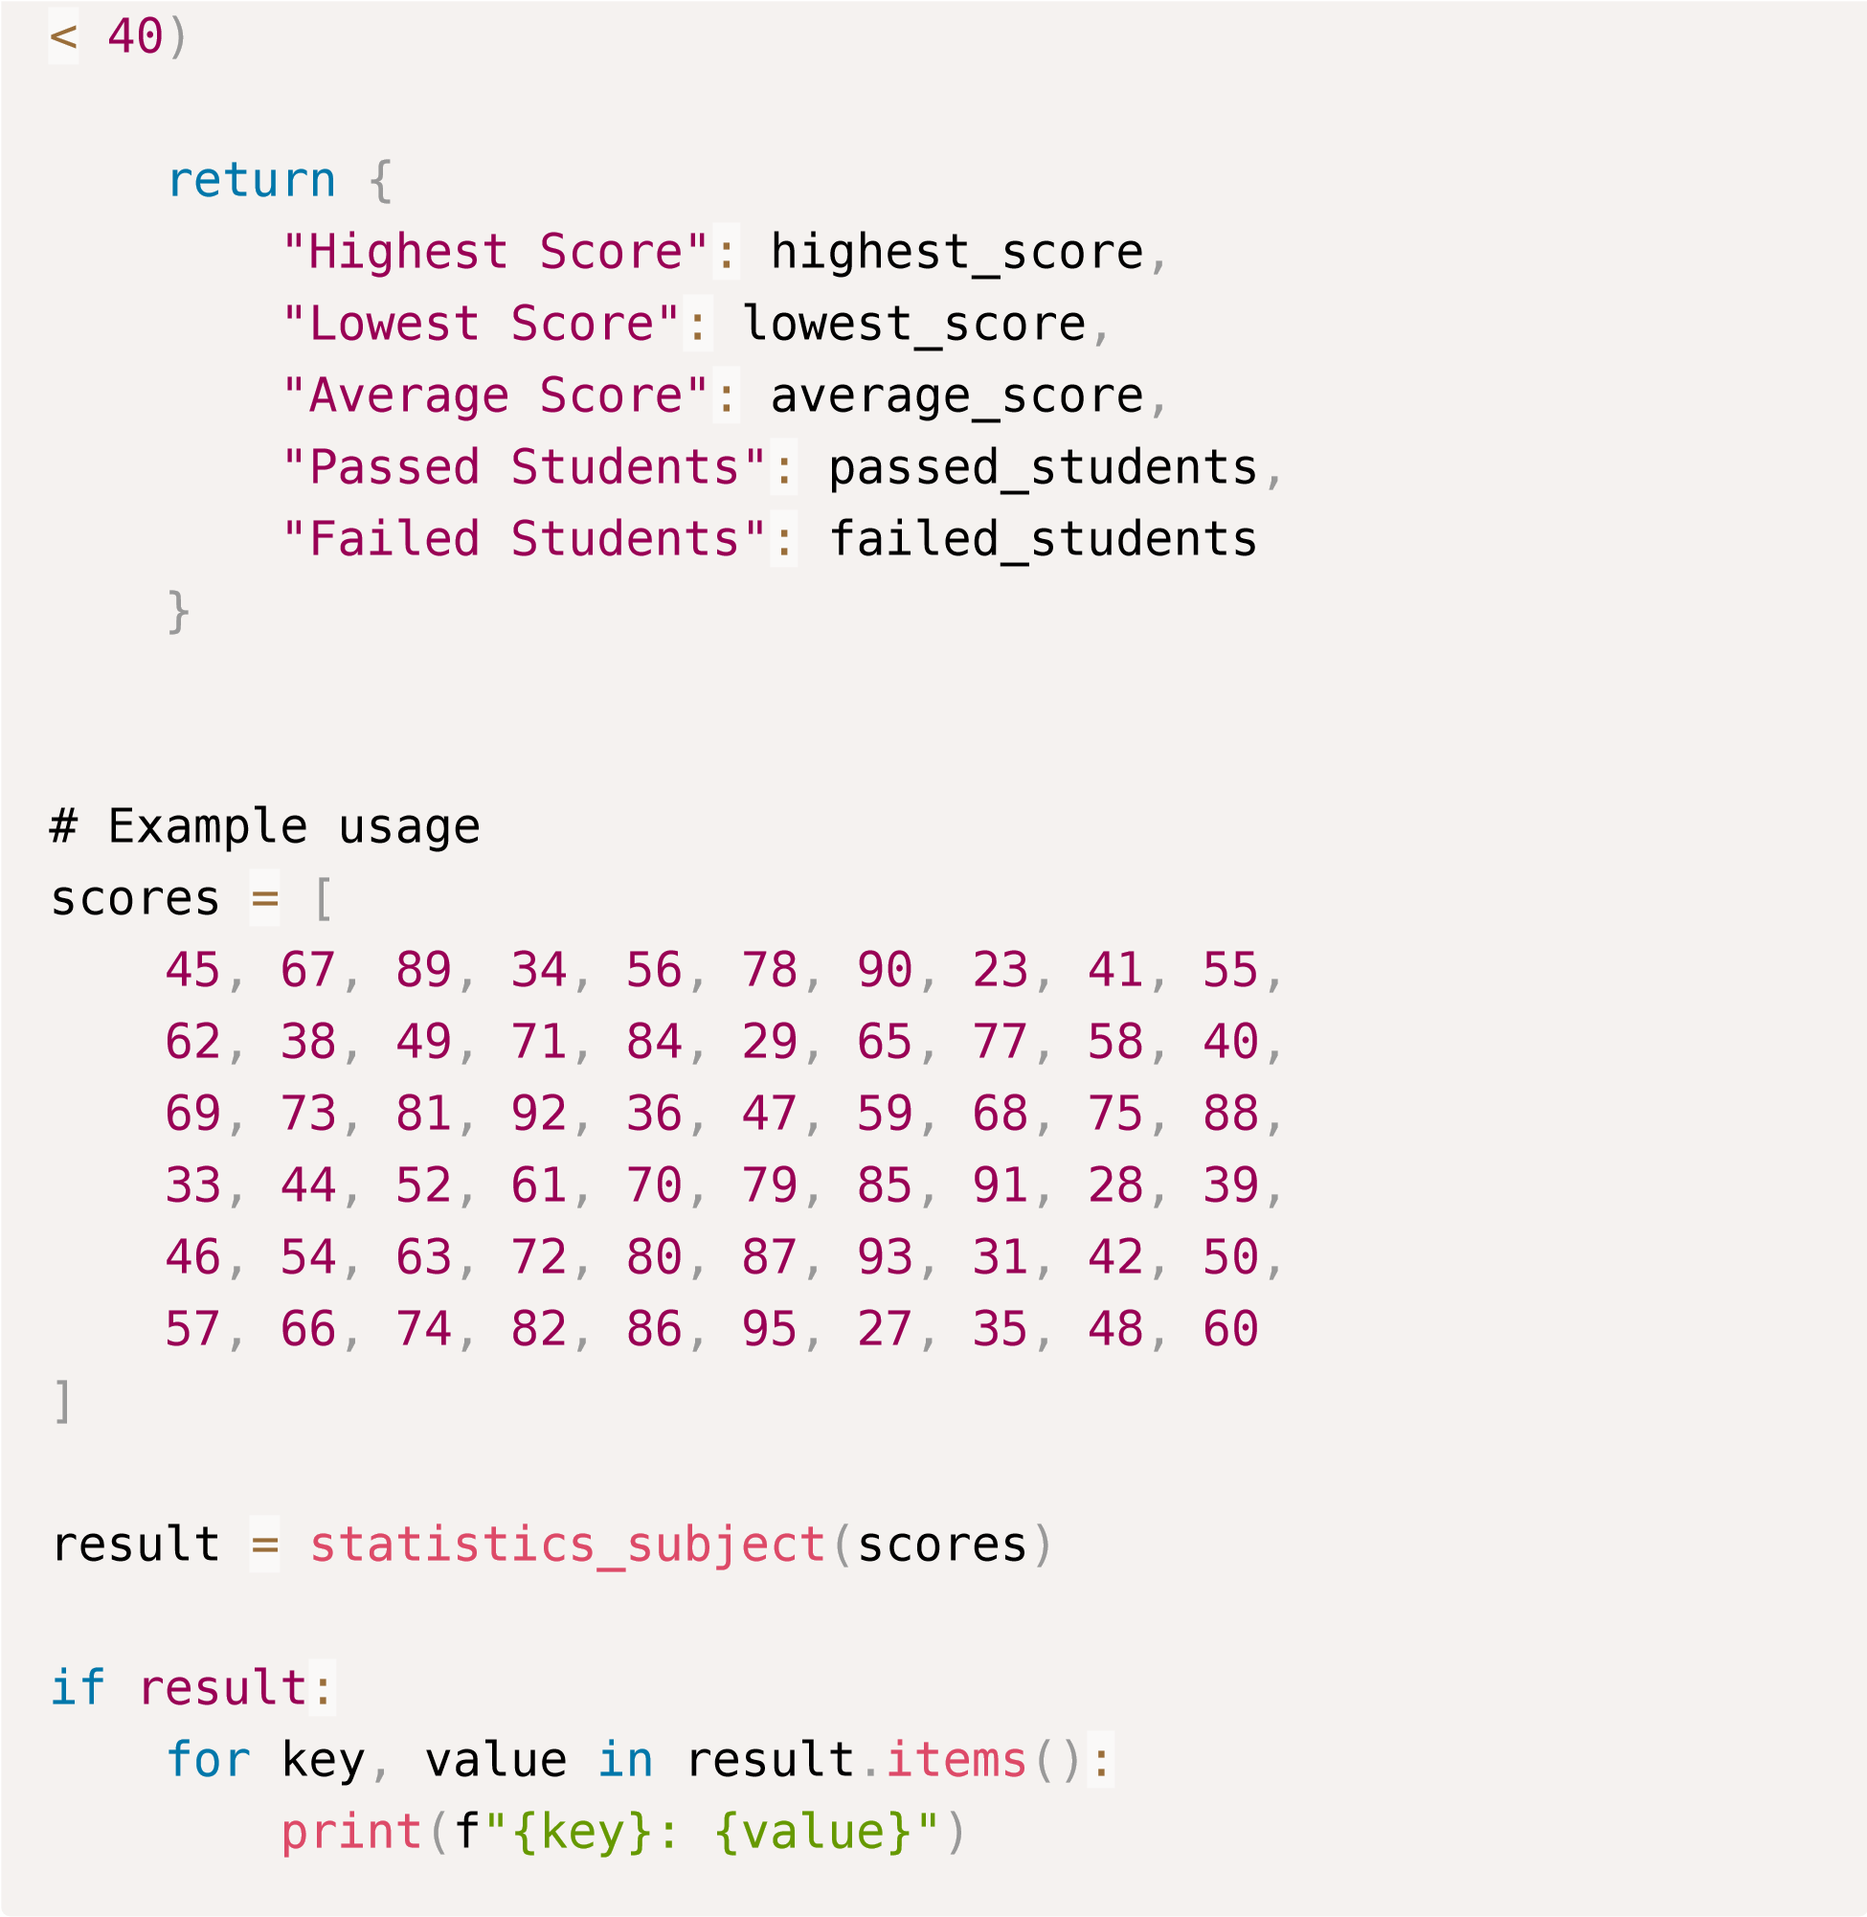
Ouput:
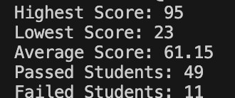
Task Description #8 Transparency in Algorithm Optimization) Task: Use AI to generate two solutions for checking prime numbers:
- Naive approach(basic) • Optimized approach Prompt:
“Generate Python code for two prime-checking methods and explain
how the optimized version improves performance.” Expected Output:
- Code for both methods.
- Transparent explanation of time complexity.
- Comparison highlighting efficiency improvements.
Code:
#Generate Python code for two prime-checking methods and expl
ain how the optimized version improves performance
def is_prime_basic(n):

"""Check if a number is prime using a basic method."""

if n <= 1:

return False

for i in range(2, n):

if n % i == 0:

return False

return True
def is_prime_optimized(n):

"""Check if a number is prime using an optimized metho
d."""

if n <= 1:

return False
if n <= 3:
return True if n % 2 == 0 or n % 3 == 0:
return False i = 5 while i * i <= n: if n % i == 0 or n % (i + 2) == 0:
return False i += 6 return True # Explanation of optimization: # The basic method checks for factors from 2 to n-1, which re sults in O(n) time complexity. # The optimized method reduces the number of checks significa ntly: # 1. It first eliminates even numbers and multiples of 3 righ t away. # 2. It only checks for factors up to the square root of n, s ince if n is divisible by any number larger than its square r oot, the corresponding factor must be smaller than the square root. # 3. It checks only numbers of the form 6k ± 1, as all prime numbers greater than 3 can be expressed in this form. # These optimizations reduce the time complexity to O(√n), ma king the optimized method much faster for larger numbers.
#example usage print(is_prime_basic(17)) # Output: True print(is_prime_optimized(17)) # Output: True
Output:
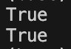

Task Description #9 Transparency in Recursive Algorithms) Objective: Use AI to generate a recursive function to calculate Fibonacci numbers. Instructions:
Ask AI to add clear comments explaining recursion.
Ask AI to explain base cases and recursive calls.
Expected Output:
- Well-commented recursive code.
- Clear explanation of how recursion works.
- Verification that explanation matches actual execution.
Code:
#generate well commented code for fibonacci series using recu
rsion and try to generate proper justification to handle test

cases also
def fibonacci(n):

"""

This function returns the nth Fibonacci number using recu
rsion.

Parameters:

n (int): The position in the Fibonacci series to retriev
e. Must be a non-negative integer.

Returns:

int: The nth Fibonacci number.

Raises:

ValueError: If n is a negative integer.

"""

# Check for invalid input

if n < 0:

raise ValueError("Input must be a non-negative intege
r.")

# Base case: the first two Fibonacci numbers

if n == 0:

return 0

elif n == 1:

return 1

# Recursive case: sum of the two preceding Fibonacci numb
ers

return fibonacci(n - 1) + fibonacci(n - 2)
# Test cases to validate the function
if __name__ == "__main__":

test_cases = [0, 1, 2, 3, 4, 5, 10, 15]

for case in test_cases:

print(f"Fibonacci({case}) = {fibonacci(case)}")

# Testing invalid input

try:

print(fibonacci(-1))

except ValueError as e:

print(e) # Expected output: Input must be a non-nega
tive integer.
Output:
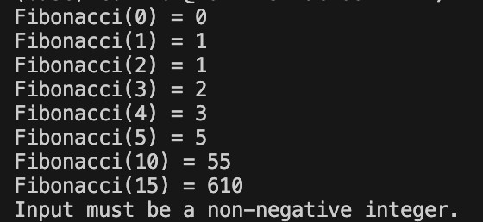

Task Description #10 Transparency in Error Handling) Task: Use AI to generate a Python program that reads a file and processes data.
Prompt:
“Generate code with proper error handling and clear explanations for each exception.”
Expected Output:
- Code with meaningful exception handling.
- Clear comments explaining each error scenario.
- Validation that explanations align with runtime behavior.
Code:
#Generate code with proper error handling and clear explanati ons for each exception class AIACError(Exception):
"""Base class for exceptions in AIAC module.""" pass class InvalidInputError(AIACError):
"""Exception raised for invalid inputs."""
def __init__(self, message="The input provided is invali
d."):
self.message = message super().__init__(self.message) class CalculationError(AIACError):
"""Exception raised for errors during calculations.""" def __init__(self, message="An error occurred during calc ulation."):
self.message = message super().__init__(self.message) class DataNotFoundError(AIACError):
"""Exception raised when required data is not found.""" def __init__(self, message="Required data not found."):
self.message = message super().__init__(self.message)
# Example function demonstrating the use of custom exceptions def perform_calculation(data): if data is None:
raise DataNotFoundError("No data provided for calcula tion.") if not isinstance(data, (int, float)):
raise InvalidInputError("Input must be a number.") try:
result = 100 / data # Example calculation except ZeroDivisionError:
raise CalculationError("Division by zero is not allow ed.") return result # Example usage try:
print(perform_calculation(0)) except AIACError as e:
print(f"Error: {e}")
Output:

