"D:\c_files4\Contamination_research\competitors\hivebotics\WO_2023075687_A2.pdf"

“
WO2023075687A2
WIPO (PCT)
Download PDF Find Prior Art Similar
Other languages
French
Inventor
Rishab PATWARI
Dung NGUYEN TUAN
Zhicheng Lin
Praveenkumar SEENIVASAN
Current Assignee
National University of Singapore

Worldwide applications
2022 WO

Application PCT/SG2022/050762 events
2022-10-25
Application filed by National University of Singapore
2023-05-04
Publication of WO2023075687A2
2023-07-13
Publication of WO2023075687A3
2024-04-29
Anticipated expiration
Status
Ceased

Info
Patent citations (5)

Cited by (1)

Legal events

Similar documents

Priority and Related Applications
External links
Espacenet
Global Dossier
PatentScope
Discuss” I don’t know why the patents says ceased…

People :
https://www.linkedin.com/in/rishab-patwari/
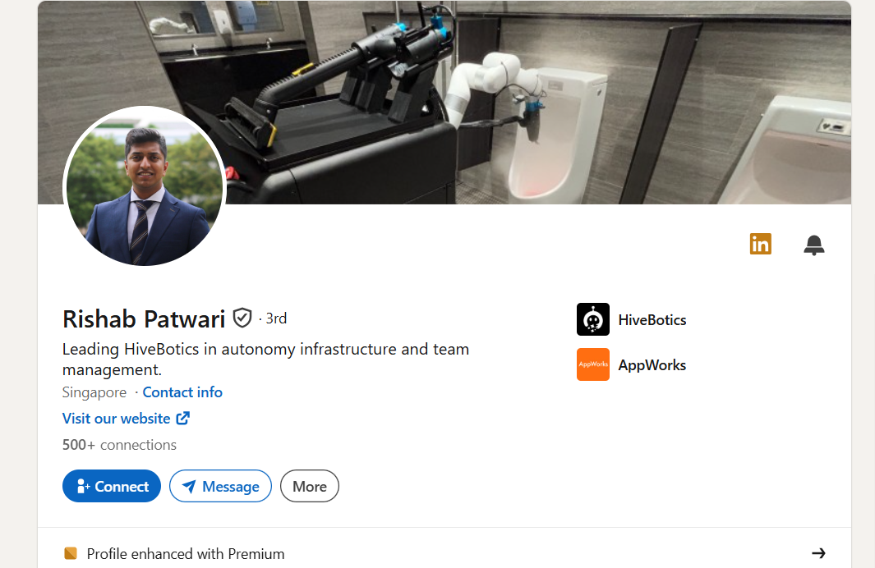

"D:\c_files4\Contamination_research\competitors\hivebotics\httpswww.linkedin.comindmitri-manajev.pdf"
https://www.linkedin.com/in/dmitri-manajev/

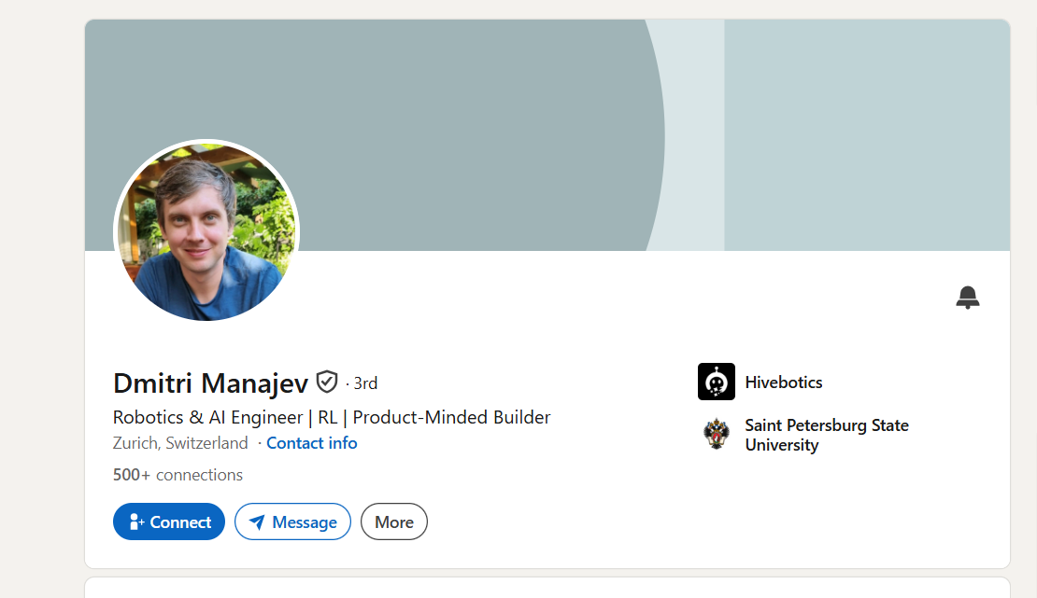

https://www.linkedin.com/in/peera-tienthong/

profile : "D:\c_files4\Contamination_research\competitors\hivebotics\httpswww.linkedin.cominpeera-tienthong.pdf"

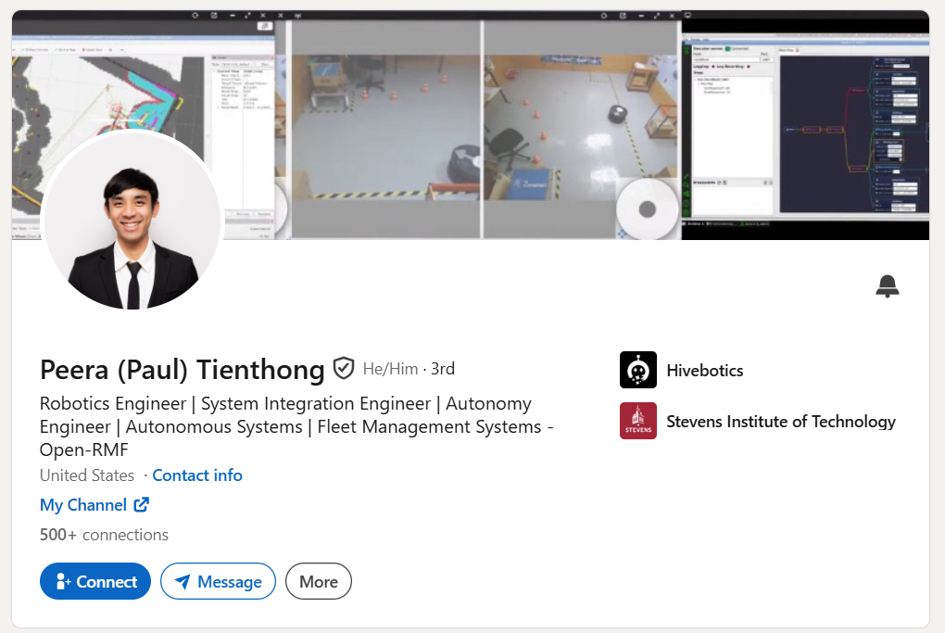


https://www.linkedin.com/in/kendrickchin/

"D:\c_files4\Contamination_research\competitors\hivebotics\httpswww.linkedin.cominkendrickchin.pdf"

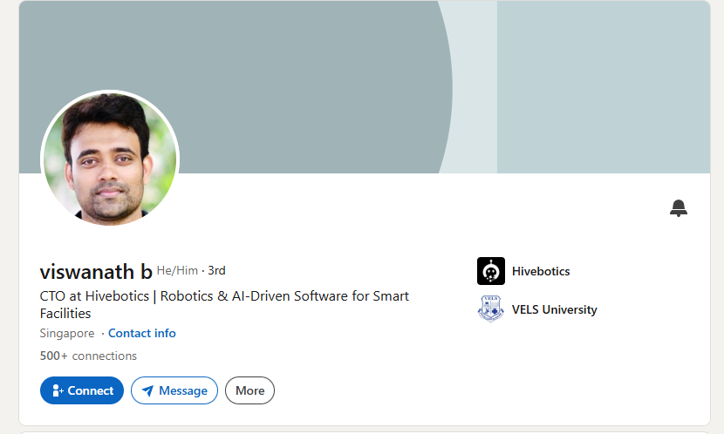
"D:\c_files4\Contamination_research\competitors\hivebotics\httpswww.linkedin.cominbviswanath.pdf"

https://www.linkedin.com/in/bviswanath/

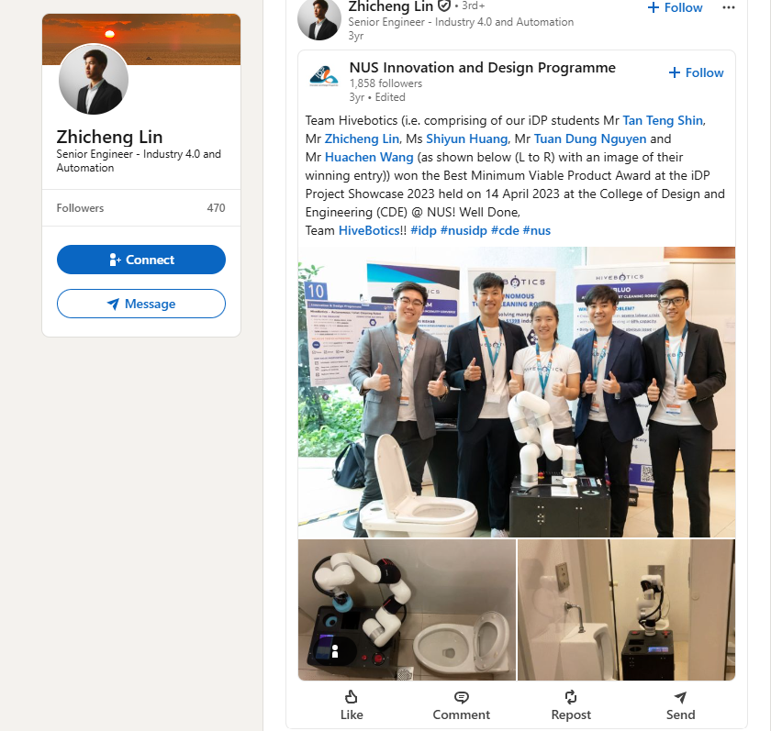

Important stuff

“联系方式 www.linkedin.com/in/zhichenglin (LinkedIn) 热门技能 Project Management Industry 4.0 Self-healing Languages Chinese (Native or Bilingual) English (Native or Bilingual) Certifications The git & github complete bootcamp Introduction to Artificial Intelligence (AI) Foundations: Data, Data, Everywhere Certified Solidworks Associate - Mechanical Design ROS for Beginners: Basics, Motion, and OpenCV Honors-Awards Dean's list AY2021/2022 Semester 1 A*STAR Research Internship Award Dean's list AY2021/2022 Semester 2 Publications Adopting Advanced Process Control Methodologies In Backend (Final Test) Adopting Advanced Process Control to reduce unscheduled downtime for equipment in Final Test Smart power solution for AI and beyond Zhicheng Lin Senior Engineer - Industry 4.0 and Automation 新加坡 工作经历 Infineon Technologies 3 年 5 个月 Senior Engineer I4.0 and Automation 2025 年 9 月 - Present (1 年 2 个月) 新加坡 Leading Industry 4.0, automation, and data engineering initiatives focused on smart manufacturing, self-healing systems, data governance, and digital transformation within semiconductor operations. Key achievements: - Project Manager for Infineon's Self-Healing Manufacturing Initiative, leading cross-functional teams across Automation, Equipment Engineering, Industrial Engineering, Product Test Engineering, and Data Science. Successfully delivered Proof-of-Concepts for Auto-Defrost and Dynamic Auto Contactor Cleaning (DACC) solutions. - Designed and implemented autonomous recovery workflows that improve equipment availability, reduce manual intervention, and support scalable smart factory operations. - Led Singapore deployment of Flexible Equipment Connectivity (FEQC), coordinating Production, IT and Automation stakeholders to accelerate future digitalization capabilities. - Developed data analytics solutions including speed-loss detection dashboards that enabled proactive identification of hidden production losses and contributed to measurable productivity improvements. - Established data pipelines, governance frameworks and asset definitions as part of enterprise Data Asset Governance initiatives, strengthening data quality and accessibility for future analytics and AI use cases. - Created operational dashboards used daily by engineering teams for alarm trending, preventive maintenance effectiveness analysis and equipment performance monitoring. - Delivered significant alarm reductions through systematic equipment analytics, including up to 87% improvement for selected high-frequency handler alarms. Page 1 of 6 - Supporting next-generation manufacturing initiatives including Load & Go (L&G), Continuous Lot Processing (CLP), Data Intelligence, and Smart Factory programs. International Graduate Programme Trainee (Package / Technology Definition Engineer) 2024 年 10 月 - 2025 年 9 月 (1 年) 马六甲市 International assignment within Infineon's Development Center supporting advanced semiconductor package development and technology definition activities for next-generation AI and power semiconductor applications. Key contributions: - Supported development of the Dual-Phase DrMOS package development through full package development cycle, contributing to one of the fastest package development cycle time within the organization - Participated across semiconductor assembly processes including Package Assembly, Die Attach, Clip Attach, Wire Bonding, Molding and Singulation. - Contributed to package design reviews, qualification activities, reliability assessments and manufacturability evaluations. - Supported technology demonstrations presented to executive leadership and contributed technical abstracts for industry conferences. - Developed 2D-to-3D CAD models workflow to speed up package development process by 30%. - Expanded expertise in semiconductor packaging technologies, failure analysis (FA) and reliability engineering. International Graduate Programme Trainee (Automation & Equipment Technology) 2024 年 3 月 - 2024 年 10 月 (8 个月) 新加坡 Focused on manufacturing automation, industrial IoT, and data engineering initiatives supporting autonomous material handling systems and smart factory digitalization. Key achievements: - Designed and deployed a production-ready monitoring platform for Mobile Industrial Robots (MiR AMRs) using Prometheus, Grafana and Python, delivering real-time fleet visibility and predictive health monitoring capabilities. - Developed automated alerting systems integrated with Webex to accelerate incident response and maintenance activities. Page 2 of 6 - Built custom data extraction and health-monitoring applications that expanded data visibility beyond native vendor capabilities. - Created debugging and analytics dashboards that contributed to over 50% reduction in prolonged Wi-Fi disconnections across autonomous robot operations. - Evaluated Advanced Process Control (APC) opportunities and established data foundations for future autonomous decision-making applications. - Standardized documentation, monitoring architecture and support processes to ensure long-term solution sustainability. International Graduate Programme Trainee (Operations) 2023 年 6 月 - 2024 年 3 月 (10 个月) 新加坡 As part of Infineon's International Graduate Programme, I supported highvolume semiconductor manufacturing operations while driving data-driven equipment improvement initiatives. Key contributions included: - Led Advanced Process Control (APC) initiatives to develop predictive maintenance capabilities for semiconductor handlers, achieving up to 93.8% alarm reduction and 3–6 hours of downtime savings per machine during pilot deployment for top occurring alarm. - Developed root-cause analysis frameworks and data models supporting Equipment Health Monitoring and reliability improvement programs. - Supported deployment and stabilization of CAN-bus data acquisition infrastructure, enabling large-scale machine data collection and analytics. HiveBotics 1 年 10 个月 Software Developer 2022 年 8 月 - 2023 年 5 月 (10 个月) Singapore - Implementing robotic arm motion pipelines to achieve cleaning manipulation tasks using Moveit. - Built gazebo toilet simulation environment for the testing of robot cleaning functionalities. - Maintain software repositories on company GitHub. Mechanical Engineer 2021 年 8 月 - 2022 年 8 月 (1 年 1 个月) Singapore Page 3 of 6 - Designed, fabricated and tested of mechanisms involved in multiple cleaning tool management system. - Update and maintain robot’s 3D CAD model across various iterations. - Integrated subsystems such as disinfectant/water dispense system into final prototype. Dyson RDD Intern 2022 年 5 月 - 2022 年 8 月 (4 个月) Singapore - Created ROS node to achieve object 6D pose tracking through 3D keypoint based methods. - Generated data to test created ROS node and evaluate learning-based pose estimators and trackers. - Written literature review for evaluation result comparison and suggested most suitable solution. A*STAR - Agency for Science, Technology and Research Project Intern 2021 年 5 月 - 2021 年 8 月 (4 个月) - Created multiple UR5 robotic arm grasping simulation environment in Pybullet and custom grippers 3D models in Unified Robot Description Format (URDF) for RL model training. - Built a deep reinforcement learning environment based on Deep Deterministic Policy Gradient algorithm with Pytorch. - Applied the concept of hardware conditioned policy for multi-robot transfer* onto custom grippers performing object grasping. * https://arxiv.org/abs/1811.09864 National University of Singapore Teaching Assistant 2020 年 12 月 - 2021 年 5 月 (6 个月) Singapore - Designed and fabricated motorized ping-pong ball guns that targets and fire autonomously. - Integrated software, electrical and mechanical components onto single system on turtlebot3. Page 4 of 6 - Guided a class of students from the module EG2310, Fundamentals of Systems Design, with the learning of system design and the necessary software and hardware skillsets to achieve the integration on a robot. NUS Biomedical Engineering Department Research Assistant 2020 年 7 月 - 2020 年 12 月 (6 个月) Singapore - Acquired basic knowledge related to robotics development for medical use. - Produced various 3D models, animations and presentation slides to showcase development work. Inland Revenue Authority of Singapore (IRAS) Temporal Tax Officer 2019 年 3 月 - 2020 年 12 月 (1 年 10 个月) Singapore - Acquired basic knowledge related to personal and property tax. - Assisted up to 200 tax payers daily in tax filing, enforcement related matters with 100% accuracy. Singapore Armed Forces (SAF) Platoon Sergeant (NS), Company Sergeant Major (NSmen) 2017 年 1 月 - 2018 年 11 月 (1 年 11 个月) Singapore - Completed My national service at 17th Mono 1st battalion Singapore Guards, with promotion to company sergeant major for ORNS. - Managed a platoon size troops and 4 sergeants to complete daily tasks/ trainings given by higher command. - Inspected administrative paperwork to allow company to pass daily and monthly store-item/armory checks with 100% accuracy. 教育经历 NUS Innovation and Design Programme Second Major in Innovation & Design, Robotics system design · (2019 年 8 月 - 2023 年 4 月) National University of Singapore Bachelor of Engineering - BE, Mechanical engineering (Robotics specialisation) · (2019 - 2023) Page 5 of 6 Hwa Chong Institution Integrated Programme Diploma · (2011 - 2016) Page 6 of 6"….imp thing Is he worked in a star ….. which also dealt with the same type of robot https://fondaglobal.com/introducing-fonda-globals-alac-automated-lavatory-cleaning-robot/ … few years ago…. Fonda collabed with a star is whats iam guessing

https://design.museaward.com/winners-info.php?id=29569

