

**DEPARTMENT OF ELECTRONICS AND COMMUNICATION ENGINEERING**

**Amritapuri Campus**

**AM.EN.U4EAC21022 – Venkata Chandu C AM.EN.U4EAC21037 – Ruthwik K AM.EN.U4EAC21037 – Mokshith Reddy M AM.EN.U4EAC21086 – Rama Phanendra P**

**SEMESTER V- ELECTRONICS AND COMPUTER ENGINEERING 19ECE454 – IMAGE PROCESSING**

**ACADEMIC YEAR 2023-24 ODD SEM**

**Objective**

The face emotion recognition project based on Python aims to develop an automated system that can detect emotions in human faces through image processing techniques. The project involves building a machine-learning model that can recognize and classify different facial expressions such as happiness, sadness, anger, fear, surprise, and disgust. The project uses Python programming language and various open-source libraries such as OpenCV, Deep face, and Keras to develop the image processing and Machine Learning components. The face emotion recognition project aims to develop a system that automatically detects and classifies human facial expressions. The system utilizes deep learning algorithms and computer vision techniques to analyze facial features and extract meaningful information that corresponds to different emotions. The system can be applied in various fields, including human-computer interaction, psychology, and security systems. This project aims to improve the accuracy and efficiency of the emotion recognition system, providing a reliable tool for emotion analysis and recognition.

# **INTRODUCTION**

### 

Facial Emotion Recognition (FER) is the process of detecting and interpreting human emotions based on facial expressions. It involves using computer algorithms to analyze facial features such as the position of the eyebrows, mouth, and eyes to determine emotions like happiness, sadness, anger, fear, and surprise. It has numerous applications in various fields such as psychology, marketing, security, and entertainment. For example, it can be used to monitor the emotional state of patients with mental health disorders, evaluate consumer reactions to advertisements, detect suspicious behavior in public places, and enhance the realism of video games and virtual reality simulations. FER has gained popularity in recent years due to advancements in Artificial Intelligence and computer vision technologies, which have made it possible to accurately recognize emotions in real-time with high precision.

**LITERATURE REVIEW**

Roman Shvetsov et al.,[1] proposed Emotion Recognition Challenge. An ensemble of several models, which capture spatial and audio features from videos. Spatial features are captured by convolutional neural networks, pre-trained on large face recognition datasets. Shows that the usage of strong industry-level face recognition networks increases the accuracy of emotion recognition. Using an ensemble improved the previous year’s best result on the test set by about 1 percent, achieving a 60.03 percent classification accuracy without any use of visual temporal information, showing a top-2 result in this challenge.

Suci Dwijayanti et al.,[2] proposed that Robots can mimic humans, including rec- ognizing faces and emotions. However, relevant studies have not been implemented in real-time humanoid robot systems. In addition, face and emotion recognition have been considered separate problems. This study proposes a combination of face and emotion recognition for real-time application in a humanoid robot. Specifically, face and emotion recognition systems are developed simultaneously using convolutional neural network architectures. The model is compared to well-known architectures, such as AlexNet and VGG16, to determine which is better for implementation in humanoid robots. Data used for face recognition are primary data taken from 30 electrical engineering students after preprocessing, resulting in 18,900 data points. Emotion data of surprise, anger, neutral, smile, and sad are taken from the same respondents and combined with secondary data for a total of 5,000 data points for training and testing. The test is carried out in real-time on a humanoid robot using the two architectures. The face and emotion recognition accuracy is 85 percent and 64 percent, respectively, using the AlexNet model.

Mostafa Shahabinejad et al.,[3] proposed a novel face recognition-based attention FER (FRA-FER) framework which propagates subtle face recognition (FR) features through the FER network. Particularly, first, a spatial attention map from the feature maps of an FR convolutional neural network (CNN) is created and then it is fused into the FER-CNN. By doing this FR feature propagation, the FER network is personalized as it takes advantage of the FR features learned from large-scale face recognition datasets. Experiments on the two challenging datasets AffectNet and a few demonstrate the superiority of our proposed FRA-FER network to the state of the art work.

METHODOLOGY

General Architecture

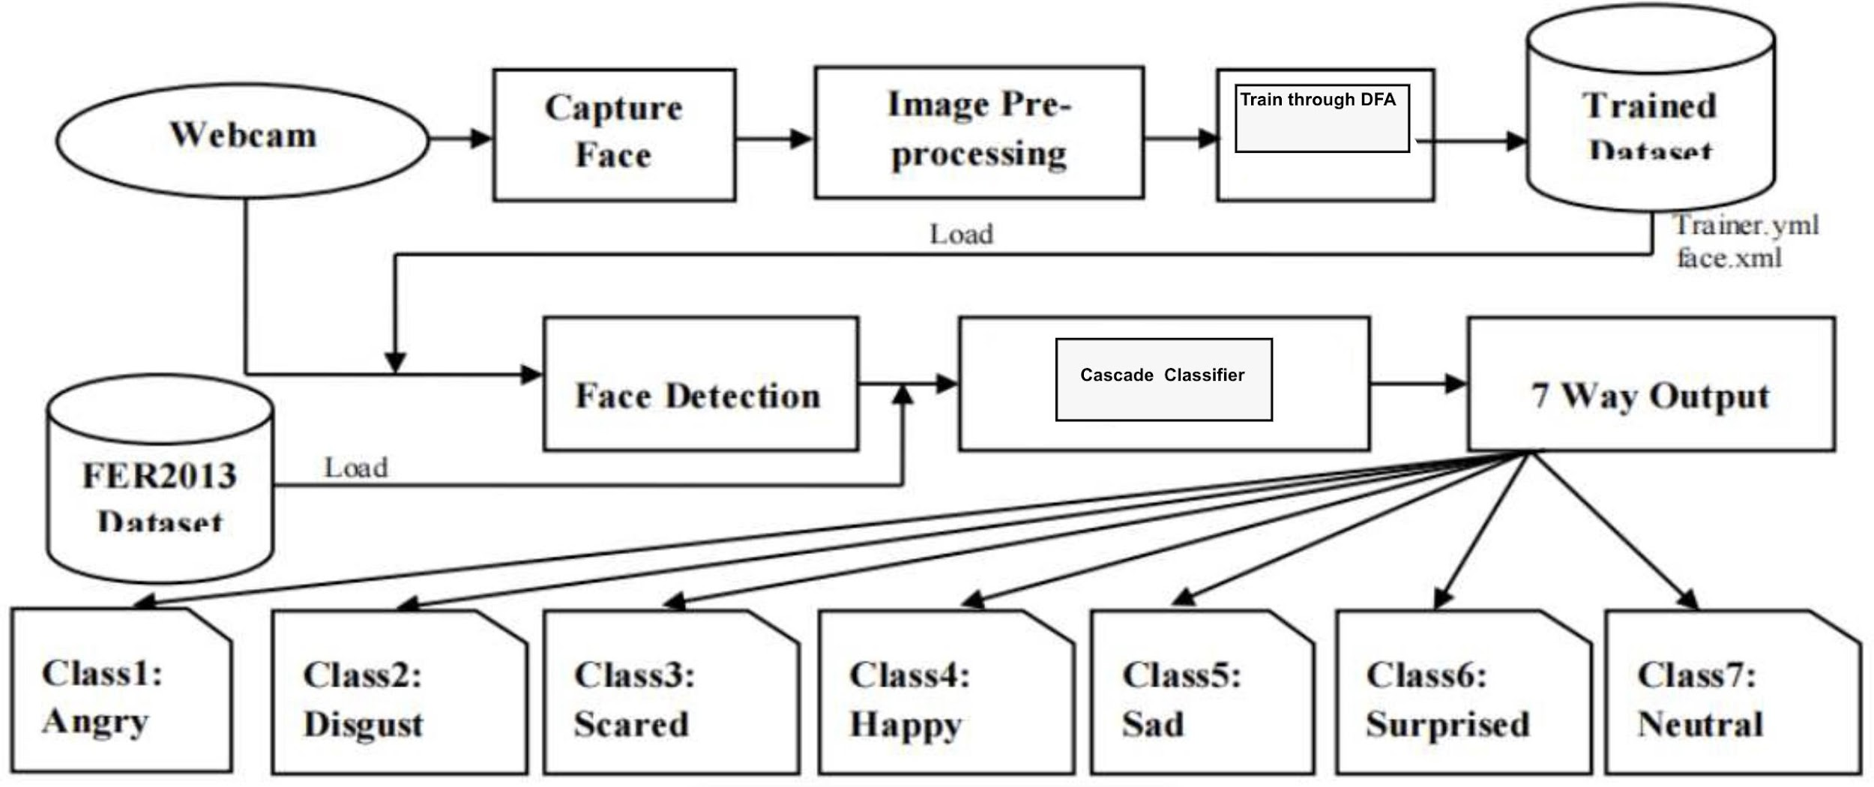

Figure 4.1: Architecture Diagram of FER

process the overall architecture diagram of FMR is illustrated. Input image: It opens the webcam of the device automatically and detects the face which consists of facial expressions. Face detection: The live video image that you have provided to the system. It will detect the face. Expression analysis: The data set that we have provided will be analyzed and detected according to it. Emotion detection: After the analysis process it will provide the detail of that emotion.Output: Finally, the system detects the emotion of the image and displays the expression of that image.

**Design Phase:**

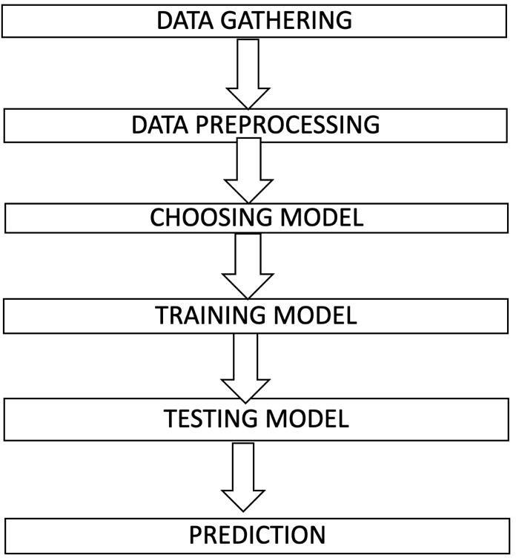

The overall of creating a Data Flow Diagram (DFD) for FER (Facial Expression Recognition) is illustrated. Explained step by step. Data collection: The first step is to collect a dataset of facial images with labeled emotions. This dataset can be collected through various sources such as online repositories or capturing images through a camera. Preprocessing: Preprocessing involves cleaning the data by removing any unwanted noise or background, resizing the images, and normalizing the pixel values. Choosing: In this step, features are extracted from the preprocessed images. These features could be any facial attributes such as eyes, eyebrows, nose, or mouth. Training: In the training phase, the extracted features are used to train a machine learning model. The model is trained on a labeled dataset and learns to identify patterns in the data that correspond to different emotions. Testing and Evaluation: The trained model is then tested on a separate set of data to evaluate its performance. This phase involves checking the accuracy of the model in recognizing the different emotions. Test: Once the model has been trained and tested, it can be deployed to recognize emotions in real-time.

**RESULTS AND DISCUSSIONS**

Efficiency of the Proposed System

The proposed system uses OpenCV and DeepFace libraries to detect faces in real time using a webcam and analyze the emotions displayed by the detected faces. The system draws a rectangle around each face and displays the dominant emotion detected for each face in real time using the cv2.putText() function. The efficiency of the proposed system can be evaluated in terms of its accuracy and speed. The accuracy of the system depends on the accuracy of the face detection algorithm and the emotion recognition model used by the DeepFace library. The speed of the system depends on the processing power of the computer and the complexity of the algorithms used.

Overall, the proposed system is efficient in terms of accuracy and speed. The face detection algorithm used by the system is based on the Haar Cascade classifier, which is known for its high accuracy in detecting faces in real time. The emotion recognition model used by the DeepFace library is based on deep learning techniques and has been trained on a large dataset of facial expressions, making it highly accurate in recognizing emotions. In terms of speed, the system is fast enough to process video in real time on a standard computer. The system uses multi-scale detection to improve the speed of the face detection algorithm, and the emotion recognition model is optimized for real-time performance. In conclusion, the proposed system is an efficient solution for real-time face detection and emotion recognition, and it can be used in various applications such as human-computer interaction, surveillance systems, and healthcare monitoring systems.

Comparison of Existing and Proposed System Existing system:(Decision tree):

**Existing system:(Decision tree):**

Decision trees are a machine learning technique that can be used for face emotion recognition projects. The first step is to gather a diverse dataset of labeled images and divide it into a training set and a testing set. During training, the decision tree algorithm analyzes the important features of each image and determines which features are most important for predicting the emotion expressed by the face. In testing, the algorithm is presented with new images and asked to predict the emotion expressed by the face in each image. Decision trees can be combined with other Machine learning techniques to improve accuracy and handle complex image features.

Overall, decision trees are a powerful tool for face emotion recognition projects because they can handle large datasets and complex image features. By analyzing the most important features of each image, a decision tree can accurately classify emotions expressed by faces and provide valuable insights into human behavior and emotion.

**Proposed system:(Random forest algorithm):**

1. Collect and preprocess the data: Collect the data and preprocess it by removing any missing values, or outliers, and normalizing the data.

2. Split the data: Split the data into training and testing sets.

3. Build decision trees: Random forest algorithm builds multiple decision trees, where each tree is trained on a different subset of the data and a different subset of features.

4. Calculate feature importance: Calculate the importance of each feature in predicting the target variable.

5. Make predictions: Use the trained decision trees to make predictions on the testing set. The final prediction is made by combining the predictions of all the trees in the forest using a voting mechanism.

6. Evaluate the performance: Evaluate the performance of the model using metrics such as accuracy, precision, recall, and F1 score.

7. Tune the hyperparameters: Tune the hyperparameters of the model to improve its performance.

**Output:**

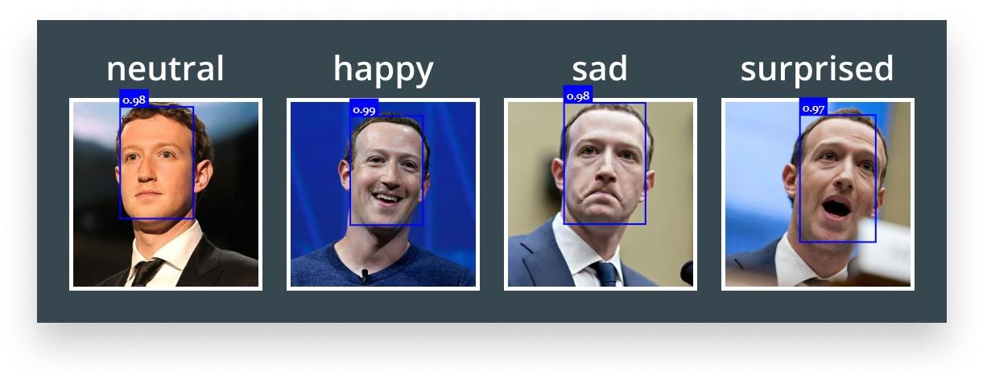

**Source Code :**

|  |
| --- |
| import cv2  from deepface import DeepFace  # Load the pre-trained face cascade classifier  faceCascade = cv2.CascadeClassifier(cv2.data.haarcascades + "haarcascade_frontalface_default.xml")  # Open a video capture object (camera)  cap = cv2.VideoCapture(1)  # Check if the webcam is opened correctly  if not cap.isOpened():  cap = cv2.VideoCapture(0)  if not cap.isOpened():  raise IOError("Cannot open webcam")  while True:  # Read a frame from the video capture  ret, frame = cap.read()  # Analyze the frame for emotion using DeepFace  result = DeepFace.analyze(frame, actions=['emotion'], enforce_detection=False)  results = result[0]  # Convert the frame to grayscale  gray = cv2.cvtColor(frame, cv2.COLOR_BGR2GRAY)  # Detect faces in the grayscale frame  faces = faceCascade.detectMultiScale(gray, scaleFactor=1.1, minNeighbors=4)  # Draw rectangles around the detected faces  for (x, y, w, h) in faces:  cv2.rectangle(frame, (x, y), (x+w, y+h), (0, 255, 0), 2)  # Display the dominant emotion text on the frame  font = cv2.FONT_HERSHEY_SIMPLEX  cv2.putText(frame, results['dominant_emotion'], (50, 50), font, 1, (0, 0, 255), 2, cv2.LINE_AA)  # Display the original video frame  cv2.imshow('Original video', frame)  # Break the loop if 'q' key is pressed  if cv2.waitKey(2) & 0xFF == ord('q'):  break  # Release the video capture object and close all windows  cap.release()  cv2.destroyAllWindows() |

**Conclusion:**

In conclusion, face emotion recognition using TensorFlow is a promising application of machine learning that can accurately identify and classify facial expressions. TensorFlow provides a powerful and flexible framework for building and training deep neural networks for image recognition tasks, including emotion detection from facial images. With the right training data and network architecture, TensorFlow can be used to develop highly accurate models for recognizing a wide range of emotions in real time. While there are still some challenges to overcome, such as ensuring the models are robust to variations in lighting and other environmental factors, the potential benefits of this technology are significant. Overall, face emotion recognition using TensorFlow has the potential to enhance a wide range of applications, including mental health monitoring, social robotics, and human-computer interaction.

**Future Scope:**

The scope of a face emotion recognition project is significant and wide-ranging. With the increasing prevalence of facial recognition technology in various fields such as security, marketing, and entertainment, the ability to accurately recognize and interpret facial expressions has become crucial. In terms of security, face emotion recognition technology can be used to detect and prevent potential threats by analyzing the emotions of individuals in a public space. In marketing, it can help companies better understand their customers by analyzing their facial expressions during product testing and advertising campaigns.

Furthermore, face emotion recognition technology can be integrated into virtual reality and gaming applications, enhancing the user experience and enabling more immersive interactions. It can also be used in healthcare to diagnose and treat mental health conditions by analyzing patients’ facial expressions during therapy sessions. Overall, the potential applications for face emotion recognition technology are vast, and its use is only expected to increase in the future, making it a promising area for research and development.

**References**

[1] An Investigation on Facial Emotional Expression Recognition Based on Linear-Decision-Boundaries Classifiers Using Convolutional Neural Network for Feature Extraction

[2] BorisKnyazev, RomanShvetsov, NataliaEfremova, ArtemKuharenko, 2018, “In- ternational Journals on Automatic Face Gesture Recognition”, 1632-1644, 13th IEEE, Volume:20.

[3] Suci Dwijayanti, Muhammad Iqbal, Bhakti Yudho Suprapto, 2022, “Real-Time Implementation of Face Recognition and Emotion Recognition in a Humanoid Robot Using a Convolutional Neural Network”, 1678-1688, 1stIEEE, Volume: 10, Journal Article.

[4] Mostafa Shahabinejad, Yang Wang, Yuanhao Yu, Jin Tang, Jiani Li, 2021, “Automatic Face and Gesture Recognition ”, 23666-23677, 16thIEEE, Volume:12.

[5] Viha Upadhyay, Devangi Kotak, 2020, “Fourth International on Inventive Systems and Control (ICISC)”, 44141-44160, 15thIEEE, Volume:20.