Advanced SQL HW

Query 1: The university wants to identify which equipment belongs to which building. Explain which tables must be connected to answer this question and identify the foreign key relationships involved. Write a query for this.
Building, Equipment, and Room must be connected to answer this question since you need to know about building and equipment relationships, and equipment is assigned to a room located within a building. The foreign keys involved in this will be RoomID and BuildingID.
SELECT E.EquipmentName, B.BuildingName
FROM Equipment E
JOIN Room R ON R.RoomID=E.RoomID
JOIN Building B ON R.BuildingID=B.BuildingID;
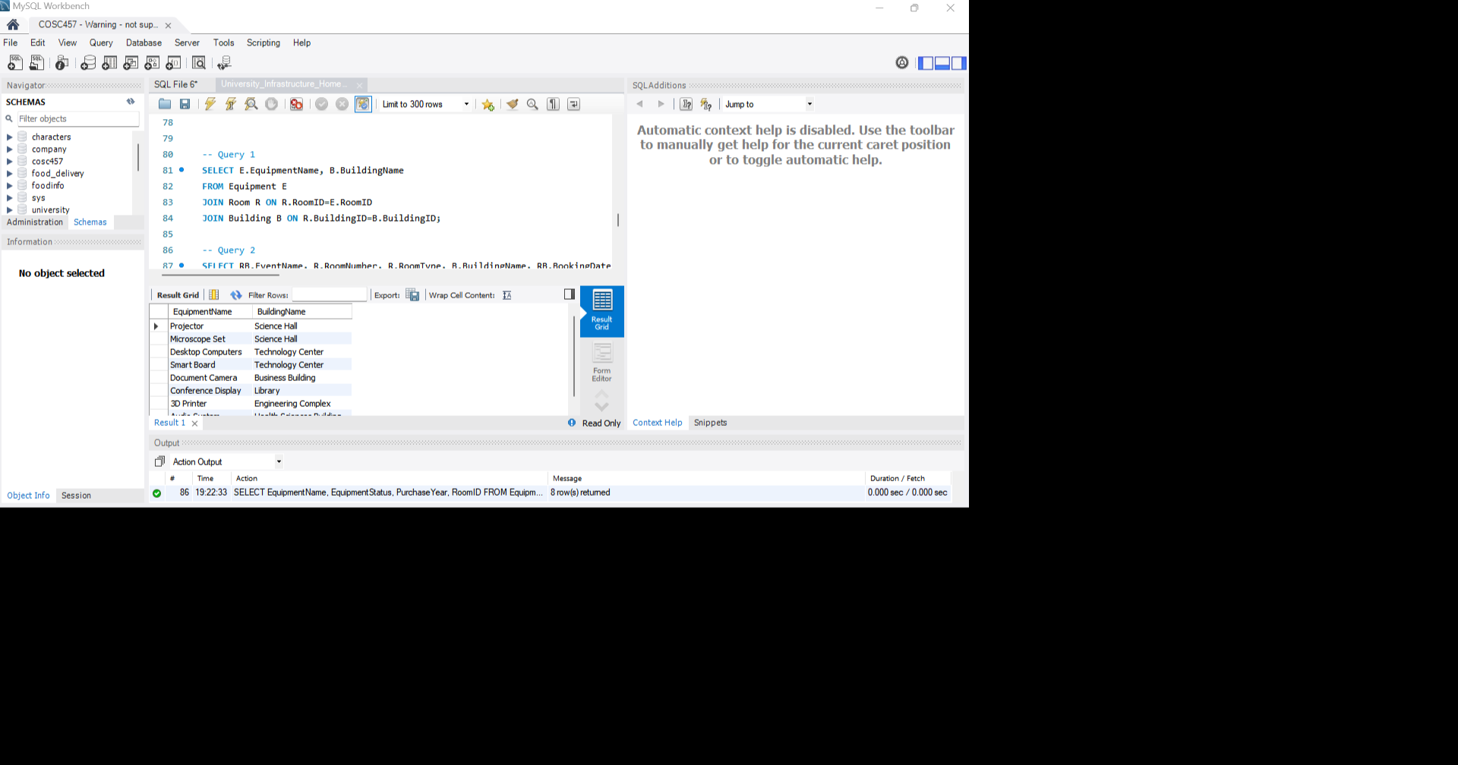

Query 2: Write a query to show each booked event along with the room number, room type, building name, booking date, and number of attendees. Only show rooms that have actual bookings.
SELECT RB.EventName, R.RoomNumber, R.RoomType, B.BuildingName, RB.BookingDate, RB.NumberOfAttendees
FROM RoomBooking AS RB
JOIN Room R ON R.RoomID=RB.RoomID
JOIN Building B ON B.BuildingID=R.BuildingID;
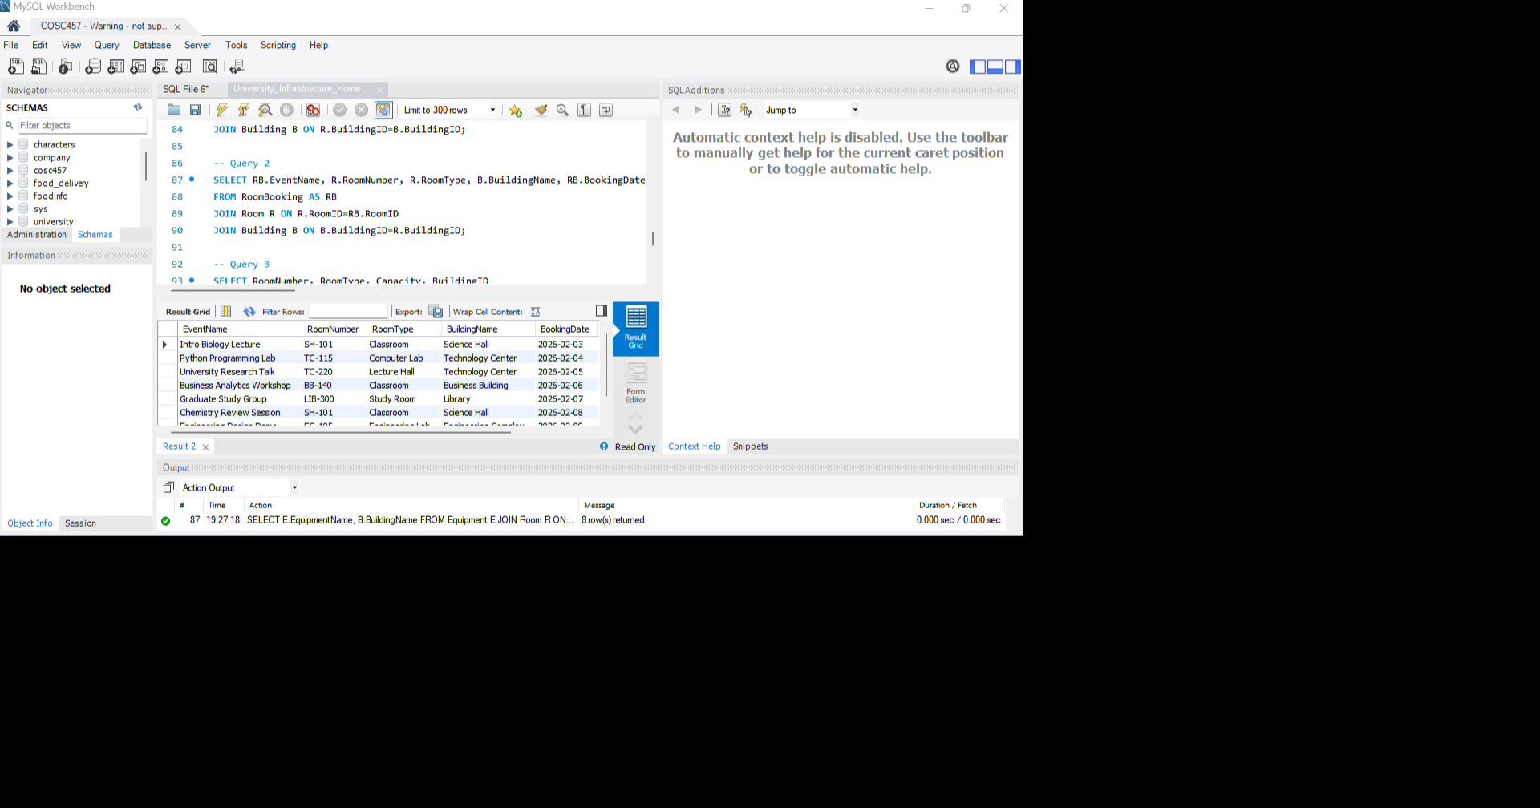

Query 3: Write a query to find rooms whose capacity is greater than the average capacity of all rooms in the university. Display the room number, room type, capacity, and building ID. Write this query as a nested query.
SELECT RoomNumber, RoomType, Capacity, BuildingID
FROM Room
WHERE Capacity > (
SELECT AVG(Capacity)
FROM Room
);
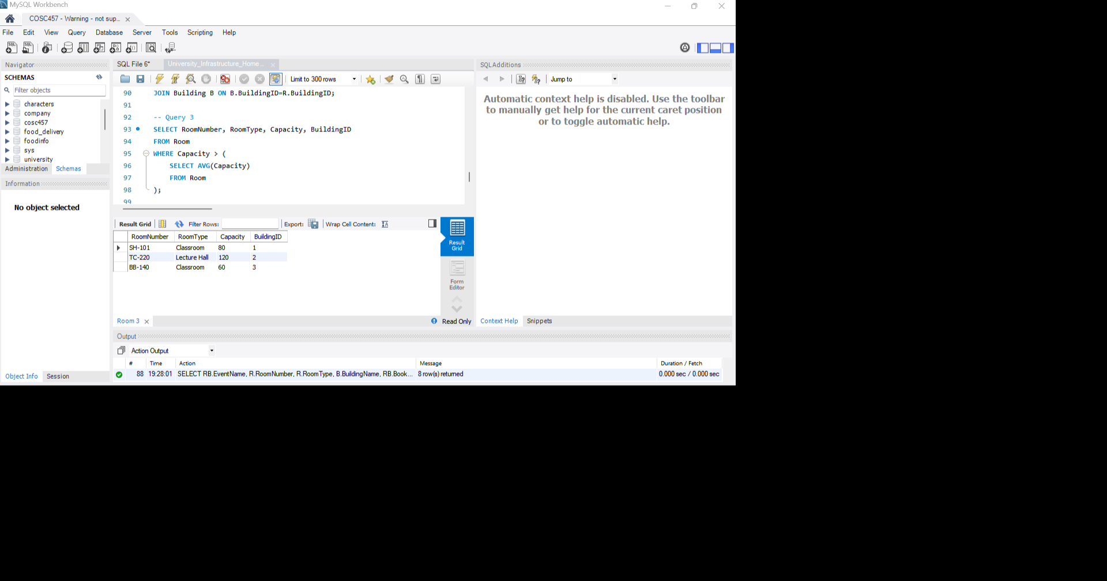

Query 4: Write a query to label each room based on its capacity:
- Capacity 100 or more = Large Room
- Capacity between 40 and 99 = Medium Room
- Capacity below 40 = Small Room
Display the room number, room type, capacity, and the capacity label.
SELECT RoomNumber, RoomType, Capacity,
CASE
WHEN Capacity >= 100 THEN 'Large Room'
WHEN Capacity > 40 THEN 'Medium Room'
ELSE 'Small Room'
END AS 'CapacityLevel'
FROM Room;
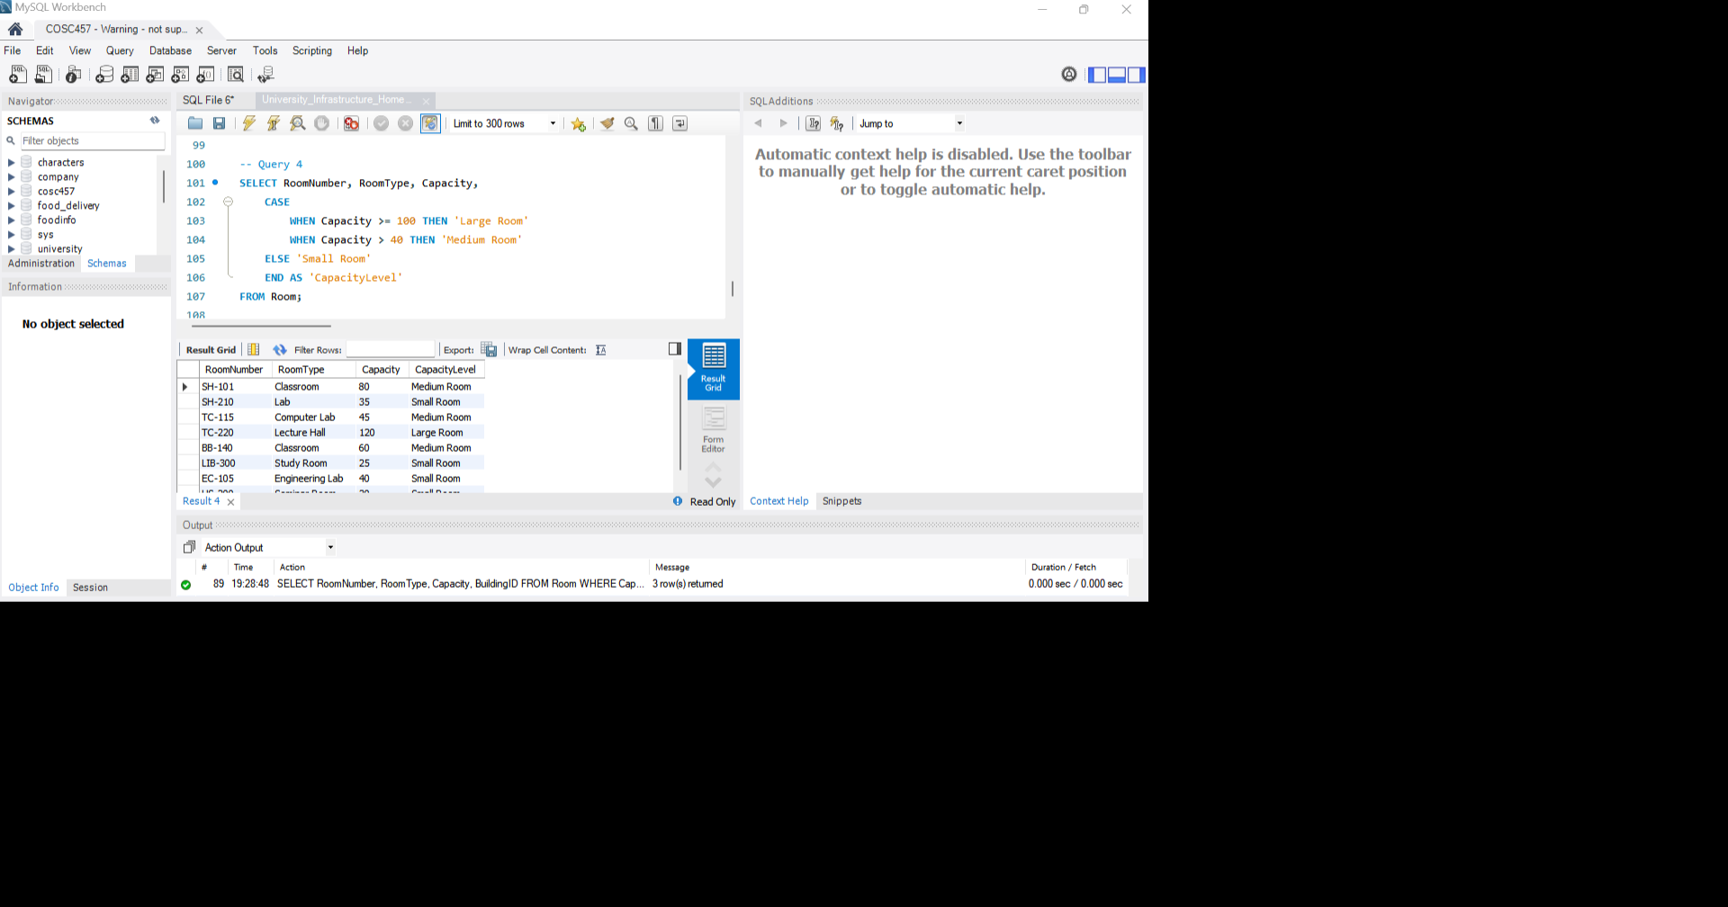

Query 5: Write a query to display all equipment ordered first by equipment status and then by purchase year, with the oldest equipment appearing first within each status category.
Display equipment name, equipment status, purchase year, and room ID.
SELECT EquipmentName, EquipmentStatus, PurchaseYear, RoomID
FROM Equipment
ORDER BY EquipmentStatus, PurchaseYear;
