Questions:
- Identify all entities in the system. (1 point)
  - The entities in the system are Patient, Admission, Hospital Room, Doctor, Department, and Insurance Policy.
- Draw a complete ER diagram with correct relationship names and min–max notation. (2 points)
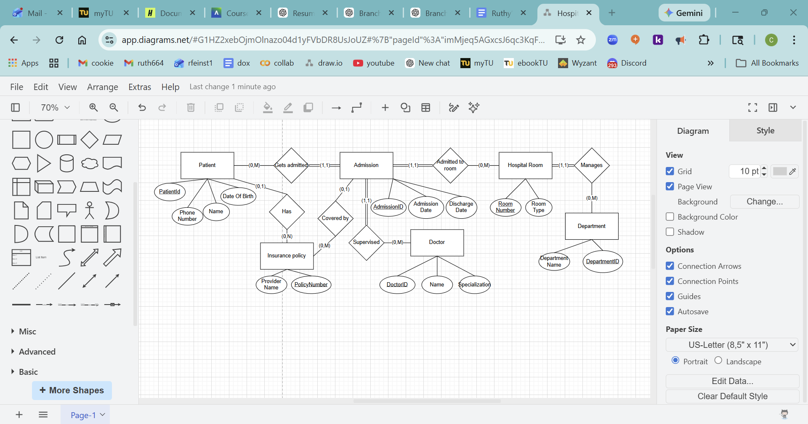
- Clearly indicate participation (optional or total) where applicable. (1 point)
  - Participation is total where there are double lines, and optional where there is a singular line.
- Where should AdmissionDate and DischargeDate be placed in the ER diagram? Explain why. (1 point)
  - AdmissionDate and DischargeDate should be placed by the admission entity, since the date information is used by the patient and the hospital room and is part of the admission.

