Polymorphism
________________________________________________________

Q. What is polymorphism?
______________________________________________________
Polymorphism means if same thing perform different behavior in different situation as per the requirement called as polymorphism.
Example: if we think about mobile phone it is best example of polymorphism because we can use mobile phone as calculator, as calender as ,as TV, as mobile etc
Means we have single device we can use single device for different purpose called as polymorphism.

If we want to implement polymorphism in programming we have two ways
1. Compile time polymorphism:
Q. What is compile time polymorphism?
___________________________________________________
If functionality bounded with object at program compile time called as compile time polymorphism.
If we want to implement compile time polymorphism practically
We have function overloading technique
2. Run time polymorphism: if functionality bounded with object at program run time called as run time polymorphism.
If we want to implement the run time polymorphism practically we have function overriding technique.
Note: we will discuss runtime polymorphism in inheritance chapter.

Now we want to discuss about function overloading.

Q. What is function overloading?
__________________________________________________
Function overloading means if we define same name function with different data type with different parameter list with different parameter sequence called as function overloading.
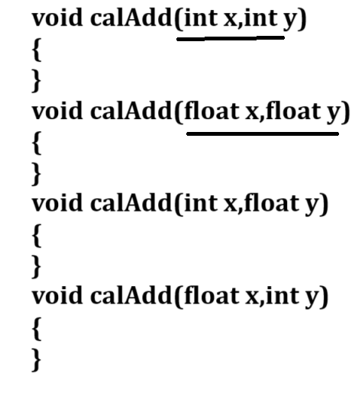
If we want to work with function overloading we have some important points.
1. Function name must be same
2. Parameter type or parameter list or parameter sequence must be different in every function definition
3. Return type is not considered means every function definition can have different return type.
4. Function calling is dependent on data type or parameter sequence or parameter type.

Example: WAP to calculate the square of integer and float using a function overloading technique.

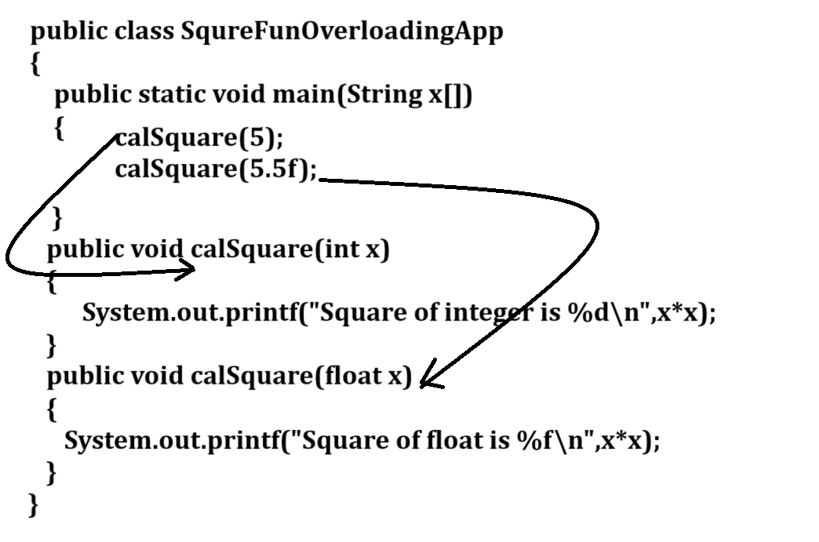
Example with source code
public class SquareFunOverloadingApp
{
public static void main(String x[])
{
calSquare(5); //call integer param function
calSquare(5.5f); //call float param function
}
public static void calSquare(int m)
{ System.out.printf("Square of integer is %d\n",m*m);
}
public static void calSquare(float n)
{ System.out.printf("Square of float is %f\n",n*n);
}
}
Q. Why use function overloading or what is benefit of function overloading?
_____________________________________________________
Some time if we have different logics under same domain and if we define we define multiple function with multiple names then programmer need to remember the different function names so it is complicated task or tedious task in real time so better way define multiple function with same name and pass different so the benefit is programmer not need to remember multiple function it is benefit overloading.

Example: suppose consider we are working on billing application and we two categories of bill like as bill with gst or bill without gst so writing two different function name is not good approach so better way you can write different function with same name and pass different parameter so we not need to remember the multiple function name it is benefit of function overloading.

Example with source code
public class BillingApp
{ public static void main(String x[])
{ calBill(10,100);
calBill(10,100,18);
}
public static void calBill(int qty,int rate)
{ System.out.printf("Bill without gst is %d\n",qty*rate);
}
public static void calBill(int qty,int rate,int gstRate)
{ int gstAmt=(qty*rate)*gstRate/100;
int total=(qty*rate)+gstAmt;
System.out.printf("Bill with GST is %d\n",total);
}
}
Assignments:
Q1. WAP to create function name as
public static void sort(int a[]): this function can accept integer array and perform sorting on it
public static void sort(char []): this function can accept character array and perform sorting on it.

Q. WAP create function name as
public static void sum(int a[]): this function can accept integer array as parameter and calculate its sum
public static void sum(char[]): this function can accept character array and extract digit from it and cal sum it
Example: abc123mno45s
Output: 1+2+3+4+5

Q. WAP create two function name as
void rev(char[]) this function can accept character array and reverse it
void rev(int []):this function can accept integer array and reverse it.

Q. WAP to create two function
boolean isAangram(int a[],int b[]): this function accept two array as parameter and check array is anagram or not if anagram return true otherwise return false
boolean isAangram(char a[],char b[]): this function accept two array as parameter and check array is anagram or not if anagram return true otherwise return false

