LANDCARE
Operational Handover
A quick-start guide for the next GIS analyst and Codex agent
Status date: August 3, 2026
Operational target: ura-gis/land-care-assurance on master
Read first: Live ArcGIS layers are authoritative at page load. Checked-in JSON/GeoJSON is the fallback/cache and finance contract.

Security: This guide contains no passwords, tokens, private keys, browser sessions, or Actions secret values. Use approved individual accounts and repository-scoped automation keys.

At a glance
Surface | Use | Link
Map Monitor | Parcel map, evidence, field notes, filters | Open monitoring
KPI Dashboard | Completion, trends, contractor and finance context | Open KPI
Contractor portal | Parcel details and approved evidence | Open contractor
Survey submission | Contractor evidence intake | Open submission

Use this document as an index. The linked Markdown runbooks remain the canonical source for implementation details.

1. Handover status
The repository and web surfaces are prepared for the ura-gis ownership model. Treat the items below as two different kinds of work: repository/app changes are documented and reproducible; account, VM, and ArcGIS ownership changes require an administrator or successor action.
Status | What is true now | Next owner action
Complete / recorded | Repository target is ura-gis/land-care-assurance; branch remains master; Pages routes are documented. | Keep the repository public and verify the Pages workflow after any transfer or permission change.
Complete / recorded | Survey adapter uses item 7a2e1d9bacba461296c54a63f104cf51 and normalizes additional_comments to additional_notes. | Use the live ArcGIS endpoint for smoke tests and keep cache-busting imports aligned.
Pending | ArcGIS content still includes assets owned by the departing user account. | An ArcGIS administrator must transfer ownership, confirm sharing, and re-test the dashboards and Survey123 flow.
Pending | VM refresh must be independent of the intern account. | Install a repository-scoped deploy key, update the VM remote, run one checked refresh, then verify two unattended cycles.
Pending | Security cutover is not complete until access is removed. | Rotate the exposed password, enable 2FA, revoke old sessions/tokens, and remove departing access only after sign-off.

Source: repository handover guide HANDOVER.md

2. How the platform works
There are three practical layers: upstream ingestion, authoritative stores, and the public app. The 4:00 AM task updates survey data; the 7:00 AM task rebuilds the checked-in fallback and publishes changes. The browser also queries ArcGIS directly at page load.
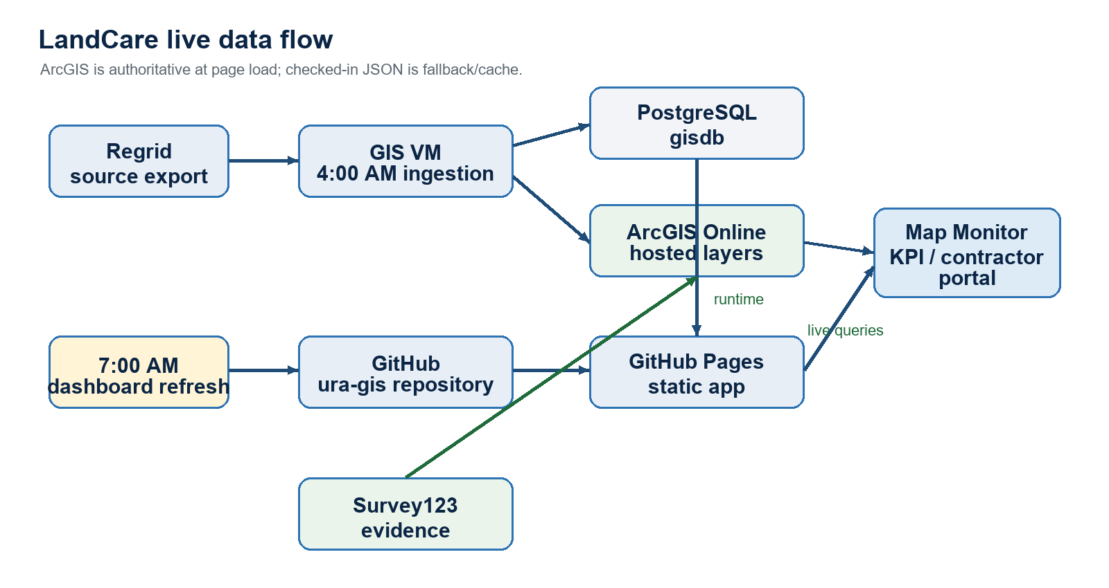
The visual above is a quick reading aid. The Mermaid source below is the editable version for future analysts and agents.
flowchart LR
Regrid["Regrid"] --> VM["GIS VM ingestion"]
VM --> PG["PostgreSQL GISDB"]
VM --> AGOL["ArcGIS Online layers"]
PG --> Refresh["7 AM dashboard refresh"]
Refresh --> Repo["ura-gis GitHub repository"]
Repo --> Pages["GitHub Pages"]
AGOL --> App["Map / KPI / Contractor"]
Pages --> App
App --> Shell["ArcGIS dashboard shell"]
Survey123["Survey123 evidence"] --> AGOL

Authoritative sources
Source | Role | Operational note
PostgreSQL gisdb | Raw Regrid survey rows, bundle assignments, ownership joins | Not public; consumed by the upstream and refresh workflows.
ArcGIS Online | Live survey, assignment, EPP, and evidence layers | Primary runtime source for current map/KPI data and comments.
GitHub Pages | Published Map, KPI, contractor, and survey-submission web app | Static deployment from the repository; Pages links do not automatically follow repository transfers.
docs/landcare/data | Fallback/cache and finance contract | Generated by the VM refresh; do not hand-edit generated values.

Source: canonical architecture docs/landcare-architecture.md

3. URLs, layers, and schedule
Asset | Identifier / URL | Use
Survey layer item | 7a2e1d9bacba461296c54a63f104cf51 | All-period survey evidence and additional comments.
Survey REST layer | FeatureServer/0 | Read-only ArcGIS queries by period, parcel, and comment.
Dashboard shell | 341377524e02486ba71684ad67d9b273 | ArcGIS dashboard shell embedding the Pages app.
Repository | ura-gis/land-care-assurance | Source, tests, Pages workflow, and operational docs.
Pages base | ura-gis.github.io/land-care-assurance | Public app base URL.

Scheduled flow (Eastern time)
Time | Task | Proof
4:00 AM | Upstream Regrid/GISDB survey pipeline | ArcGIS survey period/counts are fresh; upstream log is successful.
7:00 AM | LandCare Daily Dashboard Refresh | daily-refresh-status.json says success; validation passes; Pages deploys if files changed.
9:00 AM | Morning brief (if enabled) | Use repository variables for recipients/assignee; dry-run must not send email or create an issue.
15th, 4:15 AM | Monthly survey archive | Archive only; it is not the dashboard runtime source.

Source: VM operations runbook docs/task-scheduler-vm-operations.md

4. Daily operations

Daily check
- Check the upstream 4:00 AM task and the latest ArcGIS survey period/counts.
- Check the 7:00 AM task and open C:\srv\logs\land-care-assurance\daily-refresh-status.json.
- Confirm status is success, the generated date is today, and latest periods did not move backward.
- If data changed, open Map Monitor and KPI; inspect completion, comments, field notes, and the Field Notes pane.
- Check the Pages workflow and record any failure stage before attempting a retry.
Healthy run: The status JSON reports success, the validator passes, the latest period is current, and the public app loads live ArcGIS data.

Failure recovery
- Read the dated refresh log before changing anything.
- Use failed_stage to isolate the problem: pull/auth, PostgreSQL export, web-data build, finance build, QA, or commit/push.
- Fix only the failing stage, then run the checked refresh and validation command from the VM runbook.
- Re-open the status JSON and the public routes. If the same stage fails twice, escalate with the log, status JSON, commit SHA, and timestamp.

Rollback
For an application change, revert the focused commit through a pull request, re-run tests and Pages validation, then deploy. For generated data, restore the previous checked-in commit only after confirming the upstream source and finance inputs are not the cause. Never delete source data or rewrite history as a first response.
Source: VM smoke test docs/vm-smoke-test-regrid-daily-sync.md

5. Metric and data rules
Do not change silently: Completion denominator, parcel-key normalization, live ArcGIS endpoint, or raw-record numerator changes require metric documentation and focused tests.

Metric | Definition | Rule
Complete survey records | Raw live survey records whose normalized parcelnumb matches an assignment parcel. | This is the shared Map/KPI numerator. Repeated matched records remain by design.
Unique completed parcels | Distinct matched parcel keys. | Diagnostic only; do not substitute for the current numerator.
Active completion % | Complete survey records divided by Active assigned records. | Primary operational KPI.
Blended completion % | Complete survey records divided by all assigned records, including Request Only. | Secondary context only.
Open active | Active parcel keys with no matched survey evidence. | Use for follow-up; do not subtract raw records directly.
All AGOL survey records | Every live survey feature for the selected period. | Coverage context; not the same as matched completion.

Survey comments are normalized by the shared adapter from additional_comments, additional_notes, additional_note, or notes into canonical additional_notes. User-visible ArcGIS text must remain HTML-escaped, URL-validated, ordered, and deduplicated.
Source: metric glossary docs/landcare-metrics-context.md

6. Ownership and security handover

ArcGIS Online checklist
- Ask an ArcGIS administrator to review the item inventory owned by rutomo_urap; the current signed-in user cannot complete Change Owner without the required privilege.
- Transfer the Survey123 form, form service, evidence view, and any dashboard or web-map assets that still belong to the departing account. Keep public/queryable sharing unchanged unless the successor approves a change.
- The new survey layer item 7a2e1d9bacba461296c54a63f104cf51 is the authoritative replacement for the prior survey layer; confirm its owner, sharing, fields, and REST endpoint after transfer work.
- Re-open the dashboard shell, Map Monitor, KPI, contractor portal, and survey-submission flow after any ownership change. Confirm comments, photos, field notes, counts, and filters.
- Record item IDs and owner status, but never copy ArcGIS passwords or tokens into the repository or this document.

GitHub and VM security checklist
Control | Success condition
Account security | Exposed password rotated; 2FA enabled; old sessions, PATs, and browser sessions revoked.
Organization | ura-gis has at least two owners; successor uses an individual account; landcare-maintainers team has the needed repository access.
Repository | Remote points to https://github.com/ura-gis/land-care-assurance; branch remains master; Pages environment and workflow are healthy.
VM authentication | Repository-scoped deploy key works as the scheduled-task identity; no departing account credential is required.
Automation variables | Morning-brief recipients and assignee are repository variables; secret names are inventoried without values.
Final removal | After two successful unattended refresh cycles and successor sign-off, remove departing access and old VM credentials.

Source: GitHub and Pages runbook docs/github-handover-runbook.md

7. Safe changes with Codex
Start every session by reading HANDOVER.md, AGENTS.md, and the relevant canonical document. Keep changes small, source-aware, and reversible.
- Create a codex/* branch and state the source, denominator, affected page, tests, and rollback path in the pull request.
- Change the adapter, UI, documentation, and focused tests together when behavior changes. Keep shared survey-layer cache-busting versions aligned.
- Run the Python suite, node --test tests/survey-layer.test.mjs, Pages validation, and the read-only ArcGIS smoke test before pushing.
- Open Map Monitor, KPI, contractor, and survey-submission routes; verify loading, empty, error, comments, field notes, and responsive states.
- Push the branch and open a pull request. Merge to master only after checks are green and an owner has reviewed the metric/source impact.
First task: Make one harmless documentation edit, run the checks, open a pull request, and deploy it with the successor. This proves the new operator can use Codex end to end.

Design system reuse
Copy docs/design-system/executive-bi.css and example.html into a new framework-free app, wrap the page in .bi-dashboard, override --bi-* tokens at the root, and replace example values with source-backed metrics. Preserve semantic labels, keyboard access, 4.5:1 contrast, responsive stacking, and explicit loading/empty/error states.
Source: design-system guide docs/design-system/README.md

8. Ownership, escalation, and sign-off
Area | Primary owner | Escalate when
Regrid / GISDB / ArcGIS freshness | GIS/data operations | Period or layer counts are stale, missing, or regressing.
VM refresh and Task Scheduler | GIS/data operations | Status JSON is not success or the same stage fails again.
Map / KPI / Pages code | Web/dashboard owner | UI, tests, source mapping, endpoint, or metric contract changes.
Contractor follow-up | LandCare operations | Open work, comments, evidence, or contractor outliers need action.
Finance context | Finance owner | Workbook, budget, invoice, or contract totals change.
ArcGIS ownership / sharing | ArcGIS administrator | Change Owner, privilege, item access, or dashboard embed is blocked.

Cutover sign-off
Window | Checklist
Day 0 | Transfer/confirm GitHub ownership; verify master and Pages; update ArcGIS embeds; install/test VM deploy key; run one checked refresh; confirm all four routes.
Day +2 | Confirm two unattended refresh cycles, morning-brief dry-run, ArcGIS dashboard load, current comments/field notes, matching Map/KPI completion, and successor pull-request proof.
Closeout | Remove departing account access, old sessions/tokens, and old VM credentials only after the successor signs off.

Escalation packet: Include timestamp, route, selected period/filter, ArcGIS item or endpoint, commit SHA, failed_stage, status JSON, and the relevant log excerpt. Do not include credentials.

Canonical references
Reference | Purpose | Link
HANDOVER.md | Repository quick start | HANDOVER.md
AGENTS.md | Codex guardrails | AGENTS.md
Architecture | Source and runtime model | docs/landcare-architecture.md
Metrics | Definitions and denominator rules | docs/landcare-metrics-context.md
VM operations | Scheduler, refresh, and failure triage | docs/task-scheduler-vm-operations.md
Smoke test | Post-refresh proof checklist | docs/vm-smoke-test-regrid-daily-sync.md
GitHub handover | Repository and Pages cutover | docs/github-handover-runbook.md
Design system | Reusable BI components | docs/design-system/README.md

End of guide. The Markdown references above remain canonical and should be updated when operating behavior changes.

