Литература:

- Алгоритмы. Построение и анализ. Т. Кормен, Ч. Лейзерсон, Р. Зивест. 1999.
- Библиотека системного программиста. Аппаратное обеспечение IBM PC. 1 часть. Том 2. А.В. Фролов, Г.В. Фролов. 1992г.
- Библиотека системного программиста.Защищенный режим процессоров Intel 80286/ Intel 80386/ Intel 80486. Том 6. А.В. Фролов, Г.В. Фролов. 1993г.
- Библиотека системного программиста.Программирование видеоадаптеров. Том 21. А.В. Фролов, Г.В. Фролов. 1995г.

Кучи

Биномиальные кучи

Procedure |  | Binary heap (worst-case) | Binomial heap (worst-case) | Fibonacci heap (amortized)
MAKE-HEAP |  | Θ(1) | Θ(1) | Θ(1)
INSERT |  | Θ(lg n) | O(lg n) | Θ(1)
MINIMUM |  | Θ(1) | O(lg n) | Θ(1)
EXTRACT-MIN |  | Θ(lg n) | Θ(lg n) | O(lg n)
UNION |  | Θ(n) | O(lg n) | Θ(1)
DECREASE-KEY |  | Θ(lg n) | Θ(lg n) | Θ(1)
DELETE |  | Θ(lg n) | Θ(lg n) | O(lg n)

Binomial trees
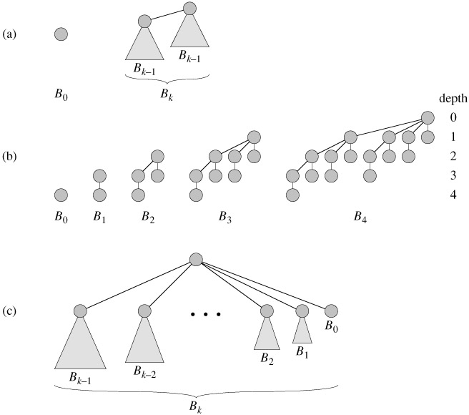
Рис. 1

Binomial heaps

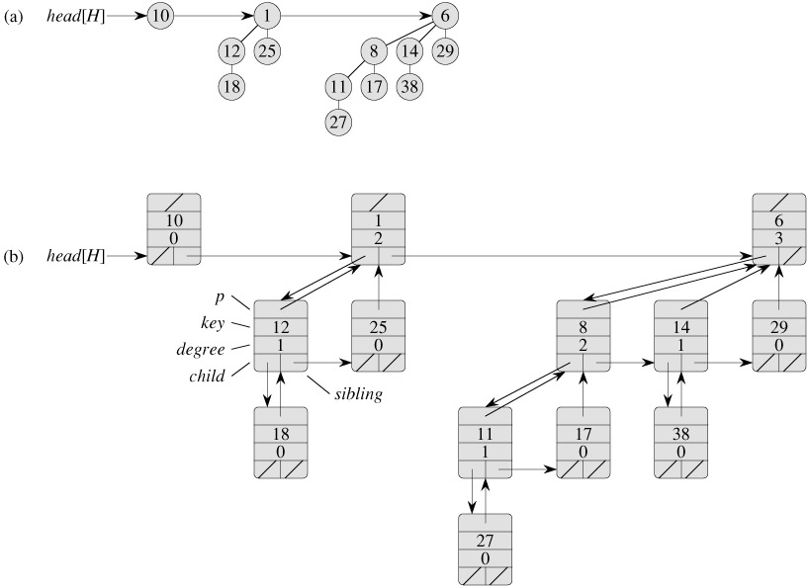

Рис. 2

Finding the minimum key

BINOMIAL-HEAP-MINIMUM(H)
1 y ← NIL
2 x ← head[H]
3 min ← ∞
4 while x ≠ NIL
5 do if key[x] < min
6 then min ← key[x]
7 y ← x
8 x ← sibling[x]
9 return y

Uniting two binomial heaps

BINOMIAL-LINK(y, z)
1 p[y] ← z
2 sibling[y] ← child[z]
3 child[z] ← y
4 degree[z] ← degree[z] + 1

BINOMIAL-HEAP-UNION(H₁, H₂)
1 H ← MAKE-BINOMIAL-HEAP()
2 head[H] ← BINOMIAL-HEAP-MERGE(H₁, H₂)
3 free the objects H₁ and H₂ but not the lists they point to
4 if head[H] = NIL
5 then return H
6 prev-x ← NIL
7 x ← head[H]
8 next-x ← sibling[x]
9 while next-x ≠ NIL
10 do if (degree[x] ≠ degree[next-x]) or
(sibling[next-x] ≠ NIL and degree[sibling[next-x]] = degree[x])
11 then prev-x ← x ▹ Cases 1 and 2
12 x ← next-x ▹ Cases 1 and 2
13 else if key[x] ≤ key[next-x]
14 then sibling[x] ← sibling[next-x] ▹ Case 3
15 BINOMIAL-LINK(next-x, x) ▹ Case 3
16 else if prev-x = NIL ▹ Case 4
17 then head[H] ← next-x ▹ Case 4
18 else sibling[prev-x] ← next-x ▹ Case 4
19 BINOMIAL-LINK(x, next-x) ▹ Case 4
20 x ← next-x ▹ Case 4
21 next-x ← sibling[x]
22 return H

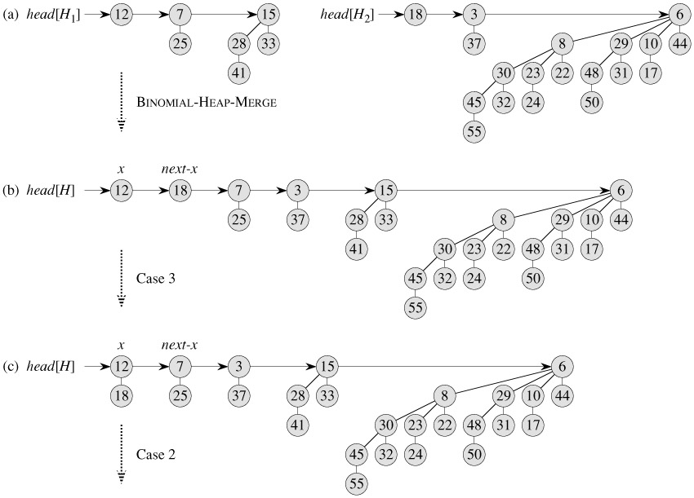
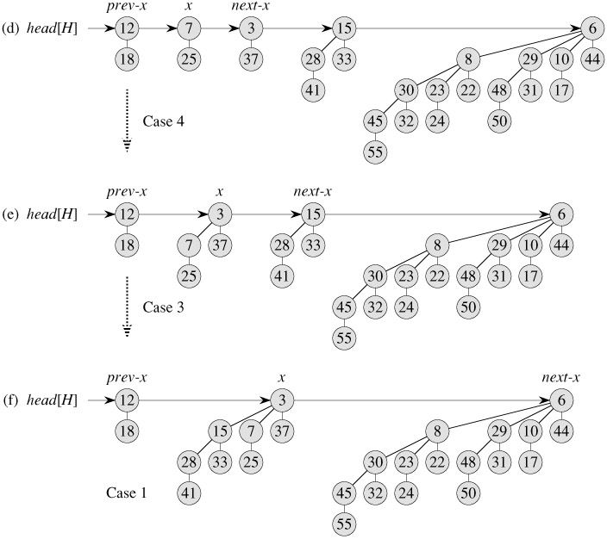
Рис. 3

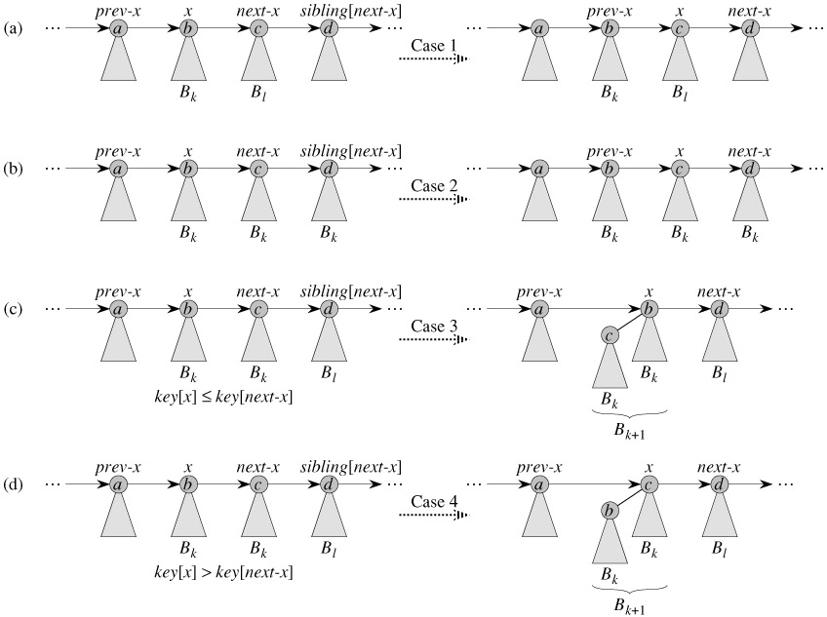

Рис. 4

Inserting a node
BINOMIAL-HEAP-INSERT(H, x)
1 H′ ← MAKE-BINOMIAL-HEAP()
2 p[x] ← NIL
3 child[x] ← NIL
4 sibling[x] ← NIL
5 degree[x] ← 0
6 head[H′] ← x
7 H ← BINOMIAL-HEAP-UNION(H, H′)

Extracting the node with minimum key
BINOMIAL-HEAP-EXTRACT-MIN(H)
1 find the root x with the minimum key in the root list of H,
and remove x from the root list of H
2 H′ ← MAKE-BINOMIAL-HEAP()
3 reverse the order of the linked list of x's children,
and set head[H′] to point to the head of the resulting list
4 H ← BINOMIAL-HEAP-UNION(H, H′)
5 return x

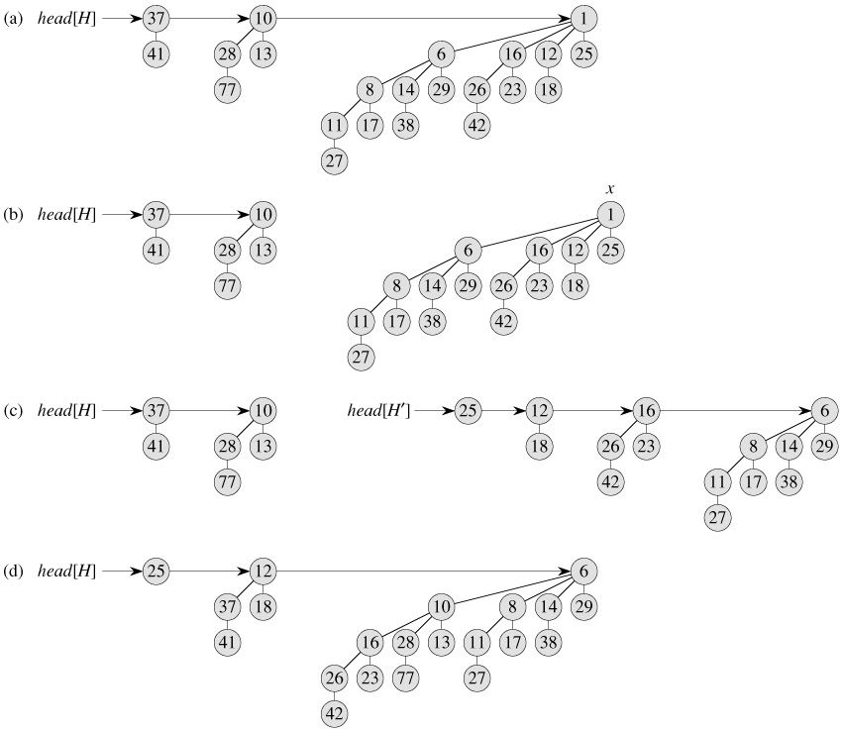

Рис. 5

Decreasing a key
BINOMIAL-HEAP-DECREASE-KEY(H, x, k)
1 if k > key[x]
2 then error "new key is greater than current key"
3 key[x] ← k
4 y ← x
5 z ← p[y]
6 while z ≠ NIL and key[y] < key[z]
7 do exchange key[y] ↔ key[z]
8 ▸ If y and z have satellite fields, exchange them, too.
9 y ← z
10 z ← p[y]

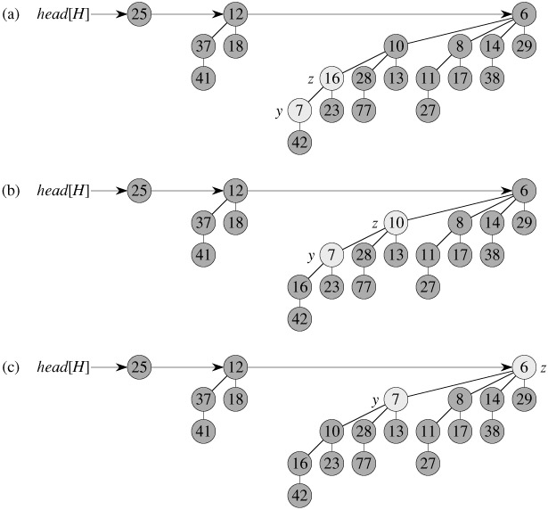
Рис. 6

Deleting a key
BINOMIAL-HEAP-DELETE(H, x)
1 BINOMIAL-HEAP-DECREASE-KEY(H, x, -∞)
2 BINOMIAL-HEAP-EXTRACT-MIN(H)

Fibonacci Heaps

Structure of Fibonacci heaps

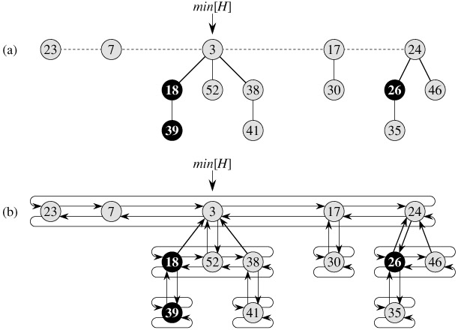
Pic. 1

Inserting a node
FIB-HEAP-INSERT(H, x)
1 degree[x] ← 0
2 p[x] ← NIL
3 child[x] ← NIL
4 left[x] ← x
5 right[x] ← x
6 mark[x] ← FALSE
7 concatenate the root list containing x with root list H
8 if min[H] = NIL or key[x] < key[min[H]]
9 then min[H] ← x
10 n[H] ← n[H] + 1

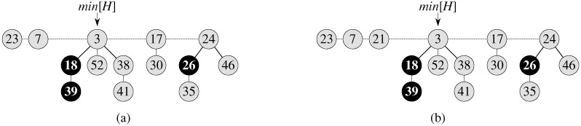
Pic. 2

Uniting two Fibonacci heaps
FIB-HEAP-UNION(H₁, H₂)
1 H ← MAKE-FIB-HEAP()
2 min[H] ← min[H₁]
3 concatenate the root list of H₂ with the root list of H
4 if (min[H₁] = NIL) or (min[H₂] ≠ NIL and min[H₂] < min[H₁])
5 then min[H] ← min[H₂]
6 n[H] ← n[H₁] + n[H₂]
7 free the objects H₁ and H₂
8 return H

Extracting the minimum node
FIB-HEAP-EXTRACT-MIN(H)
1 z ← min[H]
2 if z ≠ NIL
3 then for each child x of z
4 do add x to the root list of H
5 p[x] ← NIL
6 remove z from the root list of H
7 if z = right[z]
8 then min[H] ← NIL
9 else min[H] ← right[z]
10 CONSOLIDATE(H)
11 n[H] ← n[H] - 1
12 return z

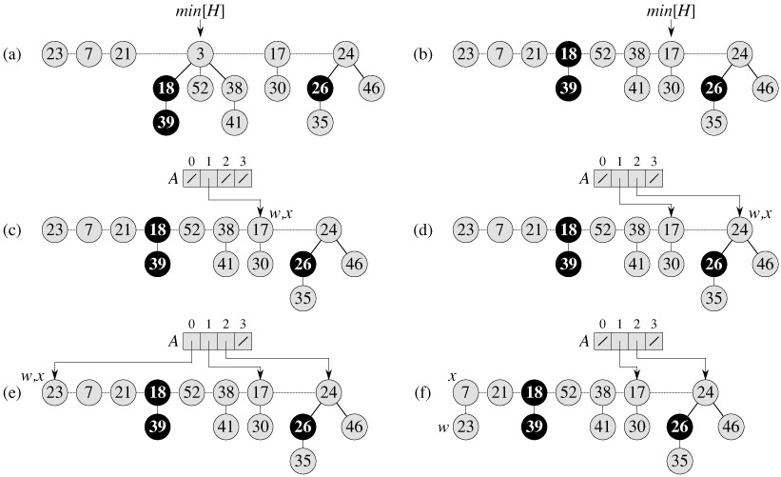
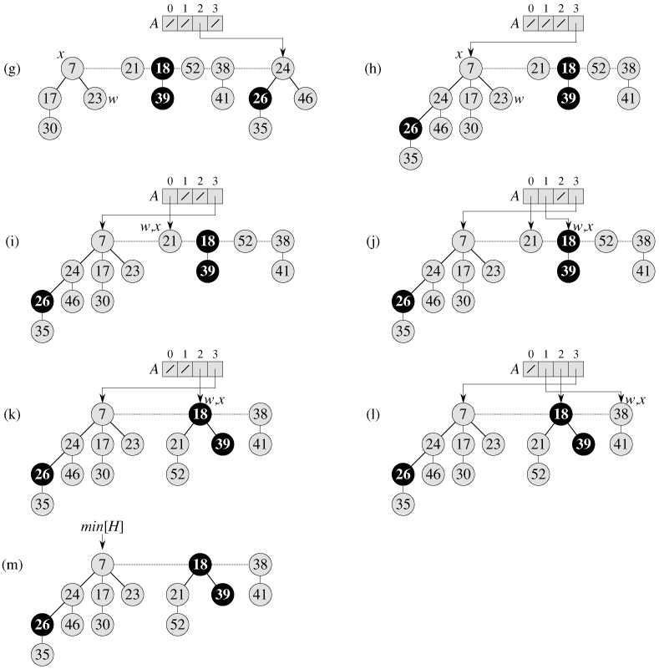

Pic. 3

CONSOLIDATE(H)
1 for i ← 0 to D(n[H])
2 do A[i] ← NIL
3 for each node w in the root list of H
4 do x ← w
5 d ← degree[x]
6 while A[d] ≠ NIL
7 do y ← A[d] ▹ Another node with the same degree as x.
8 if key[x] > key[y]
9 then exchange x ↔ y
10 FIB-HEAP-LINK(H, y, x)
11 A[d] ← NIL
12 d ← d + 1
13 A[d] ← x
14 min[H] ← NIL
15 for i ← 0 to D(n[H])
16 do if A[i] ≠ NIL
17 then add A[i] to the root list of H
18 if min[H] = NIL or key[A[i]] < key[min[H]]
19 then min[H] ← A[i]
FIB-HEAP-LINK(H, y, x)
1 remove y from the root list of H
2 make y a child of x, incrementing degree[x]
3 mark[y] ← FALSE

String Matching

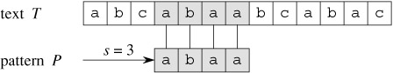

Рис 1

The naive string-matching algorithm

NAIVE-STRING-MATCHER(T, P)
1 n ← length[T]
2 m ← length[P]
3 for s ← 0 to n - m
4 do if P[1 ‥ m] = T[s + 1 ‥ s + m]
5 then print "Pattern occurs with shift" s

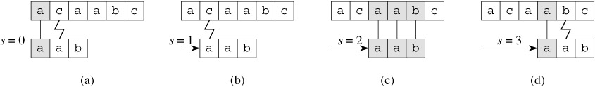

Рис 2

Procedure NAIVE-STRING-MATCHER takes time O((n - m + 1)m)
The Rabin-Karp algorithm

Пусть Σ = {0, 1, 2, . . . , 9}
p = P[m] + 10 (P[m - 1] + 10(P[m - 2] + · · · + 10(P[2] + 10P[1]) )).
t₀ <= T [1 ‥ m] in time Θ(m)
m=5
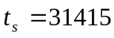
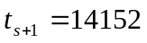
10(31415 - 10000 · 3) + 2 = 14152.
=> сложность O(n)
h=d^(m-1)

q – простое число
dq<maxint

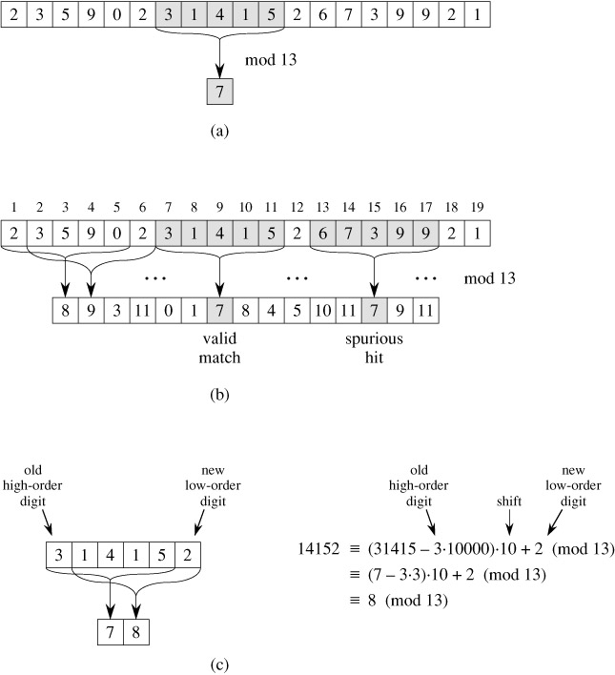
Рис 3

RABIN-KARP-MATCHER(T, P, d, q)
1 n ← length[T]
2 m ← length[P]
3 h ← d^{m-1} mod q
4 p ← 0
5 t₀ ← 0
6 for i ← 1 to m ▹ Preprocessing.
7 do p ← (dp + P[i]) mod q
8 t₀ ← (dt₀ + T[i]) mod q
9 for s ← 0 to n - m ▹ Matching.
10 do if p = t_{s}
11 then if P[1 ‥ m] = T [s + 1 ‥ s + m]
12 then print "Pattern occurs with shift" s
13 if s < n - m
14 then t_{s+1} ← (d(t_{s} - T[s + 1]h) + T[s + m + 1]) mod q

=> сложность O(n) в среднем и O(n*m) в худшем случае.

String matching with finite automata

Finite automata
A finite automaton M is a 5-tuple (Q, q₀, A, Σ, δ), where
- Q is a finite set of states,
- q₀ ∈ Q is the start state,
- A ⊆ Q is a distinguished set of accepting states,
- Σ is a finite input alphabet,
- δ is a function from Q × Σ into Q, called the transition function of M.
δ(q,a)
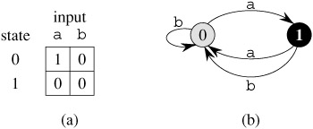
Рис 4

final-state function φ(w) – состояние, в которое перейдет автомат прочитав строку w.
φ(ε) | = | q₀,
φ(wa) | = | δ(φ(w), a)

String-matching automata
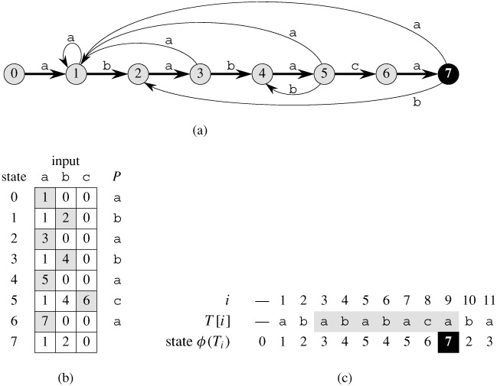
Рис 5

σ(x) = max {k : P_{k} ⊐ x}.
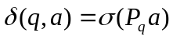

FINITE-AUTOMATON-MATCHER(T, δ, m)
1 n ← length[T]
2 q ← 0
3 for i ← 1 to n
4 do q ← δ(q, T[i])
5 if q = m
6 then print "Pattern occurs with shift" i - m

O(n)

COMPUTE-TRANSITION-FUNCTION(P, Σ)
1 m ← length[P]
2 for q ← 0 to m
3 do for each character a ∈ Σ
4 do k ← min(m + 1, q + 2)
5 repeat k ← k - 1
6 until P_{k} ⊐ P_{q}a
7 δ(q, a) ← k
8 return δ

O(m³ |Σ|)
The Knuth-Morris-Pratt algorithm

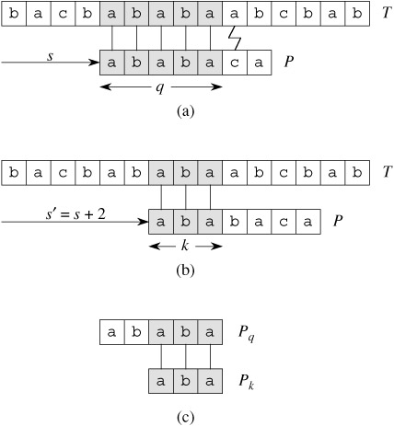
Рис 6

Префикс-функция
k=π[q] = max {k : k < q and P_{k} ⊐ P_{q}}.
KMP-MATCHER(T, P)
1 n ← length[T]
2 m ← length[P]
3 π ← COMPUTE-PREFIX-FUNCTION(P)
4 q ← 0 ▹Number of characters matched.
5 for i ← 1 to n ▹Scan the text from left to right.
6 do while q > 0 and P[q + 1] ≠ T[i]
7 do q ← π[q] ▹Next character does not match.
8 if P[q + 1] = T[i]
9 then q ← q + 1 ▹Next character matches.
10 if q = m ▹Is all of P matched?
11 then print "Pattern occurs with shift" i - m
12 q ← π[q] ▹Look for the next match.

O(n+m)

COMPUTE-PREFIX-FUNCTION(P)
1 m ← length[P]
2 π[1] ← 0
3 k ← 0
4 for q ← 2 to m
5 do while k > 0 and P[k + 1] ≠ P[q]
6 do k ← π[k]
7 if P[k + 1] = P[q]
8 then k ← k + 1
9 π[q] ← k
10 return π

