Kamala Education Society’s
Pratibha College of Commerce & Computer Studies, Chinchwad, Pune-19



A
Project Report
On
“DANCE STUDIO”
Developed by,
4962: ARUSHI AGARWAL
4967: RUTUJA WANGWAD

T.Y.B.B.A. (C.A.)
Under
Savitribai Phule Pune University
(2021-2022)
Kamala Education Society’s
Pratibha College of Commerce & Computer Studies, Chinchwad, Pune-19

Certificate
This is to certify that Ms. WANGWAD RUTUJA & Ms. AGARWAL ARUSHI satisfactorily completed the PHP & HTML entitled “DANCE STUDIO” for T.Y.B.B.A.(C.A.) Semester V CA-505 Project under the Savitribai Phule Pune University in the academic year 2021-2022.

____________________ ___________________ ____________________
Dr. Babasaheb San gale Mrs. Himalaya Chavan Mr. Tulshiram amble
Principal Program Coordinator Project Guide

__________________ _________________
Internal Examiner External Examiner

Date:
ACKNOWLEDGEMENT

Any efforts to produce successful creation require the help, Guidance and support of many people and their experience. We would like to express our sincere and heartfelt gratitude to all of them.
We would like to take this opportunity to thanks all the people who have directly or indirectly helped this project. We would like to thank our guide Mr. Tulshiram amble, for his valuable guidance.

-RUTUJA WANGWAD
-ARUSHI AGARWAL

Table of Contents
Sr. No. | Content | Page No.
1 | Introduction  - Problem Statement  - Purpose/Objective and Goals  - Project Scope  - Limitations | 5
2 | System Analysis  - Existing System  - Scope and Limitations of Existing System  - Requirement Analysis | 6
3 | System Design  - Data Dictionary  - Table Design  - Data Flow Diagram  - ER Diagram  - User Interface | 9
4 | Implementation Details  - Hardware and Software Requirement | 16
5 | Outputs and Report Testing | 17
6 | Conclusion and Recommendations | 20
7 | Future Scope | 21
8 | Bibliography and References | 22

Introduction

Problem Statement:

Student's information would be kept in the students' file and kept at the cupboard with plenty of paper files. Every payment received from students is recorded in the payment book. Class schedule is written on paper and kept in files for the administrator record. If students need to know of a particular schedule for class, she or he would need to ask at the counter.

Purpose/Objectives/Goals:
- The main objective of developing this project is to provide an easier way for candidates to register online for dance classes. In the Online Dance Registration Project, we use PHP and MySQL database. This project has two modules i.e., admin and user.
- We provide dance training for students at all levels of dance. To combine the dance with fitness and isolation exercises.
- With an aim to provide quality dance training and making dance available to all,
- for students from ages four to eighty -four providing them with training in various dance styles by expert faculty. The classes give them an opportunity to learn dance, express themselves creatively and perform on stage. Classes are available for children (4 to 6 years), juniors (7 to 11 years) and adults (12 years onwards).
Project Scope:
- Dance studio is the web application to manage the activities of dance academy.
- This project keeps track of all dance academy information like student inquiry/registration information, batch information, attendance details, staff information and keeps track of dance academy day to day transactions.
- This is the web -based application for Dance academy. In this system it will display all information about academy and at the same time this project manages all activities dance academy.
- It has online application form which helps new students to apply through online.
SYSTEM ANALYSIS
Existing System:
- This project Dance Studio is an online website which provides a platform for all age groups to learn and excel in the most amazing and loved field called Dance. It has various forms of dance available.
- It also provides a safe and fun environment that allows every individual in developing skills.
- Anyone who wants to learn dance, can visit this website and can register online.

Scope and Limitations of Existing System:
- In this web -based system, it will be able to present viewer all related information about the academy as a normal website in the internet and at the same time allow management task to be done on the system.
- The web -based system is important as to enable a better and more organized way in keeping track of the dance academy's daily business and its student's data.
- Viewers will have an easy accessibility to all information of the dance academies.

Requirement Analysis
Step 1: Identify Key Stakeholders and End-Users
The first step of the requirements analysis process is to identify key stakeholders who are the main sponsors of the project. They will have the final say on what should be included in the scope of the project. Next, identify the end-users of the product. Since the product is intended to satisfy their needs, their inputs are equally important.
Step 2: Capture Requirements:
1.Hold One-on-One Interviews
Interview each stakeholder and end-user individually. This technique will help you gather specific requirements.
2. Use Focus Groups
Conduct group interviews or group workshops to understand the flow of information between different stakeholders and end-users. This technique will ensure that there will be no conflict of interest later on during the project.
3. Utilize Use Cases
Use cases provide a walkthrough of the entire product through the eyes of the end-user. This technique will help visualize how the product will actually work.
4. Build Prototypes
A prototype provides users a sample look and feel of the final product. This technique will help address feasibility issues and identify problems ahead of time.
Functional Requirements - Functions the product is required to perform.
Technical Requirements - Technical issues to be considered for the successful implementation of the product.
Transitional Requirements - Steps required to implement a new product smoothly.
Operational Requirements - Operations to be carried out in the backend for proper functioning of the product.
Step 4: Interpret and Record Requirements
Once the requirements are categorized, determine which requirements are actually achievable and document each one of them. Here are some techniques to analyse and interpret requirements:

Define Requirements Precisely
Ensure that the requirements are clearly worded, sufficiently detailed, and related to business needs.
Prioritize Requirements
Prioritize requirements and list them out based on which ones are the “most critical” and which ones are just “nice-to-have”. Carry Out an Impact Analysis
Carry out an impact analysis to make sure that you fully understand the consequences of the requirements.
Resolve Conflicts
Arrange a meeting with key stakeholders and resolve conflicting requirements. You can also perform a scenario analysis to explore how the requirements would work for different possible scenarios.
Analyse Feasibility
Perform a detailed analysis of the product based on the requirements gathered to determine its reliability and to identify any major problems Once all the requirements are analyzed, create a detailed written document and circulate it among the key stakeholders, end-users and development teams.
Step 5: Sign off
Once a final decision is made on the requirements, ensure that you get a signed agreement from the key stakeholders. This is done to ensure that there are no changes or uncontrolled growth in the scope of the project. Now, we will learn the requirement analysis techniques.
System Design:
1.Data Dictionary:
Table Name: DATASET Description: DATA OF ADMIN
Field | Data Type | Constraints | Data Description
Name | varchar (40) | Not null | Its show name of user
Id | varchar (20) | Primary Key | Its show Id of user
Email | varchar (40) | Not null | Its show Email of user
mobile No | varchar (10) | Not null | Its show Mobile No. of user
gender | varchar (20) | Not null | Its show gender of user
dob | varchar (20) | Not null | Its show dobs of user
age | varchar (20) | Not null | Its show age of user
address | varchar (100) | Not null | its show address of user

Unauthorized Access:
Table Name: Unauthorised Access
Description: Contains the data when user enter wrong password.
Field | Data Type | Constraints | Data Description
Sr No | varchar (20) | Primary Key | Its show the SR No
time | varchar (20) | not null | show the time when user enter wrong pw
date | varchar (20) | not null | date of wrong password entered
path | varchar (20) | not null | show path of image stored
USER DATABASE:
Table Name: Users
Description: Contains the users’ data who buy system.

Field | Data Type | Constraints | Data description
Id | int (11) | Primary Key | Its show the Id for user
fname | varchar (20) | Not null | first name of user
lname | varchar (20) | Not null | last name of user
contact | varchar (20) | Not null | contact of user
email | varchar (20) | Not null | email of user
Question | varchar (20) | Not null | Question for reset password
answer | varchar (20) | Not null | answer of the question
password | varchar (20) | Not null | password for login

ER-Diagram (Admin-Control)

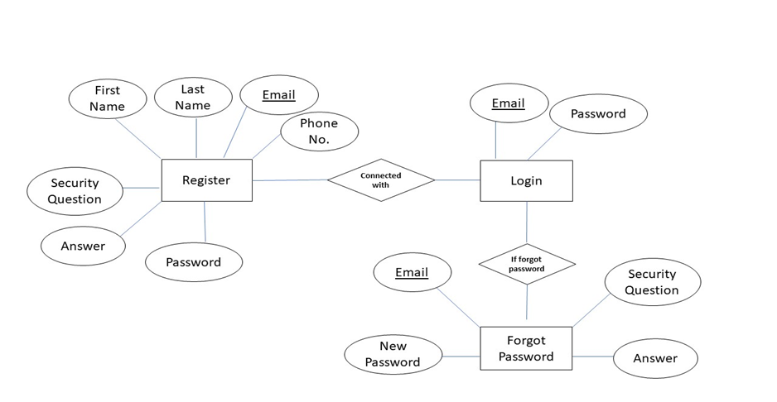

DFD
0 level

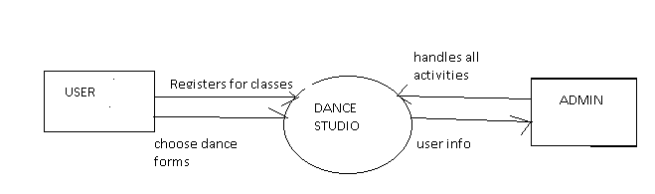

1 level
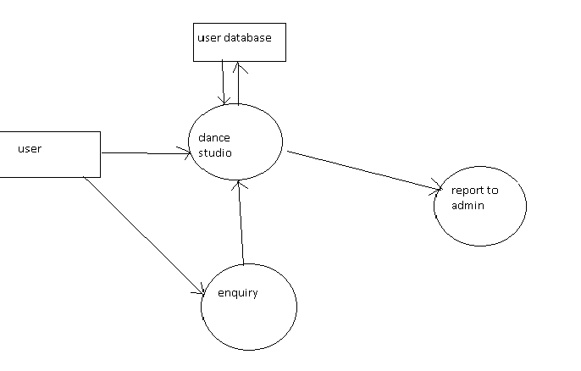

USE-CASE DIAGRAM

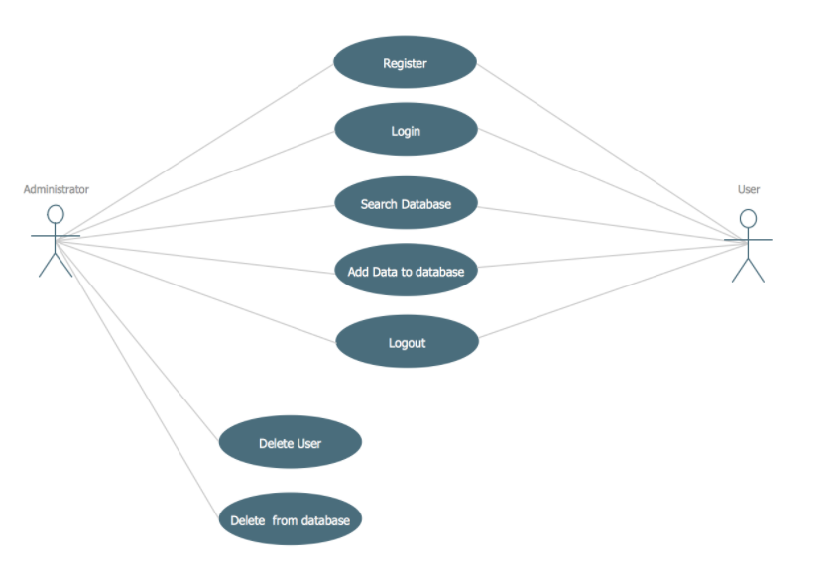

USER-INTERFACE

Home page 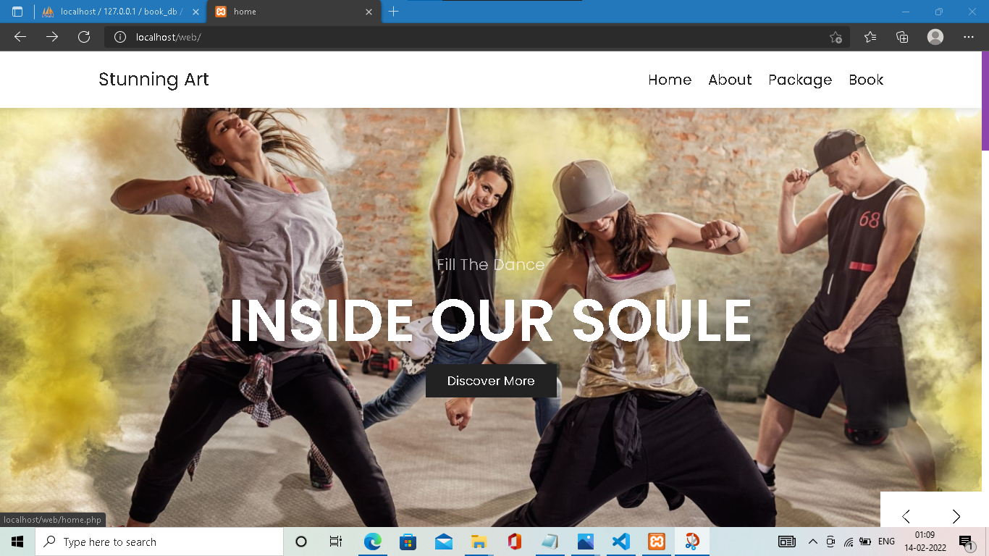

About page
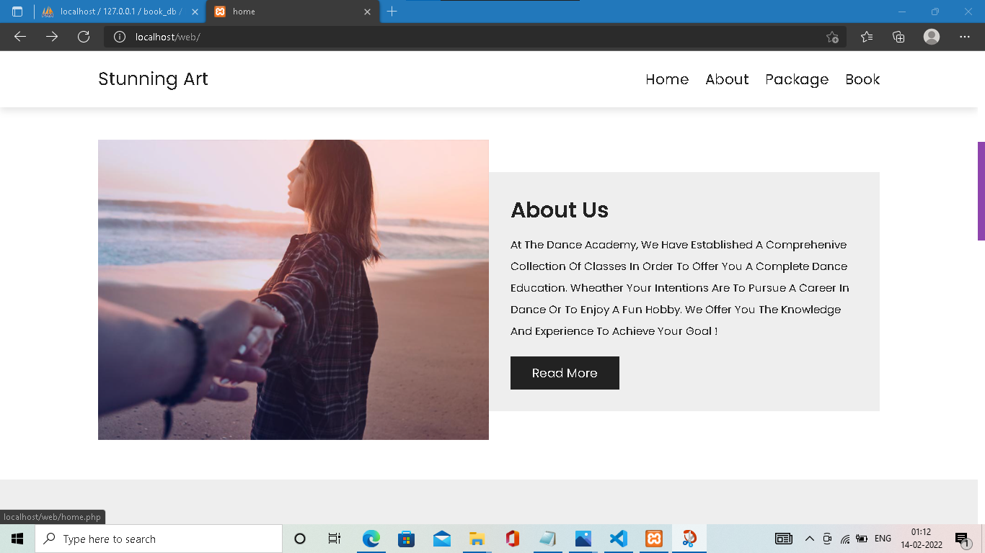
Packages page

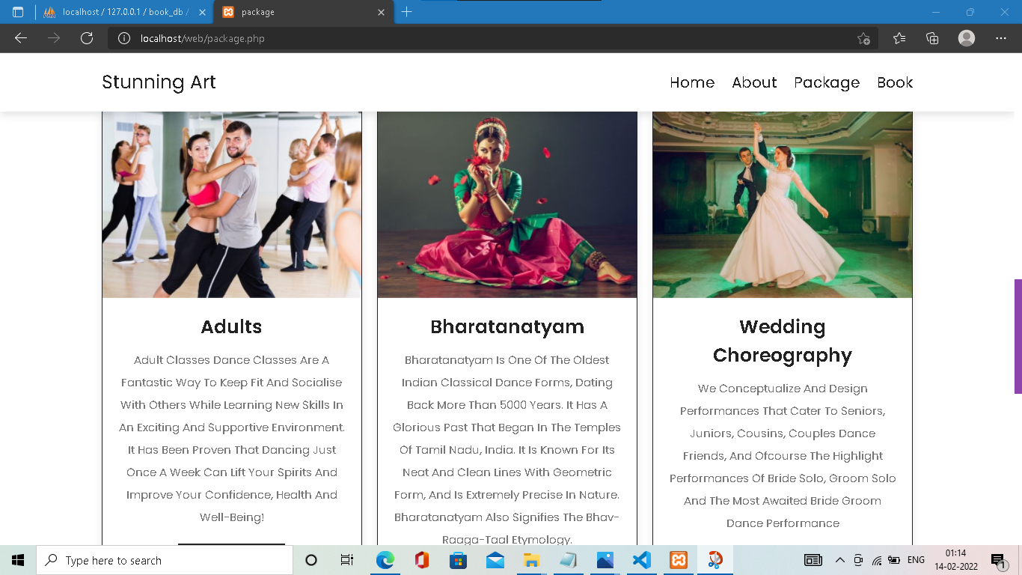

Implementation Details
Programming Language: PHP
Database: MySQL
Design and Interface: HTML, CSS
Script: Javascript.
Software Requirements-
OPERATING SYSTEM - WINDOWS/LINUX/MAC/OS,
DATABASE - MYSQL,
PLATFORM – PHP,
WEB BROWSER – CHROME, JAVA SCRIPT.

Hardware Requirements-
PROCESSOR - INTEL CORE i3(2.30 GHz),
RAM - 1 GB RAM,
HARD DISK SPACE - 10 GB HDD,
LCD MONITOR WITH MINIMUM RESOLUTION OF 1024x768

Outputs and Report Testing
Installation test, functional test, load test, Data integrity test.
To register a new user, dance studio using to provide their email and phone number. It checks if the phone number or email already has a user in the database, if it doesn’t the user is then takes to a screen where they fill in their details which include full name, email, phone number, date, address, time a short description of themselves.
booking class

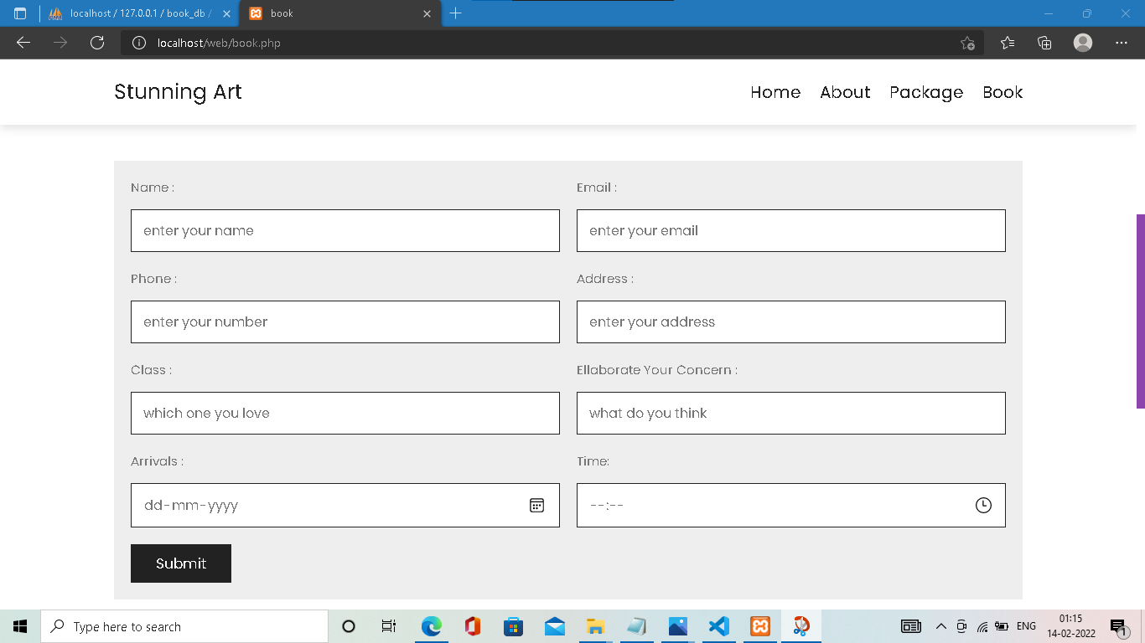

Database
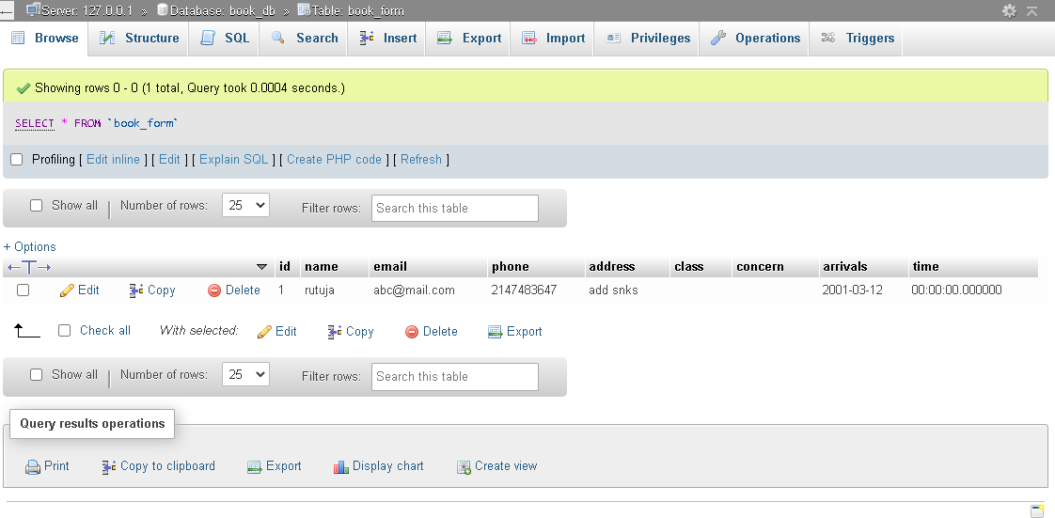
Test cases:
Test Case ID | Test Case Name | Sub Test Case ID | Steps to Execute | Expected Result | Actual Result | Pass/Fail
TC_1 | To Verify Login Page | TC_001 | Keep username and password blank and click login | Display error message for entering username and password | Displays error message | Pass
 |  | TC_002 | Enter username and blank password and click login | Display error message for entering password | Displays message to enter password | Pass
 |  | TC_003 | Enter password and blank username and click login | Display error message for entering username | Displays message to enter username | Pass
 |  | TC_004 | Enter username correct and password incorrect and click login | Display error message invalid login details & Capture image | Displays error message | Pass
 |  | TC_005 | Enter username incorrect and password correct and click login | Display error message invalid login details & Capture image | Displays error message | Pass

Conclusion: -
This project aims to develop a dance academy management system in order to provide solutions to current problems and increase the efficiency.
Thus, our system meets the very basic and necessary needs of a viewers and also makes it easier for the administrator or the academy manger to fulfill the expectations of the customers. The website has been developed with much care that is free of error and at the same time it is efficient and more useful. The important thing is that the website robust.

Future Scope: -
The currently used Dance Academy Management System is the best suitable for the web pages on a computer system, there raised some issues while using it on cross-platform, i.e., if the viewing browser or platform of the web page changes, it misbehaves.
The future system will be supporting the web precisive, feature that display the web pages on any device as per its dimensions.
Even for register users, the future system can be developed on a mobile application providing all the services same as the web application.

BIBLIOGRAPHY AND REFERENCES:

DANCE MANAGENT SYSTEM CLASSES - Search (bing.com)
https://www.google.com/search?q=porfolio+disgn+of+dance&rlz=1C1VDKB_enIN953IN953&oq=porfolio+disgn+of+dance&aqs=chrome.69i57.15887j0j4&sourceid=chrome&ie=UTF-8

