02 — Exploratory Analysis
Rutuja Kadam
library(readr)
library(dplyr)
library(tidyr)
library(ggplot2)
library(forcats)
source("../R/helpers.R")
dir.create("../figures", showWarnings = FALSE, recursive = TRUE)
dir.create("../results", showWarnings = FALSE, recursive = TRUE)
data <- read_csv("../data/processed/anonymized_survey_data.csv", show_col_types = FALSE)

Sample profile
age_distribution <- data %>% count(age_group, sort = TRUE) %>% mutate(percent = n / sum(n))
occupation_distribution <- data %>% count(occupation, sort = TRUE) %>% mutate(percent = n / sum(n))
region_distribution <- data %>% count(region_type, sort = TRUE) %>% mutate(percent = n / sum(n))
education_distribution <- data %>% count(education, sort = TRUE) %>% mutate(percent = n / sum(n))
write_csv(age_distribution, "../results/age_distribution.csv")
write_csv(occupation_distribution, "../results/occupation_distribution.csv")
write_csv(region_distribution, "../results/region_distribution.csv")
write_csv(education_distribution, "../results/education_distribution.csv")
age_distribution
## # A tibble: 4 × 3
## age_group n percent
## <chr> <int> <dbl>
## 1 18-25 114 0.781
## 2 26-35 22 0.151
## 3 36-45 6 0.0411
## 4 46 and above 4 0.0274
occupation_distribution
## # A tibble: 5 × 3
## occupation n percent
## <chr> <int> <dbl>
## 1 Student 98 0.671
## 2 Employed 39 0.267
## 3 Homemaker 4 0.0274
## 4 Unemployed 3 0.0205
## 5 Self-employed 2 0.0137
region_distribution
## # A tibble: 3 × 3
## region_type n percent
## <chr> <int> <dbl>
## 1 Urban 98 0.671
## 2 Suburban 28 0.192
## 3 Rural 20 0.137
education_distribution
## # A tibble: 7 × 3
## education n percent
## <chr> <int> <dbl>
## 1 Post Graduate 85 0.582
## 2 Graduate 43 0.295
## 3 PhD 10 0.0685
## 4 12th std 5 0.0342
## 5 M Phil 1 0.00685
## 6 MPhil 1 0.00685
## 7 Under Graduate 1 0.00685

Current product distribution
# Keep the product visualization focused on actual menstrual-hygiene products.
# Missing/not-applicable responses are documented separately rather than plotted as products.
excluded_product_responses <- data %>%
filter(is.na(primary_product) | primary_product == "Do not need after menopause") %>%
count(primary_product, .drop = FALSE, name = "n")
product_distribution <- data %>%
filter(!is.na(primary_product), primary_product != "Do not need after menopause") %>%
count(primary_product, sort = TRUE) %>%
mutate(percent = n / sum(n))
write_csv(product_distribution, "../results/product_distribution.csv")
write_csv(excluded_product_responses, "../results/product_excluded_responses.csv")
product_distribution
## # A tibble: 4 × 3
## primary_product n percent
## <chr> <int> <dbl>
## 1 Sanitary pad 133 0.924
## 2 Menstrual cup 9 0.0625
## 3 Period panties 1 0.00694
## 4 cloth 1 0.00694
product_distribution_plot <- ggplot(
product_distribution,
aes(x = fct_reorder(primary_product, n), y = n)
) +
geom_col() +
coord_flip() +
labs(
title = "Current primary menstrual-hygiene product",
x = NULL,
y = "Respondents"
) +
theme_minimal()
product_distribution_plot
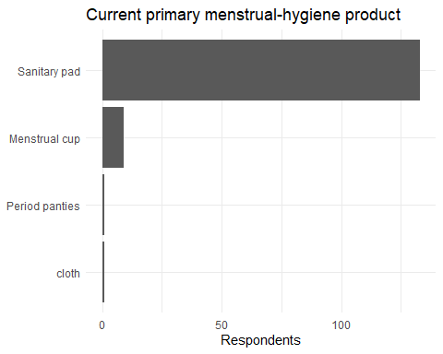
ggsave(
"../figures/product_usage_distribution.png",
plot = product_distribution_plot,
width = 8,
height = 5,
dpi = 300
)

Importance of product attributes
importance_cols <- c(
"comfort_importance", "cost_importance", "availability_importance",
"health_risk_importance", "leakage_protection_importance",
"durability_importance", "reusability_importance", "variants_importance",
"brand_importance", "quality_importance", "sustainability_importance",
"affordability_importance"
)
attribute_summary <- data %>%
summarise(across(all_of(importance_cols), ~mean(.x, na.rm = TRUE))) %>%
pivot_longer(everything(), names_to = "attribute", values_to = "mean_rating") %>%
mutate(
attribute_label = attribute %>%
sub("_importance$", "", .) %>%
gsub("_", " ", .) %>%
tools::toTitleCase()
) %>%
arrange(desc(mean_rating))
write_csv(attribute_summary, "../results/attribute_importance_summary.csv")
attribute_summary
## # A tibble: 12 × 3
## attribute mean_rating attribute_label
## <chr> <dbl> <chr>
## 1 quality_importance 4.64 Quality
## 2 affordability_importance 4.62 Affordability
## 3 comfort_importance 4.52 Comfort
## 4 leakage_protection_importance 4.48 Leakage Protection
## 5 health_risk_importance 4.38 Health Risk
## 6 durability_importance 4.36 Durability
## 7 availability_importance 4.27 Availability
## 8 variants_importance 4.19 Variants
## 9 sustainability_importance 4.13 Sustainability
## 10 brand_importance 4.02 Brand
## 11 cost_importance 3.71 Cost
## 12 reusability_importance 3.10 Reusability
attribute_summary_plot <- ggplot(
attribute_summary,
aes(x = fct_reorder(attribute_label, mean_rating), y = mean_rating)
) +
geom_col() +
coord_flip() +
labs(
title = "Average importance rating by product attribute",
x = NULL,
y = "Mean rating (1–5)"
) +
theme_minimal()
attribute_summary_plot
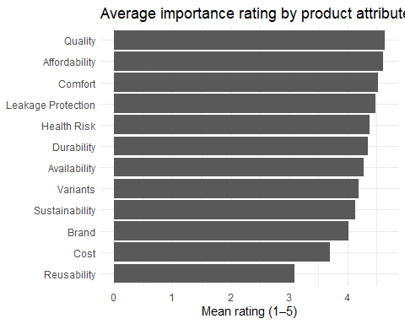
ggsave(
"../figures/product_attribute_importance.png",
plot = attribute_summary_plot,
width = 8,
height = 5,
dpi = 300
)

Behavioral outcomes
changed_product_summary <- data %>% count(changed_product_5y) %>% mutate(percent = n / sum(n))
future_switch_summary <- data %>% count(future_switch_intention) %>% mutate(percent = n / sum(n))
alternative_usage_summary <- data %>% count(uses_alternatives) %>% mutate(percent = n / sum(n))
write_csv(changed_product_summary, "../results/changed_product_distribution.csv")
write_csv(future_switch_summary, "../results/future_switch_intention_distribution.csv")
write_csv(alternative_usage_summary, "../results/alternative_product_usage_distribution.csv")
changed_product_summary
## # A tibble: 2 × 3
## changed_product_5y n percent
## <chr> <int> <dbl>
## 1 No 119 0.815
## 2 Yes 27 0.185
future_switch_summary
## # A tibble: 3 × 3
## future_switch_intention n percent
## <chr> <int> <dbl>
## 1 Maybe 84 0.575
## 2 No 33 0.226
## 3 Yes 29 0.199
alternative_usage_summary
## # A tibble: 3 × 3
## uses_alternatives n percent
## <chr> <int> <dbl>
## 1 No 95 0.651
## 2 Sometimes 38 0.260
## 3 Yes 13 0.0890

Cultural and social context
discussion_comfort_summary <- data %>% count(discussion_comfort) %>% mutate(percent = n / sum(n))
cultural_taboos_summary <- data %>% count(cultural_taboos) %>% mutate(percent = n / sum(n))
social_stigma_summary <- data %>% count(social_stigma) %>% mutate(percent = n / sum(n))
write_csv(discussion_comfort_summary, "../results/discussion_comfort_distribution.csv")
write_csv(cultural_taboos_summary, "../results/cultural_taboos_distribution.csv")
write_csv(social_stigma_summary, "../results/social_stigma_distribution.csv")
discussion_comfort_summary
## # A tibble: 3 × 3
## discussion_comfort n percent
## <chr> <int> <dbl>
## 1 No 4 0.0274
## 2 Sometimes 34 0.233
## 3 Yes 108 0.740
cultural_taboos_summary
## # A tibble: 3 × 3
## cultural_taboos n percent
## <chr> <int> <dbl>
## 1 Maybe 26 0.178
## 2 No 91 0.623
## 3 Yes 29 0.199
social_stigma_summary
## # A tibble: 3 × 3
## social_stigma n percent
## <chr> <int> <dbl>
## 1 Maybe 23 0.158
## 2 No 110 0.753
## 3 Yes 13 0.0890

Interpretation guardrail
The sample is a convenience sample and is concentrated among younger and student respondents. Descriptive patterns should therefore be interpreted as characteristics of this sample, not population estimates.

