**Name: Rutuparna Kolte**

**PRN No: 122A9042**

**Experiment 1**

**Aim:** To understand the basic Windows based network commands.

**Commands:**

1. **ping:** The ping command sends a request over the network to a specific device.

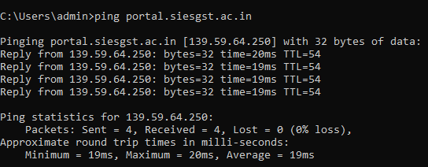

1. **ipconfig:** The ipconfig command is used to display information about your network configuration and refresh DHCP and DNS Settings. By default, the ipconfig command displays your IP Address, Subnet Mask, and default gateway.

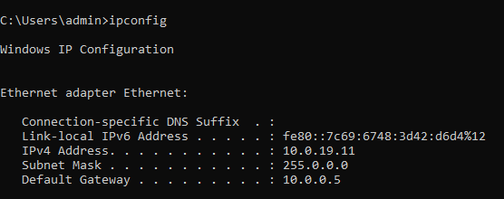

1. **ipconfig /all:** This command will show all the information about your network adapter: Physical Address: This is the MAC address of your network adapter. DHCP Enabled: Indicates if the network connection is using DHCP or Static IP Address.

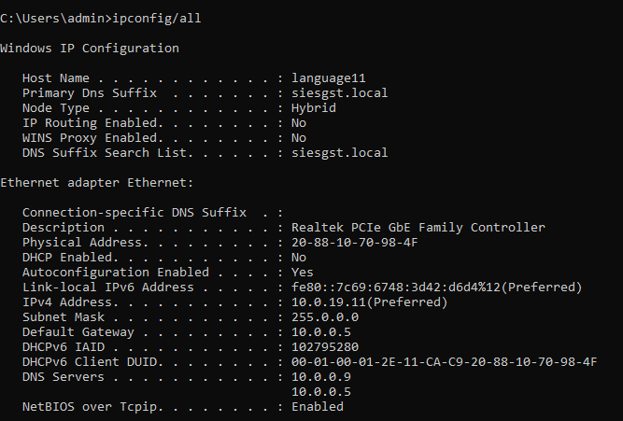

1. **hostname**:  This command displays the name of the current host system.



1. **tracert:** The command will return output indicating the hops discovered and time (in milliseconds) for each hop. Is is useful for troubleshooting large networks where several paths can lead to the same point or where many intermediate components (routers or bridges) are involved.

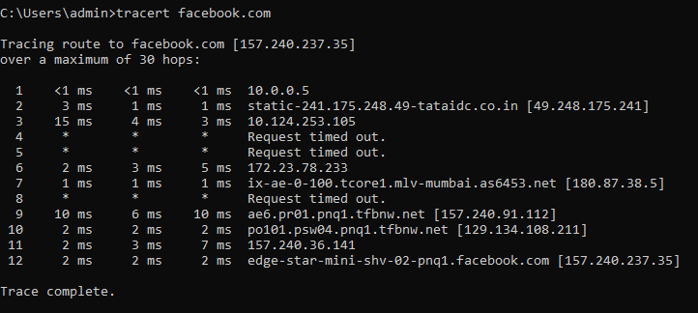

1. **netstat:** The network statistics (netstat) command is a networking tool used for troubleshooting and configuration, that can also serve as a monitoring tool for connections over the network. Both incoming and outgoing connections, routing tables, port listening, and usage statistics are common uses for this command.

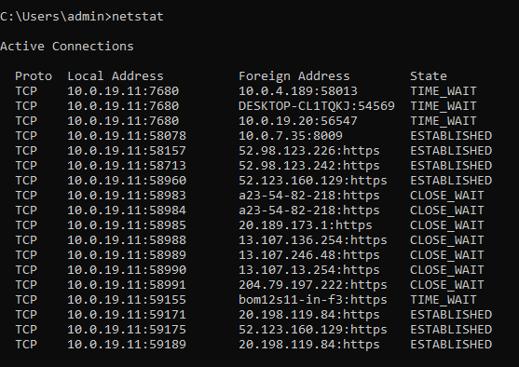

1. **pathping:** Provides information about network latency and network loss at intermediate hops between a source and destination. This command sends multiple echo Request messages to each router between a source and destination, over a period of time, and then computes results based on the packets returned from each router.

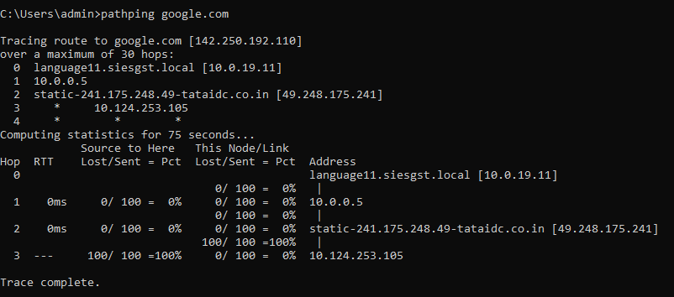

**Conclusion:** The network commands were implemented for windows operating systems. The ping command is used to send request to a server over the network. The ipconfig command is used to display information about your network configuration. The hostname command displays the name of the current host system. The tracert command returns the output indicating the hops discovered and time. The netstat command is a networking tool used for troubleshooting and configuration. The pathping command provides information about network latency and network loss at intermediate hops.

**Post Experimental Exercise:**

**1. Explore and implement any three network commands of Windows system which are not listed in the laboratory write up and write conclusions about them.**

**(1) getmac:** getmac is a Windows command used to display the Media Access Control (MAC) addresses for each network adapter in the computer.

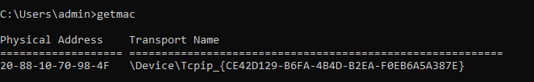

**(2) nslookup:** The nslookup command queries internet domain name servers in two modes. Interactive mode allows you to query name servers for information about various hosts and domains, or to print a list of the hosts in a domain. In noninteractive mode, the names and requested information are printed for a specified host or domain.

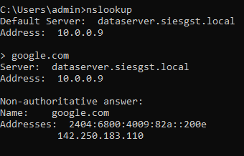

**(3) arp -a:** The arp-a command displays and modifies the Internet-to-adapter address translation tables used by the Address in Networks and communication management.

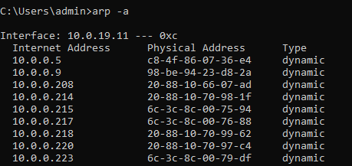

**2. Answer following questions:**

**(1) What is the full form of ICMP? Find which layer protocol is this?**

**Ans:** The Internet Control Message Protocol (ICMP) is a network layer protocol.

**(2) What is TTL? Explain how is it used?**

**Ans:** Time To Live (TTL) refers to the amount of time or “hops” that a packet is set to exist inside a network before being discarded by a router. TTL is also used in other contexts including CDN caching and DNS caching.

**(3) What is the full form of DHCP? Find which layer protocol is this?**

**Ans:** The Dynamic Host Configuration Protocol (DHCP) is Application Layer Protocol.

**(4) What is the IP address of your PC?**

**Ans:** 10.0.19.11

**(5) What is the MAC address of your PC?**

**Ans:** 20-88-10-70-98-4F