WIREFRAME

**ADULT CENSUS INCOME PREDICTION**

**Table of Contents:**

1. Home Page  
2. Database Page

1. **Homepage:**

I have created the design of an Income prediction application in a such way that user can insert their inputs according to their requirements in a flexible manner on a front page.

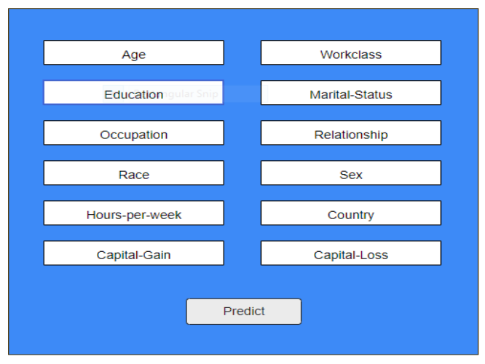

1. **Database Page:**

I have created 12 columns on the Database page. All the columns are being populated from Cassandra database on API hit

