Q1. SELECT clause with WHERE, AND, DISTINCT, Wild Card (LIKE)

- Fetch the employee number, first name and last name of those employees who are working as Sales Rep reporting to employee with employeenumber 1102(Refer employee table)

Query:
use class;
select distinct employeenumber, firstname, lastname
from employees
where jobTitle = "Sales Rep " and reportsto = 1102

Expected output:
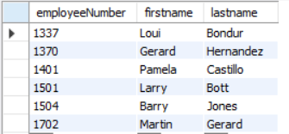

- Show the unique productline values containing the word cars at the end from the products table

Query:
use class;
select productLine
from products
where productLine like '% Cars';
desc products

Expected output:
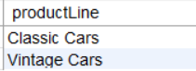

Q2. CASE STATEMENTS for Segmentation

. a. Using a CASE statement, segment customers into three categories based on their country:(Refer Customers table)
"North America" for customers from USA or Canada
"Europe" for customers from UK, France, or Germany
"Other" for all remaining countries
Select the customerNumber, customerName, and the assigned region as "CustomerSegment".

Query:
select customernumber,customername,
case
when country in ('usa','canda') then 'north america'
when country in ('uk','franc', 'germany') then 'europe'
else 'other'
end as custmersegment
from customers;

Expected output:
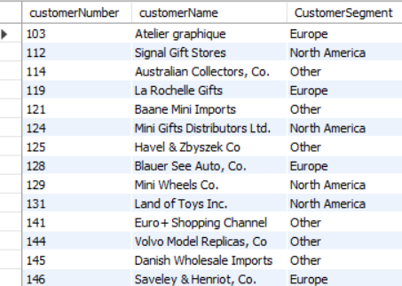

Q3. Group By with Aggregation functions and Having clause, Date and Time functions

- Using the OrderDetails table, identify the top 10 products (by productCode) with the highest total order quantity across all orders

Query:
select productcode,sum(quantityOrdered) as total_ordered
from orderdetails
group by productCode
order by total_ordered desc
limit 10;

Expected output:
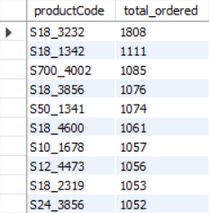

- Company wants to analyse payment frequency by month. Extract the month name from the payment date to count the total number of payments for each month and include only those months wifth a payment count exceeding 20. Sort the results by total number of payments in descending order. (Refer Payments table).

Query:
select
monthname(paymentDate) as payment_month,
count(*) as num_payments
from Payments
group by monthname(paymentDate)
having count(*) > 20
order by num_payments desc;

Expected output:
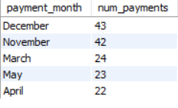

Q4. CONSTRAINTS: Primary, key, foreign key, Unique, check, not null, default

Create a new database named and Customers_Orders and add the following tables as per the description

- Create a table named Customers to store customer information. Include the following columns:

customer_id: This should be an integer set as the PRIMARY KEY and AUTO_INCREMENT.
first_name: This should be a VARCHAR(50) to store the customer's first name.
last_name: This should be a VARCHAR(50) to store the customer's last name.
email: This should be a VARCHAR(255) set as UNIQUE to ensure no duplicate email addresses exist.
phone_number: This can be a VARCHAR(20) to allow for different phone number formats.

Add a NOT NULL constraint to the first_name and last_name columns to ensure they always have a value.

Query:
create database Customer_orders ;
use Customer_orders ;

create table Customers (
customer_id int primary key auto_increment ,
first_name varchar(50) not null,
last_name varchar(50) not null,
email varchar(225) unique,
phone_number varchar(20)
);
desc Customers;

- Create a table named Orders to store information about customer orders. Include the following columns:

order_id: This should be an integer set as the PRIMARY KEY and AUTO_INCREMENT.
customer_id: This should be an integer referencing the customer_id in the Customers table (FOREIGN KEY).
order_date: This should be a DATE data type to store the order date.
total_amount: This should be a DECIMAL(10,2) to store the total order amount.

Constraints:
- Set a FOREIGN KEY constraint on customer_id to reference the Customers table.
- Add a CHECK constraint to ensure the total_amount is always a positive value.

Query:

create table orders (
order_id int primary key auto_increment,
customer_id int,
order_date date ,
total_amount decimal(10,2),
constraint orders foreign key(customer_id) references Customers(customer_id)
) engine=innodb default charset=latin1;

desc orders;

Q5. JOINS
  - List the top 5 countries (by order count) that Classic Models ships to. (Use the Customers and Orders tables)
Query:
select c.country,
count(o.orderNumber) as total_orders
from customers c join orders o
on c.customerNumber = o.customerNumber
group by c. country
order by total_orders desc
limit 5;

Expected output:

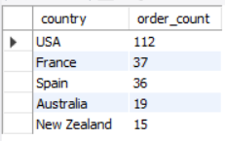

Q6. SELF JOIN
a. Create a table project with below fields.

- EmployeeID : integer set as the PRIMARY KEY and AUTO_INCREMENT.
- FullName: varchar(50) with no null values
- Gender : Values should be only ‘Male’ or ‘Female’
- ManagerID: integer
Add below data into it

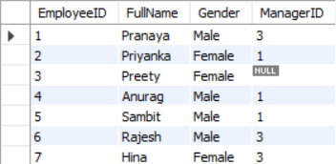
Query:
use classicmodels ;
create table project(
EmployeeID int primary key auto_increment,
FullName varchar(50) not null,
Gender varchar(8),
ManagerID int);

insert into `project`(`EmployeeID`,`FullName`,`Gender`,`ManagerID`) values
(1,'pranaya','male',3),
(2,'priyanka','female',1),
(3,'pritee','female',null),
(4,'Anurag','male',1),
(5,'Sambit','male',1),
(6,'Rajesh','male',3),
(7,'Hina','female',3);
desc project;

select *
from project;

Find out the names of employees and their related managers.
Expected output:
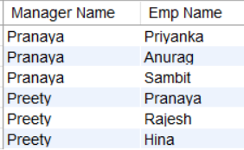

Q7. DDL Commands: Create, Alter, Rename
a. Create table facility. Add the below fields into it.
- Facility_ID
- Name
- State
- Country

i) Alter the table by adding the primary key and auto increment to Facility_ID column.
ii) Add a new column city after name with data type as varchar which should not accept any null values.

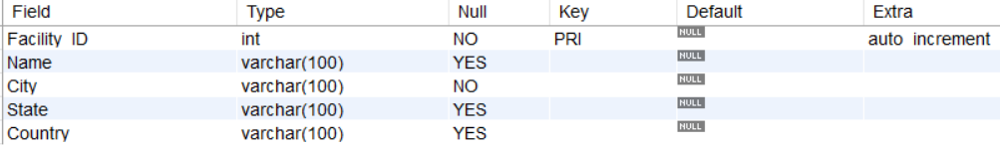

Q8. Views in SQL
a. Create a view named product_category_sales that provides insights into sales performance by product category. This view should include the following information:
productLine: The category name of the product (from the ProductLines table).

total_sales: The total revenue generated by products within that category (calculated by summing the orderDetails.quantity * orderDetails.priceEach for each product in the category).

number_of_orders: The total number of orders containing products from that category.

(Hint: Tables to be used: Products, orders, orderdetails and productlines)

The view when read should show the output as:

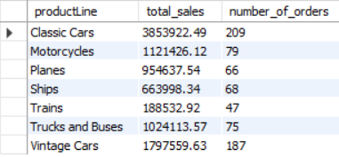

Query:
use classicmodels ;
create view product_category_sales as
select
p.productline,
sum(od.quantityOrdered * od.priceEach)
as total_sales,
count(distinct o.orderNumber) as
number_of_orders
from
products p
join
orderdetails od on p.productcode = od.productcode
join
orders o on od.orderNumber = o.orderNumber
join
productLines pl on p.productline = pl.productline
group by
p.productline;

select * from product_categoy_sales ;

Q9. Stored Procedures in SQL with parameters

a. Create a stored procedure Get_country_payments which takes in year and country as inputs and gives year wise, country wise total amount as an output. Format the total amount to nearest thousand unit (K)
Tables: Customers, Payments Expected output:

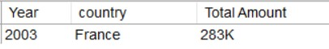

Query:
use classicmodels;
delimiter $$
create procedure Get_Country_Payments(
in year_input int,
in country_input varchar(50)
)
begin
select
year(p.paymentDate) as Year,
c.country as Country,
concat(round(sum(p.amount) / 1000, 0), 'K') as 'Total Amount'
from
Customers c
inner join Payments p on c.customerNumber = p.customerNumber
where
year(p.paymentDate) = year_input
and c.country = country_input
group by
year(p.paymentDate),c.country;
end$$
delimiter ;

call Get_Country_Payments(2003, 'France');

Q10. Window functions - Rank, dense_rank, lead and lag

a) Using customers and orders tables, rank the customers based on their order frequency

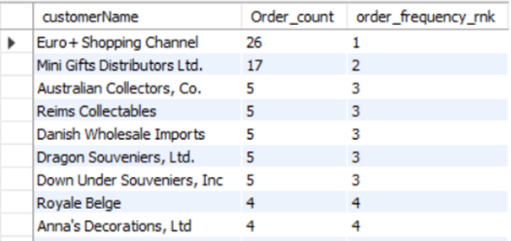
Query:
use classicmodels;
select
c.customerNumber,
c.customerName,
count(o.orderNumber) as order_count,
count(o.orderNumber) * 1.0 / count(distinct(o.orderDate)) as order_frequency_mk,
rank() over (
order by count(o.orderNumber) * 1.0 / count(distinct(o.orderDate)) desc
) as rank_by_frequency
from
customers c
join
orders o
on c.customerNumber = o.customerNumber
group by
c.customerNumber,
c.customerName
order by
rank_by_frequency;

b) Calculate year wise, month name wise count of orders and year over year (YoY) percentage change. Format the YoY values in no decimals and show in % sign.
Table: Orders
Expected output:
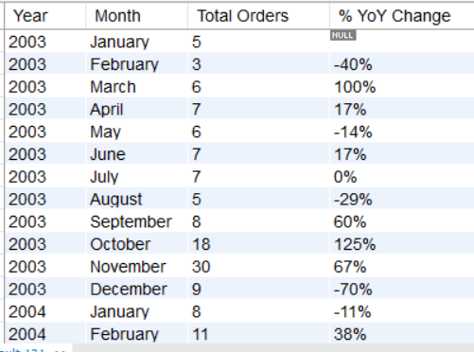
Query:
WITH monthly_orders AS (
SELECT
YEAR(orderDate) AS order_year,
MONTHNAME(orderDate) AS month_name,
COUNT(*) AS order_count
FROM orders
GROUP BY YEAR(orderDate), MONTH(orderDate), MONTHNAME(orderDate)
),
yoy_calc AS (
SELECT
m1.order_year,
m1.month_name,
m1.order_count,
LAG(m1.order_count) OVER (PARTITION BY m1.month_name ORDER BY m1.order_year) AS prev_year_count
FROM monthly_orders m1
)
SELECT
order_year,
month_name,
order_count,
CASE
WHEN prev_year_count IS NULL THEN NULL
WHEN prev_year_count = 0 THEN NULL
ELSE CONCAT(ROUND(((order_count - prev_year_count) / prev_year_count) * 100, 0), '%')
END AS YoY_Change
FROM yoy_calc
ORDER BY order_year,
MONTH(STR_TO_DATE(month_name, '%M'));

Q11.Subqueries and their applications

a. Find out how many product lines are there for which the buy price value is greater than the average of buy price value. Show the output as product line and its count.
Expected output:
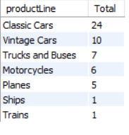
Query:
select productline,count(*) as Total
from products
where buyprice > (select avg(buyprice)
from products)
group by productLine;
Q12. ERROR HANDLING in SQL
Create the table Emp_EH. Below are its fields.
- EmpID (Primary Key)
- EmpName
- EmailAddress
Create a procedure to accept the values for the columns in Emp_EH. Handle the error using exception handling concept. Show the message as “Error occurred” in case of anything wrong.
Query:
use classicmodels;
CREATE TABLE Emp_EH (
EmpID int PRIMARY KEY,
EmpName VARCHAR(100),
EmailAddress VARCHAR(150)
);

DELIMITER $$

CREATE PROCEDURE Insert_Emp_EH(
IN p_EmpID INT,
IN p_EmpName VARCHAR(100),
IN p_EmailAddress VARCHAR(150)
)
begin
declare exit handler for sqlexception
begin
select'Error occurred' AS Message;
end;

insert into Emp_EH (EmpID, EmpName, EmailAddress)
value(p_EmpID, p_EmpName, p_EmailAddress);

select 'Record inserted successfully' as Message;
end$$

delimiter ;

call Insert_Emp_EH(1, 'John Doe', 'Join@example.com');

Q13. TRIGGERS
Create the table Emp_BIT. Add below fields in it.
- Name
- Occupation
- Working_date
- Working_hours,

Insert the data as shown in below query.
INSERT INTO Emp_BIT VALUES
('Robin', 'Scientist', '2020-10-04', 12),
('Warner', 'Engineer', '2020-10-04', 10),
('Peter', 'Actor', '2020-10-04', 13),
('Marco', 'Doctor', '2020-10-04', 14),
('Brayden', 'Teacher', '2020-10-04', 12),
('Antonio', 'Business', '2020-10-04', 11);

Create before insert trigger to make sure any new value of Working_hours, if it is negative, then it should be inserted as positive.
Query:
delimiter $$
create trigger check_working_hours
before insert
on Emp_BIT
for each row
begin
if new.Working_hours < 0 then
set new.Working_hours =
abs(new.Working_hours);
end if;
end$$

delimiter ;

