**Library Management System**

A library management system keeps track of the books present in the library. It is an important piece of software which is a must at schools and colleges. I have built this library management system using Python and Django.

The library management system in python which I am going to build will look something like this –

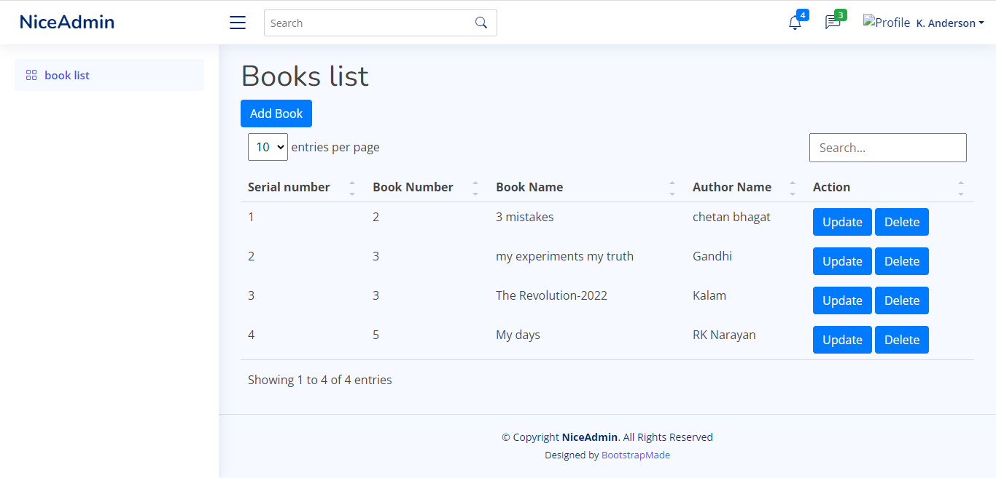

* Snaps of the code-

