1. **A1 – Create a graph display Category & Sub category wise sales:**

**Graph:**

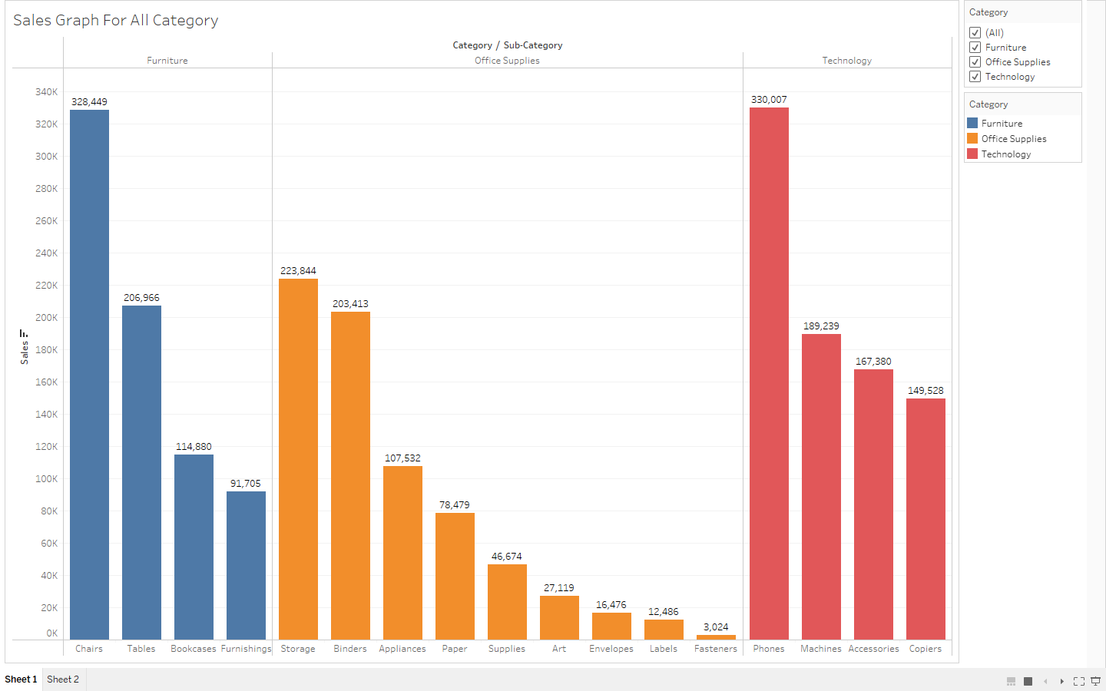

1. **A2- Create a graph display Category, Region and Sub category wise profit**

**Graph:**

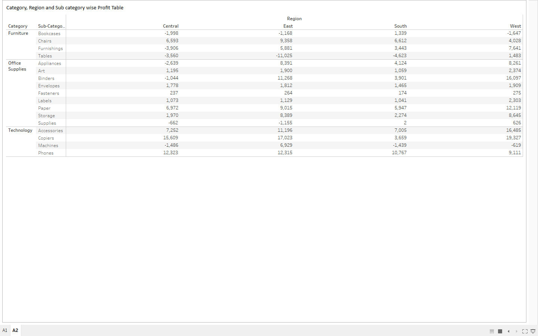

1. **A3: Year wise sales, profit, discount and quantity using measure names**

**Graph:**

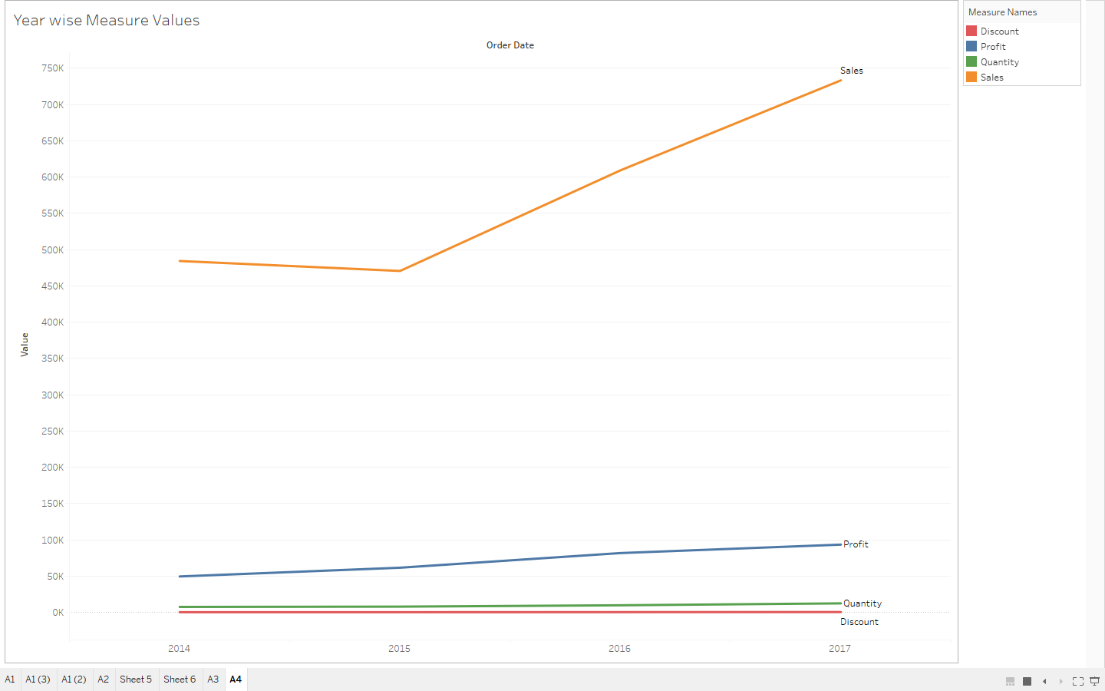

1. **A4: Sales using Hierarchy for Region, Segment, Category and Sub category**

**Graph:**

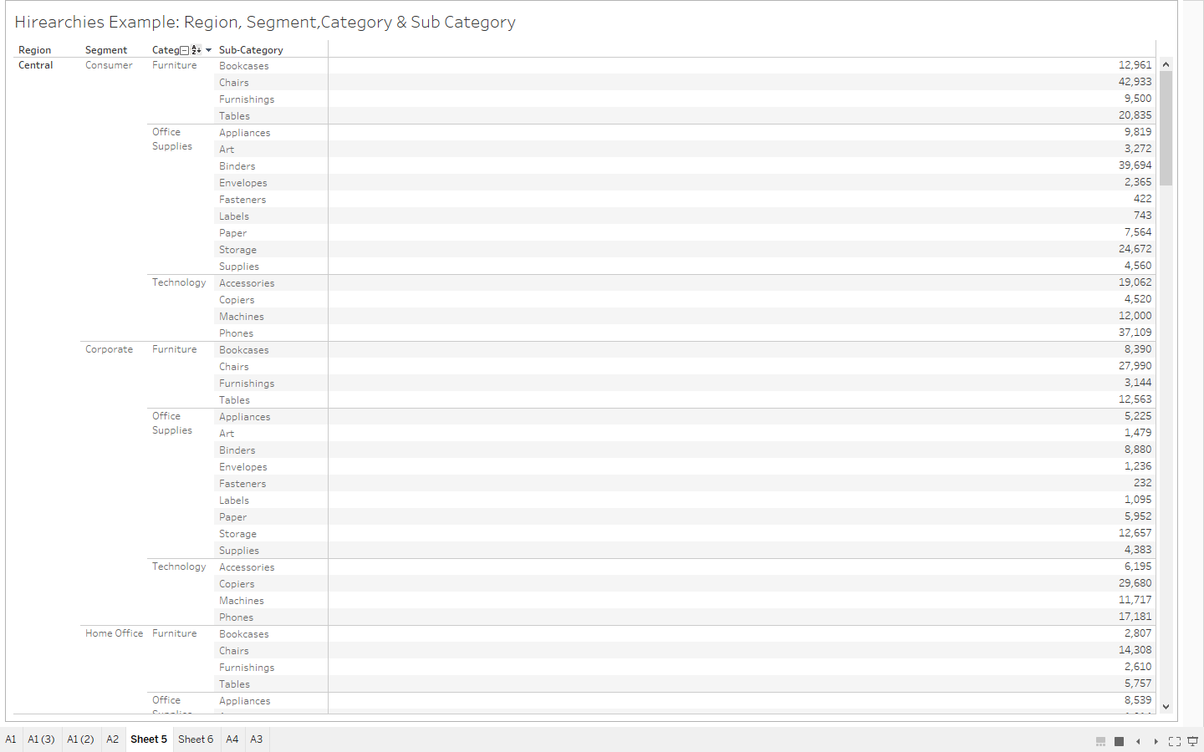

1. **A5: Horizontal bar chart to represent sub-category . Group stationary related products as stationary.**

**Graph:**

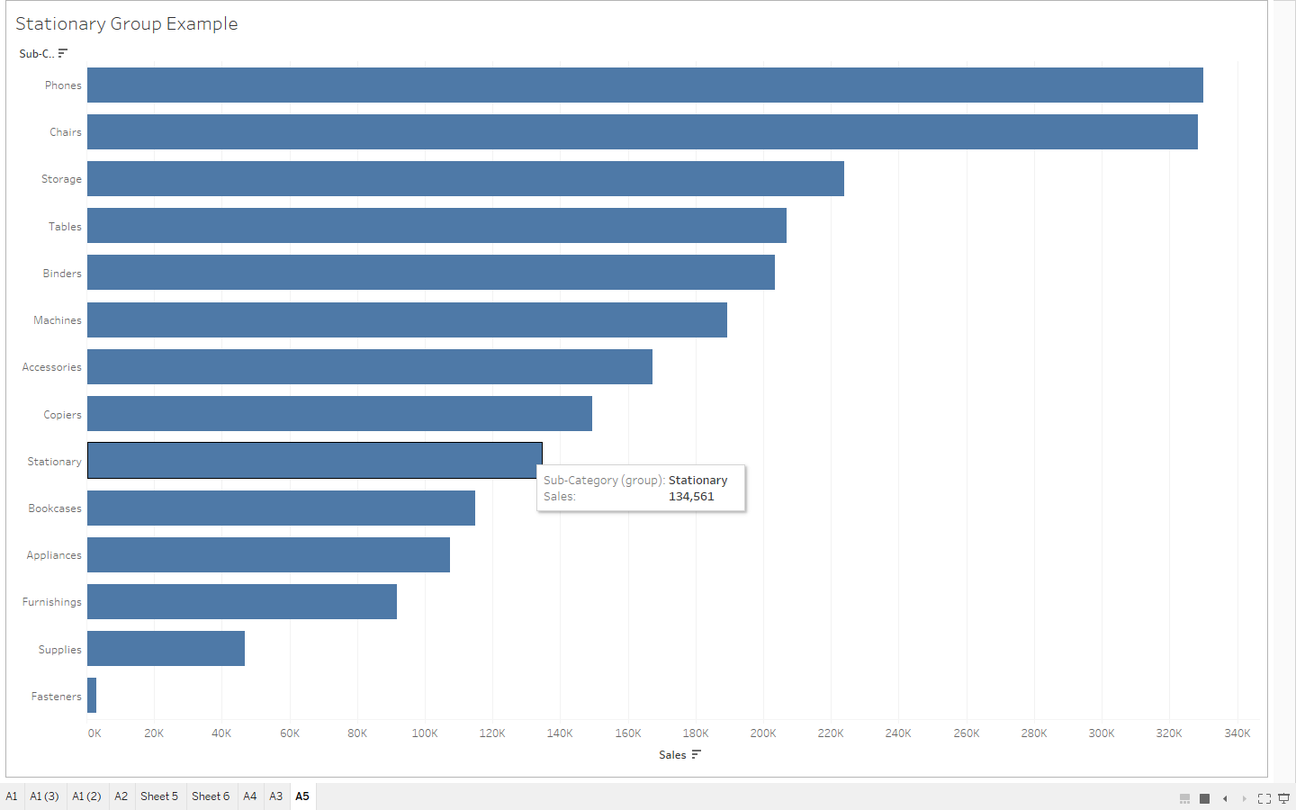

1. **A6: Represent subcategory wise profit in graphical manner, arranged in descending order of profit.**

**Graph:**

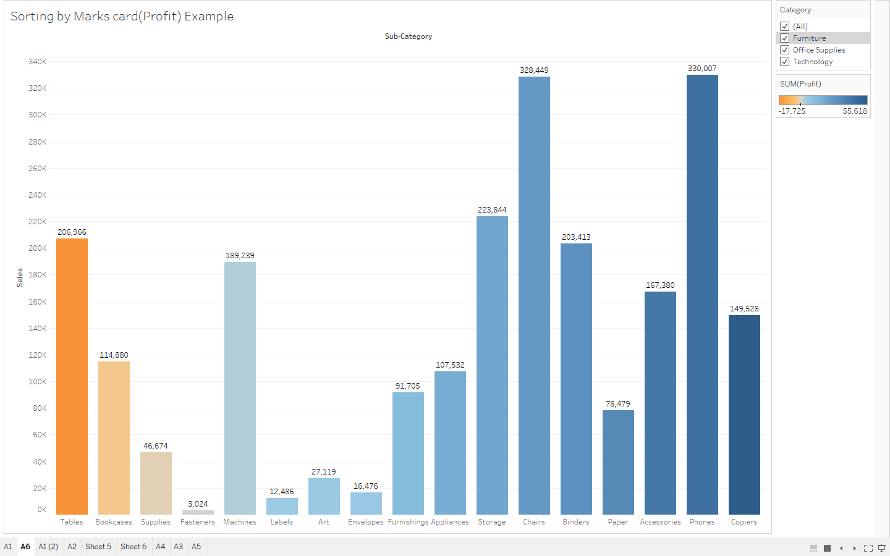

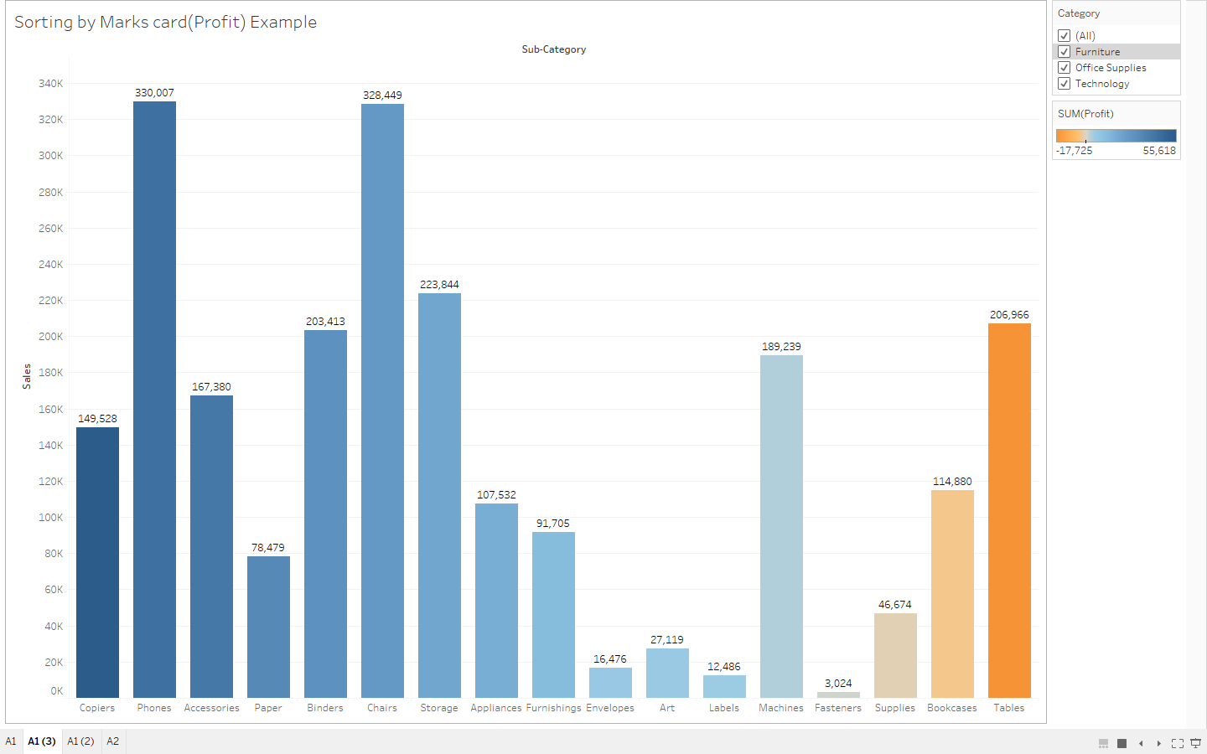

1. **A7: Interactive Graph: Use Parameter**

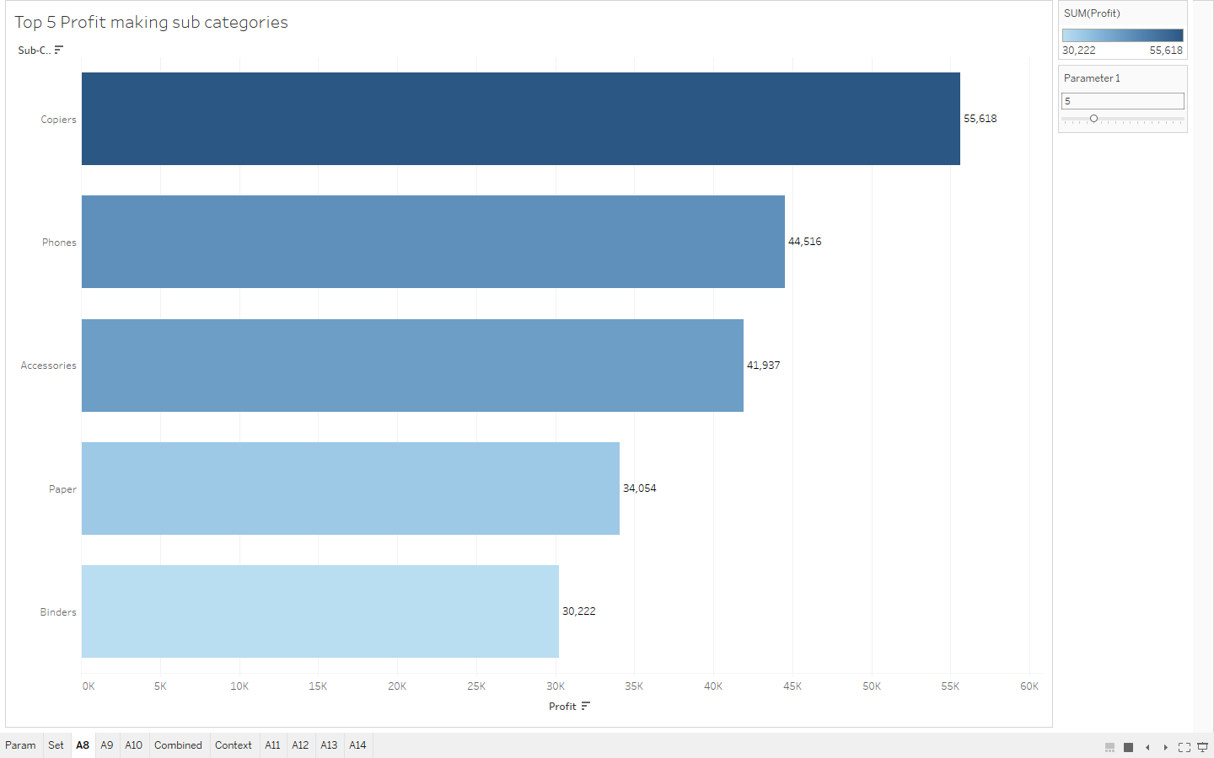

1. **A9: Interactive Category and Sub category wise sales (Set)**

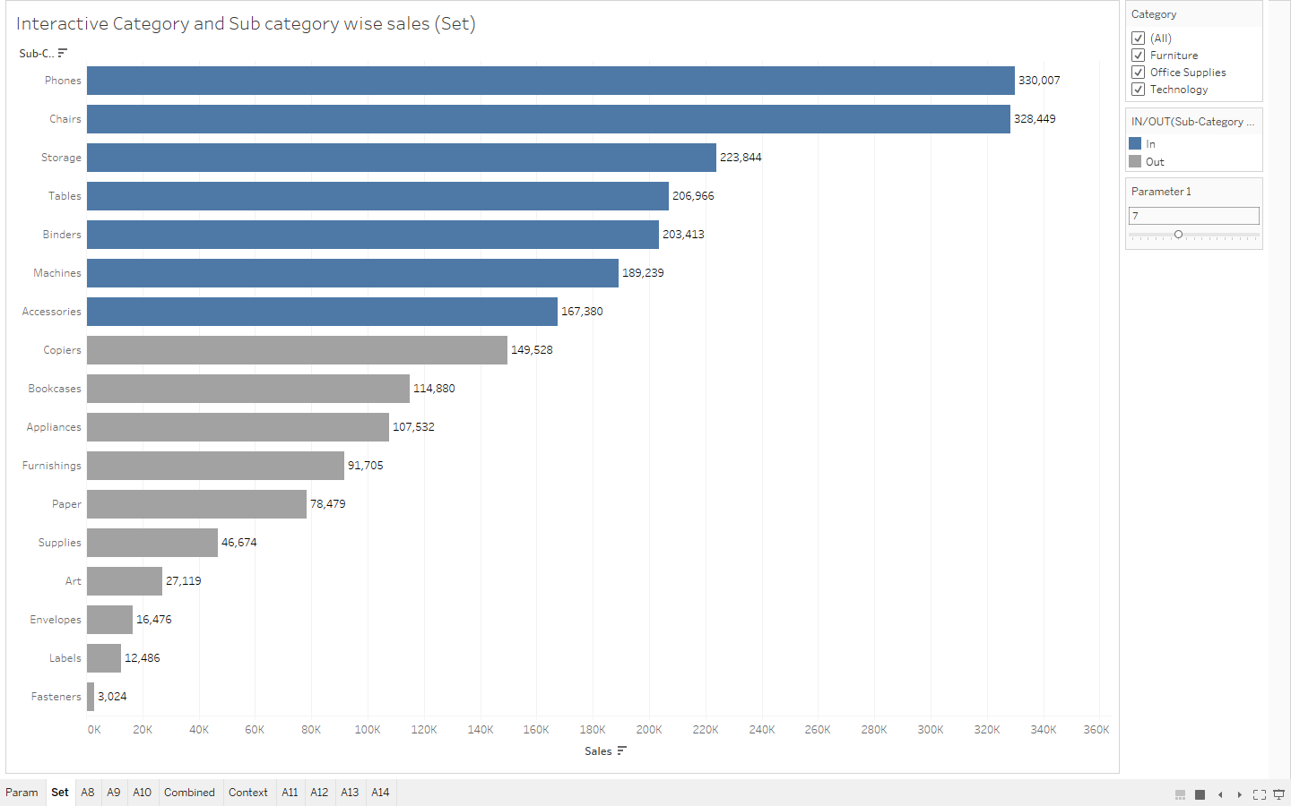

1. **A10: Year wise segment wise sale**

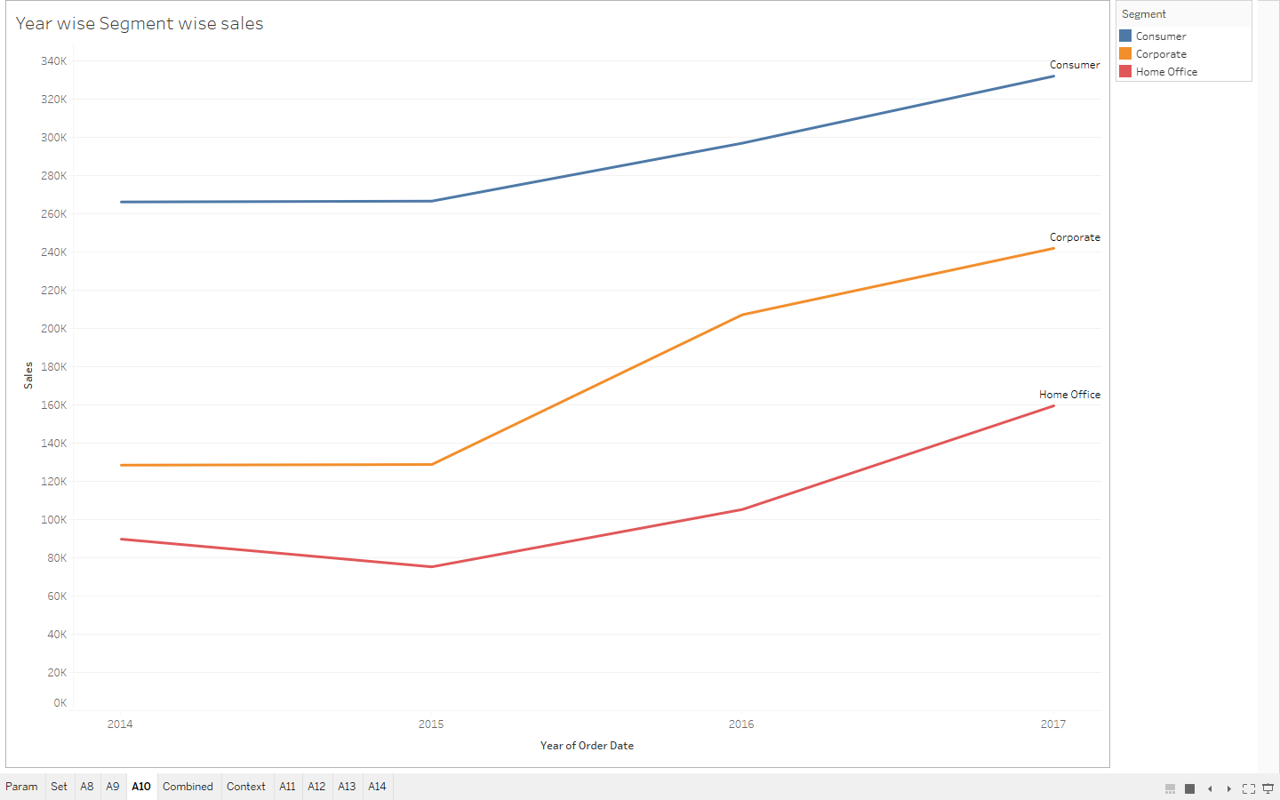

1. **A11: Display top 10 profit making sub categories along with categories**

**Graph:**

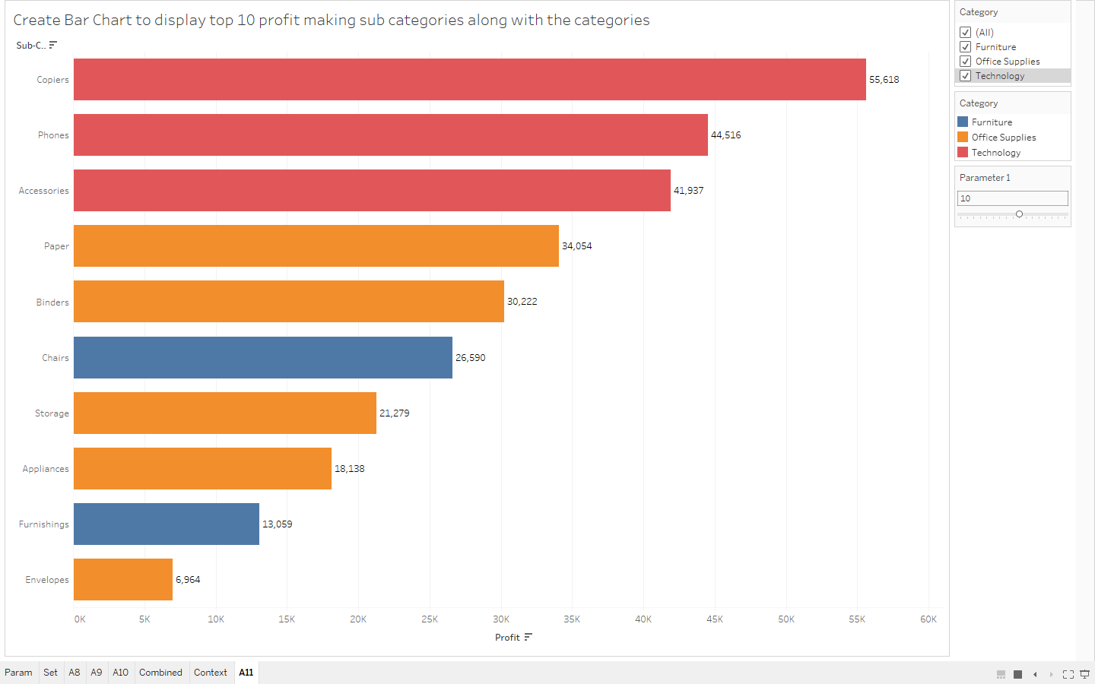

1. **A12: Sub categories and categories where revenue is 200k to 250k**

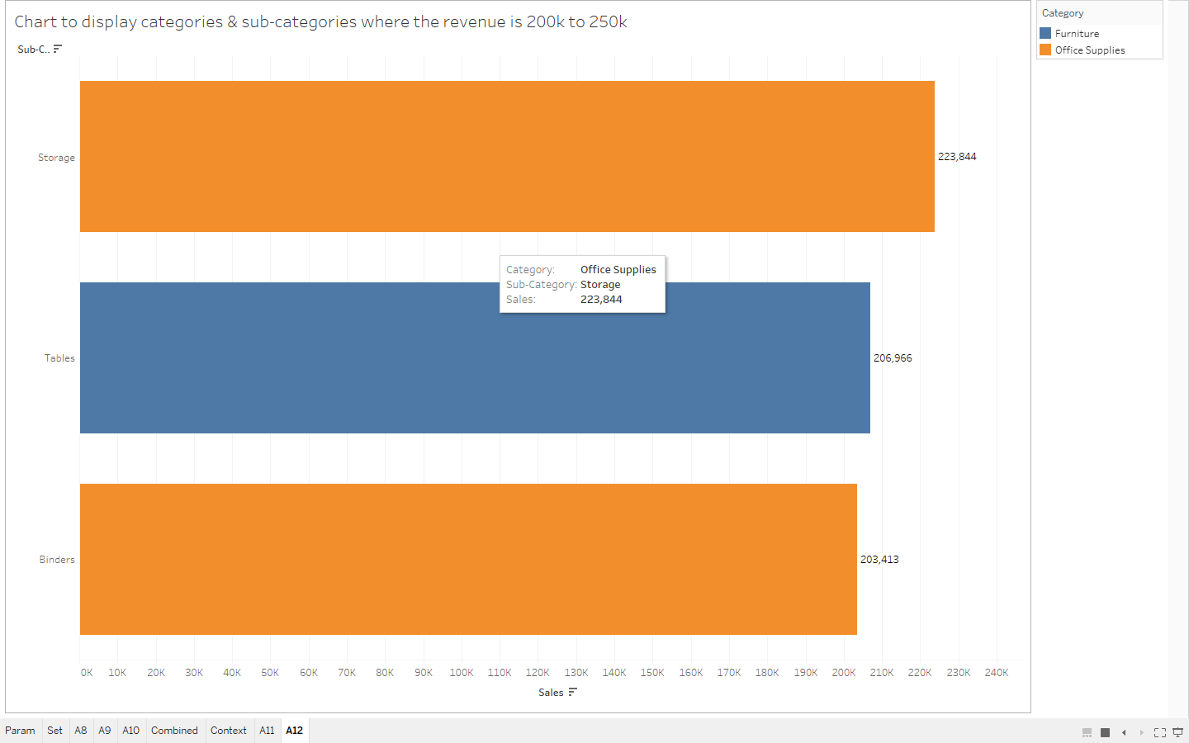

1. **A13: Month wise profit of each category. Interactive on the basis of year. Use slider as filter.**

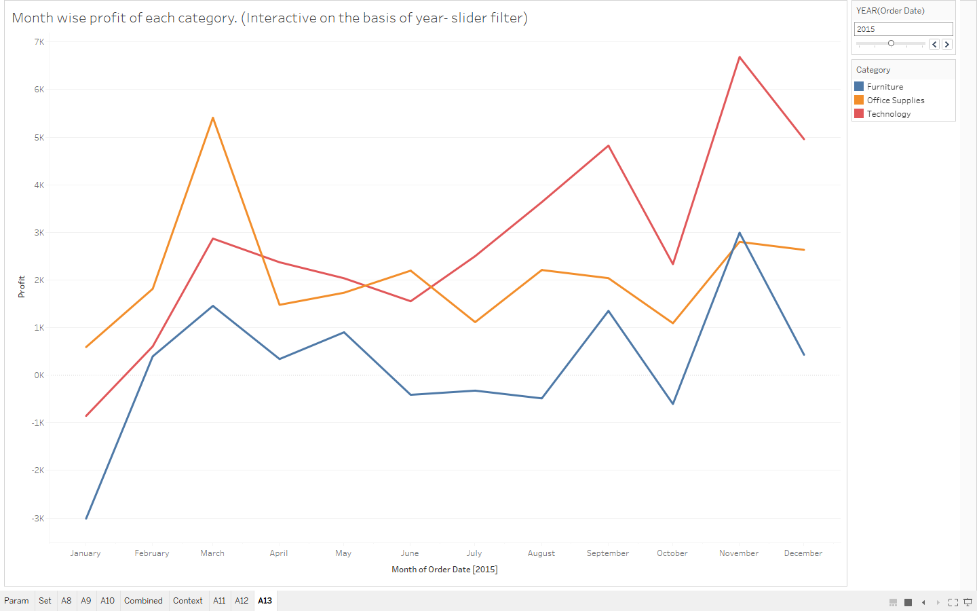

1. **A14: Category and sub category wise sales. Revenue more than 200k and profit more than 20k**

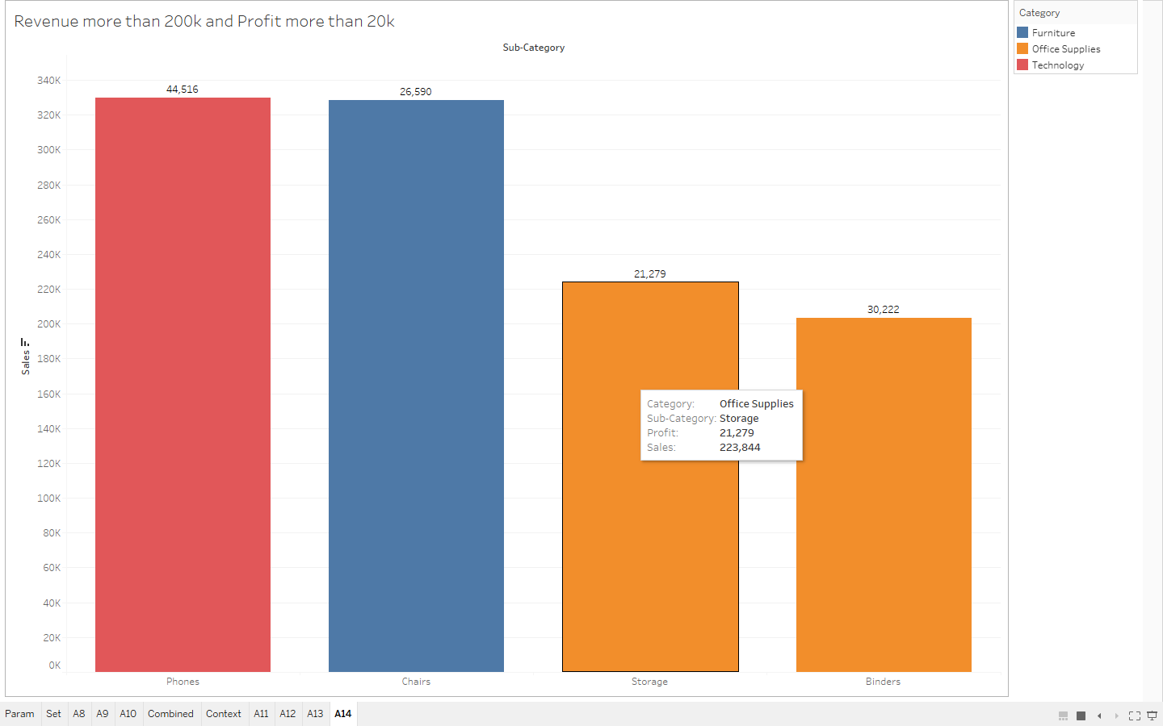

1. **A15: Data Source filter. Only for Technology category**
2. **Display top 10 profit making sub categories along with categories**

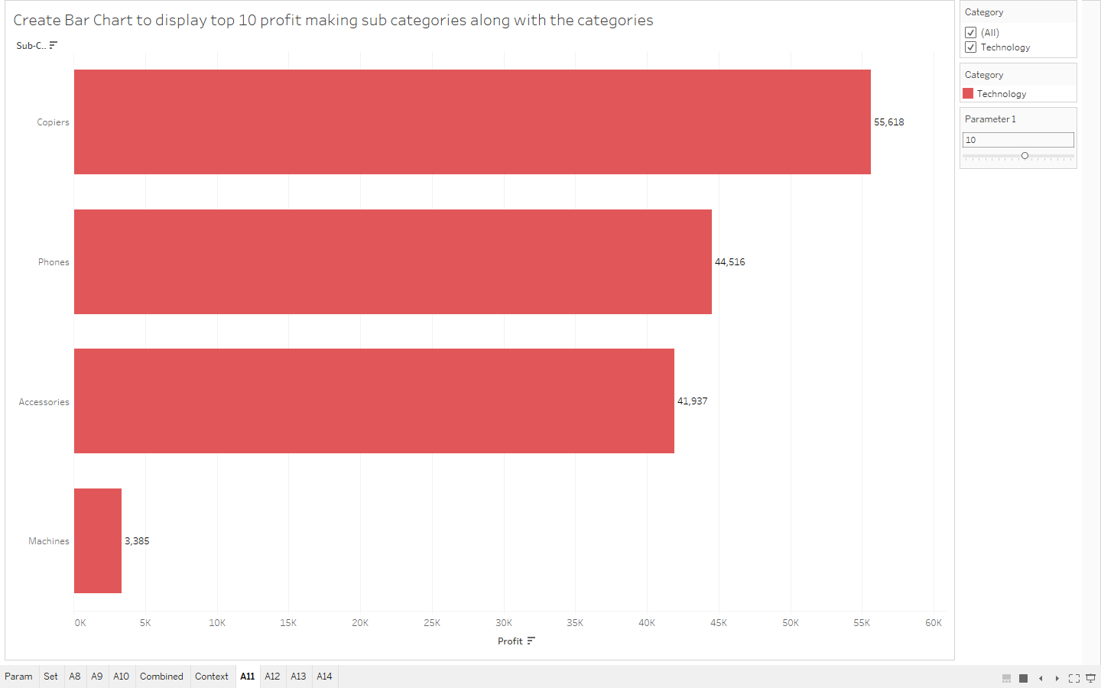

**b. Sub categories and categories where revenue is 200k to 250k(No such sub category)**

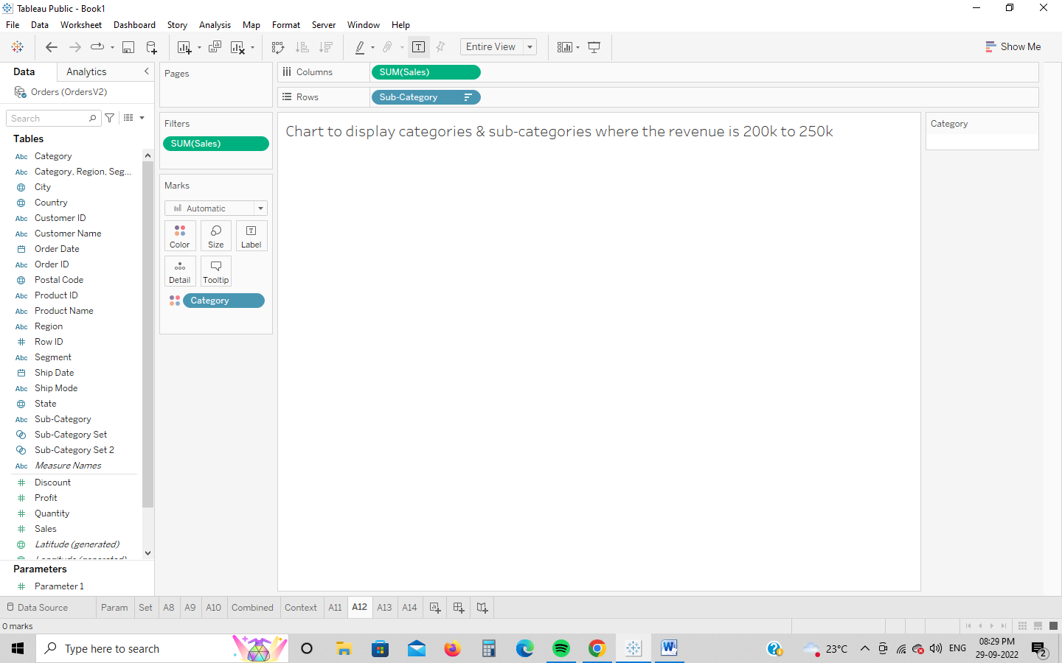

1. **Month wise profit of each category. Interactive on the basis of year. Use slider as filter.**

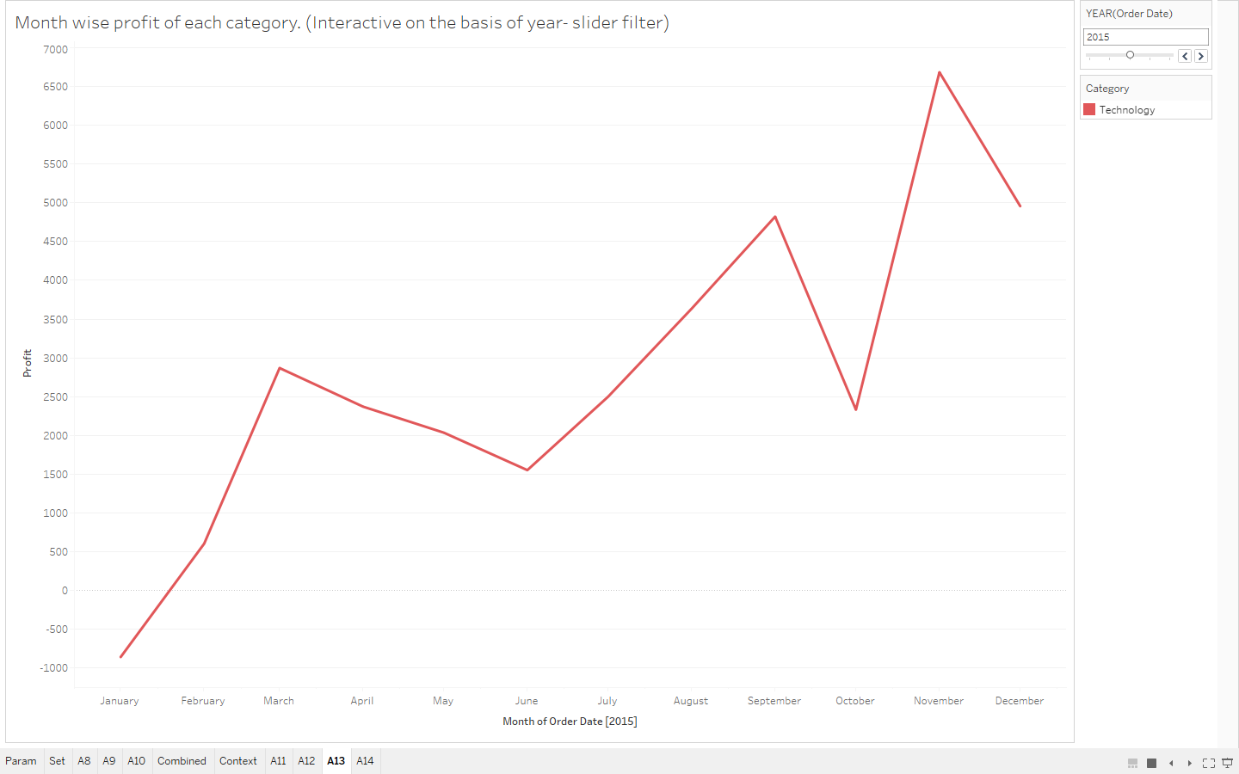

1. **Category and sub category wise sales. Revenue more than 200k and profit more than 20k**

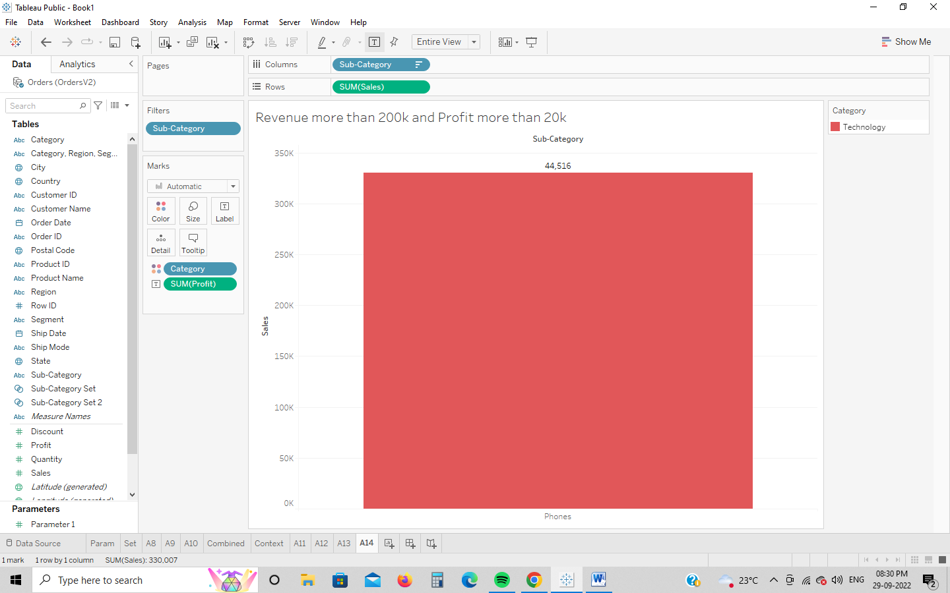

1. A16
2. 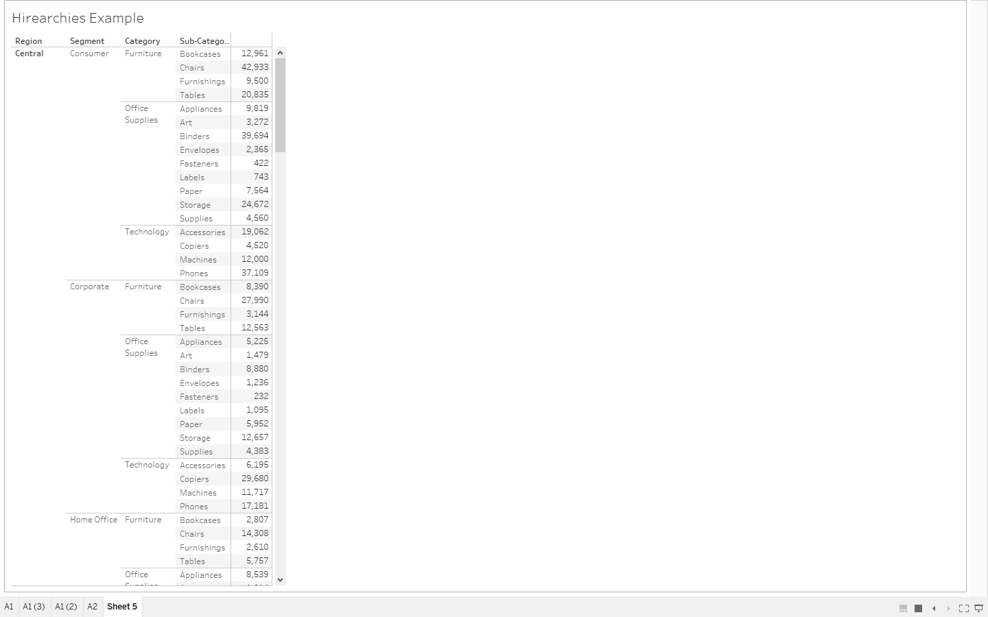
3. 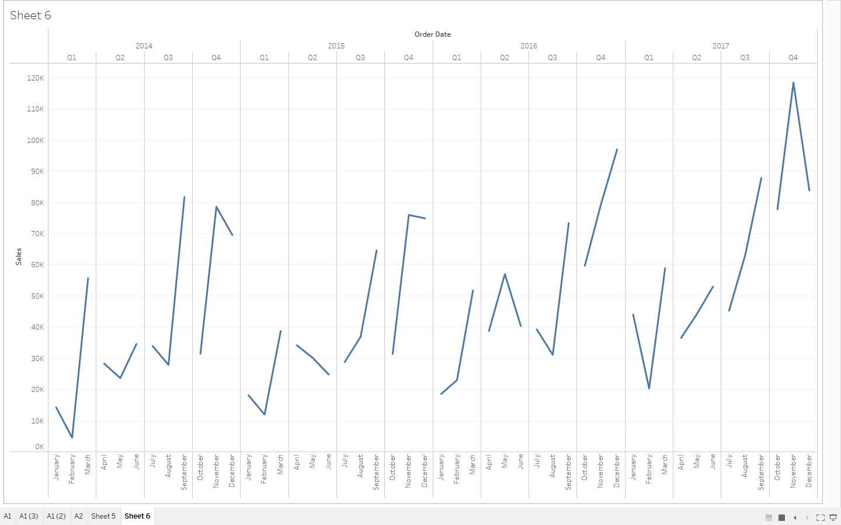
4. 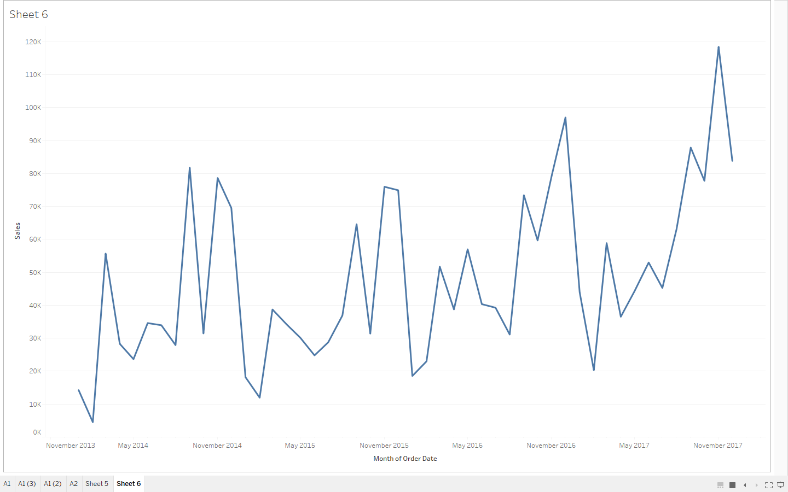
5. 