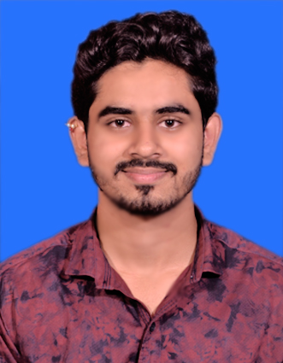

Personal Details .

Name | : Parag Sanjay Kulthe
Initials (First name) | : Parag
Title | : Associate I-Software Engineer
Year of birth | : 2001
Residence | : Nashik
Nationality | : Indian

Key Competence s
.

- Technical competences : C, C++, Basics of Core Java, SQL, HTML
- Tools : GitHub, VS Code, Dev C++, IntelliJ IDEA, Spring boot
- Functional competences : Communication, Project Management, Fast Learner and Eager To Learn New Things

Education
Year | Employment / Education
Ongoing | Capgemini
2022 | Bachelor of Engineering in E&Tc
2019 | Diploma in E&Tc

Certificates .

- Microsoft Certified : Az-900
- Cumulocity IoT Basic (E234A-7BE)
- Mendix Rapid Developer - Certified
- AWS Cloud Practitioner Essentials - Training in progress
- Completed Capgemini training in Full Stack Web Development with Angular
- Programming Workshop on Data Structures
- 3 Days Training & Workshop on PLC & Automation
- 3 days Workshop on Industrial Approach In Electronics

Projects .

- Title: Covid Vaccination Management System
Roles & Responsibility: Worked On user module (Register user, store information of user)

- Title: Face Mask Vending Machine
Roles & Responsibility: Worked on hardware part of the system. Also worked on the programming part. Made PPTs, report & published paper on project title.

- Title: Smart Helmet
Language | Speak | Read | Write
Marathi | Native language | Native language | Native language
English | Professional | Professional | Professional
Hindi | Fluent | Fluent | Fluent
Roles & Responsibility: Worked on hardware part of the system. Similarly, completed programming part of the system.
Languages .

