# **GITHUB -** [**rutuja-patil24/ansible_assignment (github.com)**](https://github.com/rutuja-patil24/ansible_assignment)

# Creating VM instances in Google Cloud Platform:

vm1: 35.235.89.22

vm2: 34.102.103.70

# Install Ansible on Ubuntu App on Windows Machine:

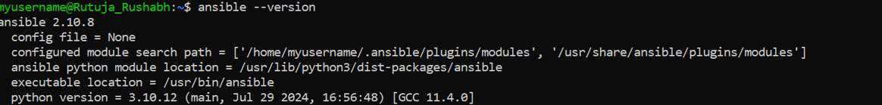

# Ansible Inventory file:

Created the inventory.ini file mentioning the webservers.

# SSH to the VMs:

Making sure the SSH to VM’s is complete.

# Installed apache2 on both the VMs using following commands:

Update the default html to validate the apace2 working, installed using the playbook in step 7

sudo apt-get update

sudo apt-get install apache2 php7.0

echo '<!doctype html><html><body><h1>Hello Rutuja!</hl></body></html>' | sudo tee /var/www/html/index.html

# Created the Ansible playbook:

This Ansible playbook performs two main functions:

1. **Deployment of Apache2**:
   * It installs Apache2, configures it to listen on port 8080, and sets up a custom index.html for both VM1 and VM2 with unique messages.
   * Apache2 is started, enabled, and reloaded to apply the configuration changes.
   * Custom HTML messages ("Hello World from SJSU-1" and "SJSU-2") are served depending on the VM.
2. **Un-deployment**: Stops Apache2, removes the package, and deletes the custom index.html file, cleaning up the environment.

# Deploy the web servers:

ansible-playbook -i inventory.ini webserver_apache.yml --tags "deploy"

Following are the terminal outputs after the play with deploy tag.

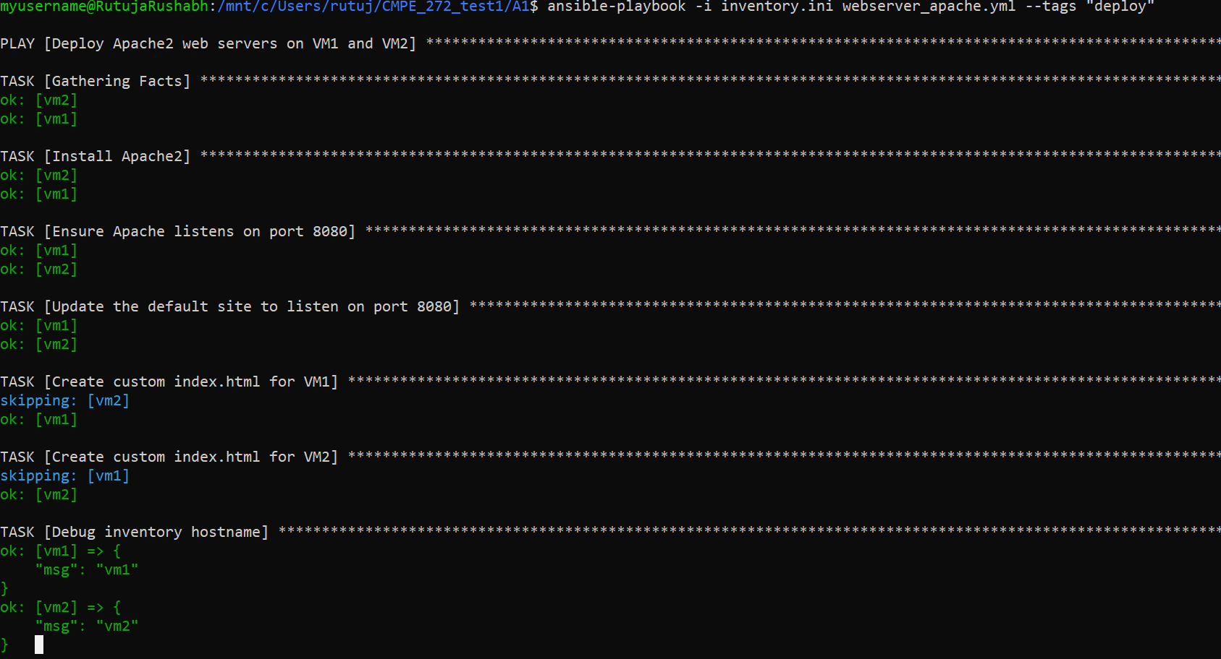

Following outputs are generated at VMs external ip address for port 8080

# Undeploy the web servers

ansible-playbook -v -i inventory.ini webserver_apache.yml --tags "undeploy"

Following outputs are generated at VMs external ip address for port 8080

After undeployment, following outputs are generated:

