**LINKS**

**Source Links:**

2009 <https://health.data.ny.gov/Health/Hospital-Inpatient-Discharges-SPARCS-De-Identified/q6hk-esrj>

2010

<https://health.data.ny.gov/Health/Hospital-Inpatient-Discharges-SPARCS-De-Identified/mtfm-rxf4>

2011

<https://health.data.ny.gov/Health/Hospital-Inpatient-Discharges-SPARCS-De-Identified/pyhr-5eas>

2012

<https://health.data.ny.gov/Health/Hospital-Inpatient-Discharges-SPARCS-De-Identified/u4ud-w55t>

2013

<https://health.data.ny.gov/Health/Hospital-Inpatient-Discharges-SPARCS-De-Identified/npsr-cm47/about_data>

2014

<https://health.data.ny.gov/Health/Hospital-Inpatient-Discharges-SPARCS-De-Identified/rmwa-zns4/about_data>

2015

<https://health.data.ny.gov/Health/Hospital-Inpatient-Discharges-SPARCS-De-Identified/82xm-y6g8/about_data>

2016

<https://health.data.ny.gov/Health/Hospital-Inpatient-Discharges-SPARCS-De-Identified/gnzp-ekau/about_data>

2017

<https://health.data.ny.gov/dataset/Hospital-Inpatient-Discharges-SPARCS-De-Identified/22g3-z7e7/about_data>

​​2018

<https://health.data.ny.gov/Health/Hospital-Inpatient-Discharges-SPARCS-De-Identified/yjgt-tq93/about_data>

2019

<https://health.data.ny.gov/Health/Hospital-Inpatient-Discharges-SPARCS-De-Identified/4ny4-j5zv/about_data>

2​​020

<https://health.data.ny.gov/Health/Hospital-Inpatient-Discharges-SPARCS-De-Identified/nxi5-zj9x/about_data>

2021

<https://health.data.ny.gov/Health/Hospital-Inpatient-Discharges-SPARCS-De-Identified/tg3i-cinn/about_data>

<https://hcup-us.ahrq.gov/toolssoftware/ccsr/prccsr.jsp>

<http://healthydatascience.com/ahrq_ccs_icd.html>

<https://meps.ahrq.gov/data_stats/download_data/pufs/h110i/h110i_icd9codes.shtml>

<https://www.nber.org/research/data/icd-9-cm-and-icd-10-cm-and-icd-10-pcs-crosswalk-or-general-equivalence-mappings>

<https://icd.codes/convert/icd10-to-icd9-pcs>

<https://www.findacode.com/ccs/icd10cm/ccs-clinical-classifications.html#:~:text=The%20Clinical%20Classifications%20Software%20>

ICD-9-CM to ICD-10-CM Codes: What? Why? How? : <https://www.ncbi.nlm.nih.gov/pmc/articles/PMC3865615/>

Icd-9-cm to ccsr code numeric - <https://meps.ahrq.gov/data_stats/download_data/pufs/h110i/h110i_icd9codes.shtml>

Icd-10-cm codes yearwise website - <https://www.icd10data.com/ICD10CM/Codes/Changes/New_Codes/1?year=2018>

Icd-9 to icd-10 transition tools - <https://www.nahdo.org/ICD9-10Tools>

SAS file codes - <http://healthydatascience.com/ahrq_ccs_icd.html>

CCSR user guide 2019.1 - <https://hcup-us.ahrq.gov/toolssoftware/ccsr/DXCCSR-User-Guide-v2019-1.pdf>

ICD-10-CM official guidelines - <https://www.cms.gov/medicare/coding/icd10/downloads/2018-icd-10-cm-coding-guidelines.pdf>

For disease CCSR codes - ICD-10-PCM code file

<https://hcup-us.ahrq.gov/toolssoftware/ccsr/dxccsr.jsp#overview>

## Markdown cells

**CCSR Codes**

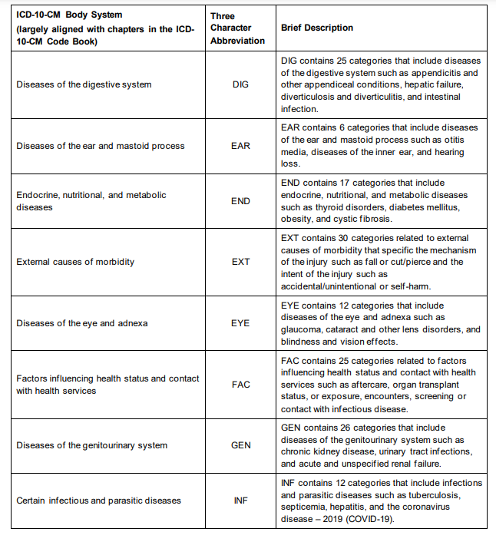

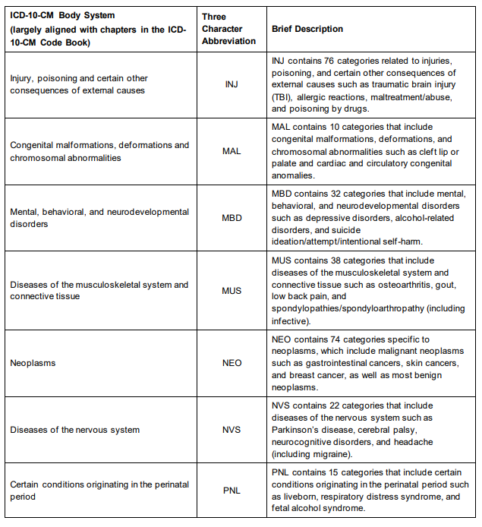

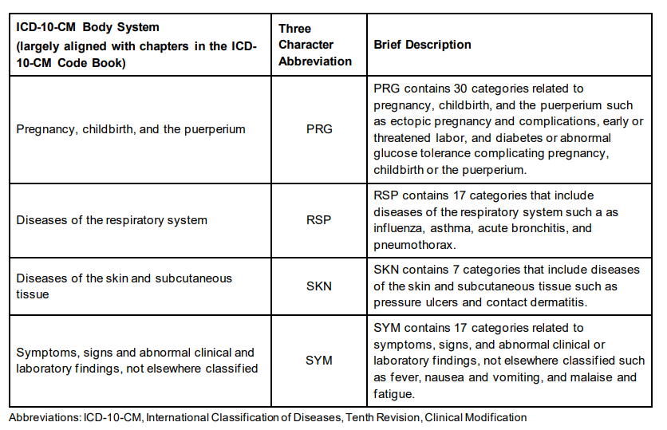

<https://hcup-us.ahrq.gov/toolssoftware/ccsr/prccsr.jsp>

<http://healthydatascience.com/ahrq_ccs_icd.html>

ICD-9-CM codes did not include information on the types of encounters for injuries. Previous versions of the CCS tool did not distinguish between the type of encounter.

ICD-10-CM coding for injuries often uses a seventh character to distinguish the type of encounter and whether there was a late effect or sequela resulting from a previous injury, and the CCSR capitalizes on this additional information. In most injury codes, the options for the seventh character are initial encounter, subsequent encounter, and sequela.16

An initial encounter, designated by a seventh character of A, is the active treatment

<https://meps.ahrq.gov/data_stats/download_data/pufs/h110i/h110i_icd9codes.shtml>

File source: icd-9-cm to icd-10-cm

<https://www.nber.org/research/data/icd-9-cm-and-icd-10-cm-and-icd-10-pcs-crosswalk-or-general-equivalence-mappings>

Online convertor: <https://icd.codes/convert/icd10-to-icd9-pcs>

<https://www.findacode.com/ccs/icd10cm/ccs-clinical-classifications.html#:~:text=The%20Clinical%20Classifications%20Software%20>(CCS,data%20on%20diagnoses%20and%20procedures.

ICD-9-CM to ICD-10-CM Codes: What? Why? How? : <https://www.ncbi.nlm.nih.gov/pmc/articles/PMC3865615/>

Icd-9-cm to ccsr code numeric - <https://meps.ahrq.gov/data_stats/download_data/pufs/h110i/h110i_icd9codes.shtml>

Icd-10-cm codes yearwise website - <https://www.icd10data.com/ICD10CM/Codes/Changes/New_Codes/1?year=2018>

Icd-9 to icd-10 transition tools - <https://www.nahdo.org/ICD9-10Tools>

SAS file codes - <http://healthydatascience.com/ahrq_ccs_icd.html>

CCSR user guide 2019.1 - <https://hcup-us.ahrq.gov/toolssoftware/ccsr/DXCCSR-User-Guide-v2019-1.pdf>

ICD-10-CM official guidelines - <https://www.cms.gov/medicare/coding/icd10/downloads/2018-icd-10-cm-coding-guidelines.pdf>

For disease CCSR codes - ICD-10-PCM code file

<https://hcup-us.ahrq.gov/toolssoftware/ccsr/dxccsr.jsp#overview>

