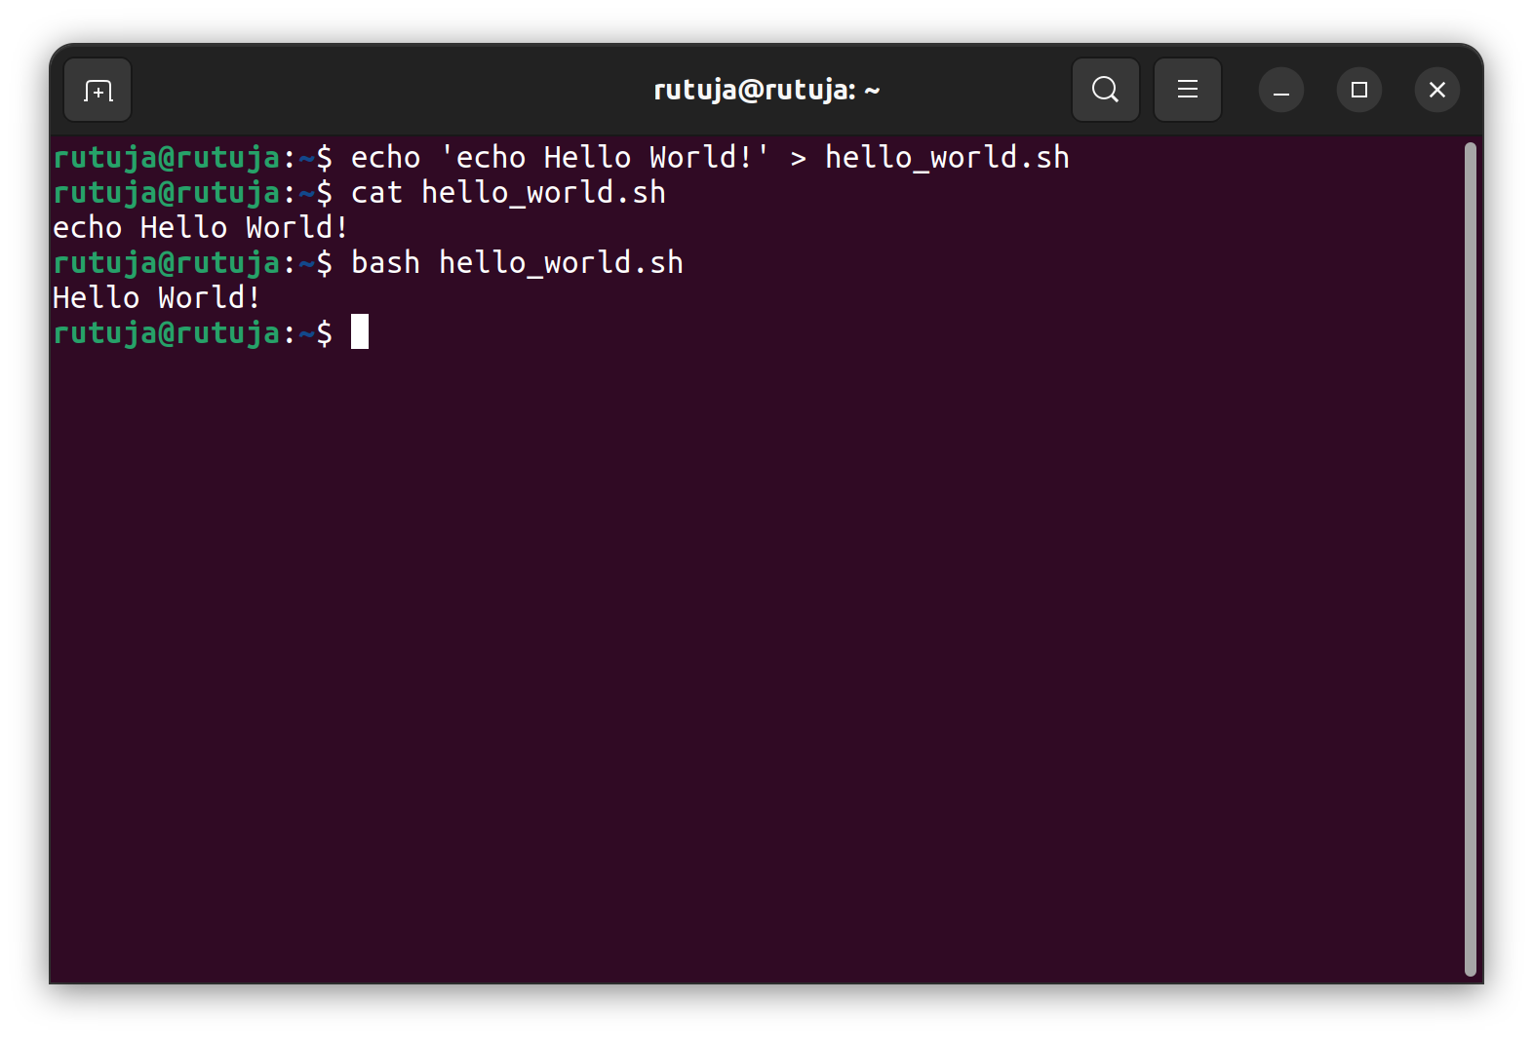
Script execution by calling bash:echo

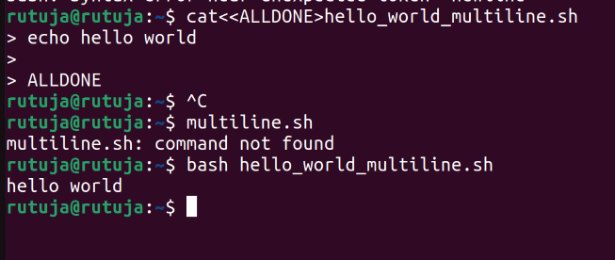
Multiline File Creation

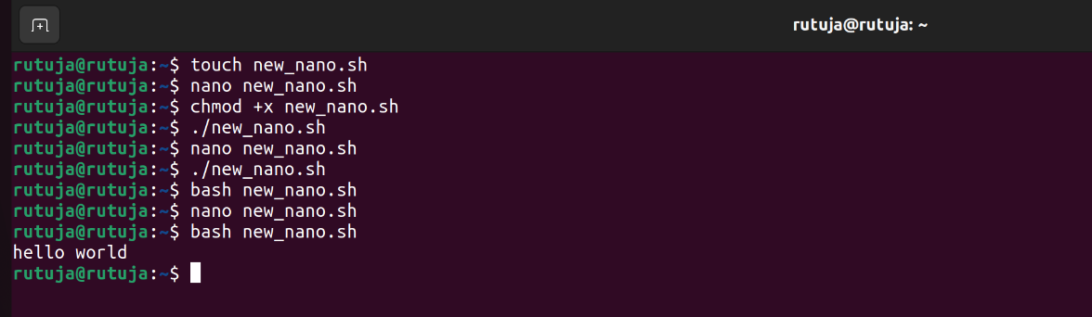
Debugging

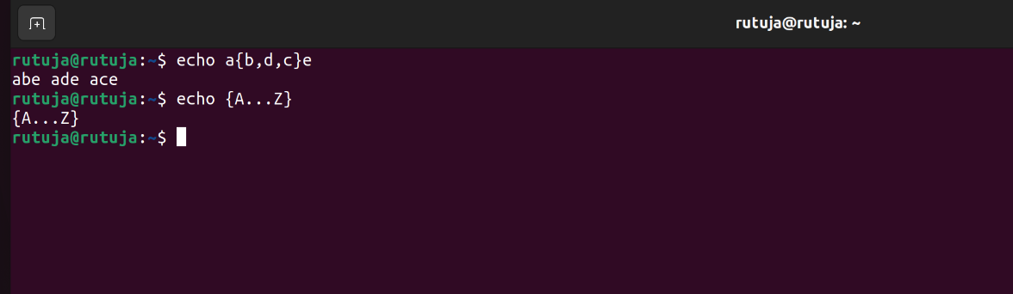
Brace Expansion

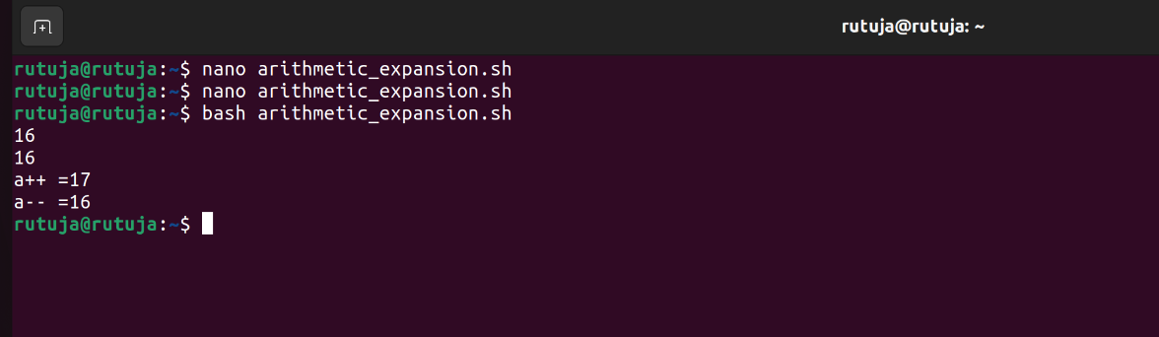
Arithmetic Expression

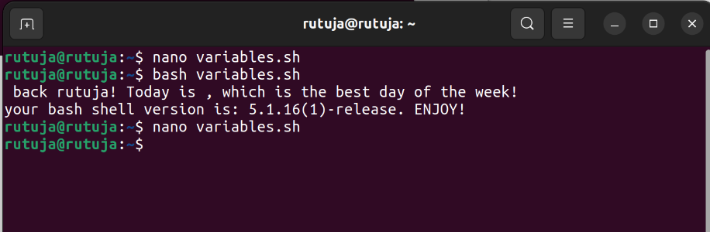
Variables

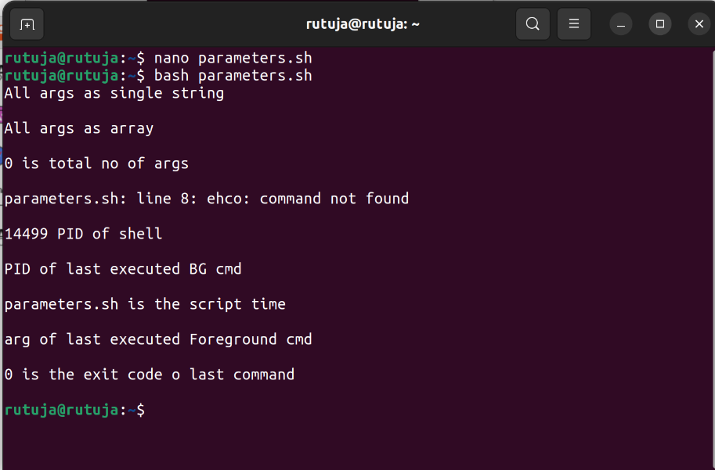
Parameters

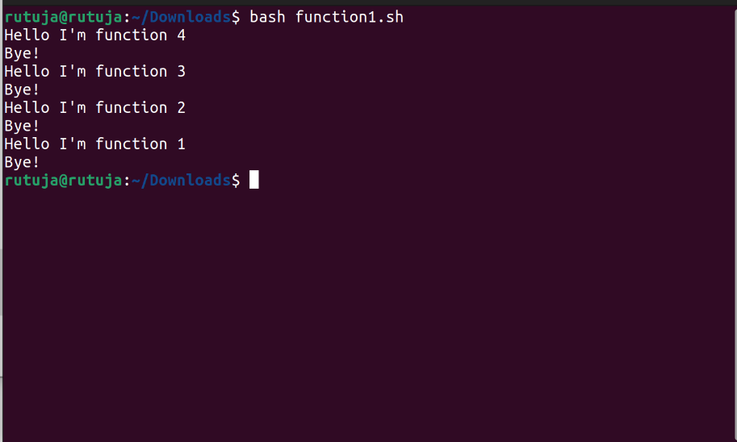
Functions

Array
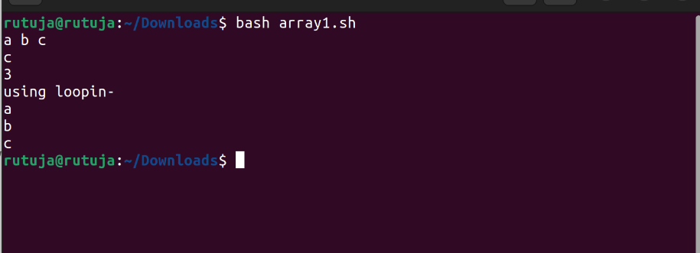
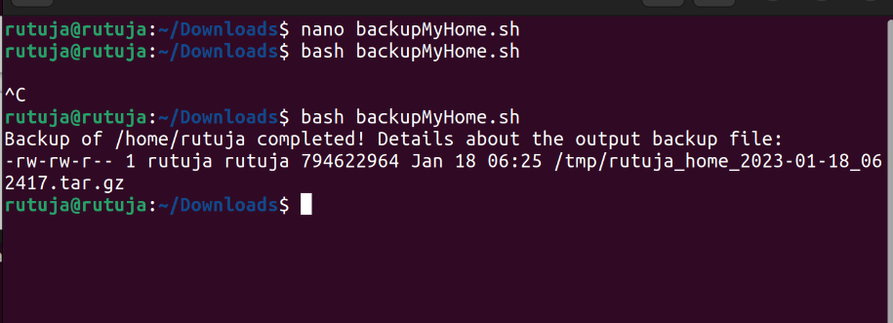
bakcupMyhome

Let
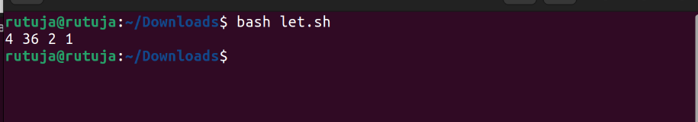
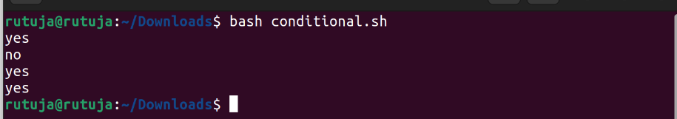
Conditional
shell expansion
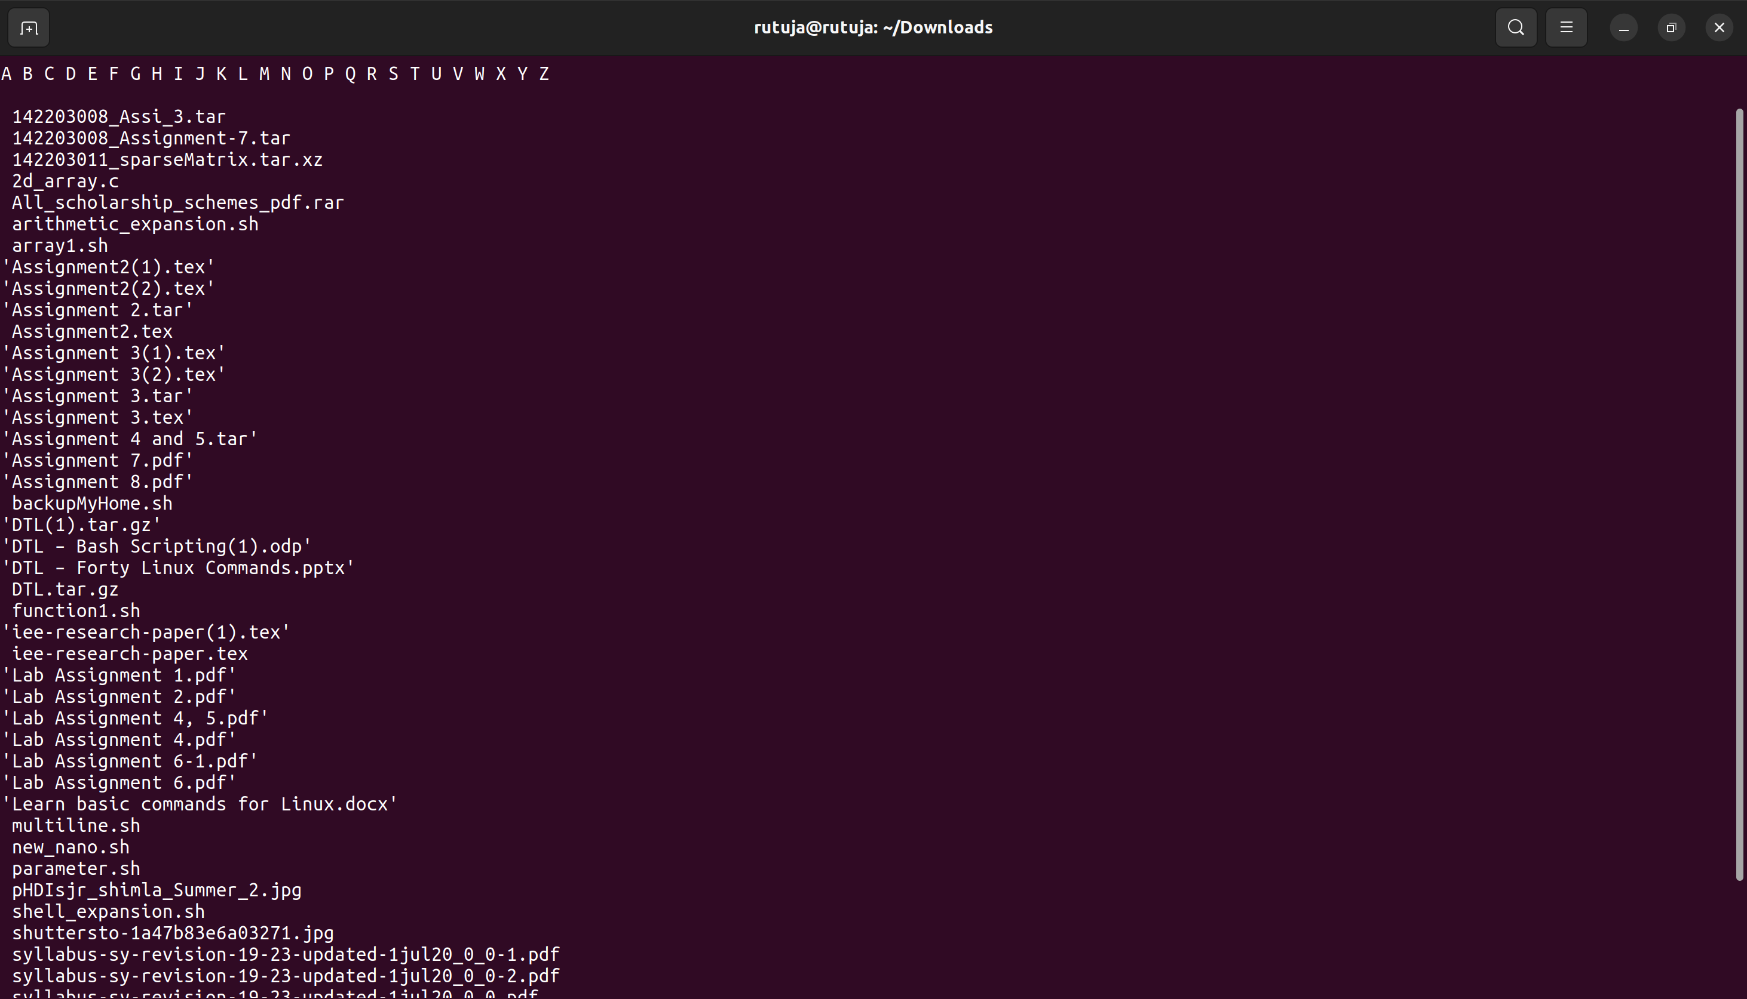
Comparison
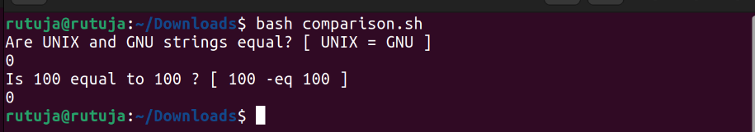
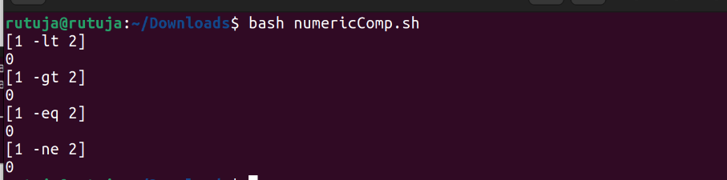
Numeric Comparsion

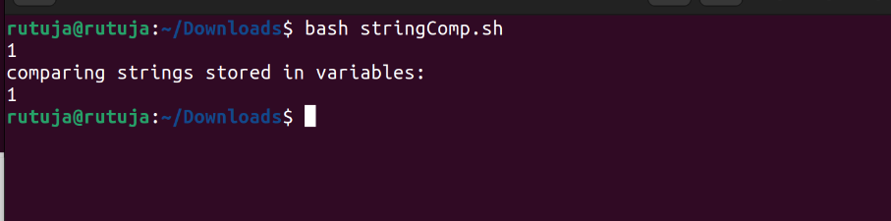
String Comparison

