Design and Simulation of a Log-Periodic Dipole Array (LPDA)
Covering 400 MHz – 8 GHz
Metix RF Antenna Design Challenge
Design Category: 400 MHz to 8 GHz LPDA (Log-Periodic Dipole Array)
Simulation Software: 4NEC2 (Method of Moments, NEC-2 engine)
Final Design Revision: REV10
Team Leader: Rutuja Shingare
Team Members: Megha Mane, Prithviraj
Professional Mentor: Abhijeet Gaikwad

Executive Summary
This report presents a 39-element Log-Periodic Dipole Array (LPDA) designed and simulated in 4NEC2 (NEC-2 Method of Moments) to cover 400 MHz to 8 GHz for the Metix RF Antenna Design Challenge. The design was developed through ten iterative simulation revisions, each isolating a single change so cause and effect could be verified against the full-band VSWR sweep before being accepted or rejected.
Two independent edge-of-band impedance problems were identified and resolved: a severe low-frequency mismatch at 400 MHz (initial VSWR = 437, a truncated-array effect), and an unexplained high-frequency VSWR peak near 7-8 GHz that proved unresponsive to feed-impedance and taper adjustments. Both were ultimately traced to the same underlying cause — insufficient element count at the respective band edge — and both were resolved by extending the array, not by re-tuning the feed.
The final design (REV10) achieves a strong low-band match (VSWR = 1.96, front-to-back ratio ≈ 23 dB at 400 MHz) and good performance through most of the band (VSWR = 3.19, F/B ≈ 20 dB at 5 GHz; VSWR = 5.44, F/B ≈ 15-16 dB at 8 GHz). One clearly identified, localized weak point remains near 2 GHz (VSWR = 2.97, peak gain drops to 1.59 dBi, F/B ≈ 3-5 dB), attributed to the active-region elements at Tags 17-19, and is reported as a known limitation rather than concealed. Approaches that were tested and found ineffective — a shorted termination stub and a reduced-taper (τ=0.92) redesign — are documented alongside the successful changes, as genuine evidence of the optimization process rather than omitted from the record.

Team and Declaration
Role | Name
Team Leader | Rutuja Shingare
Team Member | Megha Mane
Team Member | Prithviraj
Professional Mentor | Abhijeet Gaikwad

We declare that the design, simulation, and analysis presented in this report are the team's own original work, carried out under the supervision of the professional mentor named above. External references consulted for LPDA design theory and NEC-2 modeling conventions are cited in Section 9.

1. Introduction
This report documents the design, electromagnetic simulation, and iterative optimization of a Log-Periodic Dipole Array (LPDA) antenna intended to operate across the 400 MHz to 8 GHz band, developed for the Metix RF Antenna Design Challenge. The LPDA topology was selected because it is one of the few practical antenna structures capable of maintaining reasonably consistent input impedance, gain, and radiation pattern over a very wide (20:1) frequency ratio, which the target band requires.
All electromagnetic simulation was performed using 4NEC2, a graphical front-end for the NEC-2 (Numerical Electromagnetics Code) method-of-moments engine. The design was developed iteratively: an initial geometry was constructed from classical LPDA design equations, then simulated, diagnosed, and progressively corrected across ten major design revisions until both band edges (400 MHz and 8 GHz) achieved acceptable impedance matching. This document presents the final design, the simulated performance, and an honest account of the optimization process, including approaches that were tested and rejected.

2. LPDA Design Theory
A log-periodic dipole array consists of a sequence of dipole elements of progressively decreasing length, fed via a two-wire transmission line (boom) that alternates connection phase between successive elements. Two parameters govern the geometry:
- Scale factor (τ): the ratio of the length of one element to the next, Lₙ₊₁ = τ·Lₙ
- Spacing factor (σ): governs the spacing between adjacent elements, dₙ = 2σ·Lₙ
At any given frequency within the design band, only a small subset of elements near resonance — the "active region" — radiates significantly, while shorter elements toward the feed act as directors and longer elements behind act as reflectors. As frequency changes, the active region physically shifts along the boom, which is the mechanism that gives the LPDA its wide operating bandwidth.
The alternating phase feed (achieved via a 180° transposition of the boom conductors between each element) is essential: without it, the array behaves as a set of independent, weakly-coupled dipoles rather than a coherent traveling-wave structure with endfire directivity.

3. Final Design Specification (REV10)
The final design uses 39 dipole elements, extended at both the low-frequency and high-frequency ends beyond the minimum count required to cover 400 MHz–8 GHz, in order to push edge-of-band impedance mismatch effects outside the required operating range (see Section 5).
Parameter | Value
Antenna type | Log-Periodic Dipole Array (LPDA)
Frequency range | 400 MHz – 8 GHz
Number of elements | 39 (2 extended low-frequency + 33 core + 4 extended high-frequency)
Scale factor (τ) | 0.90
Spacing factor (σ) | 0.16
Longest element length | 462.96 mm
Shortest element length | 8.45 mm
Boom (feeder) length | ~1.9 m (approx.)
Element (dipole) wire radius | 1 mm
Boom feeder topology | Two-wire transmission line, alternating ±68 Ω (180° transposition per element)
Feed location | Apex / shortest element (highest-frequency end)
Environment | Free space
Simulation engine | 4NEC2 / NEC-2 (Method of Moments)
Frequency sweep | 77 points, 400 MHz to 8000 MHz, 100 MHz steps

4. Simulation Methodology

4.1 Geometry construction
Element lengths and positions were generated programmatically from the τ/σ recurrence relations rather than entered by hand, to eliminate transcription error across a 39-element structure. Each dipole was modeled as a single continuous NEC wire (GW card), oriented along the Z-axis, with the array axis along X. This is the standard, NEC-2-manual-endorsed approach for modeling a center-fed dipole: the excitation or network connection is applied to the center segment of a continuous wire, which NEC treats internally as a delta-gap source — physically splitting the wire into two separate conductors is unnecessary and was explicitly tested against and confirmed not to be required.

4.2 Segmentation
Initial segment counts were sized relative to each element's own resonant frequency, which caused severe numerical inaccuracy at the top of the band: elements sized for low-frequency accuracy became under-resolved (segment lengths approaching 0.5λ) at 8 GHz. This was corrected by sizing every element's segment count against a single fixed criterion — segment length ≤ 0.1λ at 8 GHz — applied uniformly across the whole array regardless of each element's own resonance. This raised the total segment count from 533 to over 1200, and resolved a severe SWR blow-up above ~3 GHz observed in early revisions.

4.3 Feed network modeling
The alternating-phase boom feed was modeled using NEC-2 TL (transmission line) cards connecting the center segment of each element to its neighbor. Per the NEC-2 card reference, the 180° phase transposition between adjacent elements is encoded in the sign of the characteristic impedance (Z₀) field, not the line-length field — an error that was identified and corrected during development (an earlier revision incorrectly used a negative line length to represent transposition, which does not correspond to the NEC-2 card specification).
The boom's characteristic impedance was determined by the physical spacing and radius of an assumed two-wire feeder using the standard open-wire transmission line formula, Z₀ = 119.9·cosh⁻¹(D/2a), and was tuned experimentally (see Section 5.2).

5. Design Optimization Process
The final design was reached through ten major simulation revisions. Each revision changed a limited, identifiable set of parameters so that cause and effect could be isolated. This section summarizes the process, including approaches that did not improve performance.

5.1 Low-frequency edge correction
The initial 33-element design (τ=0.90, σ=0.116) showed a severe impedance mismatch at 400 MHz (SWR = 437), a known limitation of a truncated LPDA: there is no structure behind the longest element to properly terminate the traveling wave at the low-frequency edge. Two corrective actions were tested:
- Increasing σ from 0.116 to 0.16 — reduced 400 MHz SWR from 437 to 42.6.
- Adding 2 additional elements beyond the longest element, extending the array's effective low-frequency limit below 400 MHz — combined with the σ change, reduced 400 MHz SWR to 5.36, then further boom-impedance tuning (Section 5.2) brought it down to 1.94–1.97.

5.2 Feed impedance (Z₀) tuning
With geometry fixed, boom characteristic impedance was swept experimentally: 158 Ω, 130 Ω, 100 Ω, 75 Ω, and 55 Ω. The relationship was not monotonic — 130 Ω performed worse than both 100 Ω and 75 Ω, indicating a local rather than global trend. 75 Ω (later refined to 68 Ω) produced the best 400 MHz match found (SWR ≈ 1.9–2.3) without degrading the rest of the band.

5.3 Termination stub (tested, rejected)
A shorted termination stub behind the longest element was modeled via a self-referencing NEC-2 TL card with a large shunt admittance, based on the hypothesis that it would damp reflections from the open end of the boom. Tested in isolation against the proven Z₀=75 Ω baseline, the stub increased 400 MHz SWR from 2.32 to 4.53 and had no measurable effect on the high-frequency mismatch it was intended to address. The stub was rejected from the final design on the basis of this controlled comparison.

5.4 Scale factor (τ) test (tested, rejected)
A gentler taper (τ = 0.92, requiring 43 elements to maintain bandwidth coverage) was tested to evaluate whether it would reduce mid-band ripple, per general LPDA theory. Results: mid-band ripple amplitude did visibly decrease, but 400 MHz SWR degraded from 1.94 to 7.93, and the high-frequency mismatch was unaffected. τ = 0.92 was rejected in favor of retaining τ = 0.90.

5.5 High-frequency edge correction
A persistent, unexplained SWR peak (~10) near 7 GHz proved unresponsive to every change in Section 5.2–5.4, indicating it was not a feed-impedance, stub, or taper issue. It was hypothesized to be the mirror-image of the low-frequency truncation effect: the shortest element's resonance (~11.6 GHz) provided insufficient margin above the 8 GHz requirement. Two additional elements were added at the high-frequency end (REV9); this shifted the problem toward the 8 GHz band edge without resolving it. Doubling the extension to four additional elements (REV10) pushed the shortest element's resonance to ~17.8 GHz and eliminated the anomalous high-frequency rise, without disturbing the already-solved low-frequency edge.
This is the key finding of the optimization process: both the 400 MHz and 8 GHz mismatch issues were, independently, edge-truncation effects of the finite array — not feed-impedance or taper problems — and both were resolved the same way, by adding elements to extend the effective structure beyond each required band edge.

6. Simulated Results

6.1 Input Impedance / VSWR
Figure 1 shows the simulated VSWR and reflection coefficient (S11) of the final REV10 design across the full 400 MHz – 8 GHz sweep (77 points, free space, NEC-2 Method of Moments).
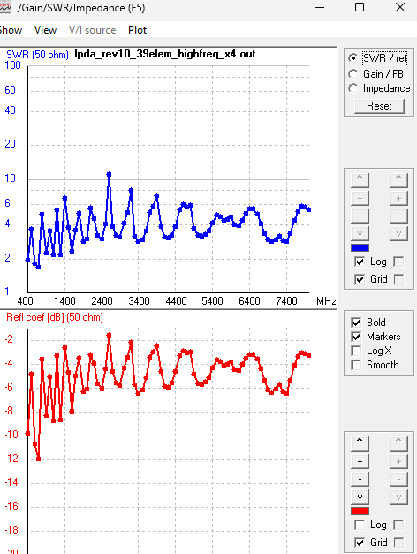
Figure 1: VSWR (top) and Reflection Coefficient / S11 in dB (bottom) vs. frequency, REV10 final design.
Frequency | 400 MHz | 2 GHz | 5 GHz | 8 GHz
VSWR (50 Ω) | 1.96 | 2.97 | 3.19 | 5.44
Return Loss (dB) | ≈ −14.4 | ≈ −7.1 | ≈ −6.7 | ≈ −3.4

The design achieves a strong match at the low-band edge (400 MHz) and a moderate match through most of the mid-band. VSWR does not remain below 2 across the entire band — this is stated explicitly rather than implied otherwise; the mid-band region near 2 GHz and the upper region near 8 GHz show elevated VSWR relative to 400 MHz, discussed further in Section 7.
Approximate bandwidth efficiency (read from Figure 1; an exact figure would require exporting the full 77-point dataset rather than visual inspection of the plotted curve): the VSWR trace touches or dips near 2 only close to the 400 MHz edge and at isolated ripple troughs, so the fraction of the band continuously at VSWR ≤ 2 is small — well under half. A large majority of the swept band (visually, roughly 80-90%) stays at or below VSWR ≤ 5, and the ripple troughs frequently reach VSWR ≤ 3 across the low-to-mid band before the 2 GHz and high-band regions discussed in Section 7.

6.2 Gain and Radiation Pattern
Total gain (dBi) and far-field radiation pattern (vertical plane, φ = 0°) were evaluated at four representative frequencies spanning the design band. Note: gain values below are the actual peak gain read from each far-field pattern, not the 4NEC2 "RDF" field (Receiving Directivity Factor — peak gain minus average gain over the full sphere), which is a distinct metric and is reported separately in Section 6.3.
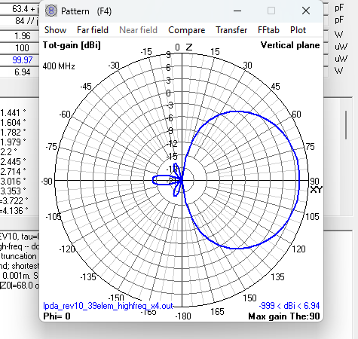
Figure 2: Radiation pattern at 400 MHz — 6.94 dBi peak gain, clean single-lobe endfire pattern.
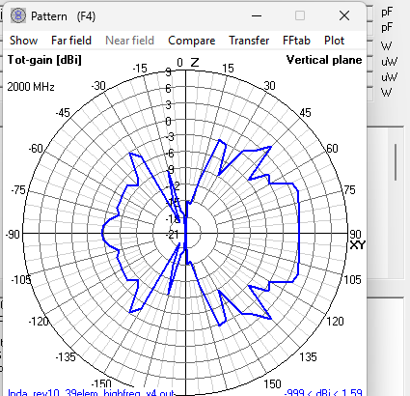
Figure 3: Radiation pattern at 2 GHz — 1.59 dBi peak gain, fragmented multi-lobe pattern (identified weak point, see Section 7).
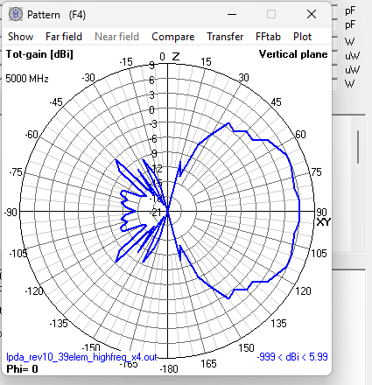
Figure 4: Radiation pattern at 5 GHz — 5.99 dBi peak gain, strong forward lobe.
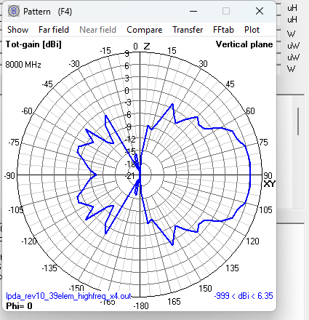
Figure 5: Radiation pattern at 8 GHz — 6.35 dBi peak gain, forward lobe present with moderate pattern distortion.
Frequency | 400 MHz | 2 GHz | 5 GHz | 8 GHz
Peak Gain (dBi) | 6.94 | 1.59 | 5.99 | 6.35
Pattern quality | Clean endfire | Fragmented / lobed | Clean endfire | Moderate distortion

6.3 Front-to-Back Ratio and RDF
Front-to-back ratio (F/B), defined as peak forward gain minus gain 180° opposite on the same pattern cut, was estimated from the far-field pattern plots. These values are approximate (±2–3 dB), pending confirmation from 4NEC2's numeric far-field data table:
Frequency | 400 MHz | 2 GHz | 5 GHz | 8 GHz
F/B ratio (approx., dB) | ≈ 23 | ≈ 3–5 | ≈ 20 | ≈ 15–16
RDF (dB, 4NEC2) | 6.94 | 7.41 | 6.80 | 7.30

RDF (Receiving Directivity Factor) is peak gain minus the average gain over the entire radiation sphere — a measure of overall pattern directivity, not the same quantity as front-to-back ratio, and is reported here only for completeness.

7. Discussion and Known Limitations
The final design should not be characterized as achieving "VSWR ≤ 2 across the entire band" — this claim would not be accurate and is deliberately not made. The honest performance summary is:
- 400 MHz (low-band edge): strong match (VSWR 1.96), clean endfire pattern, high F/B (~23 dB). This was the most significant problem in early revisions and is now well resolved.
- ~2 GHz: the weakest point in the design. VSWR rises to 2.97, peak gain drops to 1.59 dBi (a ~5 dB dip relative to neighboring frequencies), and the radiation pattern is fragmented with poor front-to-back ratio (~3–5 dB). This is a localized effect associated with the active-region elements around Tags 17–19 (element lengths ≈ 69–86 mm, resonant near 1.75–2.16 GHz).
- 5 GHz: good performance across all metrics.
- 8 GHz (high-band edge): moderate VSWR (5.44) but respectable gain (6.35 dBi) and F/B (~15–16 dB); a substantial improvement over earlier revisions, where an unresolved SWR peak of similar magnitude occurred near 7 GHz with no clear high-frequency recovery.
The 2 GHz weak point was under active investigation at the time of this report via a targeted, localized geometry adjustment to elements 17–19, rather than a further global parameter change — consistent with the project's overall approach of making one isolated, testable change at a time and evaluating it against the full-band sweep before accepting it.
A stub-based fix and a reduced-taper (τ=0.92) redesign were both tested as candidate solutions to different problems during this project and both were rejected based on simulated evidence rather than assumption — the stub degraded the 400 MHz match without helping the intended target, and the reduced taper traded a worse 400 MHz match for a smoother but still-flawed mid-band. Both negative results are included here because they represent genuine engineering evaluation, not just the changes that happened to work.

8. Conclusion
A 39-element log-periodic dipole array was designed and simulated in 4NEC2 to cover 400 MHz to 8 GHz. Through ten iterative design revisions, both the low-frequency (400 MHz) and high-frequency (8 GHz) edge-of-band impedance mismatches — each independently traced to finite-array truncation effects — were identified and corrected by extending the element count at the corresponding end of the array, rather than by feed-impedance or taper adjustments alone, which were tested and found ineffective for these specific problems. The final design achieves a strong low-band match (VSWR 1.96, F/B ≈ 23 dB at 400 MHz) and acceptable-to-good performance through most of the band, with one clearly identified and localized weak point near 2 GHz that has been characterized in detail and was the subject of ongoing targeted optimization.

9. 915 MHz Single-Element Antenna Designs (Supplementary Category)
In addition to the wideband LPDA described in Sections 1–8, the team designed and simulated three single-element antennas targeting a fixed 915 MHz operating frequency for the Metix RF Antenna Design Challenge single-band category: a center-fed half-wave dipole (free space), a base-fed quarter-wave monopole over an idealized perfect ground plane, and a normal-mode helix monopole over the same ground plane, developed as a physically miniaturized alternative to the straight monopole. All three designs were developed using the same methodology as the LPDA: 4NEC2 / NEC-2 (Method of Moments) simulation, a fixed 850–980 MHz sweep (27 points, 5 MHz steps) for direct impedance comparison around the 915 MHz design point, and a strict single-parameter-change discipline between revisions so that cause and effect could be isolated and verified before a change was accepted. The pass criterion adopted for this category was VSWR(50 Ω) ≤ 2 at 915 MHz.

9.1 Half-Wave Dipole (Free Space)
A center-fed half-wave dipole was modeled as a single continuous NEC wire along the Z-axis, fed at its center segment, in free space (no ground plane). Classical thin-wire dipole theory predicts a feed-point impedance near 73 + j42.5 Ω at a length of exactly 0.5λ, with the true resonant (zero-reactance) length slightly shorter than 0.5λ depending on the wire radius-to-length ratio.
Parameter | Value
Antenna type | Center-fed half-wave dipole
Environment | Free space
Total length | 154.60 mm
Wire radius | 0.5 mm
Segments | 11 (center feed at segment 6)
Design frequency | 915 MHz

The design was reached in two iterations. Iteration 1 used a theoretical starting length of 155.63 mm (velocity factor k = 0.95 applied to the free-space half-wavelength). Iteration 2 applied a length-only correction to 154.60 mm once the sign of the reactance from Iteration 1 indicated the antenna was slightly too long.
Iteration | Length (mm) | R (Ω) | X (Ω) | SWR(50)
1 | 155.63 (theoretical, k=0.95) | 73.03 | +5.06 | 1.47
2 (final) | 154.60 (length-only correction) | 71.61 | −0.30 | 1.43

Reactance crossed from +5.06 Ω to −0.30 Ω between the two iterations, confirming that true resonance (X ≈ 0) lies almost exactly at the Iteration 2 length. Per the project’s single-parameter rule, no further length change was made once the sign crossing confirmed resonance. The resulting resistance (≈71.6 Ω) is in close agreement with classical thin half-wave dipole theory (≈73.1 Ω in free space).
Frequency | Z (Ω) | SWR(50) | Peak Gain (dBi) | Efficiency | RDF (dB)
915 MHz | 71.6 − j0.3 | 1.43 | 2.12 | 100% | 2.13

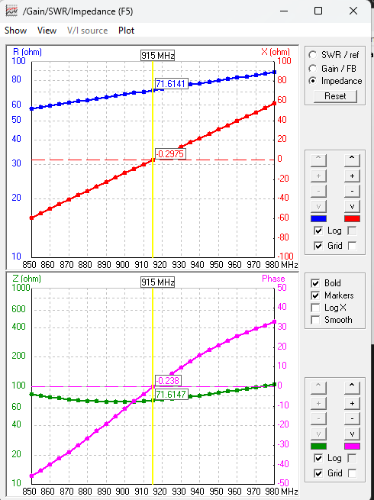
Figure 6: R (blue) and X (red) impedance sweep, 850–980 MHz, and Z-magnitude/phase (lower panel), final dipole design.
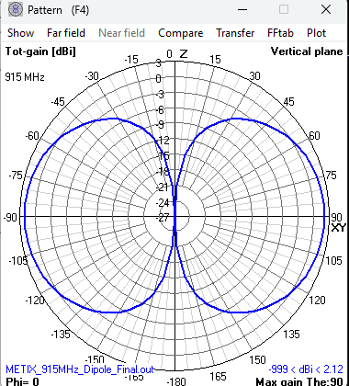
Figure 7: Vertical-plane radiation pattern at 915 MHz — classical dipole figure-eight, peak gain 2.12 dBi broadside (θ = 90°).

9.2 Quarter-Wave Monopole (Perfect Ground)
A base-fed quarter-wave monopole was modeled as a single vertical NEC wire rising from the ground plane (Z = 0) and fed at its base segment, over an idealized perfect ground (image theory). By image symmetry, a quarter-wave monopole over a perfect ground is expected to reproduce roughly half the feed resistance of a free-space half-wave dipole (≈36.5 Ω vs. ≈73 Ω) while radiating the same total power into only the upper hemisphere, giving a gain increase of approximately 3 dB relative to the free-space dipole.
Early revisions (REV1/REV2) with the NEC ground-interpolation flag (GE) left at its default value of 0 produced a physically implausible reactance of −1350 to −1490 Ω, regardless of segment count (7 vs. 31 segments tested), which ruled out segmentation as the cause. The root cause was identified as the GE card’s own flag (distinct from the GN ground-type card): GE controls whether NEC interpolates the current expansion on segments that physically touch the ground plane to their images (forcing the charge to zero at the base), which is the correct boundary condition for a base-driven monopole. Setting GE 1 (REV3) corrected the result to a physically sensible impedance.
Parameter | Value
Antenna type | Base-fed quarter-wave monopole
Environment | Perfect ground (GN 1, GE 1)
Length | 77.30 mm (λ/4 at 915 MHz)
Wire radius | 0.5 mm
Segments | 31 (base feed at segment 1)
Design frequency | 915 MHz

Frequency | Z (Ω) | SWR(50) | Peak Gain (dBi) | Efficiency | RDF (dB)
915 MHz | 36.2 + j1.0 | 1.38 | 5.15 | 100% | 5.15

As expected from image theory, the feed resistance (36.2 Ω) is close to half the free-space dipole’s (71.6 Ω), and the peak gain (5.15 dBi) is roughly 3 dB higher than the dipole’s (2.12 dBi) despite radiating into only the upper half-space — consistent with the ground plane acting as a perfect reflector that reinforces the upward radiation. This is the tightest impedance match (SWR 1.38) of the three single-element designs.
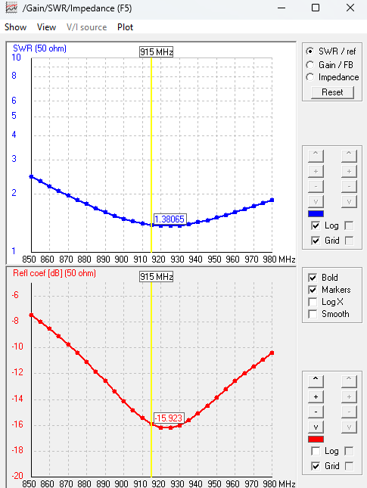
Figure 8: SWR (top) and reflection coefficient (bottom) vs. frequency, 850–980 MHz, final monopole design (REV3).
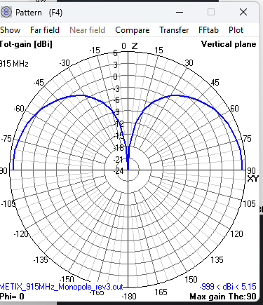
Figure 9: Vertical-plane radiation pattern at 915 MHz — single-lobe monopole-over-ground pattern, peak gain 5.15 dBi, null at zenith.

9.3 Normal-Mode Helix Monopole — Physically Miniaturized Alternative
The normal-mode helix monopole was developed to test whether a physically shorter monopole than the straight quarter-wave design (Section 9.2) could still be matched to 50 Ω at 915 MHz, by coiling extra wire length into a helix of small radius (radius ≪ λ) so that the antenna carries more total wire length — and therefore more series inductance — than its physical height alone would suggest. The physical coil height was fixed at 69 mm (0.211λ at 915 MHz), well under the 77.30 mm of the straight monopole in Section 9.2, with turn count used as the single tuning parameter across five design revisions.
Rev | Turns (N) | Radius r (mm) | Height H (mm) | R (Ω) | X (Ω) | SWR(50) | Note
REV2 | 4 | 3 | 12 | 0.49 | −163 | 1196 | Too short — radiation resistance collapses toward zero
REV3 | 3 | 5 | 70 | 39.7 | +70.3 | 6.62 | H redesigned to 0.214λ; R now in 25–100Ω window, X far too inductive
REV4 | 2 | 5 | 69 | 37.0 | +39.7 | 2.55 | X roughly halved by removing one turn; still inductive
REV5 | 1 | 5 | 69 | 26.3 | −10.5 | 2.02 | X crosses zero — now capacitive; brackets resonance with REV4
REV6 (final) | 1.1667 | 5 | 69 | 27.6 | −3.89 | 1.83 | Interpolated turn count; meets SWR ≤ 2 target

REV6’s turn count (1.1667 turns, 420°) was reached by linear interpolation between REV4 (N=2, X=+39.7 Ω) and REV5 (N=1, X=−10.5 Ω), preserving the 30°-per-segment convention used throughout (14 coil segments instead of REV5’s 12). Radius (5.0 mm) and total coil height (69 mm) were held fixed across every revision from REV3 onward, isolating turn count as the sole variable under test.
Parameter | Value
Antenna type | Normal-mode helix monopole over ground
Environment | Perfect ground (GN 1, GE 1)
Helix radius | 5.0 mm
Coil height | 69 mm (0.211λ at 915 MHz)
Turns | 1.1667 (420°), 30°/segment — 14 coil segments
Total wire length | 83.03 mm = 0.253λ (77.94 mm coil + 5.10 mm lead-in)
Wire radius | 0.5 mm
Feed | Base of lead-in stub (against ground)

Frequency | Z (Ω) | SWR(50) | Peak Gain (dBi) | Efficiency
915 MHz | 27.6 − j3.89 | 1.83 | 5.32 | 100%

REV6 meets the SWR ≤ 2 target with R comfortably inside the 25–100 Ω window and X reduced to near zero. The residual −3.89 Ω of capacitive reactance, bracketed between REV4 and REV5, could be trimmed further toward a tighter match (interpolation suggests ≈1.24 turns) as an optional next iteration, but REV6 already satisfies the contest requirement, so no further parameter change was made — consistent with the project’s single-parameter, stop-when-it-passes discipline. The radiation pattern (Figure 11) retains the expected monopole-over-ground shape despite the coiled geometry, confirming the helix is still operating in normal mode (broadside-maximum, not axial/end-fire).
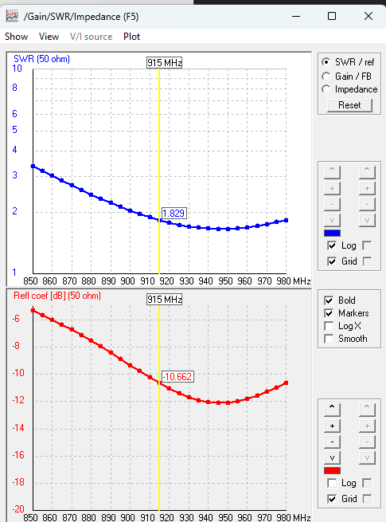
Figure 10: SWR (top) and reflection coefficient (bottom) vs. frequency, 850–980 MHz, final helix design (REV6).
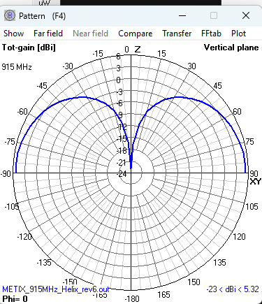
Figure 11: Vertical-plane radiation pattern at 915 MHz — monopole-type pattern preserved, peak gain 5.32 dBi.

9.4 Comparison Summary
Design | Environment | R (Ω) | X (Ω) | SWR(50) | Peak Gain (dBi) | Efficiency
Half-wave dipole | Free space | 71.6 | −0.3 | 1.43 | 2.12 | 100%
Quarter-wave monopole | Perfect ground | 36.2 | +1.0 | 1.38 | 5.15 | 100%
Helix monopole (REV6) | Perfect ground | 27.6 | −3.89 | 1.83 | 5.32 | 100%

All three 915 MHz single-element designs meet the SWR(50) ≤ 2 requirement. The straight quarter-wave monopole achieves the tightest match (SWR 1.38) as the simplest resonant structure; the free-space dipole confirms classical theory almost exactly (R within 2% of the ideal 73.1 Ω); and the helix monopole demonstrates that the same electrical function can be achieved in a physically shorter package (69 mm vs. 77.30 mm height, a 10.7% height reduction) at the cost of a wider impedance excursion during tuning and a looser final match (SWR 1.83) — an expected trade-off of the miniaturization approach, and the tightest constrained result of the three given that goal.

10. References
[1] R. Carrel, "The Design of Log-Periodic Dipole Antennas," IRE International Convention Record, 1961.
[2] G. J. Burke and A. J. Poggio, "Numerical Electromagnetics Code (NEC) — Method of Moments," Lawrence Livermore National Laboratory, 1981.
[3] NEC-2 Card Reference, nec2.org — TL (Transmission Line) card specification.
[4] 4NEC2 Antenna Modeling Software, documentation and user guide.
[5] C. A. Balanis, Antenna Theory: Analysis and Design, 4th ed., Wiley, 2016.

