Name : Rutuja Ravindra Desai

Roll No. : 61

Department : Computer Engineering

Div : A

Batch : B2

**Assignment - Shell Script**

**Problem Statement:**

Write a shell script :

1. For Calculator using command line arguments

2. To reverse the given string

3. To execute linux commands using case statements.

4. To print the pyramid of *

5.To write a function for factorial of a number

6. To sort the given elements using any sorting method.

**1. For Calculator using command line arguments**

**Code :**

# !/bin/bash

# Take user Input

echo "Enter Two numbers : "

read a

read b

# Input type of operation

echo "Enter Choice :"

echo "1. Addition"

echo "2. Subtraction"

echo "3. Multiplication"

echo "4. Division"

read ch

# Switch Case to perform

# calculator operations

case $ch in

1)res=`echo $a + $b | bc`

;;

2)res=`echo $a - $b | bc`

;;

3)res=`echo $a \* $b | bc`

;;

4)res=`echo "scale=2; $a / $b" | bc`

;;

esac

echo "Result : $res"

**Output:**

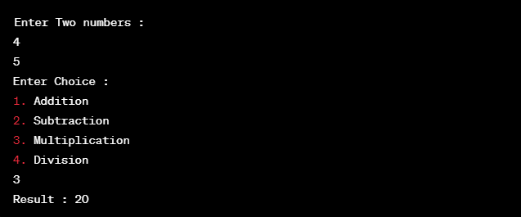

**2. To reverse the given string**

**Code:**

#!/bin/bash

echo "Enter a string: "

read s

strlen=${#s}

for (( i=$strlen-1; i>=0; i-- ));

do

revstr=$revstr${s:$i:1}

done

echo "Original String : $s"

echo "Reversed String : $revstr"

**Output:**

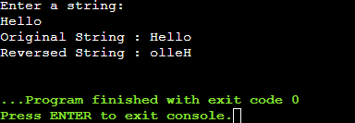

**3. To execute linux commands using case statements.**

**Code:**

echo -e "1.List of files\n

2.No. of processes\n

3.Today's date\n

4.Logged users\n

5.exit\n"

echo "Enter your choice"

read ch

case $ch in

1)ls ;;

2)ps ;;

3)date ;;

4)who ;;

5)exit ;;

*) echo "Wrong choice, enter again“

esac

**4. To print the pyramid of \***

**Code:**

#!/bin/bash

for (( i=1; i<=5; i++ ))

do

for (( j=1; j<=i; j++ ))

do

echo -n "*"

done

echo

done

**Output:**

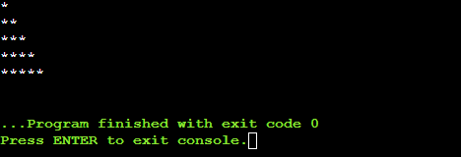

**5.To write a function for factorial of a number**

**Code:**

#!/bin/bash

# Recursive factorial function

factorial()

{

product=$1

# Defining a function to calculate factorial using recursion

if((product <= 2)); then

echo $product

else

f=$((product -1))

# Recursive call

f=$(factorial $f)

f=$((f*product))

echo $f

fi

}

# main program

# reading the input from user

echo "Enter the number:"

read num

# defining a special case for 0! = 1

if((num == 0)); then

echo 1

else

#calling the function

factorial $num

fi

**Output:**

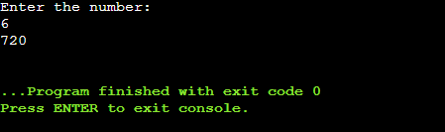

**6. To sort the given elements using any sorting method.**

**Code:**

# Sorting the array in Bash

# using Bubble sort

# Static input of Array

arr=(10 8 20 100 12)

echo "Array in original order"

echo ${arr[*]}

# Performing Bubble sort

for ((i = 0; i<5; i++))

do

for((j = 0; j<5-i-1; j++))

do

if [ ${arr[j]} -gt ${arr[$((j+1))]} ]

then

# swap

temp=${arr[j]}

arr[$j]=${arr[$((j+1))]}

arr[$((j+1))]=$temp

fi

done

done

echo "Array in sorted order :"

echo ${arr[*]}

**Output:**

