CA – II ASSIGNMENT

GEN-AI

Name : Rutuja Durge PRN: 21070521062

Semester : 7 Section : A

Q:5 Generate a model for Covid 19 with symptoms of parameters like fever, cold, shivering, weight loss, generate 100 model data with random values for each parameter and order by parameter lowest to highest in display based on the input parameter.

**Model code:**

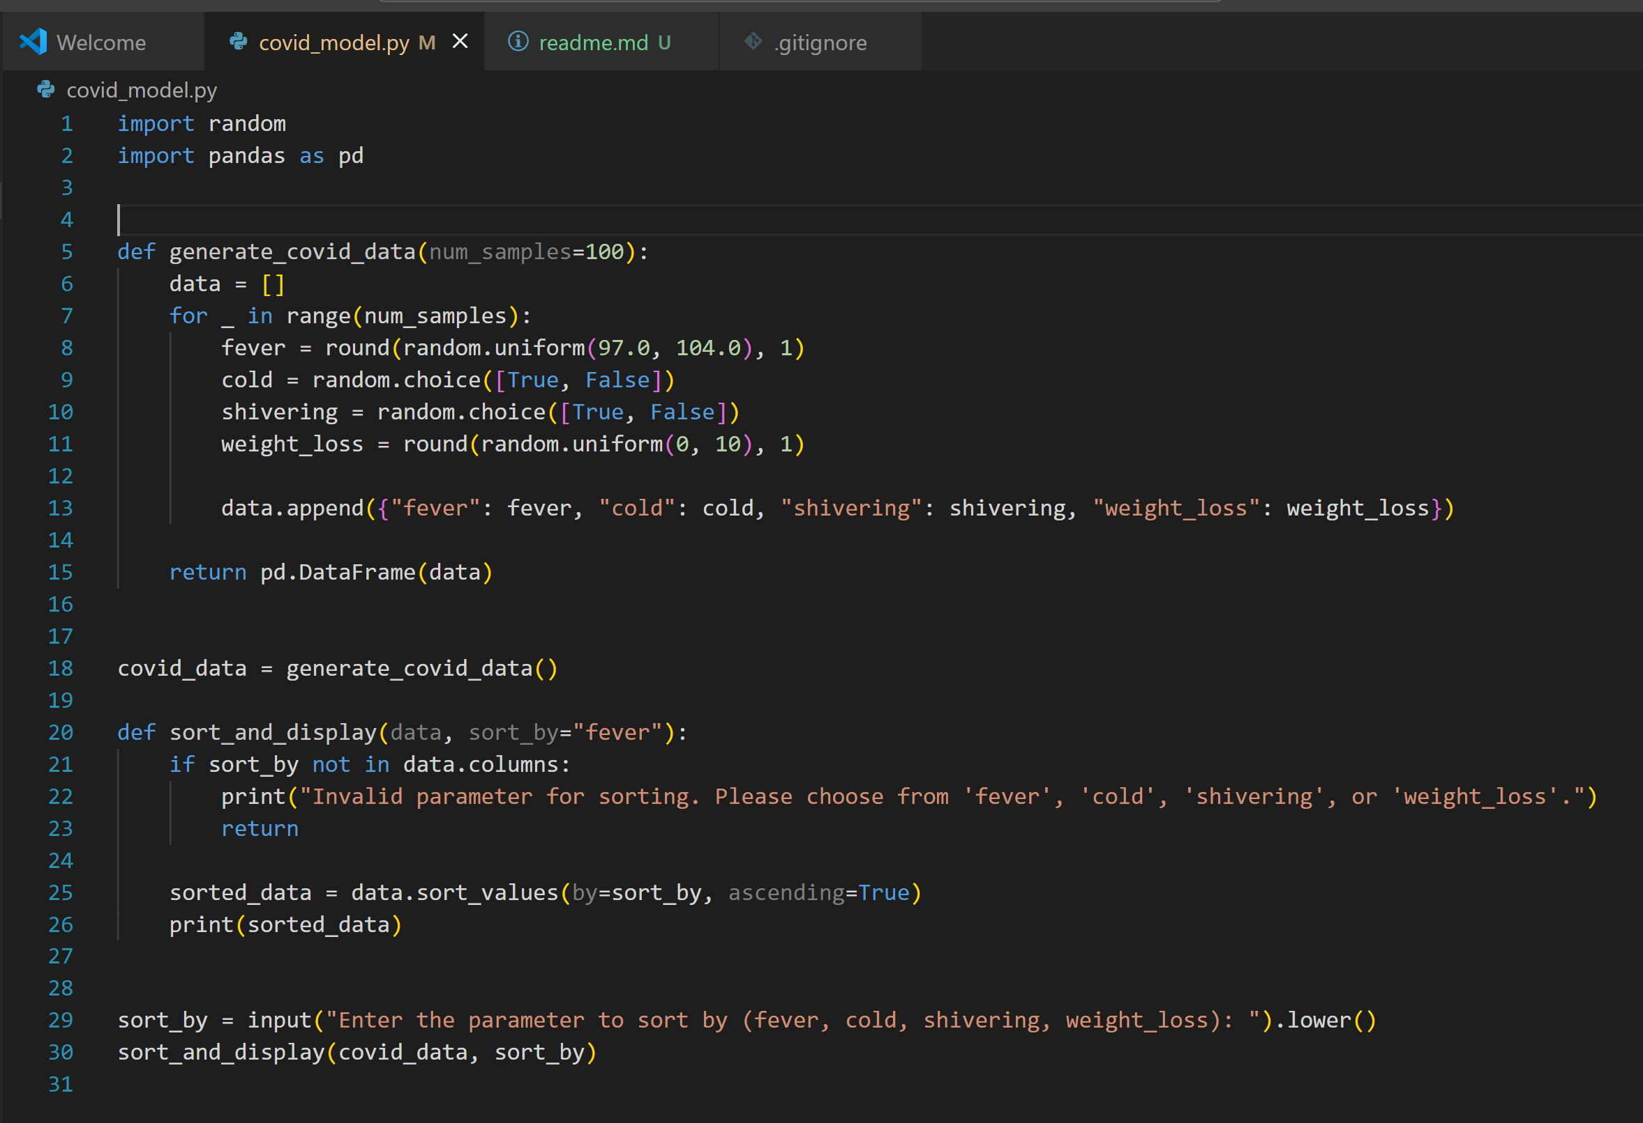

**OUTPUT:**

1. Fever as a parameter

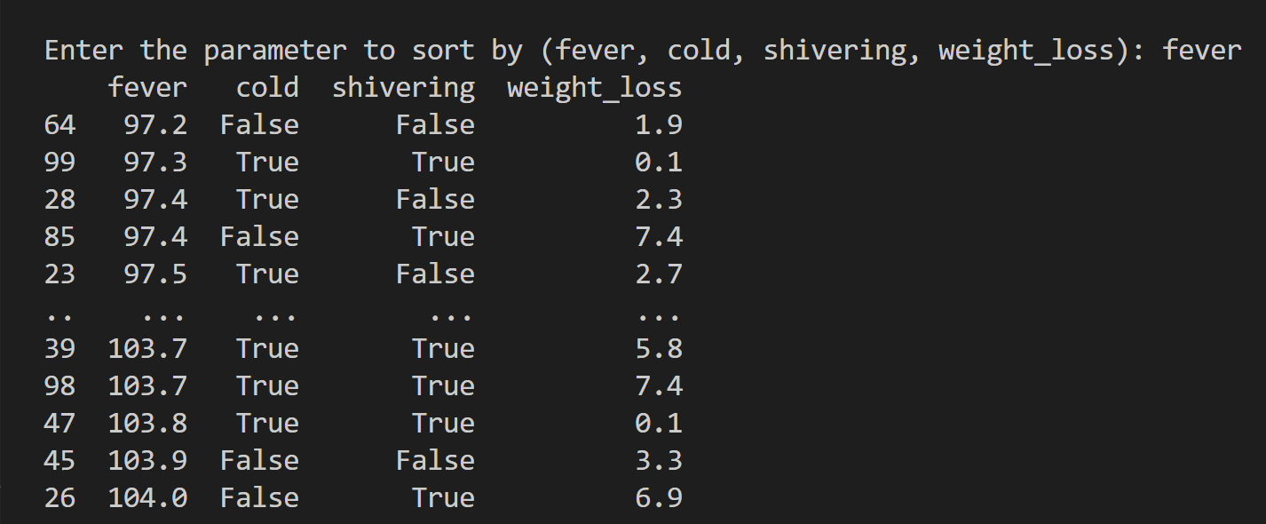

1. Cold as a parameter

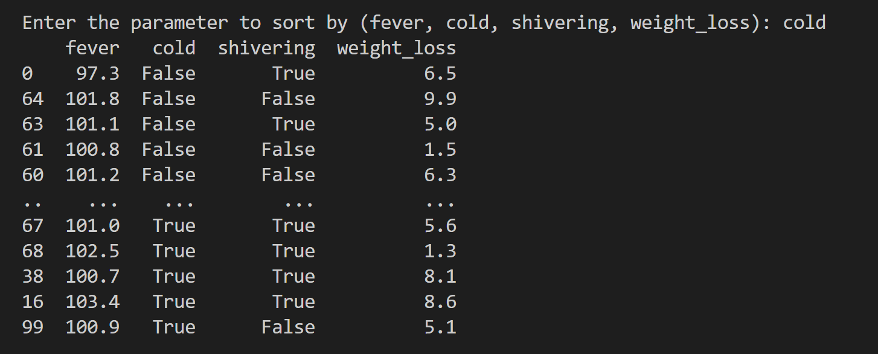

1. Shivering as a parameter

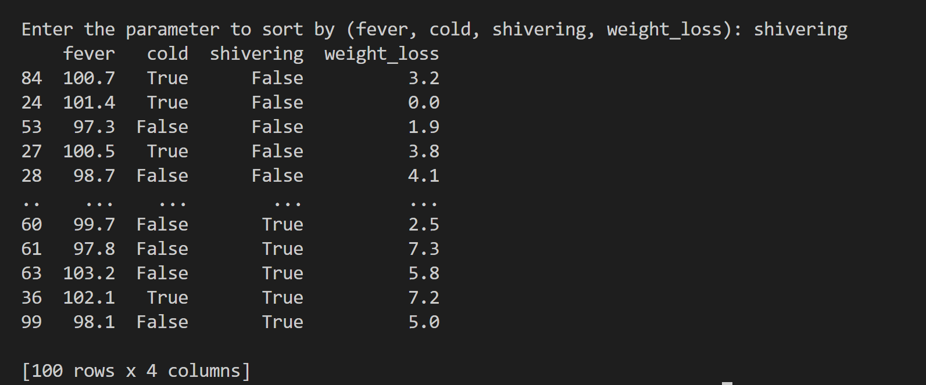

1. Weight_loss as a parameter

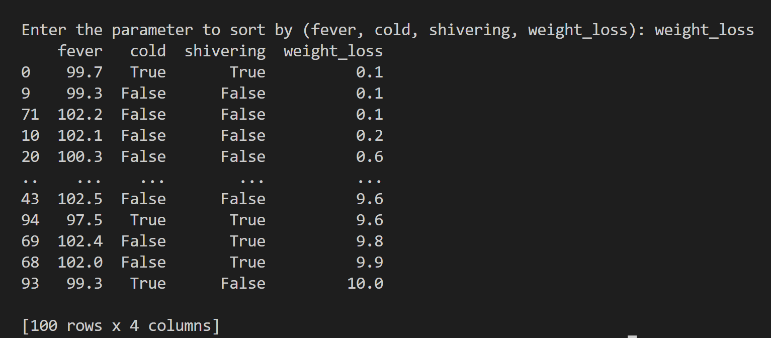

**Explaination of code:**

This Python code generates synthetic COVID-related health data, stores it in a Pandas DataFrame, and allows the user to sort and display the data based on a chosen parameter.

1. `**generate_covid_data(num_samples=100)**`: This function generates a dataset with `num_samples` (default is 100) entries. For each entry:

- `fever`: Randomly generated float between 97.0 and 104.0.

- `cold`: Randomly assigned `True` or `False`.

- `shivering`: Randomly assigned `True` or `False`.

- `weight_loss`: Randomly generated float between 0 and 10.

These data points are appended to a list and then converted into a Pandas DataFrame, which is returned.

2. `**sort_and_display(data, sort_by="fever")**`: This function takes the generated DataFrame (`data`) and sorts it based on the `sort_by` column, which defaults to "fever". The sorted data is then printed. If the input column for sorting is invalid, an error message is displayed.

3**. User Input**: The user is prompted to enter a sorting parameter (`fever`, `cold`, `shivering`, or `weight_loss`), and the DataFrame is sorted accordingly.