Coding Question Template for LMS
Question 1 :
Program Title: Container with Most Water
Programming Language: Java
Description: You are given an integer array height of length n. There are n vertical lines drawn such that the two endpoints of the i^{th} line are (i, 0) and (i, height[i]).
Find two lines that together with the x-axis form a container, such that the container contains the most water.
Return the maximum amount of water a container can store
Constraints:
n == height.length
2 <= n <= 10⁵
0 <= height[i] <= 10⁴

Example:
Test Case 1:
Input: height = [1, 8, 6, 2, 5, 4, 8, 3, 7]
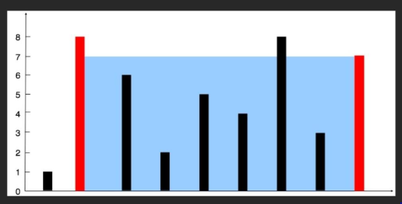
Start end
Old Area=0
Length= 6
Height =3
New Area=18
Old Area= 49
Output: 49

Test Case 2:
Input: height = [1, 8, 9, 2, 5, 8]
Output: 32

Solution : Code

Question 2 :
Program Title: Longest Common Prefix
Programming Language: Java
Description: Write a function to find the longest common prefix string amongst an array of strings.
If there is no common prefix, return an empty string ""
Constraints:
1 <= strs.length <= 200
0 <= strs[i].length <= 200
strs[i] consists of only lowercase English letters if it is non-empty

Example:
Test Case 1:
Input: strs = [“FLOWERS”,”FLOW”,”FLIGHT”]
Output: “FL”

Test Case 2:
Input: strs = [“apple”,”racecar”,”race”]
Output: “”
Explanation : there is no common prefix

Solution
package day32.dsa;

import java.util.Arrays;

public class LongestCommonPrefix {

public static void main(String[] args)
{ // i
String strs[] = {"FLOWERS","FLOW","FLIGHT"};
System.out.println(findLongestCommonPrefix(strs));
}

private static String findLongestCommonPrefix(String[] strs) {
String prefix = strs[0]; //FLOWERS

for (int i = 1; i < strs.length; i++) {

while (!strs[i].startsWith(prefix))
{
prefix = prefix.substring(0, prefix.length() - 1);

if (prefix.isEmpty()) {
return "";
}
}
}

return prefix;

}

}

Dry run
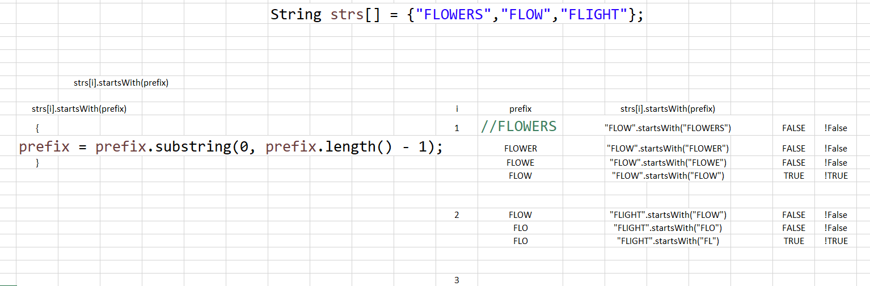

Question 3 :
Program Title: Valid Parentheses
Programming Language: Java
Description: Given a string s containing just the characters '(', ')', '{', '}', '[' and ']', determine if the input string is valid.
An input string is valid if:
- Open brackets must be closed by the same type of brackets.
- Open brackets must be closed in the correct order.
- Every close bracket has a corresponding open bracket of the same type
Constraints:
1 <= s.length <= 104
s consists of parentheses only '()[]{}'.

Example:
Test Case 1:
Input: s = {[()]}
Output: true

Test Case 2:
Input: height = {[(])}
Output: false

Question 4 :
Program Title: Remove Duplicates From an Array
Programming Language: Java
Description: Given an integer array, remove all the duplicates and return the array with all unique values
Constraints:
2 <= array size <= 10⁵
0 <= array[i] <= 10⁴

Example:
Test Case 1:
Input: arr = [1, 3, 6,1, 8, 5, 4, 8, 3, 6]
Output: [1,3,6,8,5,4]

Test Case 2:
Input: arr = [1,2,2,3,3,3,4,5]
Output: [1,2,3,4,5]

Question 5 :
Program Title: Remove Element
Programming Language: Java
Description: Given an integer array nums and an integer val, remove all occurrences of val in nums
Constraints:
n == height.length
2 <= n <= 10⁵
0 <= height[i] <= 10⁴

Example:
Test Case 1:
Input: nums = [3,2,2,3], val=3
Output: [2,2]

Test Case 2:
Input: nums = [1,2,3,2,2,3], val=2
Output: [1,3,3]

Question 6:
Program Title: Bank Steal Mission
Programming Language: Java
Description: A bank is guarded by multiple security guards working in different time shifts during the day. Each guard is active during a specific time interval.
You are given:
- numOfGuards → number of guards
- timeToSteal → total hours required to successfully steal
- totalBankHours → total number of hours the bank operates
- ShiftTimings[] → an array representing guard shifts in pairs
  - (start₁, end₁), (start₂, end₂), …
Your task is to determine whether a robbery is possible based on unguarded hours.
👉 If total unguarded hours ≥ timeToSteal → return "Possible"
👉 Otherwise → return "Impossible"

Constraints:
ShiftTimings.length = 2 * numOfGuards
0 <= start < end <= totalBankHours
1 <= totalBankHours <= 10^5
1 <= timeToSteal <= totalBankHours
Guards do not overlapping shifts
Example:
Test Case 1:
Input:
numOfGuards = 2
timeToSteal = 2
totalBankHours = 10
ShiftTimings = [0, 3, 6, 10]
Output: Possible
Test Case 2:
Input:
numOfGuards = 4
timeToSteal = 3
totalBankHours = 15
ShiftTimings = [0, 2, 2, 6, 6, 8, 9, 15]
Output: Impossible

Question 7 :
Program Title: Product of Array Except Self position
Programming Language: Java
Description: Given an integer array nums, return an array answer such that answer[i] is equal to the product of all elements of nums except nums[i].
Constraints:
2 <= nums.length <= 10^5
-30 <= nums[i] <= 30

Example:
Test Case 1:
Input: nums = [1,2,3]
Output: [6,3,2]

Test Case 2:
Input: nums = [1,2,3,4]
Output: [24,12,8,6]

Question 8 :
Program Title: 3Sum
Programming Language: Java
Description: Given an integer array nums, return all unique triplets [nums[i], nums[j], nums[k]] such that:
nums[i] + nums[j] + nums[k] == 0
Constraints:
3 <= nums.length <= 3000
-10^5 <= nums[i] <= 10^5
The solution set must not contain duplicate triplets

Example:
Test Case 1:
Input: nums = [-1,0,1,2,-1,-4]
Output: [[-1,-1,2],[-1,0,1]]
Test Case 2:
Input: nums [-2,0,1,1,2]
Output: [[-2,0,2],[-2,1,1]]

Question 9:
Program Title: Minimum Size Subarray Sum
Programming Language: Java
Description: Given an array of positive integers nums and a positive integer target, return the minimal length of a contiguous subarray whose sum is equal to target.
If no such subarray exists, return 0.
Constraints:
1 <= target <= 10^9
1 <= nums.length <= 10^5
1 <= nums[i] <= 10^5
Example:
Test Case 1:
Input
target = 7
nums = [2,3,2,1,4,3]
Output: 2
Explanation
Subarray [4,3] has sum = 7
Minimum length = 2

Test Case 2:
Input:
target = 15
nums = [1,2,3,4,5]
Output: 5

Question 10:
Program Title: Best Time to Buy and Sell Stock
Programming Language: Java
Description: You are given an array prices where prices[i] represents the price of a stock on the i-th day.
Your task is to find the maximum profit you can achieve by:
Buying one stock on one day
Selling it on a later day
You must buy before you sell.
If no profit is possible, return 0
Constraints:
1 <= prices.length <= 10^5
0 <= prices[i] <= 10^4

Example:
Test Case 1:
Input
prices = [7,1,5,3,6,4]
Output: 5

Test Case 2:
Input: [7, 3, 5, 2,3, 3]
Output: 2

Question 11 :
Program Title: Find First and Last Position of Element in Sorted Array
Programming Language: Java
Description: Given an array of integers nums sorted in non-decreasing order, find the starting and ending position of a given target value.
If target is not found in the array, return [-1, -1].
You must write an algorithm with O(log n) runtime complexity
Constraints:
0 <= nums.length <= 105
-109 <= nums[i] <= 109
nums is a non-decreasing array.
-109 <= target <= 109

Example:
Test Case 1:
Input: nums = [5,7,7,8,8,10] target=8
Output: [3,4]

Test Case 2:
Input: nums = [5,7,7,8,8,10] target=6
Output: [-1,-1]

Test Case 3:
Input: nums = [5,7,7,8,8,10] target=5
Output: [0,0]

Question 12 :
Program Title: Search Insert Position
Programming Language: Java
Description: Given a sorted array of distinct integers and a target value, return the index if the target is found. If not, return the index where it would be if it were inserted in order.
You must write an algorithm with O(log n) runtime complexity.
Constraints:
- 1 <= nums.length <= 10⁴
- -10⁴ <= nums[i] <= 10⁴
- nums contains distinct values sorted in ascending order.
- -10⁴ <= target <= 10⁴

Example:
Test Case 1:
Input: height = [1,3,5,6] target=5
Output: 2

Test Case 2:
Input: height = [1,3,5,6] target=2
Output: 1

Test Case 2:
Input: height = [1,3,5,6] target=7
Output: 4

Question 13 :
Program Title: Valid Sudoku
Programming Language: Java
Determine if a 9 x 9 Sudoku board is valid. Only the filled cells need to be validated according to the following rules:
- Each row must contain the digits 1-9 without repetition.
- Each column must contain the digits 1-9 without repetition.
- Each of the nine 3 x 3 sub-boxes of the grid must contain the digits 1-9 without repetition.
Note:
- A Sudoku board (partially filled) could be valid but is not necessarily solvable.
- Only the filled cells need to be validated according to the mentioned rules.
Constraints:
- board.length == 9
- board[i].length == 9
- board[i][j] is a digit 1-9 or '.'.

Example:
Test Case 1:
Input: board =
[["5","3",".",".","7",".",".",".","."]
,["6",".",".","1","9","5",".",".","."]
,[".","9","8",".",".",".",".","6","."]
,["8",".",".",".","6",".",".",".","3"]
,["4",".",".","8",".","3",".",".","1"]
,["7",".",".",".","2",".",".",".","6"]
,[".","6",".",".",".",".","2","8","."]
,[".",".",".","4","1","9",".",".","5"]
,[".",".",".",".","8",".",".","7","9"]]
Output: true

Test Case 2:
Input: board =
[["8","3",".",".","7",".",".",".","."]
,["6",".",".","1","9","5",".",".","."]
,[".","9","8",".",".",".",".","6","."]
,["8",".",".",".","6",".",".",".","3"]
,["4",".",".","8",".","3",".",".","1"]
,["7",".",".",".","2",".",".",".","6"]
,[".","6",".",".",".",".","2","8","."]
,[".",".",".","4","1","9",".",".","5"]
,[".",".",".",".","8",".",".","7","9"]]
Output: false

Question 14:
Program Title: Sudoku solver
Programming Language: Java
Write a program to solve a Sudoku puzzle by filling the empty cells.
A sudoku solution must satisfy all of the following rules:
- Each of the digits 1-9 must occur exactly once in each row.
- Each of the digits 1-9 must occur exactly once in each column.
- Each of the digits 1-9 must occur exactly once in each of the 9 3x3 sub-boxes of the grid.
The '.' character indicates empty cells.
Constraints:
- board.length == 9
- board[i].length == 9
- board[i][j] is a digit or '.'.
- It is guaranteed that the input board has only one solution.
Example:
Test Case 1:
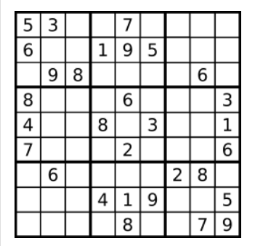
Input: board =
[["5","3",".",".","7",".",".",".","."]
,["6",".",".","1","9","5",".",".","."]
,[".","9","8",".",".",".",".","6","."]
,["8",".",".",".","6",".",".",".","3"]
,["4",".",".","8",".","3",".",".","1"]
,["7",".",".",".","2",".",".",".","6"]
,[".","6",".",".",".",".","2","8","."]
,[".",".",".","4","1","9",".",".","5"]
,[".",".",".",".","8",".",".","7","9"]]

Output:
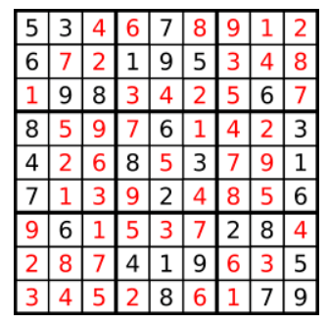
[["5","3","4","6","7","8","9","1","2"]
,["6","7","2","1","9","5","3","4","8"]
,["1","9","8","3","4","2","5","6","7"]
,["8","5","9","7","6","1","4","2","3"]
,["4","2","6","8","5","3","7","9","1"]
,["7","1","3","9","2","4","8","5","6"]
,["9","6","1","5","3","7","2","8","4"]
,["2","8","7","4","1","9","6","3","5"]
,["3","4","5","2","8","6","1","7","9"]]

Question 15 :
Program Title: Combination Sum (including duplicates)
Programming Language: Java
Description: Given an array of distinct integers candidates and a target integer target, return a list of all unique combinations of candidates where the chosen numbers sum to target. You may return the combinations in any order.
The same number may be chosen from candidates an unlimited number of times. Two combinations are unique if the frequency of at least one of the chosen numbers is different.
The test cases are generated such that the number of unique combinations that sum up to target is less than 150 combinations for the given input.
Constraints:
- 1 <= nums.length <= 10⁴
- -10⁴ <= nums[i] <= 10⁴
- nums contains distinct values sorted in ascending order.
- -10⁴ <= target <= 10⁴

Example:
Test Case 1:
Input: height = [2,3,6,7] target=7
Output: [[2,2,3],[7]]
Explanation:
2 and 3 are candidates, and 2 + 2 + 3 = 7. Note that 2 can be used multiple times.
7 is a candidate, and 7 = 7.
These are the only two combinations.

Test Case 1:
Input: height = [2,3,5] target=8
Output: [[2,2,2,2],[2,3,3],[3,5]]

Question 16 :
Program Title: Combination Sum (excluding duplicates)
Each number in candidates may only be used once in the combination.
Example:
Test Case 1:
Input: height = [10,1,2,7,6,1,5] target=8
Output: [
[1,1,6],
[1,2,5],
[1,7],
[2,6]
]

Test Case 1:
Input: height = [2,5,2,1,2] target=5
Output: [
[1,2,2],
[5]
]

Question 17 :
Program Title: Trapping Rain Water
Programming Language: Java
Description: Given n non-negative integers representing an elevation map where the width of each bar is 1, compute how much water it can trap after raining.
Constraints:
- 1 <= nums.length <= 10⁴
- -10⁴ <= nums[i] <= 10⁴
- -10⁴ <= target <= 10⁴

Example:
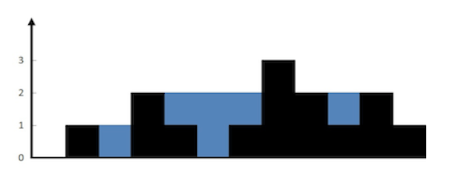
Test Case 1:
Input: height = [0,1,0,2,1,0,1,3,2,1,2,1]
Output: 6

Test Case 2:
Input: height = [4,2,0,3,2,5]
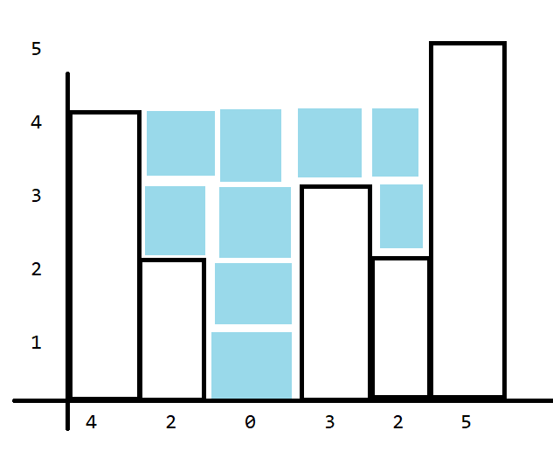
Output: 9

Solution
package day9;

import java.util.Arrays;

public class Water2 {
public static void main(String[] args) {
int wallsHeight[]= {4,2,0,3,2,5};
//int wallsHeight[]= {0,1,0,2,1,0,1,3,2,1,2,1};
int max=maxWaterCollection(wallsHeight);
System.out.println(max);
}

private static int maxWaterCollection(int[] height) {
int n=height.length; // i
// {4,2,0,3,2,5} height

int maxLeft[]=new int[n]; // [4,4,4,4,4,5] maxLeft
int maxRight[]=new int[n]; // [5,5,5,5,5,5] maxRight
maxLeft[0]=height[0]; //water [0,2,4,1,2,0] = 9
for(int i=1;i<n;i++)
{
maxLeft[i]=Math.max(height[i], maxLeft[i-1]);
}
maxRight[n-1]=height[n-1];
for(int i=n-2;i>=0;i--)
{
maxRight[i]=Math.max(height[i], maxRight[i+1]);
}
System.out.println("Left "+Arrays.toString(maxLeft));
System.out.println("Right "+Arrays.toString(maxRight));
int water=0;
for(int i=0;i<n;i++)
water+=(Math.min(maxLeft[i], maxRight[i]))-height[i];
return water;

}
}

Question 18 :
Program Title: Permutations (input array will not have duplicates)
Programming Language: Java
Description: Given an array nums of distinct integers, return all the possible permutations. You can return the answer in any order

Constraints:
- 1 <= nums.length <= 6
- -10 <= nums[i] <= 10
- All the integers of nums are unique.

Example:
Test Case 1:
Input: nums = [1,2,3]
Output: [[1,2,3], [1,3,2], [2,1,3], [2,3,1], [3,1,2], [3,2,1]]

Test Case 2:
Input: nums = [0,1]
Output: [[0,1], [1,0]]

Question 19 :
Program Title: Permutations (input array may contain duplicates)
Programming Language: Java
Description: Given an array nums of distinct integers, return all the possible permutations. You can return the answer in any order

Constraints:
- 1 <= nums.length <= 6
- -10 <= nums[i] <= 10
- All the integers of nums are not unique.

Example:
Test Case 1:
Input: nums = [1,1,2]

Output:
[[1,1,2],
[1,2,1],
[2,1,1]]

Test Case 2:
Input: nums = [1,2,3]
Output: [[1,2,3], [1,3,2], [2,1,3], [2,3,1], [3,1,2], [3,2,1]]

Question 20 :
Program Title: Rotate Image
Programming Language: Java
Description: You are given an n x n 2D matrix representing an image, rotate the image by 90 degrees (clockwise).
You have to rotate the image in-place, which means you have to modify the input 2D matrix directly. DO NOT allocate another 2D matrix and do the rotation.

Constraints:
- n == matrix.length == matrix[i].length
- 1 <= n <= 20
- -1000 <= matrix[i][j] <= 1000

Example:
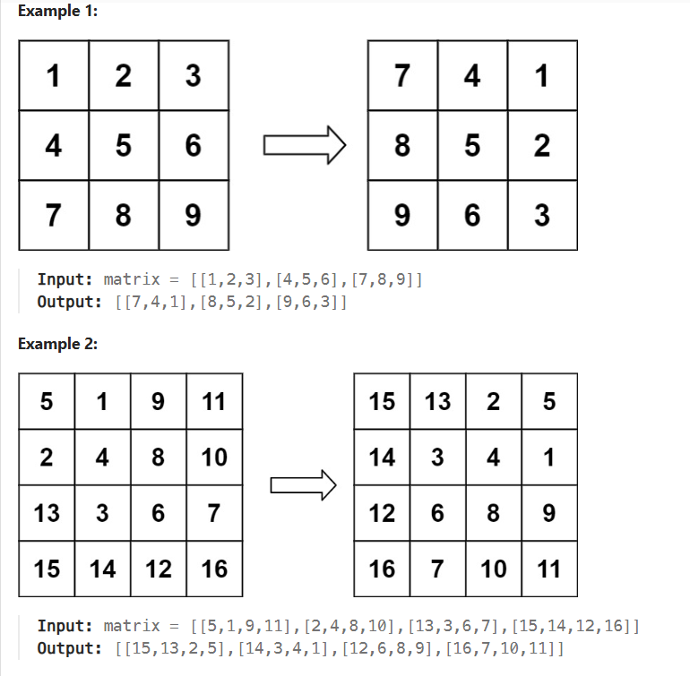

Question 21 :
Program Title: N-Queens
Programming Language: Java
Description: The n-queens puzzle is the problem of placing n queens on an n x n chessboard such that no two queens attack each other.
Given an integer n, return all distinct solutions to the n-queens puzzle. You may return the answer in any order.
Each solution contains a distinct board configuration of the n-queens' placement, where 'Q' and '.' both indicate a queen and an empty space, respectively.

Constraints:
- 1 <= n <= 9
Example:
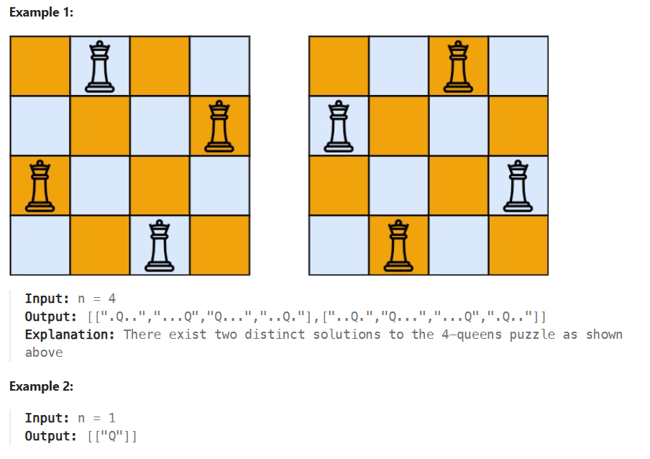

Question 22 :
Program Title: Spiral Matrix
Programming Language: Java
Description: Given an m x n matrix, return all elements of the matrix in spiral order.

Constraints:
- m == matrix.length
- n == matrix[i].length
- 1 <= m, n <= 10
- -100 <= matrix[i][j] <= 100
Example:
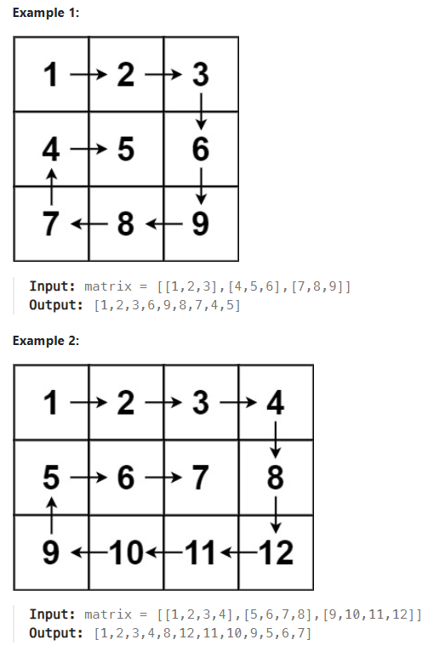

Question 23 :
Program Title: Jump Game
Programming Language: Java
Description: You are given an integer array nums. You are initially positioned at the array's first index, and each element in the array represents your maximum jump length at that position.
Return true if you can reach the last index, or false otherwise.
.

Constraints:
- 1 <= nums.length <= 10⁴
- 0 <= nums[i] <= 10⁵

Example:
Example 1:
Input: nums = [2,3,1,1,4]
Output: true
Explanation:
You start from index zero. Value of which is 2 meaning you can jump max 2 indexes
So lets assume you jump 1, so you have reached index 1

Value at index 1 is 3 meaning you can jump max 3 indexes so if you jump 3 indexes you reach the end, hence output true indicating MISSION SUCCESS

Example 2:
Input: nums = [3,2,1,0,4]
Output: false
Explanation: You will always arrive at index 3 no matter what. Its maximum jump length is 0, which makes it impossible to reach the last index.

Question 24 :
Program Title: Merge Intervals
Programming Language: Java
Description: Given an array of intervals where intervals[i] = [start_{i}, end_{i}], merge all overlapping intervals, and return an array of the non-overlapping intervals that cover all the intervals in the input.

Constraints:
- 1 <= intervals.length <= 10⁴
- intervals[i].length == 2
- 0 <= start_{i} <= end_{i} <= 10⁴

Example:
Example 1:
Input: intervals = [[1,3],[2,6],[8,10],[15,18]]
Output: [[1,6],[8,10],[15,18]]
Explanation: Since intervals [1,3] and [2,6] overlap, merge them into [1,6].

Example 2:
Input: intervals = [[1,4],[4,5]]
Output: [[1,5]]
Explanation: Intervals [1,4] and [4,5] are considered overlapping.

Example 2:
Input: intervals = [[4,7],[1,4]]
Output: [[1,7]]
Explanation: Intervals [1,4] and [4,7] are considered overlapping.

Solutions
package day33.dsa;
import java.util.ArrayList;
import java.util.Arrays;
import java.util.List;

public class MergeIntervals {

public static void main(String[] args) {
// i
int intervals[][] = {{1,3},{2,6},{8,10},{15,18}};
//int intervals[][] = {{1,4},{4,5}};
//int intervals[][] = {{4,7},{1,4}};

Arrays.sort(intervals, (a, b) -> a[0] - b[0]); //positive means swap

System.out.println(Arrays.deepToString(intervals));
List<List<Integer>> finalResult=new ArrayList();
int start = intervals[0][0]; //15
int end = intervals[0][1]; //18

for(int i=1;i<intervals.length;i++)//i=3
{
if(intervals[i][0]<=end)
{
end=intervals[i][1];
}
else
{
List<Integer> range=new ArrayList(); //[[1,6] [8,10],[15,18]]
range.add(start);
range.add(end);
start = intervals[i][0];
end = intervals[i][1];
finalResult.add(range);
}
}
List<Integer> range=new ArrayList(); //[15,18]
range.add(start);
range.add(end);
finalResult.add(range);
System.out.println(finalResult);
}

}
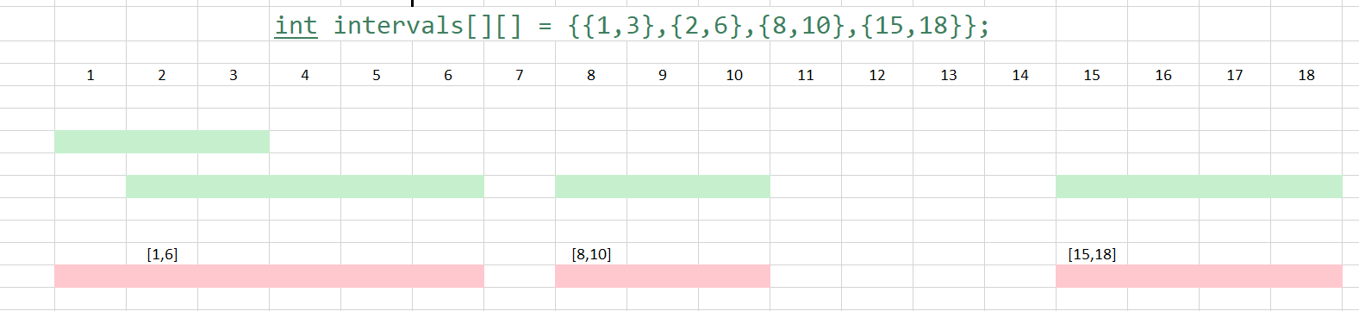

Question 25 :
Program Title: Length of Last Word
Programming Language: Java
Description Given a string s consisting of words and spaces, return the length of the last word in the string.
A word is a maximal substring consisting of non-space characters only.

Constraints:
- 1 <= s.length <= 10⁴
- s consists of only English letters and spaces ' '.
- There will be at least one word in s.

Example:
Example 1:
Input: s = "Hello World"
Output: 5
Explanation: The last word is "World" with length 5.
Example 2:
Input: s = " fly me to the moon "
Output: 4
Explanation: The last word is "moon" with length 4.
Example 3:
Input: s = "luffy is still joyboy"
Output: 6
Explanation: The last word is "joyboy" with length 6.

Question 26 :
Program Title: Rotate List
Programming Language: Java
Description Given the head of a linked list, rotate the list to the right by k places..
Constraints:
- The number of nodes in the list is in the range [0, 500].
- -100 <= Node.val <= 100
- 0 <= k <= 2 * 10⁹
Example:
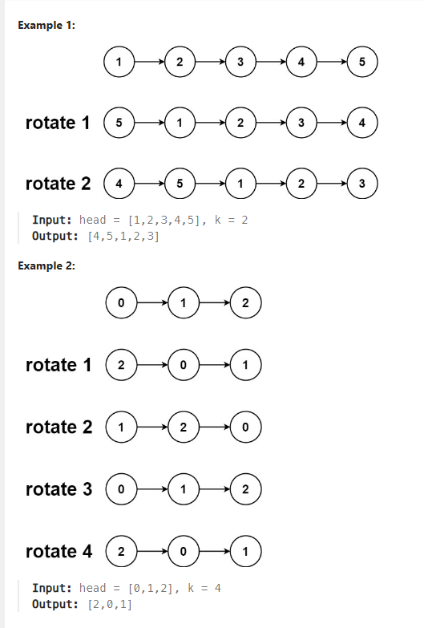

Question 27:
Program Title: Unique Paths
Programming Language: Java
Description There is a robot on an m x n grid. The robot is initially located at the top-left corner (i.e., grid[0][0]). The robot tries to move to the bottom-right corner (i.e., grid[m - 1][n - 1]). The robot can only move either down or right at any point in time.
Given the two integers m and n, return the number of possible unique paths that the robot can take to reach the bottom-right corner.
Constraints:
- 1 <= m, n <= 100
Example:
Input: m = 3, n = 2

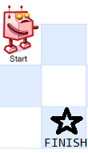

Output: 3

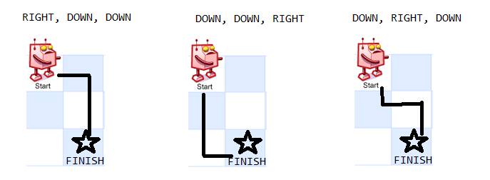
Example 2:

Input: m = 3, n = 7

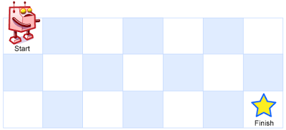

Output: 28

String Encoding
package day29;

import java.util.LinkedHashMap;
import java.util.Map;
import java.util.Map.Entry;

public class StringEncoding {
public static void main(String[] args) {

String str="aaaabbbccaa"; //output : "a4b3c2"

Map<Character,Integer> hashmap=new LinkedHashMap();

for(char key:str.toCharArray())
hashmap.put(key, hashmap.getOrDefault(key, 0)+1);

System.out.println(hashmap);

StringBuilder sb=new StringBuilder();
for(Entry<Character,Integer> entry:hashmap.entrySet())
{
sb.append(entry.getKey()).append(entry.getValue());
}

System.out.println(sb);
}
}

String encoding using stream api

package day29;

import java.util.LinkedHashMap;
import java.util.Map;
import java.util.Map.Entry;
import java.util.stream.Collectors;

public class StringEncodingUsingStreamAPI {
public static void main(String[] args) {

//String str="aaaabbbcc"; //output : "a4b3c2"
String str="banana";

Map<Character,Long> hashmap=new LinkedHashMap();

// hashmap=str.chars()
// .mapToObj(i->(char)i)
// .collect(
// Collectors.groupingBy(ch->ch,LinkedHashMap::new,Collectors.counting())
// );

//System.out.println(hashmap);

String result=str.chars()
.mapToObj(i->(char)i)
.collect(Collectors.groupingBy(ch->ch,LinkedHashMap::new,Collectors.counting()) )
.entrySet()
.stream()
.map(entry->""+entry.getKey()+entry.getValue())
.collect(Collectors.joining());
System.out.println(result);

}
}

String encoding continuous sequence
package day29;

import java.util.LinkedHashMap;
import java.util.Map;
import java.util.Map.Entry;

public class StringEncodingContinousSequence {
public static void main(String[] args) {
// i
//String str="aaabbbccaa"; //output : "a4b3c2"
String str="AaabBbccaa";
//String str="";
//String str=null;
//String str=" ";

if(str==null || str.length()==0)
{
System.out.println("Invalid Input");
return;
}
str=str.replaceAll("\\s", "").toLowerCase();
StringBuilder sb=new StringBuilder(); //count 1,2,3
int count=1;
for(int i=0;i<str.length();i++)
{
if(i<str.length()-1 && str.charAt(i)==str.charAt(i+1))
{
count++;
}
else
{
sb.append(str.charAt(i)).append(count);
count=1;
}
}

System.out.println(sb);
}
}

