LP-II (Software Testing and Quality Assurance)
Mini Project 1

Title : Blood Donation Application

Team Members :
- Anish Dhage (41105)
- Apoorv Dixit (41106)
- Gayatri Deokar (41116)

Problem Statement :
Create a Medical System / relevant system by selecting relevant system environment / platform and programming languages. Narrate consice Test Plan consisting features to be tested and bug taxonomy. Prepare Test Cases inclusive of Test Procedures for identified Test Scenarios. Perform selective Black-box and White-box testing covering Unit and Integration test by using suitable Testing tools. Prepare Test Reports based on Test Pass / Fail Criteria and judge the acceptance of application developed.

Objective :
- Develop a java application with GUI for Blood Donation
- To prepare suitable test cases for developed application
- Prepare a test report for the application

Outcome :
Be able to,
- Understand testing tools like Junit and Maven
- Differentiate between different types of testing
- Write tests for different types of applications

S/w, H/w Requirement :
- Ubuntu 18 OS
- MySQL
- JUnit4
- JDK 1.8
- Eclipse IDE
- Working PC

Theory Concept with Algorithm :
JUnit :
JUnit is a unit testing framework for Java programming language. JUnit has been important in the development of test-driven development, and is one of a family of unit testing frameworks collectively known as xUnit, that originated with Junit.
Features of Junit :
- JUnit is an open source framework, which is used for writing and running tests.
- Provides annotations to identify test methods.
- Provides assertions for testing expected results.
- Provides test runners for running tests.
- JUnit tests allow you to write codes faster, which increases quality.
- JUnit is elegantly simple. It is less complex and takes less time.
- JUnit tests can be run automatically and they check their own results and provide immediate feedback.
- JUnit tests can be organized into test suites containing test cases and even other test suites.
- JUnit shows test progress in a bar that is green if the test is running smoothly, and it turns red when a test fails.
Unit Test Case :
A Unit Test Case is a part of code, which ensures that another part of code (method) works as expected. To achieve the desired results quickly, a test framework is required. JUnit is a perfect unit test framework for Java programming language.
A formal written unit test case is characterized by a known input and an expected output, which is worked out before the test is executed. The known input should test a precondition and the expected output should test a post-condition.

Java Swing :
Java Swing tutorial is a part of Java Foundation Classes (JFC) that is used to create window-based applications. It is built on the top of AWT (Abstract Windowing Toolkit) API and entirely written in java.
Unlike AWT, Java Swing provides platform-independent and lightweight components.
The javax.swing package provides classes for java swing API such as JButton, JTextField, JTextArea, JRadioButton, JCheckbox, JMenu, JColorChooser etc.

Types of Testing :
1. Exploratory (Black Box Testing): The purpose of this test is to make sure critical
defects are removed before the next levels of testing can start.
2. Funtional Test (White Box Testing): Functional testing will be performed to check the functions of the application. The input is fed and the output from the application is validated.
3. User Acceptance Test (Integration Testing): This test focusses on validating the
business logic. It allows the end user to complete one final review of the system prior to deployment.

Blood Donation :

A blood donation occurs when a person voluntarily has blood drawn and used for transfusions and/or made into biopharmaceutical medications by a process called fractionation (separation of whole-blood components). Donation may be of whole blood, or of specific components directly (the latter called apheresis). Blood banks often participate in the collection process as well as the procedures that follow it.

The limited storage time means that it is difficult to have a stockpile of blood to prepare for a disaster. The subject was discussed at length after the September 11 attacks in the United States, and the consensus was that collecting during a disaster was impractical and that efforts should be focused on maintaining an adequate supply at all times. Blood centers in the U.S. often have difficulty maintaining even a three-day supply for routine transfusion demands.

Benefits
Donating blood has benefits for your emotional and physical health. According to a report by the Mental Health Foundation, helping others can:
- reduce stress
- improve your emotional well-being
- benefit your physical health
- help get rid of negative feelings
- provide a sense of belonging and reduce isolation
- Research has found further evidence of the health benefits that come specifically from donating blood.

What Blood Types Match?

In living donation, the following blood types are compatible:
Donors with blood type A... can donate to recipients with blood types A and AB
Donors with blood type B... can donate to recipients with blood types B and AB
Donors with blood type AB... can donate to recipients with blood type AB only
Donors with blood type O... can donate to recipients with blood types A, B, AB and O (O is the universal donor: donors with O blood are compatible with any other blood type)
So,
Recipients with blood type O... can receive a kidney from blood type O only
Recipients with blood type A... can receive a kidney from blood types A and O
Recipients with blood type B... can receive a kidney from blood types B and O
Recipients with blood type AB... can receive a kidney from blood types A, B, AB and O (AB is the universal recipient: recipients with AB blood are compatible with any other blood type)

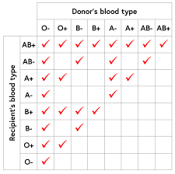

Use Case Diagram :

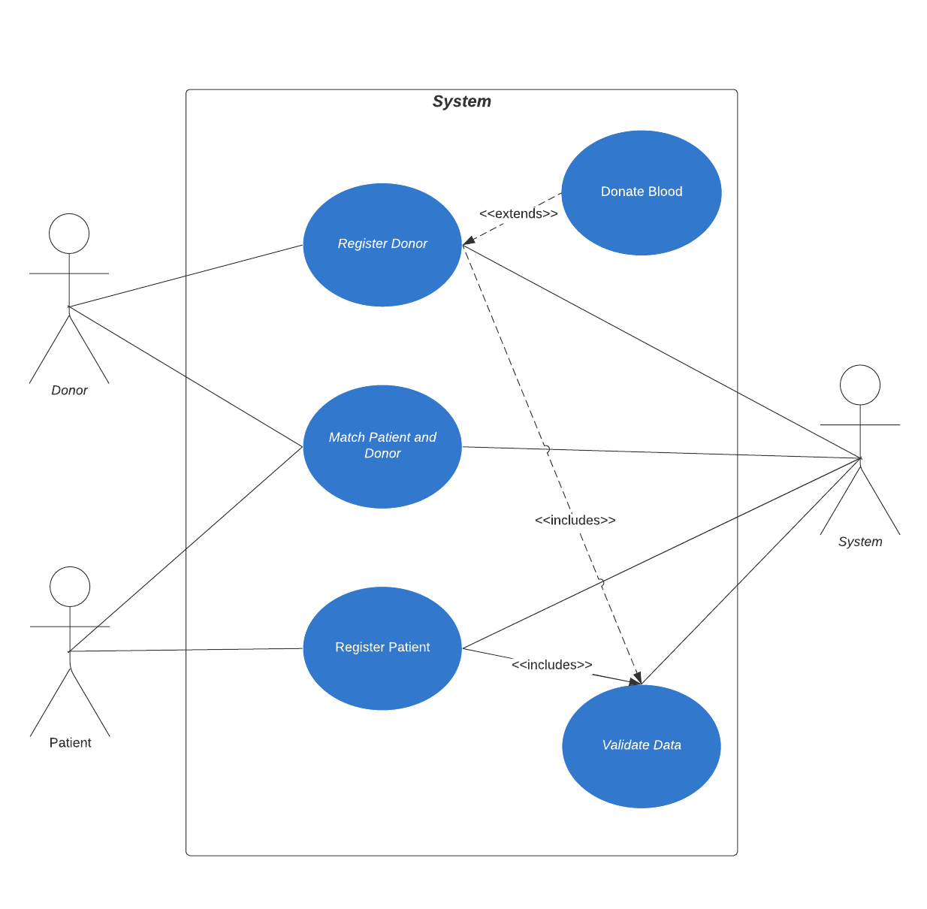

System Diagram :

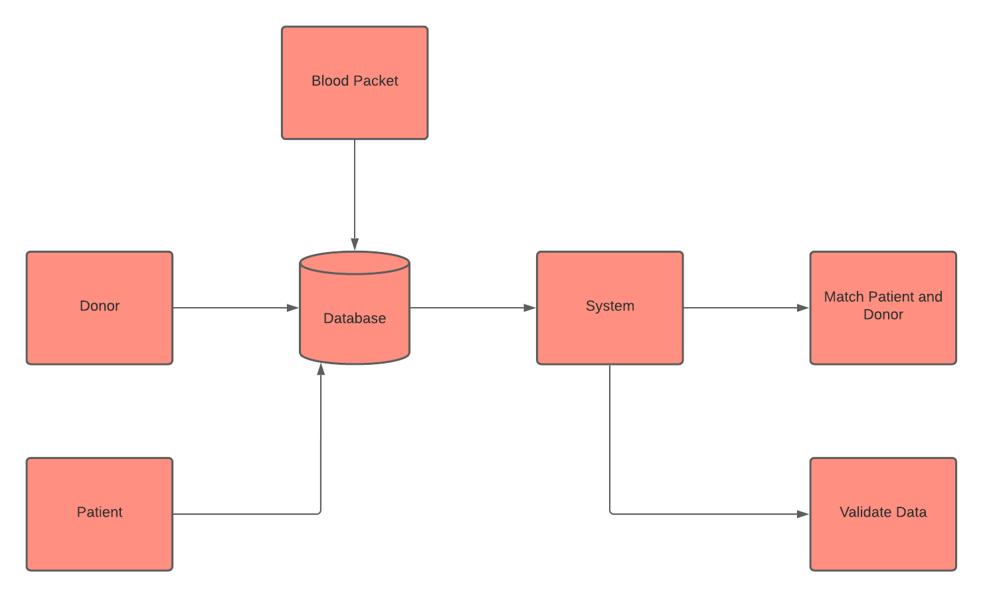

Test Cases :

Name | Input | Expected Output | Description
Validate Blood Group | B+ | True | Valid - A+,B+,AB+,O+,A-,B-,AB-,O-
 | C+ | False
Validate Name | Henry Cavill | True | Valid - FirstName LastName
 | XEA-12 | False | Name Shouldn’t be alphanumeric
Validate Gender | M | True | Valid - M,F,O
 | F | True
 | O | True
 | D | False
Validate Age | 24 | True | 18 <= age <= 60
 | 16 | False
 | 67 | False
 | -1 | False
Validate Phone Number | 9028510333 | True
 | 902851033 | False | Should be 10 digit number
 | 4028510333 | False | Should start with 7,8,9
 | 9028ab0333 | False | Can only contain numeric characters
Validate Aadhar Number | 548450008000 | True
 | 54845000800 | False | Should be 12 digit number
 | 548450ba8000 | False | Can only contain digits
 | 548450008001 | False | Should satisfy Verhoeff Checksum Algorithm
Validate Email | abc@gmail.com | True | Validate -  [^@]+@[^\.]+\..+
 | abc@gmail.con | False | Not A Valid Email Id
 | abc.yahoo.com | False | Not A Valid Email Id
 | @yahoo.com | False | Not A Valid Email Id
Validate Compatible Blood Groups | Donor: O+  Receiver: A+ | True | A+ compatible with A+,A-,O+,O-
 | Donor: AB-  Receiver: O- | False | O- is compatible with only O-
 | Donor: A+  Receiver: O+ | O+, O- | O+is compatible with O+, O-
 | Donor: A+  Receiver: AB+ | True | AB+ is compatible with A+,A-,B+,B-,O+,O-
Validate Successful Connection to DB | Input - Credentials  Output - Successfully Connected | True
 | Input - Credentials  Output - Error in Connection | False | Credentials entered for connection to the DB must be wrong
Validate Successful Insertion and Retrieval from DB | Input: Entered correct details  Output: Entered into the DB successfully | True | Record was entered successfully
 | Input: Entered wrong details  Output: Entered into the DB successfully | False | Incorrect record wasn’t entered into the DB.

Test Report :
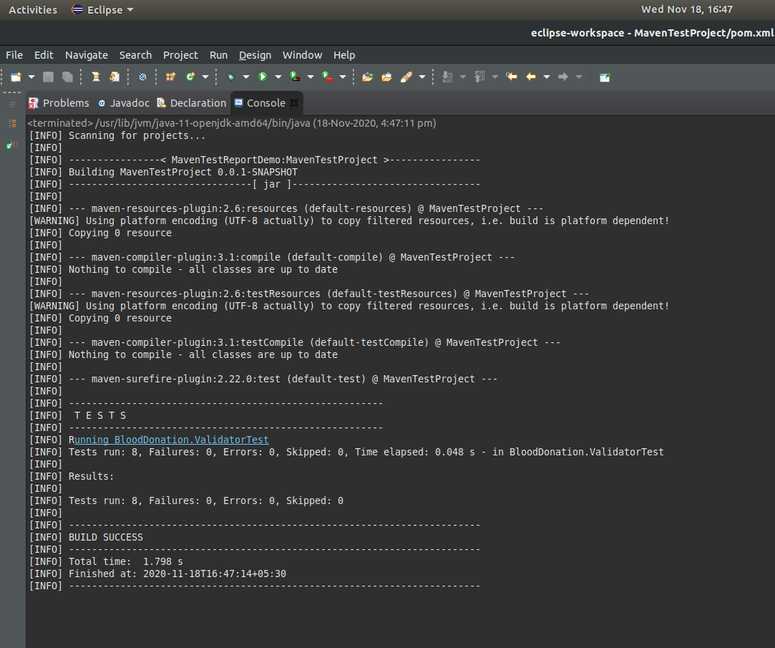

Conclusion :
Successfully implemented Blood Donation Application and wrote test cases for the same.

