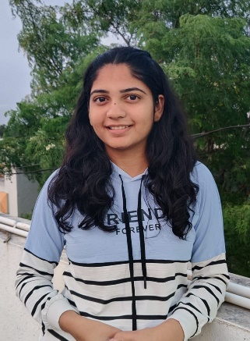

**Srushti Mane**

8999897368

srushti.mane24@vit.edu

Motivated and detail-oriented 20-year-old aspiring Java Full Stack Developer with a passion for

building dynamic, user-friendly web applications. Eager to apply skills in front-end and

back-end development to contribute to innovative projects. Known for exceptional communication

skills, public speaking, and a structured approach to learning. Dedicated to solving real-world

problems, mastering academic subjects, and achieving excellence in both tech and personal growth

**LinkedIn**

www.linkedin.com/in/srushti-mane-

46a8a0271

Work Experience

**Web Developement Intern**

**Wolfox Services Pvt. Ltd**

**May 2023 - July 2023**

Learnt basics of web developement.

Created and maintained client

website.

**Frontend Intern**

**Herbs Magic**

**December 2024 - February 2025**

Designed and implemented new

features in herbs magic website. using

react js.

Educational History

Diploma In Computer Engineering

Government Polytechnic Miraj

2021-2024

**Bachelor of Information Technology**

Vishwakarma Institute if Technology , Pune

2024 - 2027

Relevant Skills

Beginner in Java , C++

HTML , CSS & JAVASCRIPT

Frontend Developement

Extra Curricular Activites

A

**bhivriddhi - Student training and**

**Developement Committee , VIT Pune**

Technical Coordinator

Provides technical assistance.

**Social Welfare and Developement**

**Committee , VIT Pune**

Innovation & Reseacrh Coordinator

Projects

**Hospital Management System**

Created platform for managing activites in

hospital

Using Java AWT & Swing , Microsoft Database

**Ayurveda Website**

Designed ayurvedic hospital website

according to client demand.