|  |
| --- |
| Bansilal Ramnath Agarwal Charitable Trust’s  **[VISHWAKARMA INSTITUTE OF TECHNOLOGY,](https://www.vit.edu/)**  **[PUNE 411037](https://www.vit.edu/)**  (An Autonomous Institute affiliated to University of Pune)    [**Social Welfare & Development Committee**](https://swd.vit.edu/)  [Vishwakarma Institute of Technology, Pune](https://www.vit.edu/)  (Help One, Inspire Many)  **Event / Activity Report**  **Academic Year 2024 – 2025 (Semester II)** |

|  |
| --- |
| AashaKiran  Event Report |

INDEX

Activity / Event Description 3

Activity / Event Details 3

Collaborations 4

Session Description 4

Impact on the Society 5

Learning by Participants 5

Links 5

Glimpses 6

Organizing Committee 7

## Activity / Event Description

|  |  |  |
| --- | --- | --- |
| Activity / Event | : | AashaKiran |
| Activity / Event Domain | : | Social Welfare, Early Childhood Development, Public Health, and Community Service. |
| Duration | : | Every Weekend |
| Activity / Event Heads | : | Mohit Deo (9404817998) |
| Activity / Event POC / EI | : | Tejas Hatedikar (8766634473) |
| Organizing Committee | : | 21 <Total Coordinators> |
| Volunteers Participants | : | 100 |
| Collaborations | : | 1 |
| Organizing Committee | : | Social Welfare and Development Committee |
| Location | : | Vishwakarma Institute of Technology, Pune |
| Link | : | <https://maps.app.goo.gl/eJWkVq9EVfXSCZTZ6> |
| Contact | : | Sandip Pawar ((357375280) <Report Author> |
|  | | |

## Activity / Event Details

Activity / Event Description (100-150 words):

Aashakiran is a social welfare activity organized by the Social Welfare and Development Committee in collaboration with an NGO that focuses on mental ability improvement for children aged 0-3 year

This initiative involves student volunteers conducting surveys to gather data from parents of infants (0-3 years old) and engaging in various activities that contribute to child development awareness.

## Session Description

|  |  |  |  |  |  |  |
| --- | --- | --- | --- | --- | --- | --- |
| | 1. **Session No.** | **Session Details** | **Date** | **Time** | **Location** | **Duration (hrs)** | | --- | --- | --- | --- | --- | --- | |
| |  |  |  |  |  |  | | --- | --- | --- | --- | --- | --- | | 1 | **Orientation & Volunteer Briefing** | Week 1 (Saturday) | 2:00 PM – 5:00 PM | College Seminar Hall | 3 | |
| |  |  |  |  |  |  | | --- | --- | --- | --- | --- | --- | | 2 | **Survey Training & Process Explanation** | Week 1 (Sunday) | 2:00 PM – 5:00 PM | College Seminar Hall | 3 | |
| |  |  |  |  |  |  | | --- | --- | --- | --- | --- | --- | | 3 | **Field Survey – Data Collection** | Week 2 (Saturday) | 2:00 PM – 5:00 PM | Community Areas | 3 | |
| |  |  |  |  |  |  | | --- | --- | --- | --- | --- | --- | | 4 | **Field Survey – Data Collection** | Week 2 (Sunday) | 2:00 PM – 5:00 PM | Community Areas | 3 | |
| |  |  |  |  |  |  | | --- | --- | --- | --- | --- | --- | | 5 | **Survey Revision & Data Compilation** | Week 3 (Saturday) | 10:00 AM – 1:00 PM & 2:00 PM – 5:00 PM | Community Areas | 6 | |
| |  |  |  |  |  |  | | --- | --- | --- | --- | --- | --- | | 6 | **Survey Revision & Data Compilation** | Week 3 (Sunday) | 10:00 AM – 1:00 PM & 2:00 PM – 5:00 PM | Community Areas | 6 | |
| |  |  |  |  |  |  | | --- | --- | --- | --- | --- | --- | | 7 | **Awareness Workshop for Parents** | Week 4 (Saturday) | 10:00 AM – 1:00 PM & 2:00 PM – 5:00 PM | NGO Center | 6 | |
| |  |  |  |  |  |  | | --- | --- | --- | --- | --- | --- | | 8 | **Awareness Workshop for Parents** | Week 4 (Sunday) | 10:00 AM – 1:00 PM & 2:00 PM – 5:00 PM | NGO Center | 6 | |
| |  |  |  |  |  |  | | --- | --- | --- | --- | --- | --- | | 9 | **Interactive Activities with Parents & Infants** | Week 5 (Saturday) | 10:00 AM – 1:00 PM & 2:00 PM – 5:00 PM | NGO Center | 6 | |
| |  |  |  |  |  |  | | --- | --- | --- | --- | --- | --- | | 10 | **Interactive Activities with Parents & Infants** | Week 5 (Sunday) | 10:00 AM – 1:00 PM & 2:00 PM – 5:00 PM | NGO Center | 6 | |
| |  |  |  |  |  |  | | --- | --- | --- | --- | --- | --- | | 11 | **Final Data Compilation & Impact Assessment** | Week 6 (Saturday) | 2:00 PM – 5:00 PM | College Lab | 3 | |
| |  |  |  |  |  |  | | --- | --- | --- | --- | --- | --- | | 12 | **Conclusion, Certificate Distribution & Feedback** | Week 6 (Sunday) | 2:00 PM – 5:00 PM | College Seminar Hall | 3 | |

## Collaborations

1. **Collaboration 1**: Lorem ipsum dolor sit amet, consectetur adipiscing elit, sed do eiusmod tempor incididunt ut labore et dolore magna aliqua.

Contact – Sandesh (8055788004), sandesh.kawane21@vit.edu

## Impact on the Society

Aashakiran plays a crucial role in fostering **early childhood development awareness** by equipping parents with essential knowledge about **mental and cognitive growth in infants (0-3 years old)**. Through **student-led surveys and interactive sessions**, this initiative ensures that parents, especially from underprivileged backgrounds, receive **scientifically backed guidance** on nutrition, stimulation, and emotional bonding.

By collaborating with an NGO, Aashakiran bridges the **gap between education and healthcare**, promoting **early interventions** that can prevent developmental delays. Additionally, the involvement of student volunteers **instills social responsibility and empathy**, encouraging future leaders to prioritize **child welfare and community service**.

This initiative **strengthens families, reduces inequalities**, and fosters a **more informed and caring society**, ultimately contributing to a **healthier, smarter, and more capable next generation**.

## Learning by Participants

The **student volunteers** participating in Aashakiran gain valuable insights into **early childhood development**, understanding how the **first three years shape a child’s cognitive, emotional, and social well-being**. They learn the importance of **nutrition, parental interaction, and mental stimulation** in a child’s formative years. Through **surveys and direct engagement with parents**, they enhance their **communication, problem-solving, and data analysis skills**, making them more socially aware and empathetic.

Parents involved in the initiative **learn best practices** for nurturing their children’s growth, such as **interactive play, storytelling, and proper nutrition**, which significantly impact their child’s future. The collaboration with the NGO also helps volunteers **develop leadership, teamwork, and social responsibility**, fostering a deeper commitment to community welfare.

Overall, Aashakiran serves as a **transformative experience**, empowering both students and parents with **knowledge, skills, and a sense of purpose** in building a **healthier and more educated society**.

## Links

|  |  |  |
| --- | --- | --- |
| **Link No.** | **Link** | **Platform** |
| 1 | Link 1 | Instagram |
| 2 | Link 2 | Google Drive |
| 3 | Link 3 | YouTube |
| 4 | Volunteers Sheet Link | Google Sheets (Drive) |
|  | | |

1. 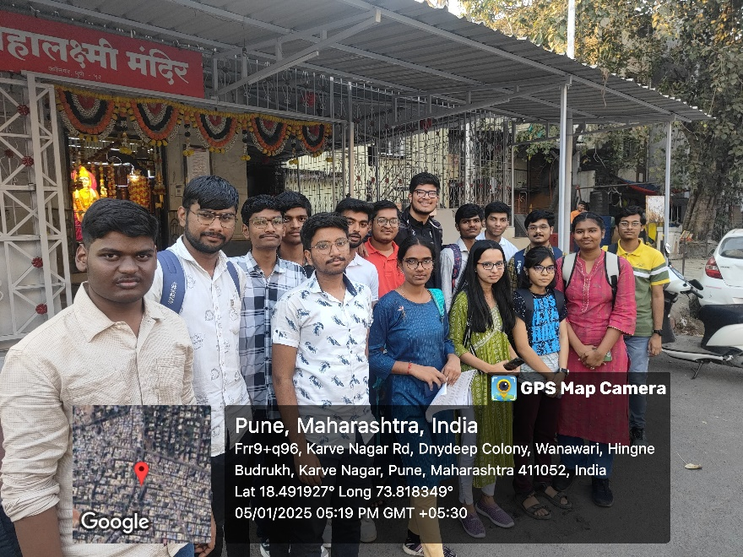Glimpse

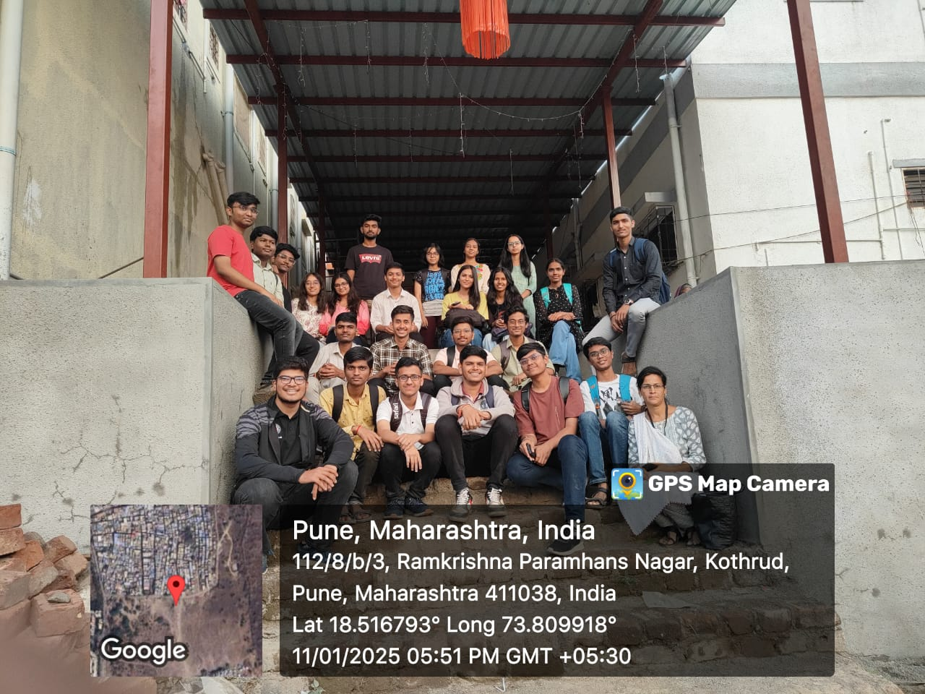

## Glimpses

Social Services’23:



Social Services’23 | Vishwakarma Institute of Technology, Pune

## Organizing Committee

|  |  |
| --- | --- |
| Name | Role |
| Sandesh | Head |
| Name 1 | POC / EI |
| Name 2 | OC – Publicity |
| Name 3 | OC – Aesthetics |
| Name 4 | OC – Outside |
| Name 5 | OC – Sector |
| Name 6 | OC – Sector |
| Name 7 | OC – Sector |
| Name 8 | OC – Sector |
| Name 9 | OC – Sector |
| Name 10 | OC – Sector |
| Name 11 | OC – Sector |
| Name 12 | OC – Sector |
| Name 13 | OC – Sector |
| Name 14 | OC – Sector |
| Name 15 | OC – Sector |
| Name 16 | OC – Sector |
| Name 17 | OC – Sector |
| Name 18 | OC – Sector |
| Name 19 | OC – Sector |
| Name 20 | OC – Sector |
| Name 21 | OC – Sector |

## <Add Point>

Add point(s) if Needed!