OTT PLATFORM BUSINESS ANALYTICS
PHASE 9 — SIMPLE LINEAR REGRESSION ANALYSIS & EVALUATION
Topic 5: Analyse OTT Platform Viewing Patterns to Support Data-Driven Content Decisions
This document records the complete Phase 9 machine-learning work for the OTT capstone. It explains the business question, data preparation, feature selection, modelling methodology, evaluation, statistical inference, diagnostics, findings, limitations and business implications.

1. Phase 9 Objective
The objective is to implement at least one Simple Linear Regression model that addresses a business problem identified in the earlier phases. The main model evaluates whether content duration can predict viewer watch duration.

2. Business Question and Objective Alignment
Business question: Can Content Duration (Duration_Minutes) be used to predict Watch Duration (Watch_Duration_Minutes)?
Role | Variable | Description
Predictor (X) | Duration_Minutes | Length of OTT content in minutes
Target (Y) | Watch_Duration_Minutes | Minutes watched during a viewing session
This model supports the project's content-performance and viewer-engagement objective by quantifying the relationship between content length and viewing duration.

3. Data Used
Dataset | Use in Phase 9
Content Library | Content duration, content age, rating, popularity and other candidate predictors.
Viewing Activity | Viewing-session information and Watch_Duration_Minutes target.
The datasets were connected using a numeric Content_Key extracted from their content identifiers. This makes content-level attributes available for the corresponding viewing sessions.

4. Data Preparation
A modelling dataset was created by joining the cleaned Content Library and Viewing Activity data. The candidate numeric predictors were:
- Content_Age_Years
- Duration_Minutes
- Numeric_Rating
- Popularity_Score
- Engagement_Proxy
- Genre_Count
Rows missing any required modelling feature or the target were removed because a regression model requires complete predictor-target observations. No missing business values were fabricated.

5. Feature Selection
To satisfy the feature-selection requirement, SelectKBest with f_regression was applied to rank the candidate predictors by their individual linear association with Watch_Duration_Minutes.
Feature | F-Score | P-Value
Duration_Minutes | 80792.46 | 0.0000e+00
Engagement_Proxy | 4608.38 | 0.0000e+00
Numeric_Rating | 85.44 | 2.5467e-20
Content_Age_Years | 41.08 | 1.4847e-10
Genre_Count | 12.84 | 3.4049e-04
Popularity_Score | 1.11 | 2.9173e-01
The strongest single predictor was Duration_Minutes. Because this phase requires a Simple Linear Regression model, the strongest single predictor was retained for the final model.

6. Feature Engineering and Transformation
The main feature-engineering step was the creation of Content_Key to integrate content-level and viewing-level information. The selected modelling fields were converted to numeric form. No unnecessary transformations were applied.

7. Scaling / Standardisation Decision
Standardisation was considered but was not applied to the final ordinary least-squares regression. OLS does not require standardised predictors for a valid fit. Keeping Duration_Minutes in minutes also makes the regression coefficient directly understandable to a business audience.

8. Train–Validation–Test Split
The data was divided into approximately 70% training, 15% validation and 15% test observations. Content_Key was used as the grouping variable so the same content item was not deliberately distributed across multiple partitions. Random state = 42 was used for reproducibility.
Partition | Purpose
Training (~70%) | Estimate regression coefficients
Validation (~15%) | Check performance on unseen data during development
Test (~15%) | Final evaluation on unseen data

9. Simple Linear Regression Method
Simple Linear Regression models a continuous dependent variable using one independent variable.
Ŷ = β₀ + β₁X
The fitted project equation is: Predicted Watch Duration = 1.1354 + (0.5049 × Duration_Minutes).

10. Coefficient Interpretation
The coefficient is 0.5049. Thus, within this fitted model, a one-minute increase in content duration is associated with approximately 0.505 additional minutes of predicted watch duration.
This is an observed statistical association and must not be interpreted as proof that increasing content duration will cause watch duration to increase.

11. Model Evaluation
Dataset | R2 | MAE | RMSE
Train | 0.7197 | 87.6508 | 213.8044
Validation | 0.7517 | 84.4468 | 215.1772
Test | 0.7423 | 88.6101 | 218.4641
On the held-out test data, the model achieved R² = 0.7423 (74.23%), MAE = 88.61 minutes and RMSE = 218.46 minutes.
R² represents the proportion of variation explained by the model. MAE is the average absolute prediction error. RMSE gives more weight to large errors. The larger RMSE relative to MAE indicates that some sessions have substantially larger prediction errors.

12. Statistical Significance of the Predictor
An OLS model with HC3 robust standard errors was used for inference. The robust p-value for Duration_Minutes is 1.3258e-264. Since this is below 0.05, there is statistically significant evidence that Duration_Minutes contributes to the fitted linear relationship with Watch_Duration_Minutes.

13. Regression Assumption — Heteroscedasticity
The Breusch–Pagan test was used to check the constant-variance assumption.
Test | P-value | Decision
Breusch–Pagan | 0.0000e+00 | Evidence of heteroscedasticity
The result indicates non-constant residual variance. This is documented as a limitation. Robust HC3 standard errors are therefore used for statistical inference.

14. Model Diagnostics
Actual vs Predicted Watch Duration
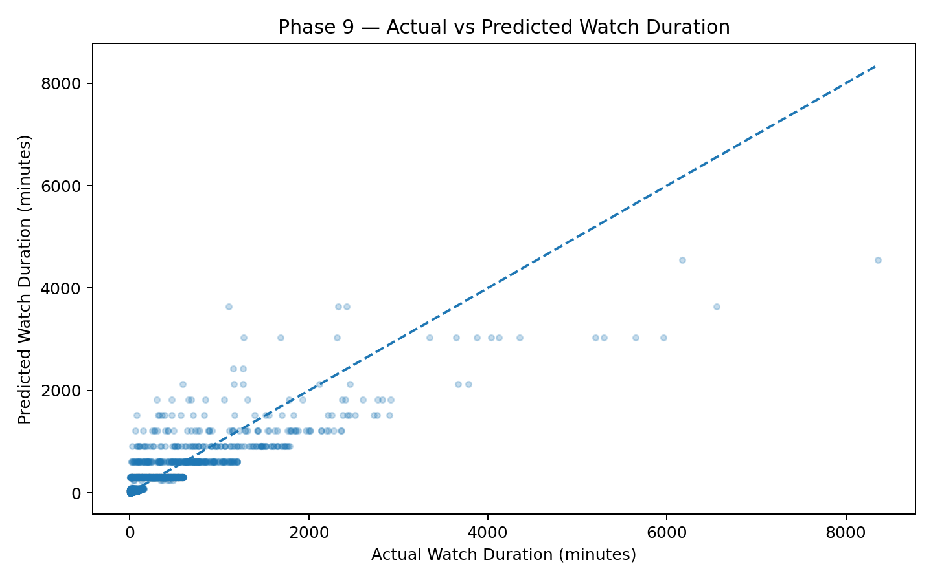
Residuals vs Predicted Watch Duration
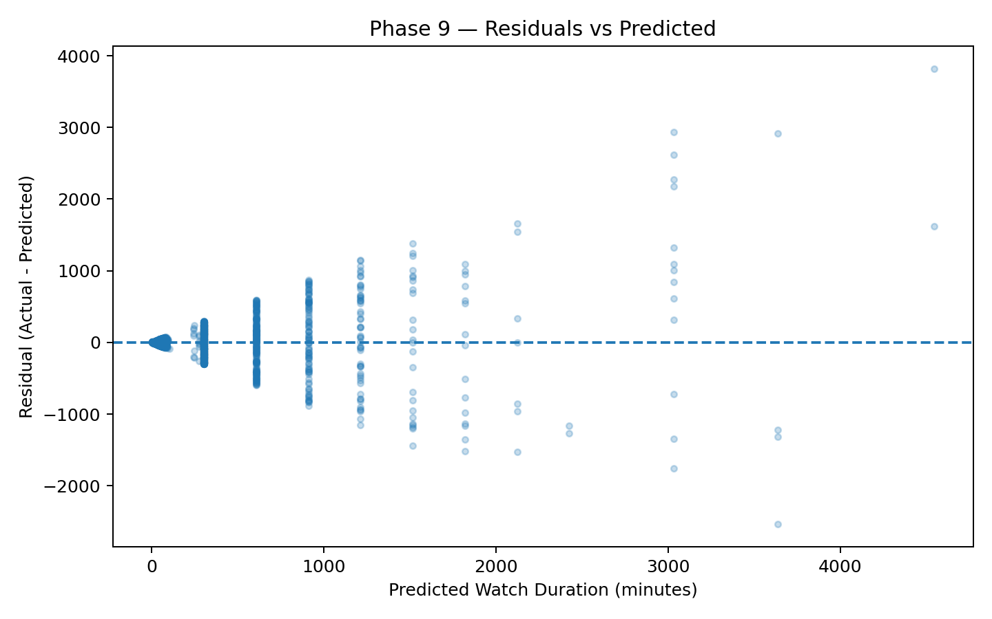
Content Duration vs Watch Duration
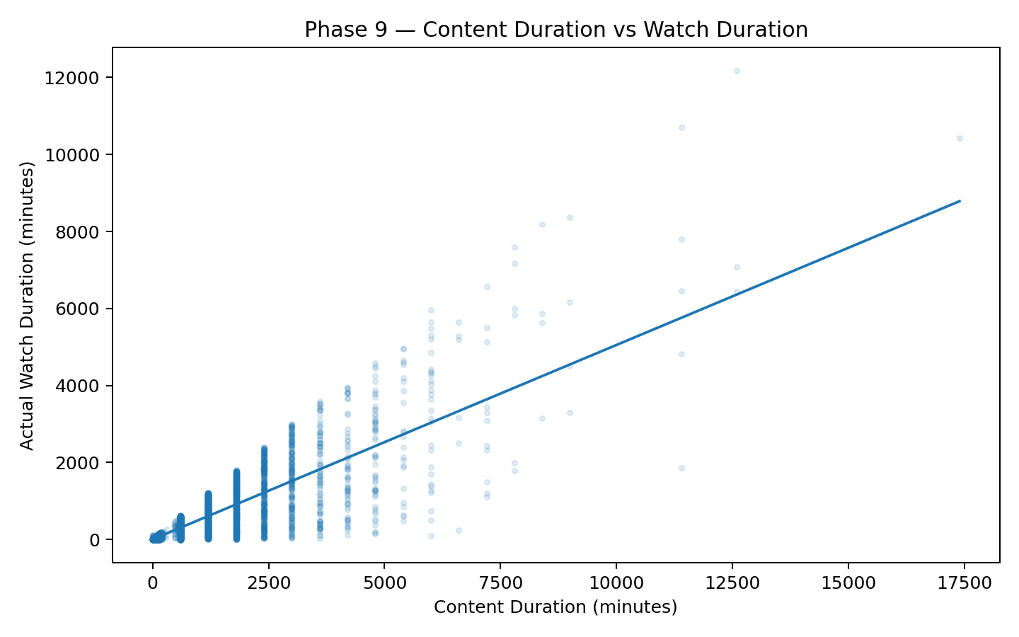
The diagnostic plots are included to visually assess prediction accuracy, residual behaviour and the overall linear relationship.

15. Secondary Validation of Phase 3 O1.4
Phase 3 identified O1.4 — whether content age affects popularity and completion percentage — as a regression candidate. A separate simple regression using Content_Age_Years as X and Completion_Percentage as Y was therefore evaluated.
The secondary model showed negligible linear predictive value for completion, consistent with the Phase 8 statistical finding that content age was not statistically significant as a linear driver of completion.

16. Key Business Findings
- Duration_Minutes was selected as the strongest single numeric predictor of Watch_Duration_Minutes.
- The final model achieved approximately 74.23% test R².
- Typical absolute prediction error was approximately 88.61 minutes.
- The fitted coefficient of approximately 0.505 indicates a positive association between content duration and predicted watch duration.
- Content age alone should not be treated as a strong standalone completion predictor.
- Heteroscedasticity is present, so robust inference and cautious interpretation are required.

17. Business Recommendations
- Use content duration as one supporting variable in content-performance benchmarking.
- Combine duration with content type, genre, platform, device, user segment and engagement indicators before making content decisions.
- Do not increase content length solely to increase watch duration because the regression does not establish causality.
- Do not use content age alone to determine whether content will achieve high completion.
- For future modelling, develop a multivariate regression using additional content and viewer variables.

18. Limitations
- The model contains one predictor because the capstone requires Simple Linear Regression.
- OTT viewing behaviour depends on many variables beyond content duration.
- Observational regression identifies association, not causation.
- The Breusch–Pagan test indicates heteroscedasticity.
- RMSE is substantially higher than MAE, indicating some large prediction errors.

19. Phase 9 Completion Checklist
- ✓ Data preparation and feature engineering completed
- ✓ Feature selection implemented using SelectKBest + f_regression
- ✓ Simple Linear Regression implemented
- ✓ Train / validation / test split completed
- ✓ Predictions generated
- ✓ R², MAE and RMSE calculated
- ✓ Predictor statistical significance evaluated
- ✓ Regression assumption check completed
- ✓ Diagnostic plots created
- ✓ Business interpretation documented
- ✓ Limitations documented
- ✓ Phase 3 O1.4 regression candidate considered

20. Final Conclusion
Phase 9 successfully implements a Simple Linear Regression model using the cleaned OTT project data. Feature selection identified Duration_Minutes as the strongest single candidate for predicting viewer watch duration. The model achieved a test R² of 74.23%, MAE of 88.61 minutes and RMSE of 218.46 minutes. The coefficient of 0.505 indicates a positive association between content duration and predicted watch duration. The model provides useful quantitative evidence for content-performance analysis, while the assumption check and limitations show why it should be used as a supporting analytical tool rather than as the sole basis for OTT decisions.

21. Suggested Viva Explanation
- Start with the business question: whether content duration can predict viewer watch duration.
- Explain the target and predictor clearly.
- Explain that SelectKBest + f_regression was used for feature selection.
- State that Duration_Minutes was selected as the strongest single predictor.
- Explain the grouped train/validation/test split.
- State the model equation and interpret the coefficient of 0.505.
- Report test R² of 74.23%, MAE of 88.61 minutes and RMSE of 218.46 minutes.
- Explain that the relationship is statistically significant but does not prove causation.
- Mention heteroscedasticity as a limitation and the use of robust HC3 inference.
- Finish with the business recommendation to use duration together with other OTT content and viewer variables.

22. Deliverables
- OTT_Phase_9_CLEAN_COMPLETE_JUPYTER.ipynb
- OTT_Phase_9_Linear_Regression.py
- feature_selection_results.csv
- model_evaluation_metrics.csv
- phase9_model_summary.csv
- test_predictions_sample.csv
- actual_vs_predicted.png
- residuals_vs_predicted.png
- duration_vs_watch_duration.png
- OTT_Phase_9_COMPLETE_DETAILED_DOCUMENTATION.docx

