Internship Report
on
SmartData AI Agent: A Tool-Using Assistant for Data Analysis and Prediction

Submitted by
Rutuja Devanand Soundale
Roll No. EN23102062
B.Tech Electronics and Telecommunication Engineering

In partial fulfilment of the requirements for the degree of
Bachelor of Technology
in
Electronics and Telecommunication Engineering

Under the guidance of
[Faculty Guide Name] Faculty Guide
Dr. Alok Yadav Industry Guide
YBI Foundation

DEPARTMENT OF ELECTRONICS AND TELECOMMUNICATION ENGINEERING
VIDYA PRATISHTHAN'S
KAMALNAYAN BAJAJ INSTITUTE OF ENGINEERING AND TECHNOLOGY, BARAMATI
2025 - 2026

CERTIFICATE
This is to certify that RUTUJA DEVANAND SOUNDALE, Roll No. EN23102062, a student of Bachelor of Technology in Electronics and Telecommunication Engineering at Vidya Pratishthan's Kamalnayan Bajaj Institute of Engineering and Technology, Baramati, has successfully completed the internship at YBI FOUNDATION in the domain of Artificial Intelligence and Generative AI during the period from 18th June 2026 to 18th October 2026.
The internship work included Python programming, data analysis and visualization, machine learning and predictive modelling, deep learning with artificial neural networks, binary and multi-class classification, an introduction to Generative AI, and the design and development of a basic tool-using AI agent for data analysis and prediction.
The work presented in this report was carried out during the internship period under the guidance and supervision of the industry guide and the faculty guide.

Dr. Alok Yadav [Faculty Guide Name]
Industry Guide Faculty Guide

External Examiner Dr. S. B. Lande
Principal

Head of Department
Department of E&TC
Date:

ACKNOWLEDGEMENT
I am thankful to everyone who supported me during my internship and during the preparation of this report.
I sincerely thank Dr. Alok Yadav, my mentor and industry guide at YBI Foundation, for the structured weekly training, for the regular review meetings and for the valuable suggestions that helped me improve my work. I also thank YBI Foundation for giving me the opportunity to learn Artificial Intelligence and Generative AI through practical, project-based training.
I am grateful to my faculty guide, [Faculty Guide Name], for the guidance and encouragement given during the internship and in the preparation of this report.
I express my thanks to the Head of the Department of Electronics and Telecommunication Engineering and to the faculty members of the department for their support. I am also thankful to the Principal, Dr. S. B. Lande, and to Vidya Pratishthan's Kamalnayan Bajaj Institute of Engineering and Technology, Baramati, for providing an environment that encourages internships and practical learning.
Finally, I thank my family and friends for their constant support and motivation.

Rutuja Devanand Soundale

ABSTRACT
This report describes my four-month internship in Artificial Intelligence and Generative AI at YBI Foundation from 18 June 2026 to 18 October 2026, carried out under the mentorship of Dr. Alok Yadav. The internship followed a structured curriculum. It started with Python programming: setup, basics, operators, conditional statements, loops and functions. It continued with data analysis using Pandas: reading and writing external data, data summarization, data manipulation and building data dashboards with Matplotlib.
The next phase covered predictive modelling and predictive analytics. I studied and applied Logistic Regression, K-Nearest Neighbours (KNN), Decision Trees, Random Forest, K-Means and clustering models to business problems. This was followed by deep learning, Artificial Neural Network (ANN) regression and binary and multi-class classification, along with their advantages, disadvantages, applications and limitations. I was also introduced to Generative AI, large language models and prompt engineering.
In the final phase I designed and built the SmartData AI Agent, a basic tool-using AI agent written in Python. A user types a request in plain English, and the agent follows a simple Perceive, Think, Act, Observe and Respond loop. Its brain decides which of six tools to use: dataset summary, chart creation, model comparison, species prediction, K-Means clustering and a safe calculator. The brain is rule-based and works fully offline, and it can optionally use the Google Gemini large language model to choose tools. The agent also keeps a short conversation memory.
The agent was tested with eleven test cases covering every tool and also unclear or unsupported requests, and it handled all of them correctly. On the Iris dataset, the four models reached test accuracies of 94.7% (Logistic Regression), 97.4% (KNN), 89.5% (Decision Tree) and 92.1% (Random Forest), and the agent automatically selected KNN for prediction. The report also presents the week-wise work, the skills gained, the challenges faced, the limitations of the project and its future scope.
Keywords: Python; Pandas; data visualization; machine learning; logistic regression; KNN; decision tree; random forest; K-Means; artificial neural network; classification; Generative AI; large language model; AI agent; tool calling.

DECLARATION
I, Rutuja Devanand Soundale, Roll No. EN23102062, a student of Bachelor of Technology in Electronics and Telecommunication Engineering at Vidya Pratishthan's Kamalnayan Bajaj Institute of Engineering and Technology, Baramati, declare that this internship report titled "SmartData AI Agent: A Tool-Using Assistant for Data Analysis and Prediction" is the result of my own work carried out during my internship at YBI Foundation from 18th June 2026 to 18th October 2026.
Ideas, figures and text taken from other sources are acknowledged through citations and listed in the References. This report does not contain any confidential data, passwords or API keys.

Rutuja Devanand Soundale
Roll No. EN23102062
Date:
Place: Baramati

CONTENTS
CERTIFICATE II
ACKNOWLEDGEMENT III
ABSTRACT IV
DECLARATION V
CONTENTS VI
LIST OF FIGURES IX
LIST OF TABLES X
CHAPTER 1 INTRODUCTION 1
1.1 Internship Overview 1
1.2 Objectives of the Internship 1
1.3 Scope of the Internship 2
1.4 Technologies and Platforms Used 2
1.5 Methodology 2
1.6 Organization of the Report 3
CHAPTER 2 ORGANIZATION AND INTERNSHIP BACKGROUND 4
2.1 Organization Overview 4
2.2 My Role and Way of Working 4
2.3 Internship Curriculum 4
2.4 Why an AI Agent Project 5
CHAPTER 3 PYTHON PROGRAMMING FOUNDATIONS 6
3.1 Python Setup and Installation 6
3.2 Python Basics 6
3.3 Python Operators 6
3.4 Conditional Statements 6
3.5 Loops 6
3.6 Functions 7
CHAPTER 4 DATA ANALYSIS AND VISUALIZATION 8
4.1 External Data Read and Write 8
4.2 Data Summarization 8
4.3 Data Manipulation 8
4.4 Data Visualization and Dashboards 8
CHAPTER 5 MACHINE LEARNING AND PREDICTIVE MODELLING 10
5.1 Types of Machine Learning 10
5.2 Standard Workflow for a Business Problem 10
5.3 Logistic Regression 10
5.4 K-Nearest Neighbours (KNN) 10
5.5 Decision Trees 11
5.6 Random Forest 11
5.7 K-Means and Clustering 11
5.8 Review and Feedback 12
CHAPTER 6 DEEP LEARNING, CLASSIFICATION AND GENERATIVE AI 13
6.1 Deep Learning 13
6.2 Artificial Neural Networks for Regression 13
6.3 Binary Classification 13
6.4 Multi-Class Classification 13
6.5 Generative AI and Large Language Models 14
6.6 From Models to Agents 14
CHAPTER 7 PROJECT DESIGN: SMARTDATA AI AGENT 15
7.1 Problem Statement 15
7.2 Project Objectives 15
7.3 What Is an AI Agent? (Simple Explanation) 15
7.4 System Architecture 15
7.5 Tools of the Agent 16
7.6 The Brain: Rule-Based and LLM 17
7.7 Dataset 17
CHAPTER 8 IMPLEMENTATION 18
8.1 Project Structure 18
8.2 The Tool Registry 18
8.3 Model Comparison Tool 18
8.4 The Rule-Based Brain 18
8.5 The Agent Loop 19
8.6 Safe Calculator 19
8.7 Running the Project 19
CHAPTER 9 TESTING, RESULTS AND DISCUSSION 20
9.1 Testing Approach 20
9.2 Functional Test Cases 20
9.3 Model Comparison Results 21
9.4 Clustering Result 22
9.5 Discussion 22
9.6 Limitations 23
CHAPTER 10 WEEK-WISE INTERNSHIP SUMMARY 24
10.1 Overview 24
10.2 Phase 1: Python Foundations (Weeks 1-2) 24
10.3 Phase 2: Data Analysis and Visualization (Weeks 3-4) 24
10.4 Phase 3: Machine Learning (Weeks 5-8) 24
10.5 Phase 4: Deep Learning, Classification and Generative AI (Weeks 9-14) 25
10.6 Phase 5: AI Agent Project (Weeks 15-18) 25
CHAPTER 11 SKILLS, CHALLENGES AND LEARNING OUTCOMES 27
11.1 Technical Skills Gained 27
11.2 Professional Skills Gained 27
11.3 Performance Evaluation by the Organization 27
11.4 Challenges and How They Were Solved 28
11.5 Learning Outcomes 28
CHAPTER 12 CONCLUSION AND FUTURE SCOPE 30
12.1 Conclusion 30
12.2 Future Scope 30
REFERENCES 31
APPENDIX A: SAMPLE RUN OF THE AGENT 32
APPENDIX B: GLOSSARY 34
ANNEXURE I: INTERNSHIP JOINING / OFFER LETTER 35
ANNEXURE II: INTERNSHIP COMPLETION CERTIFICATE 36
ANNEXURE III: WEEKLY INTERNSHIP REPORTS 37
ANNEXURE IV: INTERNSHIP PERFORMANCE REPORT 38

LIST OF FIGURES
Figure 1: Phases of the internship 3
Figure 2: Data dashboard of the Iris dataset produced by the agent's chart tool 9
Figure 3: The Perceive-Think-Act-Observe-Respond loop of the agent 15
Figure 4: Architecture of the SmartData AI Agent 16
Figure 5: Test accuracy of the four classification models 21
Figure 6: Confusion matrix of the best model (KNN) on 38 test flowers 22

LIST OF TABLES
Table 1: Technologies and platforms used 2
Table 2: Internship curriculum of YBI Foundation 4
Table 3: Comparison of the machine learning models studied 11
Table 4: Summary of deep learning and classification topics 14
Table 5: Tools of the agent and the learning behind each tool 16
Table 6: Functional test cases of the agent (offline mode) 20
Table 7: Accuracy of the four models on the test set 21
Table 8: K-Means groups compared with the real species 22
Table 9: Weeks 1-2: Python foundations 24
Table 10: Weeks 3-4: data analysis and visualization 24
Table 11: Weeks 5-8: machine learning and predictive analytics 24
Table 12: Weeks 9-14: deep learning, classification and Generative AI 25
Table 13: Weeks 15-18: AI agent project 25
Table 14: Technical skills gained during the internship 27
Table 15: Internship performance evaluation 28
Table 16: Challenges faced and their solutions 28
Table 17: Terms used in this report 34

CHAPTER 1 INTRODUCTION

1.1 Internship Overview
I completed a four-month live project-based internship in Artificial Intelligence and Generative AI at YBI Foundation. The internship started on 18 June 2026 and was completed on 18 October 2026, a period of about 18 weeks (120 days). The internship was conducted online and was unpaid. My mentor and industry guide was Dr. Alok Yadav.
The internship followed a clear path. In the first weeks I learned Python programming. I then learned how to read, summarize, manipulate and visualize data with Pandas and Matplotlib. After that I studied machine learning models used for predictive modelling and predictive analytics, and applied each of them to business problems. This was followed by deep learning, Artificial Neural Networks (ANN) and classification models, together with an introduction to Generative AI. In the last five weeks I used this knowledge to design and build a project called the SmartData AI Agent.
Every week ended with a weekly internship report issued by YBI Foundation that listed the daily tasks. These tasks are summarized in Chapter 10. Regular discussions with the mentor guided the project work in the final weeks.

1.2 Objectives of the Internship
The objectives of the internship were:
- to learn Python programming from setup to functions and use it to solve problems;
- to read, summarize, manipulate and visualize data using Pandas and Matplotlib;
- to understand supervised and unsupervised machine learning models and apply them to business problems;
- to understand deep learning, ANN regression, and binary and multi-class classification, including their advantages, disadvantages and limitations;
- to understand the basics of Generative AI, large language models (LLMs) and prompt engineering;
- to design, build, test and document a basic AI agent that brings these skills together in one working application.

1.3 Scope of the Internship
The learning part of the internship covered the full path from Python basics to machine learning, deep learning and Generative AI. The project part is a basic AI agent that works on the Iris flower dataset. The dataset is small and well known, so the focus stays on how an agent works: how it understands a request, how it chooses a tool, how the tool does the work and how the answer is returned. The agent runs in the command line on a normal laptop and does not need the internet. The optional LLM brain needs an internet connection and an API key.

1.4 Technologies and Platforms Used
Table 1: Technologies and platforms used
Category | Technology / Platform | Use in the internship
Language | Python 3 | All programs, exercises and the project
Data handling | NumPy, Pandas | Reading, summarizing and manipulating data
Visualization | Matplotlib | Charts and data dashboards
Machine learning | scikit-learn | Logistic Regression, KNN, Decision Tree, Random Forest, K-Means
Deep learning | Artificial Neural Networks (Keras / TensorFlow) | ANN regression and classification exercises
Generative AI | Google Gemini, ChatGPT | Prompt engineering; optional LLM brain of the agent
Notebooks | Jupyter Notebook, Google Colab | Practice and experiments
Editor and version control | VS Code, Git, GitHub | Writing the project code and storing it

1.5 Methodology
The internship was divided into five phases. Each phase built on the previous one. For every topic the order of work was the same: understand the concept, study its application to a business problem, and then implement it in Python. Figure 1 shows the phases.
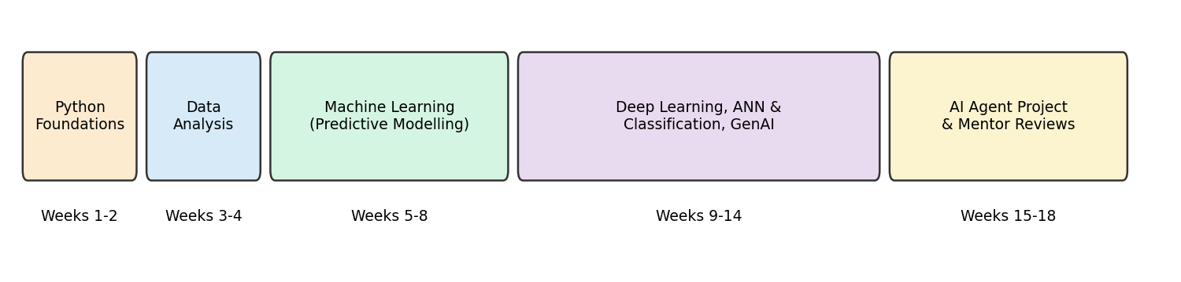
Figure 1: Phases of the internship

1.6 Organization of the Report
Chapter 2 describes YBI Foundation and the way the internship was carried out. Chapters 3 to 6 explain what I learned: Python, data analysis, machine learning, and deep learning with Generative AI. Chapter 7 presents the design of the SmartData AI Agent and Chapter 8 its implementation. Chapter 9 gives the testing and results. Chapter 10 gives the week-wise summary, Chapter 11 the skills, challenges and learning outcomes, and Chapter 12 the conclusion and future scope.

CHAPTER 2 ORGANIZATION AND INTERNSHIP BACKGROUND

2.1 Organization Overview
YBI Foundation is an industry-oriented training and internship provider in the areas of Artificial Intelligence, Machine Learning, Data Science, Python and Generative AI. Its internships follow a hands-on, project-based learning model, and students receive a certificate on successful completion. The internship is delivered online, with learning modules, weekly reports and mentor guidance.

2.2 My Role and Way of Working
I joined as an intern in the Artificial Intelligence and Generative AI domain on 18 June 2026. Each week had five working days, and each day had a defined task. I studied the topic of the day, practised it in a notebook and applied it to an example problem. At the end of every week YBI Foundation issued a weekly internship report listing the tasks of that week, signed by the HR Manager. In the final phase, project work was combined with regular discussions with my mentor, Dr. Alok Yadav, and I incorporated the mentor's suggestions into the project.

2.3 Internship Curriculum
The curriculum followed by YBI Foundation is shown in Table 2. A first review presentation was given after about one and a half months of the internship, when the Python, Python libraries and data visualization modules were complete and the machine learning module was in progress.
Table 2: Internship curriculum of YBI Foundation
Module | Topic | Main contents
1 | Introduction | Orientation, overview of AI and Generative AI, tool setup
2 | Python Programming | Setup, basics, operators, conditional statements, loops, functions
3 | Python Libraries | NumPy and Pandas: reading, writing, summarizing and manipulating data
4 | Data Visualization | Matplotlib charts and data dashboards
5 | Machine Learning | Regression, classification, KNN, decision trees, random forest, K-Means, clustering
6 | Artificial Intelligence | Deep learning, ANN regression, binary and multi-class classification
7 | Generative AI | LLMs, prompt engineering, hands-on with ChatGPT and Gemini, responsible AI
8 | Project Work | Design and development of the project with mentor discussions
9 | Project Submission | Testing, documentation, final review

2.4 Why an AI Agent Project
Most of the training covered separate skills: Python, Pandas, charts and several machine learning models. A real AI application must combine these skills. An AI agent is a good way to do this, because it is a program that understands a request, decides what to do, uses tools to do the work and returns an answer. Each tool of my agent uses one skill from the internship, so the project brings the whole internship together in one working application that is also easy to demonstrate and explain.

CHAPTER 3 PYTHON PROGRAMMING FOUNDATIONS
Python was the base of the whole internship. It is simple to read, has a very large set of libraries for data science and AI, and is the most common language used for machine learning. Weeks 1 to 3 covered the topics below.

3.1 Python Setup and Installation
I installed Python, set up Jupyter Notebook and used Google Colab, which runs Python in the browser without any installation. I learned to install libraries with pip and to run programs both in notebooks and from the command line.

3.2 Python Basics
I learned variables, data types (int, float, string, boolean), type conversion, input and output, and the main data structures: lists, tuples, sets and dictionaries. Dictionaries were especially useful later, because the agent stores its tools in a dictionary that maps a tool name to a function.

3.3 Python Operators
I studied arithmetic operators (+, -, *, /, //, %, **), comparison operators, logical operators (and, or, not), assignment operators and membership operators (in, not in). The calculator tool of the agent supports the arithmetic operators, and the brain of the agent uses the membership operator to check whether a keyword is present in the user's message.

3.4 Conditional Statements
I learned if, elif and else statements to make decisions in a program. The rule-based brain of the agent is built from a chain of such conditions: if the message contains the word "predict" and four numbers, the prediction tool is chosen; otherwise the next condition is checked.

3.5 Loops
I learned for loops, while loops, the range() function, and the break and continue statements. The main program of the agent is a while loop that keeps reading messages until the user types exit.

3.6 Functions
I learned how to define functions with def, pass parameters, use default values and return results. Functions make code reusable and easy to test. In the project, every tool is a separate Python function, which keeps the code simple and easy to explain.
def calculator(expression):
result = evaluate(expression)
return f"{expression} = {result}"

CHAPTER 4 DATA ANALYSIS AND VISUALIZATION
Weeks 3 and 4 covered data analysis with the Pandas library and data visualization with Matplotlib. These skills are needed before any machine learning, because a model is only as good as the data given to it.

4.1 External Data Read and Write
I learned to read data from CSV and Excel files into a Pandas DataFrame with read_csv() and read_excel(), and to save results back with to_csv(). A DataFrame is a table with rows and named columns, similar to a spreadsheet.

4.2 Data Summarization
I used head(), info(), shape, describe(), value_counts() and groupby() to understand a dataset quickly: how many rows and columns it has, what type each column is, the average and spread of each numeric column, and how many records belong to each category. The dataset summary tool of the agent uses exactly these functions.

4.3 Data Manipulation
I learned to select columns and rows, filter rows with conditions, sort data, add new columns, handle missing values with isnull(), fillna() and dropna(), rename columns, and merge or join tables. These steps prepare raw data for analysis and modelling.

4.4 Data Visualization and Dashboards
I used Matplotlib to make line charts, bar charts, histograms, scatter plots and pie charts, and combined several charts in one figure with subplots to build a simple data dashboard. A good chart shows patterns that are hard to see in a table. For example, the scatter plot in Figure 2 shows that the three Iris species form clear groups by petal size; this was produced by the chart tool of the agent.
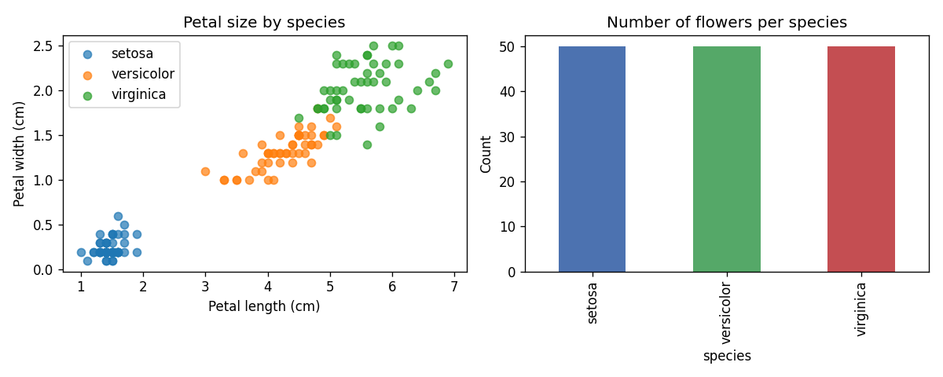
Figure 2: Data dashboard of the Iris dataset produced by the agent's chart tool

CHAPTER 5 MACHINE LEARNING AND PREDICTIVE MODELLING
Weeks 4 to 8 covered predictive modelling and predictive analytics. Machine learning is a way to let a computer learn patterns from past data and use them to make predictions on new data. For each model I first understood how it works, then studied its application to a business problem, and then implemented it in Python with scikit-learn.

5.1 Types of Machine Learning
- Supervised learning: the data has a known answer (label). The model learns the link between inputs and the label. Regression predicts a number (for example, sales); classification predicts a category (for example, whether a customer will leave).
- Unsupervised learning: the data has no label. The model finds hidden groups or patterns by itself, for example customer segments.

5.2 Standard Workflow for a Business Problem
Every model was implemented with the same steps: define the business problem; collect and clean the data; choose the input features (X) and the target (y); split the data into a training set and a test set with train_test_split(); train the model with fit(); make predictions with predict(); and evaluate the model using accuracy, a confusion matrix, precision and recall, or error measures for regression. This workflow is also used inside the model comparison tool of the agent.

5.3 Logistic Regression
Logistic Regression is a classification model. It calculates a weighted sum of the inputs and passes it through the sigmoid function, which gives a probability between 0 and 1. If the probability is above a threshold, the record is put in the positive class. Business applications include predicting customer churn, loan default and whether an email is spam. It is fast and easy to interpret, but it works best when classes can be separated by a straight boundary.

5.4 K-Nearest Neighbours (KNN)
KNN classifies a new record by looking at the K closest records in the training data and taking a majority vote. It needs no real training step and is easy to understand. Its applications include recommendation systems and customer classification. Its drawbacks are that it becomes slow on large datasets and it needs features on a similar scale.

5.5 Decision Trees
A Decision Tree asks a series of yes/no questions about the features, such as "Is petal length less than 2.5 cm?", and follows the branches to reach a decision. It is easy to visualize and explain to non-technical people, which makes it useful for credit approval and customer segmentation. A single tree can overfit, which means it memorizes the training data and performs worse on new data.

5.6 Random Forest
Random Forest builds many decision trees on random samples of the data and features, and combines their votes. This reduces overfitting and usually gives better and more stable accuracy than a single tree. It is used for fraud detection, sales forecasting and risk scoring. It is slower and harder to interpret than a single tree.

5.7 K-Means and Clustering
K-Means is an unsupervised model. It places K centre points, assigns every record to the nearest centre, moves each centre to the mean of its records, and repeats until the groups stop changing. Clustering is used for customer segmentation, market analysis and grouping similar products. The number of groups K must be chosen in advance, for example with the elbow method.
Table 3: Comparison of the machine learning models studied
Model | Type | Advantage | Limitation
Logistic Regression | Supervised, classification | Fast, gives probabilities, easy to interpret | Assumes a simple (linear) boundary
KNN | Supervised, classification | Simple, no training step | Slow on large data; needs scaling
Decision Tree | Supervised, classification / regression | Easy to visualize and explain | Can overfit
Random Forest | Supervised, classification / regression | High accuracy, robust | Slower, less interpretable
K-Means | Unsupervised, clustering | Finds groups without labels | K must be chosen; sensitive to scale

5.8 Review and Feedback
At the end of Week 8 the work done so far was reviewed and I incorporated the mentor's suggestions, mainly about clearly explaining the business problem before building a model and always checking the model on unseen test data.

CHAPTER 6 DEEP LEARNING, CLASSIFICATION AND GENERATIVE AI
Weeks 9 to 14 covered deep learning, artificial neural networks and classification models, together with an introduction to Generative AI. For each model family I studied the understanding, advantages, disadvantages, applications and limitations, and implemented it on a business problem.

6.1 Deep Learning
Deep learning is a part of machine learning that uses neural networks with many layers. It performs very well on large and complex data such as images, speech and text, because it learns useful features automatically. I also studied its limitations: it needs a large amount of data, high computing power and long training time, and it behaves like a black box that is hard to explain. For small tabular datasets, simple models such as Random Forest are often just as good.

6.2 Artificial Neural Networks for Regression
An Artificial Neural Network (ANN) is made of an input layer, one or more hidden layers and an output layer. Each neuron calculates a weighted sum of its inputs and applies an activation function such as ReLU. The network learns by comparing its output with the correct answer using a loss function and adjusting the weights through backpropagation and gradient descent. For regression, the output layer has a single neuron without activation and the loss is the mean squared error. Advantages are the ability to model non-linear relationships; disadvantages are the need for more data, tuning of many settings and the risk of overfitting.

6.3 Binary Classification
Binary classification predicts one of two classes, for example whether a customer will buy or not. In an ANN, the output layer has one neuron with a sigmoid activation and the loss is binary cross-entropy. The model is evaluated with accuracy, precision, recall, F1-score and the confusion matrix.

6.4 Multi-Class Classification
Multi-class classification predicts one of three or more classes, such as the three Iris species used in my project. In an ANN, the output layer has one neuron per class with a softmax activation, which gives a probability for each class, and the loss is categorical cross-entropy. Applications include product categorization, handwritten digit recognition and document classification. Its limitations are that it needs enough examples of every class and that similar classes are easily confused.
Table 4: Summary of deep learning and classification topics
Topic | Advantages | Disadvantages / Limitations | Business application
Deep learning | Learns features automatically; best for images, text, speech | Needs large data and computing power; hard to explain | Image and speech recognition
ANN regression | Models non-linear relationships | Needs tuning; can overfit | Price and demand prediction
Binary classification | Simple output; clear metrics | Class imbalance affects results | Churn and fraud detection
Multi-class classification | Handles many categories at once | Similar classes get confused | Product and document categorization

6.5 Generative AI and Large Language Models
Generative AI creates new content such as text, images or code. A Large Language Model (LLM), such as ChatGPT or Google Gemini, is trained on a very large amount of text and generates an answer one word piece (token) at a time. I learned prompt engineering: writing clear instructions, giving examples, asking for a fixed output format such as JSON, and checking the answer, because an LLM can produce confident but wrong answers. I also studied responsible use of AI: privacy, bias and the need for human checking.

6.6 From Models to Agents
A model answers one fixed kind of question. An AI agent is a program that can understand a goal, decide which action to take, use tools to take that action, and look at the result before answering. Modern agents often use an LLM as the brain that chooses the tools, while normal code performs the actual work. This idea became the basis of my project.

CHAPTER 7 PROJECT DESIGN: SMARTDATA AI AGENT

7.1 Problem Statement
A beginner who wants to analyze a dataset must remember many different commands: one for a summary, another for a chart, several for training and comparing models, and more for predictions. The goal of this project is to build a basic AI agent that accepts a request in simple English, decides by itself which analysis is needed, performs it and explains the result.

7.2 Project Objectives
- to build an agent that understands simple English requests about a dataset;
- to give the agent tools that use the skills learned in the internship: Pandas summary, Matplotlib charts, four classification models, K-Means clustering and a calculator;
- to make the agent choose the correct tool automatically, using a rule-based brain that works offline and an optional LLM brain;
- to keep a short memory of the conversation;
- to handle unclear or unsupported requests safely instead of crashing or guessing;
- to keep the code small and clear so that it is easy to explain.

7.3 What Is an AI Agent? (Simple Explanation)
A simple way to explain the project is to compare the agent with a helpful assistant in an office. The assistant listens to the request (perceive), thinks about which tool or person can do the job (think), uses that tool (act), checks the result (observe) and then reports back (respond). The assistant also remembers what was asked earlier (memory). The SmartData AI Agent works in exactly this way, as shown in Figure 3.
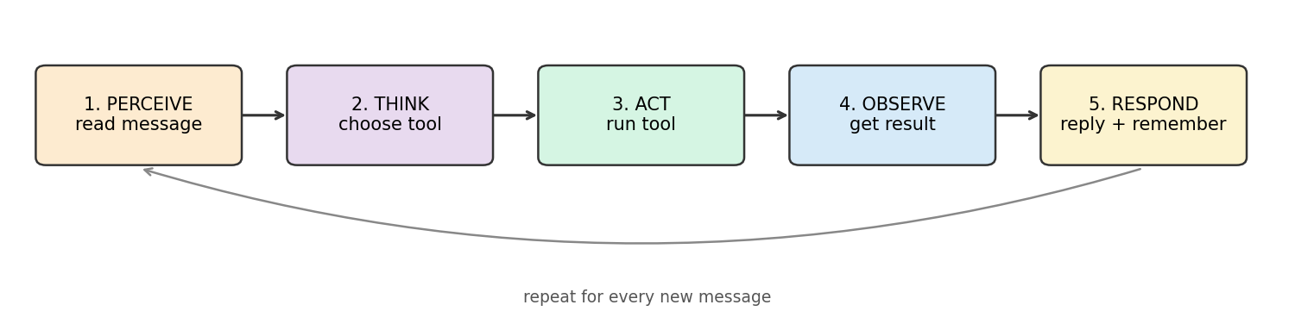
Figure 3: The Perceive-Think-Act-Observe-Respond loop of the agent

7.4 System Architecture
The agent has three parts, each in its own Python file (Figure 4):
- agent.py (the agent loop): receives the message, asks the brain for a decision, runs the chosen tool, stores the result in memory and prints the answer.
- brain.py (the brain): decides which tool to use and with which inputs. It returns a decision such as {"tool": "predict_species", "args": {...}}.
- tools.py (the hands): contains the six tools. Each tool is a normal Python function that does one job.
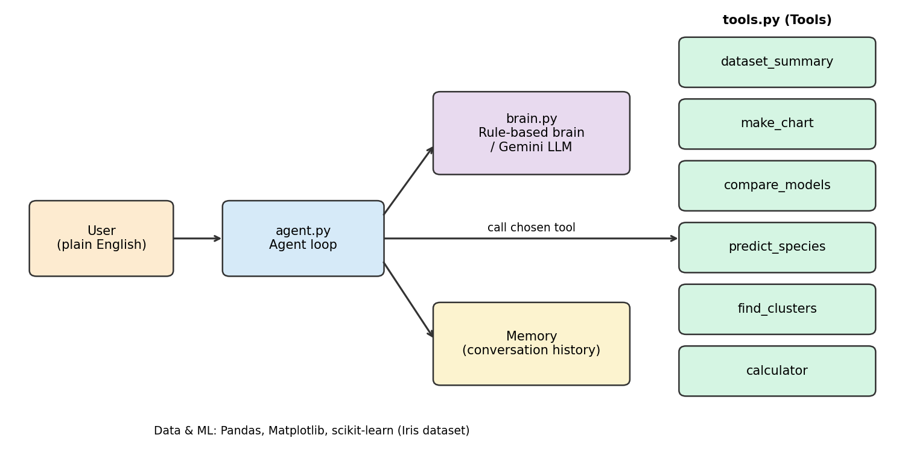
Figure 4: Architecture of the SmartData AI Agent

7.5 Tools of the Agent
Table 5: Tools of the agent and the learning behind each tool
Tool | What it does | Internship learning used
dataset_summary | Rows, columns, flowers per species, average measurements | Pandas: summarization, groupby (Week 3)
make_chart | Scatter plot and bar chart saved as an image | Matplotlib dashboards (Weeks 3-4)
compare_models | Trains Logistic Regression, KNN, Decision Tree, Random Forest and reports accuracy | Predictive modelling (Weeks 5-7)
predict_species | Predicts the species of a new flower with the best model | Multi-class classification (Weeks 13-14)
find_clusters | Groups flowers with K-Means and compares groups with real species | K-Means and clustering (Weeks 7-8)
calculator | Safely evaluates arithmetic such as (45+15)*2/3 | Python operators and functions (Weeks 2-3)

7.6 The Brain: Rule-Based and LLM
The rule-based brain reads the message in lower case, finds numbers with a regular expression, and checks keywords in a fixed order. For example, a message with "predict" and four numbers goes to predict_species, and a message with "compare" or "accuracy" goes to compare_models. If nothing matches, the agent politely says that it did not understand and suggests typing help. This brain works without the internet and always gives the same result for the same input.
The optional LLM brain sends the user's message and the list of tools to Google Gemini and asks it to reply only in JSON with the tool name and its inputs. The LLM only chooses the tool; the calculation is still done by the Python tool, so the numbers in the answer are always correct. If the LLM fails, returns invalid JSON or names a tool that does not exist, the agent automatically falls back to the rule-based brain. This acts as a simple guardrail.

7.7 Dataset
The project uses the Iris flower dataset, which is built into scikit-learn. It contains 150 flowers of three species (setosa, versicolor and virginica), 50 of each, with four measurements in centimetres: sepal length, sepal width, petal length and petal width. It is clean, balanced and easy to understand, which makes it ideal for explaining multi-class classification and clustering. The data is split into 112 training flowers and 38 test flowers (75% / 25%), keeping the same species ratio in both sets.

CHAPTER 8 IMPLEMENTATION

8.1 Project Structure
ai-agent/
agent.py - agent loop and command-line chat (run this file)
brain.py - rule-based brain and optional Gemini LLM brain
tools.py - the six tools and the tool registry
requirements.txt - pandas, numpy, matplotlib, scikit-learn
README.md - how to run the project
outputs/ - saved chart and sample run

8.2 The Tool Registry
All tools are listed in one dictionary. The key is the tool name and the value is the function with a short description. The brain only needs this list to know what the agent can do, and a new tool can be added with a single line.
TOOLS = {
"dataset_summary": (dataset_summary, "Describe the Iris dataset"),
"make_chart": (make_chart, "Draw and save a chart"),
"compare_models": (compare_models, "Train and compare 4 ML models"),
"predict_species": (predict_species, "Predict species from 4 measurements"),
"find_clusters": (find_clusters, "Group flowers using K-Means"),
"calculator": (calculator, "Evaluate an arithmetic expression"),
}

8.3 Model Comparison Tool
This tool trains the four models on the same training data, measures their accuracy on the same test data and remembers the best one. The prediction tool then uses that best model.
models = {
"Logistic Regression": LogisticRegression(max_iter=500),
"KNN (k=5)": KNeighborsClassifier(n_neighbors=5),
"Decision Tree": DecisionTreeClassifier(random_state=42),
"Random Forest": RandomForestClassifier(n_estimators=100, random_state=42),
}
for name, model in models.items():
model.fit(X_train, y_train)
scores[name] = accuracy_score(y_test, model.predict(X_test))
best_model_name = max(scores, key=scores.get)

8.4 The Rule-Based Brain
def decide(self, message):
text = message.lower()
numbers = [float(n) for n in re.findall(NUMBER, text)]
if "predict" in text and len(numbers) >= 4:
return {"tool": "predict_species", "args": {...first four numbers...}}
if "compare" in text or "accuracy" in text:
return {"tool": "compare_models", "args": {}}
...
return {"tool": None, "reply": "I did not understand that. Type 'help'."}

8.5 The Agent Loop
The handle() method of the agent is the heart of the project. It follows the five steps of the agent loop and also catches errors from a tool, so the agent never crashes on a bad input.
def handle(self, message):
decision = self.brain.decide(message) # THINK
tool_name = decision.get("tool")
if tool_name is None:
answer = decision.get("reply")
else:
function, _ = TOOLS[tool_name]
try:
answer = function(**decision.get("args", {})) # ACT + OBSERVE
except Exception as error:
answer = f"The tool '{tool_name}' failed: {error}"
self.memory.append((message, tool_name, answer)) # REMEMBER
return answer # RESPOND

8.6 Safe Calculator
Python's eval() function can run any code, which is unsafe if a user types something harmful. The calculator therefore uses Python's ast module to read the expression and allows only numbers and the operators +, -, *, /, ** and %. Anything else is rejected with a clear message.

8.7 Running the Project
pip install -r requirements.txt
python agent.py --offline # rule-based brain, no internet needed
python agent.py # uses Gemini if GEMINI_API_KEY is set

CHAPTER 9 TESTING, RESULTS AND DISCUSSION

9.1 Testing Approach
The agent was tested by giving it a fixed list of eleven messages in the offline mode, so that the results can be repeated exactly. The messages cover every tool, two different ways of asking for a prediction, a prediction request with missing numbers, an unsupported question and the memory command. The complete output is saved in outputs/demo_run.txt and reproduced in Appendix A.

9.2 Functional Test Cases
Table 6: Functional test cases of the agent (offline mode)
No. | User message | Tool chosen | Result | Status
1 | help | show_help | Listed the seven things the agent can do | Pass
2 | summary of the dataset | dataset_summary | 150 rows, 4 inputs, 50 flowers per species, averages per species | Pass
3 | draw a chart | make_chart | Dashboard image saved (Figure 2) | Pass
4 | compare models | compare_models | Accuracy of 4 models; best model KNN | Pass
5 | predict 5.1 3.5 1.4 0.2 | predict_species | setosa (confidence 100%) | Pass
6 | which species is 6.7 3.0 5.2 2.3 | predict_species | virginica (confidence 100%) | Pass
7 | predict this flower | none | Asked the user for the 4 measurements | Pass
8 | find clusters | find_clusters | 3 groups; setosa perfectly separated | Pass
9 | calculate (45+15)*2/3 | calculator | 40.0 | Pass
10 | what is the weather | none | Polite message suggesting 'help' | Pass
11 | history | memory | Listed the 10 earlier messages and tools | Pass

All eleven test cases passed. Cases 7 and 10 are important: when the request is incomplete or outside the agent's abilities, the agent does not guess or crash but explains what it needs.

9.3 Model Comparison Results
Table 7: Accuracy of the four models on the test set
Model | Test accuracy | Correct out of 38
Logistic Regression | 94.7% | 36
KNN (k = 5) | 97.4% | 37
Decision Tree | 89.5% | 34
Random Forest | 92.1% | 35

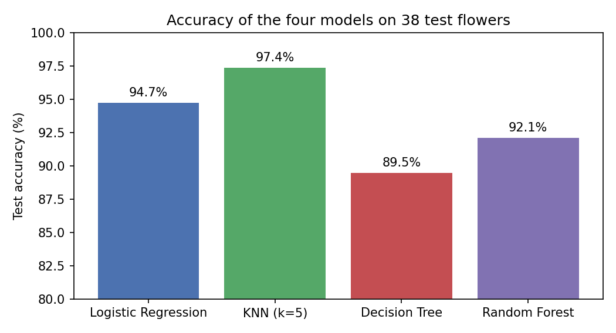
Figure 5: Test accuracy of the four classification models
KNN gave the best accuracy (97.4%) and was selected automatically by the agent for predictions. Figure 6 shows its confusion matrix: all setosa and versicolor test flowers were classified correctly and only one virginica flower was confused with versicolor. These two species have overlapping measurements, as is also visible in the scatter plot of Figure 2.
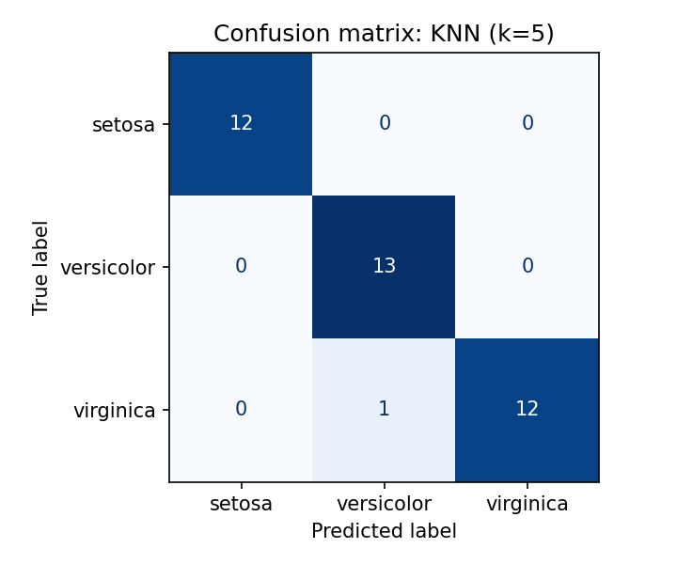
Figure 6: Confusion matrix of the best model (KNN) on 38 test flowers

9.4 Clustering Result
Table 8: K-Means groups compared with the real species
K-Means group | setosa | versicolor | virginica
Group 0 | 0 | 48 | 14
Group 1 | 50 | 0 | 0
Group 2 | 0 | 2 | 36

Without being given any labels, K-Means placed all 50 setosa flowers in one group. 48 of 50 versicolor and 36 of 50 virginica flowers were placed in their own groups, so 134 of the 150 flowers (89.3%) fall in a group that matches their species. This shows how unsupervised learning can discover natural groups, and also that it is less accurate than supervised learning when classes overlap.

9.5 Discussion
The results show that a small amount of clear code is enough to build a useful agent. Separating the brain from the tools has two benefits. First, the brain can be changed from rules to an LLM without touching the tools. Second, because the tools do the real calculations, the numbers in the answers are always exact, even when an LLM is used to choose the tool. The fallback from the LLM brain to the rule-based brain keeps the agent working even without an internet connection.

9.6 Limitations
- The rule-based brain understands only the keywords it was written for; unusual wording may not be understood.
- The agent works on one built-in dataset; it cannot yet load any CSV file chosen by the user.
- The test set is small (38 flowers), so a difference of one flower changes the accuracy by about 2.6%.
- The memory lasts only while the program is running.
- The LLM brain needs an internet connection and an API key, and its tool choice can vary between runs.

CHAPTER 10 WEEK-WISE INTERNSHIP SUMMARY

10.1 Overview
This chapter lists the tasks of each week as recorded in the weekly internship reports issued by YBI Foundation. Each week had five working days (Monday to Friday).

10.2 Phase 1: Python Foundations (Weeks 1-2)
Table 9: Weeks 1-2: Python foundations
Week | Dates | Tasks and learning
1 | 18-06-2026 to 19-06-2026 | Joining and orientation; introduction to the internship curriculum, Artificial Intelligence and Generative AI; setting up the learning tools
2 | 22-06-2026 to 26-06-2026 | Python Training: Python setup and installation; Python basics; Python operators; Python conditional statements; Python loops

10.3 Phase 2: Data Analysis and Visualization (Weeks 3-4)
Table 10: Weeks 3-4: data analysis and visualization
Week | Dates | Tasks and learning
3 | 29-06-2026 to 03-07-2026 | Python Training: Python functions. Data Analysis: external data read and write; data summarization; data manipulation; data dashboard
4 | 06-07-2026 to 10-07-2026 | Data visualization practice; introduction to machine learning and predictive modelling; understanding regression models and applying them to business problems

10.4 Phase 3: Machine Learning (Weeks 5-8)
Table 11: Weeks 5-8: machine learning and predictive analytics
Week | Dates | Tasks and learning
5 | 13-07-2026 to 17-07-2026 | Predictive Modelling: implementation to solve business problems; understanding Logistic Regression; application of Logistic Regression for business; implementation to solve business problems; understanding the KNN model
6 | 20-07-2026 to 24-07-2026 | Predictive Modelling: application of the KNN model for business; implementation to solve business problems. Predictive Analytics: understanding the Decision Trees model; application of Decision Trees for business; implementation to solve business problems
7 | 27-07-2026 to 31-07-2026 | Predictive Analytics: understanding the Random Forest model; application of Random Forest for business; implementation to solve business problems; understanding the K-Means model; application of K-Means for business
8 | 03-08-2026 to 07-08-2026 | Predictive Analytics: implementation to solve business problems; understanding the clustering model; application of the clustering model for business; implementation to solve business problems. Review and feedback: incorporating mentor suggestions

10.5 Phase 4: Deep Learning, Classification and Generative AI (Weeks 9-14)
Table 12: Weeks 9-14: deep learning, classification and Generative AI
Week | Dates | Tasks and learning
9 | 10-08-2026 to 14-08-2026 | Introduction to Generative AI and large language models; prompt engineering; hands-on with ChatGPT and Gemini; responsible use of AI
10 | 17-08-2026 to 21-08-2026 | Deep Learning: understanding models; advantages; disadvantages; applications of deep learning models
11 | 24-08-2026 to 28-08-2026 | Deep Learning: limitations of models; implementation to solve business problems. ANN Regression: understanding models; advantages of models; disadvantages of models
12 | 31-08-2026 to 04-09-2026 | ANN Regression: applications; limitations; implementation to solve business problems. Binary Classification: understanding models
13 | 07-09-2026 to 11-09-2026 | Binary Classification: advantages; disadvantages; applications and limitations; implementation to solve business problems. Multi Classification: understanding models
14 | 14-09-2026 to 18-09-2026 | Multi Classification: advantages of models; disadvantages of models; applications of models; limitations of models; implementation to solve business problems

10.6 Phase 5: AI Agent Project (Weeks 15-18)
Table 13: Weeks 15-18: AI agent project
Week | Dates | Tasks and learning
15 | 21-09-2026 to 25-09-2026 | Working on project (Mon, Tue, Wed, Fri); discussion with mentor (Thu). Selected the AI agent idea and the Iris dataset; designed the agent loop and the tool list
16 | 28-09-2026 to 02-10-2026 | Working on project (Mon, Tue, Thu, Fri); discussion with mentor (Wed). Built the tools: summary, chart, model comparison, prediction, clustering, calculator
17 | 05-10-2026 to 09-10-2026 | Working on project (Mon, Wed, Thu, Fri); discussion with mentor (Tue). Built the rule-based brain, the optional Gemini brain with fallback, and the conversation memory
18 | 12-10-2026 to 15-10-2026 | Discussion with mentor (Mon); working on project (Tue-Thu). Testing, fixing issues, documentation and final review. Performance review on 16-10-2026

CHAPTER 11 SKILLS, CHALLENGES AND LEARNING OUTCOMES

11.1 Technical Skills Gained
Table 14: Technical skills gained during the internship
Area | Skills
Python | Data types, operators, conditions, loops, functions, dictionaries, regular expressions, error handling
Data analysis | Reading and writing data; summarizing with describe() and groupby(); filtering, cleaning and merging data
Visualization | Bar, line, scatter, histogram and pie charts; multi-chart dashboards in Matplotlib
Machine learning | Train/test split; Logistic Regression, KNN, Decision Tree, Random Forest, K-Means; accuracy and confusion matrix
Deep learning | ANN structure, activation functions, loss functions, ANN regression, binary and multi-class classification
Generative AI | LLM basics, prompt engineering, structured JSON output, using an LLM to choose tools
AI agents | Agent loop, tool registry, rule-based and LLM brains, fallback guardrail, memory
Tools | Jupyter Notebook, Google Colab, VS Code, Git and GitHub

11.2 Professional Skills Gained
- Time management: completing a defined task every day while balancing college academics.
- Communication: explaining technical ideas clearly in mentor discussions, review presentations and this report.
- Accepting feedback: incorporating mentor suggestions into the work.
- Problem solving: breaking a large goal into small steps and solving them one at a time.

11.3 Performance Evaluation by the Organization
The internship performance report issued by YBI Foundation on 16 October 2026 and signed by Dr. Alok Yadav rated my work as follows. The overall observation was "Good performance throughout the internship".
Table 15: Internship performance evaluation
No. | Criterion | Rating
1 | Shows interest in work and initiative (dependable) | Good
2 | Produces high quality work and accepts responsibility | Good
3 | Uses technical knowledge / expertise (proficiency achieved) | Excellent
4 | Analyses problems effectively | Excellent
5 | Communicates well and writes effectively | Excellent
6 | Punctuality (on time, time management, discipline) | Excellent
7 | Accepts criticism (feedback) | Very Good
8 | Teamwork (cooperation, relations with others) | Very Good
9 | Professional behaviour (appearance, meeting deadlines) | Excellent
10 | Demonstrates creativity / originality | Very Good

11.4 Challenges and How They Were Solved
Table 16: Challenges faced and their solutions
Challenge | How it was solved
Learning many ML algorithms and libraries in a short time | Followed the same order for every model (understand, apply, implement) and practised each one on a small dataset
Choosing a project that is useful but easy to explain | Chose a basic AI agent on the well-known Iris dataset, so the focus stays on how the agent works
Making the agent understand different ways of asking | Used several keywords per tool and regular expressions to pick out numbers; added a polite fallback message
LLM answers are not always in the expected format | Asked the LLM for JSON only, checked the tool name, and fell back to the rule-based brain on any error
Using eval() for the calculator is unsafe | Used the ast module to allow only numbers and arithmetic operators
Balancing internship work with college academics | Planned daily tasks in advance and used weekends for revision

11.5 Learning Outcomes
By the end of the internship I am able to write Python programs, analyze and visualize a dataset, choose and evaluate a suitable machine learning model for a business problem, explain the working, advantages and limitations of neural networks and classification models, use LLMs with good prompts, and combine all of these skills into a working AI agent.

CHAPTER 12 CONCLUSION AND FUTURE SCOPE

12.1 Conclusion
The four-month internship at YBI Foundation gave me a complete, step-by-step path into Artificial Intelligence and Generative AI, from Python basics to data analysis, machine learning, deep learning and large language models. The SmartData AI Agent brought these skills together. It understands simple English requests, chooses the right tool, performs data analysis and prediction, remembers the conversation and handles unclear requests safely. It passed all eleven test cases, and its best model, KNN, reached 97.4% accuracy on unseen data. The project showed me that an AI agent is not magic: it is a clear loop of perceiving, thinking, acting, observing and responding, built from the same Python and machine learning skills learned during the internship.

12.2 Future Scope
- Allow the user to upload any CSV file, so the agent can analyze any business dataset.
- Add a web interface using Streamlit so that non-technical users can use the agent in a browser.
- Use an LLM to also write the final answer in natural language and to explain the results.
- Add more tools, such as regression for numeric prediction and an ANN model.
- Save the memory to a file so the agent remembers previous sessions.
- Add Retrieval-Augmented Generation (RAG) so the agent can answer questions from documents.

REFERENCES
[1] Python Software Foundation, "The Python Tutorial," docs.python.org/3/tutorial.
[2] The pandas development team, "pandas documentation," pandas.pydata.org/docs.
[3] J. D. Hunter, "Matplotlib: A 2D Graphics Environment," Computing in Science & Engineering, vol. 9, no. 3, pp. 90-95, 2007.
[4] F. Pedregosa et al., "Scikit-learn: Machine Learning in Python," Journal of Machine Learning Research, vol. 12, pp. 2825-2830, 2011.
[5] R. A. Fisher, "The Use of Multiple Measurements in Taxonomic Problems," Annals of Eugenics, vol. 7, no. 2, pp. 179-188, 1936.
[6] A. Geron, Hands-On Machine Learning with Scikit-Learn, Keras and TensorFlow, 3rd ed. O'Reilly Media, 2022.
[7] I. Goodfellow, Y. Bengio and A. Courville, Deep Learning. MIT Press, 2016.
[8] S. Russell and P. Norvig, Artificial Intelligence: A Modern Approach, 4th ed. Pearson, 2021.
[9] S. Yao et al., "ReAct: Synergizing Reasoning and Acting in Language Models," International Conference on Learning Representations (ICLR), 2023.
[10] Google, "Gemini API documentation," ai.google.dev.
[11] YBI Foundation, internship programme and learning modules, ybifoundation.org.

APPENDIX A: SAMPLE RUN OF THE AGENT
The listing below is the complete output of the agent for the eleven test messages of Chapter 9, run with python agent.py --offline.
============================================================
SmartData AI Agent | brain: Rule-based brain (offline)
============================================================
I can do these things:
1. 'summary' - describe the dataset
2. 'chart' - draw and save a chart
3. 'compare models' - train 4 ML models and compare accuracy
4. 'predict 5.1 3.5 1.4 0.2' - predict the species of a flower
5. 'clusters' - group flowers with K-Means
6. 'calculate 12*7+3' - do arithmetic
7. 'history' - show what we discussed
Type 'exit' to quit.

You: Agent: I can do these things:
1. 'summary' - describe the dataset
2. 'chart' - draw and save a chart
3. 'compare models' - train 4 ML models and compare accuracy
4. 'predict 5.1 3.5 1.4 0.2' - predict the species of a flower
5. 'clusters' - group flowers with K-Means
6. 'calculate 12*7+3' - do arithmetic
7. 'history' - show what we discussed
Type 'exit' to quit.

You: Agent: The dataset has 150 rows and 4 input columns: sepal_length, sepal_width, petal_length, petal_width.
Flowers per species: {'setosa': 50, 'versicolor': 50, 'virginica': 50}.
Average measurements (cm) per species:
sepal_length sepal_width petal_length petal_width
species
setosa 5.01 3.43 1.46 0.25
versicolor 5.94 2.77 4.26 1.33
virginica 6.59 2.97 5.55 2.03

You: Agent: Chart saved to outputs\iris_dashboard.png

You: Agent: Model comparison on the test set (38 unseen flowers):
Logistic Regression accuracy = 94.7%
KNN (k=5) accuracy = 97.4%
Decision Tree accuracy = 89.5%
Random Forest accuracy = 92.1%
Best model: KNN (k=5)

You: Agent: Using KNN (k=5), the flower with measurements (5.1, 3.5, 1.4, 0.2) is most likely 'setosa' (confidence 100%).

You: Agent: Using KNN (k=5), the flower with measurements (6.7, 3.0, 5.2, 2.3) is most likely 'virginica' (confidence 100%).

You: Agent: Please give 4 numbers: sepal length, sepal width, petal length, petal width.

You: Agent: K-Means found 3 groups. How the groups match the real species:
species setosa versicolor virginica
cluster
0 0 48 14
1 50 0 0
2 0 2 36

You: Agent: (45+15)*2/3 = 40.0

You: Agent: I did not understand that. Type 'help' to see what I can do.

You: Agent: Conversation so far:
1. You: help -> tool: show_help
2. You: summary of the dataset -> tool: dataset_summary
3. You: draw a chart -> tool: make_chart
4. You: compare models -> tool: compare_models
5. You: predict 5.1 3.5 1.4 0.2 -> tool: predict_species
6. You: which species is 6.7 3.0 5.2 2.3 -> tool: predict_species
7. You: predict this flower -> tool: none
8. You: find clusters -> tool: find_clusters
9. You: calculate (45+15)*2/3 -> tool: calculator
10. You: what is the weather -> tool: none

You: Goodbye!

APPENDIX B: GLOSSARY
Table 17: Terms used in this report
Term | Meaning
AI agent | A program that understands a goal, decides on an action, uses tools and returns a result
Tool | A function the agent can call to do one job, such as making a chart
Brain | The part of the agent that decides which tool to use
LLM | Large Language Model, an AI model trained on large text data that generates text
Prompt | The instruction given to an LLM
Feature | An input column used by a model, such as petal length
Label / target | The answer a supervised model learns to predict, such as the species
Training / test set | Data used to train a model / unseen data used to check it
Accuracy | Percentage of test records predicted correctly
Confusion matrix | Table comparing true classes with predicted classes
Overfitting | When a model memorizes training data and performs worse on new data
Clustering | Grouping similar records without labels
ANN | Artificial Neural Network: layers of connected neurons that learn weights
Guardrail | A check that keeps an AI system safe, such as a fallback on error

ANNEXURE I: INTERNSHIP JOINING / OFFER LETTER
Attach the offer letter and the joining confirmation letter issued by YBI Foundation.

ANNEXURE II: INTERNSHIP COMPLETION CERTIFICATE
Attach the 4-Months Internship completion certificate issued by YBI Foundation (Oct 18, 2026).

ANNEXURE III: WEEKLY INTERNSHIP REPORTS
Attach the weekly internship reports (Weeks 1-18) issued by YBI Foundation.

ANNEXURE IV: INTERNSHIP PERFORMANCE REPORT
Attach the internship performance report dated 16 October 2026.

