DWH- Data Warehouse
RDBMS or Database: In this the concerned person can read or write data and which can be changed after every update, insert or modification, which will be impacted.
If we want to convert RDBMS or database into DWH then it should have below features to be applicable.
DWH:
DWH is defined as Subject Oriented, Integrated, time variant and non-volatile collection of data for decision making.
subject oriented: This is used to analyses subject area.
Integrated: It should integrate data from different sources.
Time Variant: Historical data is usually maintained in a data warehouse, i.e. retrieval can be for any period.
Non-Volatile: Once data is stored in data warehouse, it cannot be altered.
Data ware house concepts
OLTP - Online Transaction Processing system
OLTP is Nothing but a database which stores daily transactions which is called current data.
OLTP is used more for online applications, where application needs to update very frequently to maintain consistency of data.

OLAP - Online analytical processing
OLAP delas with analyzing data for decision making and planning. It will maintain historical data.

COB - Close of business - 9AM to 4PM

DATA MART:
- It is smallest version of DWH.
- DATA MART deals with single subject area.
- DATA MART focuses on one area hence they carry data from limited data source.

DATA MART types
1.Dependent: Dependent DM are created from DWH.
2.Independet: Independent DM are created directly from source system and suitable for small organization
3.Hybrid: In Hybrid DM data can be feed from data warehouse or operational data (OLTP).
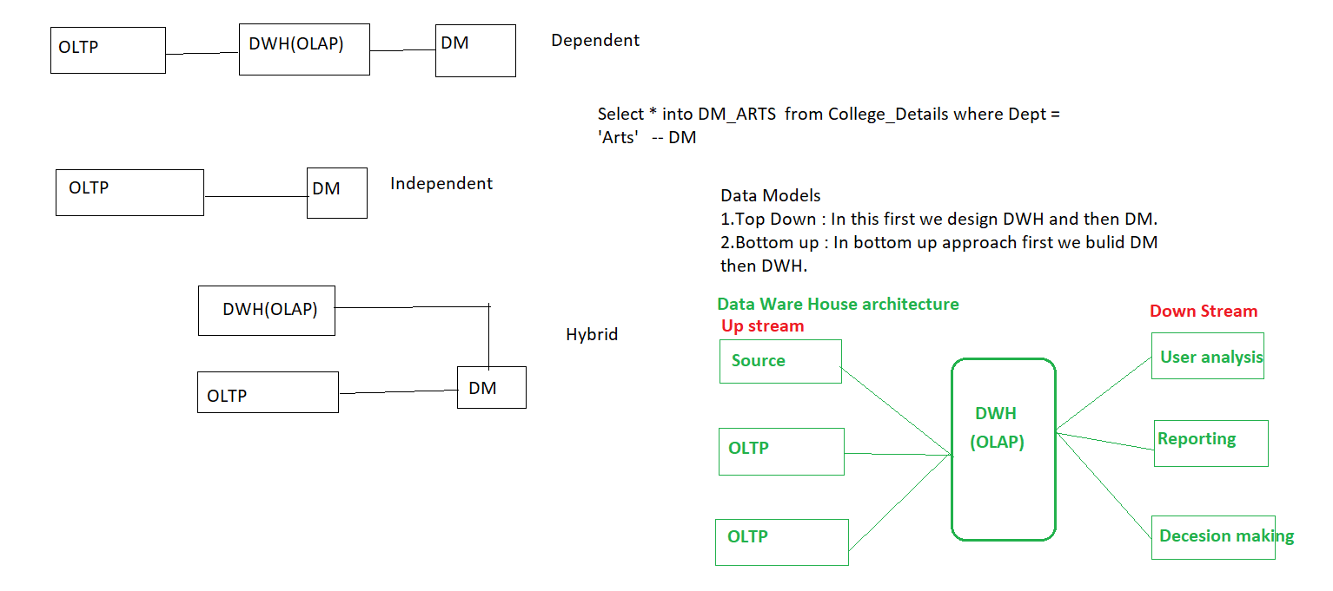
Data Models
- Data Model tells how the logical structure of database is modeled.
- Data Models are fundamental entities to introduce ideas in RDBMS.
Data Models defines how data is connected to each other and how it will be processed and stored inside the system.
- Data Models are designed by Principal Architect/ Data Base Solution Engineer and designed document is called as HLSD (High Level Design Specification Document) / HLD (High Level design)/DSD (Design Specification Document).

To design a final Data Models, they follow step – by -step approaches and those are
1.Conceptual
2. Logical
3. Physical

For Example:
For manufacturing unit need develop DATA MODEL then we have some below entities
PRODUCT
CUSTOMER
STORE
TIME
SALES
1.Conceptual
This model usually pictures highest level of relationship between entities
- Displays important entities and relationships among them.
- No attributes or columns specified.
- No primary key is associated or defined.
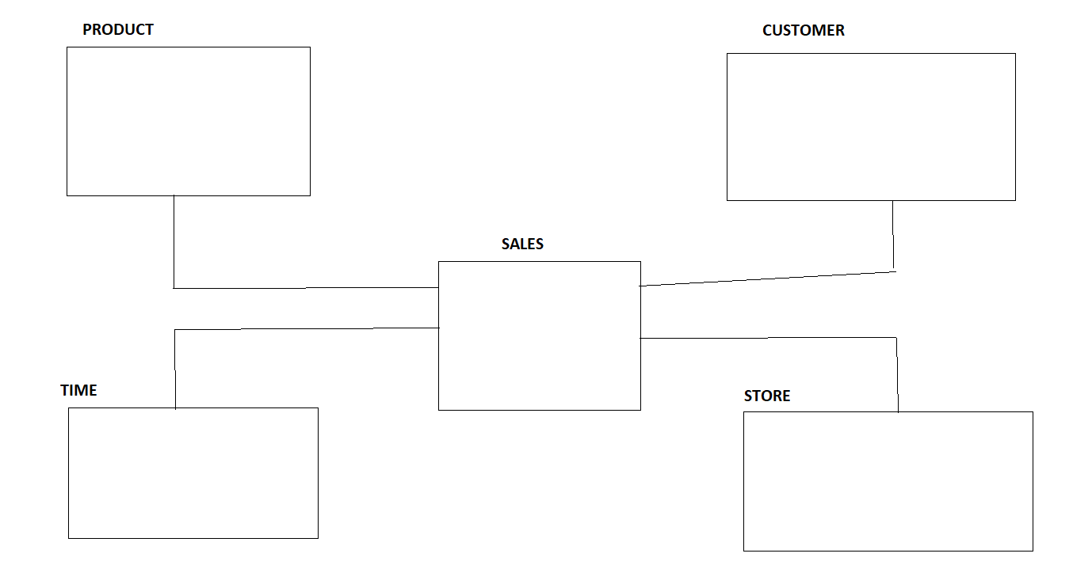

2.Logical
Logical Data Model defines data as much as possible, To show how they can be physically implemented in database.
- Displays all the entities and attributes and relationship among them.
- Primary key for each entity is specified.
- Foreign keys for each entity if exists then specify.

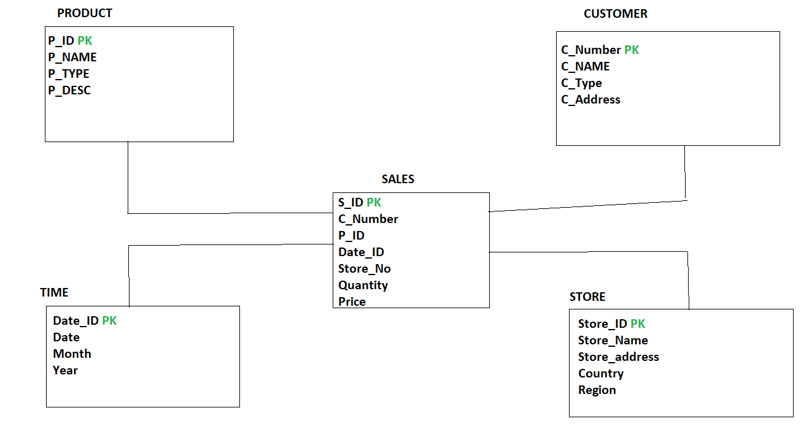
3.Physical Data Model
Physical model defines how the model is physically exists in the system
- Displays all the table names and columns
- Displays foreign keys
- Displays relationship among all the tables and changed into FK.
- Entity becomes table.
- Attributes becomes column and its data types.
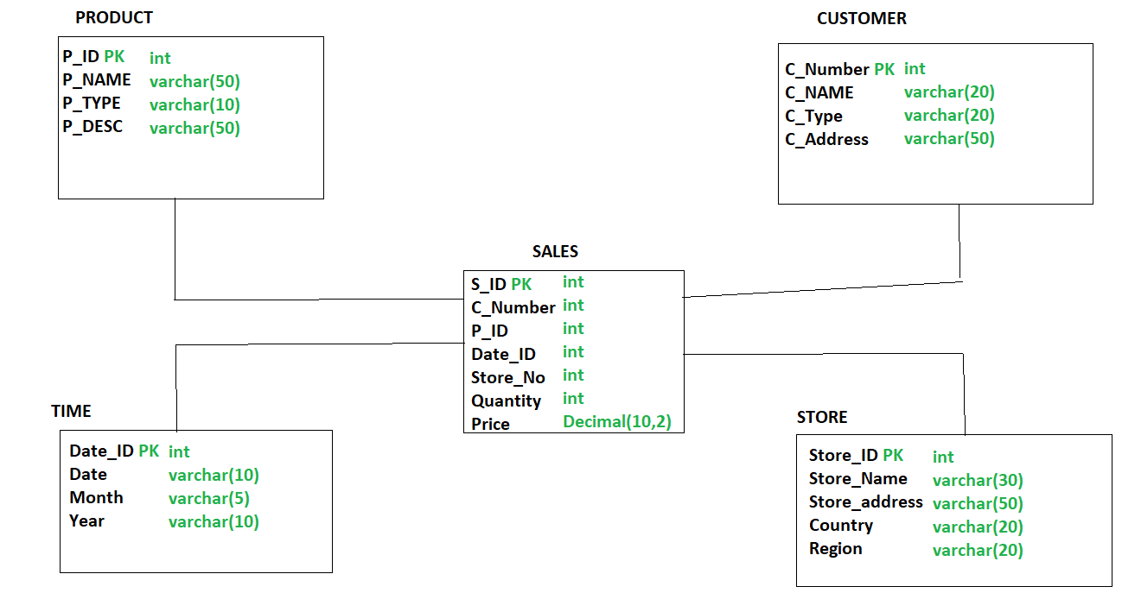
Dimensions and Facts
Dimension:
Dimension is nothing but descriptive characteristics of attributes.
Facts:
Facts are measures or numbers.
Types of dimensions
1.SCD (Slowly Changing Dimension)
2.Confirmed dimension
3.Degenarated dimension
4.Junk Dimension
5.Static Dimension
6.Roll Playing dimension
7.Shrunken Dimension
1.SCD (Slowly Changing Dimension)
Dimension that changes slowly over a period of time rather than changing regularly is known as SCD.
For ex: Location, City, Address, DOJ etc.
Types
1.SCD Type1 (SCD1) – Current
2.SCD Type2 (SCD2) – Current as well as historical data.
3.SCD Type3 (SCD3) – Current as well as historical data but there is limited period of data we can store.
Example: CUTOMER_DETAILS
Consider a customer with name AMIT who is living in MUMBAI from 2018
CUST_ID | CUST_NAME | DOJ_YEAR | LOCATION
1 | AMIT | 2018 | MUMBAI

1.SCD Type1 (SCD1)
Dimensions that replace old entry with new entry.
In SCD1 we can maintain only Current records.
In the above example on Location column if we apply SCD1 then if AMIT is changing his location to PUNE in year 2020, In SCD1 the above table changed as follows

Before Applying SCD1
 |  |  | SCD1
CUST_ID | CUST_NAME | DOJ_YEAR | LOCATION
1 | AMIT | 2018 | MUMBAI
`
After Applying SCD1
 |  |  | SCD1
CUST_ID | CUST_NAME | DOJ_YEAR | LOCATION
1 | AMIT | 2020 | PUNE
In this case, Previous entry which is treated as history, which will be lost in SCD1 and it maintains only current records.
2.SCD Type 2 (SCD2)
In SCD2 dimension we maintain current as well as historical records into the table.
To Identify current record and historical records from table we have two methods in SCD2
1.We must add columns like START_DATE and END_DATE.
2.We need to add column ETL_CurrentRecordFlag or ETL_RecordFlag(True/False or Y/N or Current/Expired).
- With the above example if AMIT is changing his location form MUMBAI to PUNE to INDORE in different years, then in SCD2 we are maintaining all the history and current records and which will be identified clearly by adding START_DATE and END_DATE columns into table which shown below

 |  |  | SCD2
CUST_ID | CUST_NAME | DOJ_YEAR | LOCATION | START_DATE | END_DATE
1 | AMIT | 2018 | MUMBAI | 1/1/2018 | 1/3/2020
1 | AMIT | 2020 | PUNE | 1/3/2020 | 31/05/2021
1 | AMIT | 2021 | INDORE | 31/05/2021 | NULL

In the above table we can easily identify current records from table by writing simple SQL query
SELECT * FROM CUSTOMER_DETAILS where END_DATE is NULL
- With the above example if AMIT is changing his location form MUMBAI to PUNE to INDORE in different years, then in SCD2 we are maintaining all the history and current records and which will be identified clearly by adding ETL_CurrentRecordFlag column into table which shown below
 |  |  | SCD2
CUST_ID | CUST_NAME | DOJ_YEAR | LOCATION | ETL_CurrentRecordFlag
1 | AMIT | 2018 | MUMBAI | Expired
1 | AMIT | 2020 | PUNE | Expired
1 | AMIT | 2021 | INDORE | Current

In the above table we can easily identify current records from table by writing simple SQL query
SELECT * FROM CUSTOMER_DETAILS where ETL_CurrentRecordFlag = ‘current’

What is the need Primary Key in database table?
- For good practice in database designing, we must maintain primary key in every table.
- Primary key is use to uniquely identifies each row/record in a table.
Natural key
- Primary key is made up of real data in table, that primary key is called as natural primary key.
- For example, In HR database, Employees table having Eid column which is unique and not null and we can call this real data because every employee should be identified by its Eid.
- Here we can make Eid as primary key in Employees table and this primary key is called as natural primary key.

Eid | FirstName | Last Name | Dept
1 | Kishor | Bhosale | Testing
2 | Pavan | Patil | Dev
3 | Amit | Chavan | Admin
Surrogate key
- Some times in database table we cannot make primary key from real data.
- In this situation, we must add one artificial column in table which is having unique and not null values, and make this column as primary in table.
- This primary which is generated from artificial column is called as Surrogate key.
Example:
If we want to maintained history of employee table then Eid should be not the primary key column in table, because there are chances of duplicity in Eid column
Eid | FirstName | Last Name | Dept | Date created
1 | Kishor | Bhosale | Testing | 10/9/2021
2 | Pavan | Patil | Dev | 11/10/2021
3 | Amit | Chavan | Admin | 7/9/2021
1 | Kishor | Bhosale | Testing | 11/1/2022
2 | Pavan | Patil | Dev | 31/03/2022

- To resolve this problem of primary key in employee table, we must add column ETL_RECORD_KEY column which should be unique, not null values.
- And we can make ETL_RECORD_KEY as primary key in employee table, as this primary is also called as surrogate key.

3.SCD Type3 (SCD3)

2.Confirmed dimension
A dimension table is used in multiple facts or a dimension which is used in multiple fact tables those dimensions considered as Confirmed dimension.
For Ex: If we have Product_dimension Table which shown below
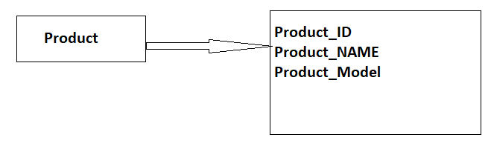
From the above dimension table, we are using Product_ID dimension inside multiple fact tables i.e. Sales and Revenue but it meaning remains same so that we can called it is confirmed dimension.
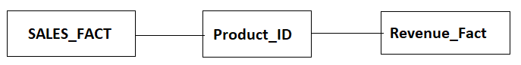

3.Dengenrated Dimension
Degenerated dimension which is derived from fact table and does not have it’s dimension table.

Example:
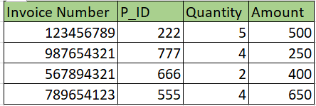
In the above example P_ID comes from Product dimension table. Invoice number is a standalone attribute and has no other attributes/columns are associated with it.

4. JUNK Dimension
It is single table with combination of different and unrelated attributes/columns to avoid large number of FK.
Junk dimensions are used to reduce number of dimensions in the dimension model and reduce the number of columns in the fact table.
Example:
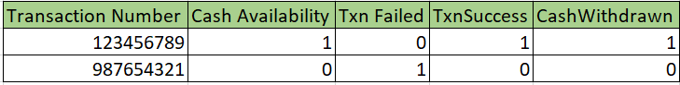
5. Static Dimension
Static dimension is nothing but constant. If this kind of dimensions are not extracted from Source but created in DWH context.
Example:
Gender is constant i.e., MALE and FEMALE.
6.Roll Playing Dimension
Dimension which is often used for multiple purpose within the same database are called Roll Playing dimension.

Example:
A fact table may include FK for both sales and delivery table.
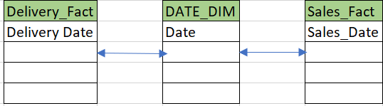
7.Shrunken Dimension
A shrunken dimension is subset of another aspect.
Example: In the below example cutomer Type is derived from Customer_Details i.e cutomer Type

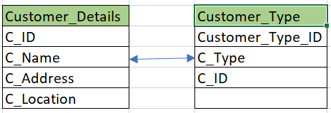

Facts:
Facts are nothing but measures or we can say numeric values.
Fact is numeric value which have impact on business process.
Ex: sales, quantity , profit etc.
BOA
DIM_BOA_CUSTOMER_DETAILS
FACT_BOA_REVENUE

Types of facts
1.Additive Facts
2.Semi-Additive facts
3.Non-Additive Facts

1.Additive Facts
Additive Facts are those facts which can be summed up through all the Dimension keys from fact table.
The fact which is added across all the dimensions is known as additive fact.
Example:
FACT_SALES
P_ID, C_ID, S_ID, D_ID, Quantity
P_ID (DMK) -FK | C_ID(DMK) -FK | S_ID(DMK) -FK | D_ID(DMK) -FK | Quantity (Fact)
111 | 5678 | 6543 | 20220921 | 30
222 | 7865 | 7766 | 20220920 | 50
111 | 5678 | 6543 | 20220919 | 40
222 | 7865 | 7766 | 20220921 | 30

Q. What is the total quantity sold of product 222?
Q. What is total quantity sold for customer 5678?
Q. What is total quantity sold on 21st sept 2022?
Q. What is total quantity sold for store 7766?

2.Semi-Additive facts
Semi-Additive Facts are those facts which can be summed of for some of the dimension keys from fact table.
Facts which can be added across some of the dimension is known as semi-additive facts.
Example: Fact_Current_Balance
Date | Account | Current_Balance
20210913 | 1111288785 | 1000
20210913 | 1111288786 | 500
20210913 | 1111288787 | 700
20210914 | 1111288785 | 900
20210914 | 1111288786 | 1000
20210914 | 1111288787 | 800

Current Balance is semi additive fact, It makes sense to add them for particular date entries so that we can get total current balance for the day and which will be useful along with date but when we add w.r.t accounts and total current balance for accounts is some number then it wont make any sense adding current balance w.r.to accounts
For Example:
If you have number of items in warehouse for each day, You can sum up the items for each day(total items in the warehouse for each day) but it wont make sense to sum up in the year.
3.Non-Additive Facts
Non-Additive fact are those facts which can not be summed up for any of the dimension keys from the fact table.
The fact which can not be added across any of the dimension keys.
Example : FACT_CURRENT_BALANCE
Date | Account | Current_Balance | Profit (%)
20210913 | 1111288785 | 1000 | 70
20210913 | 1111288786 | 500 | 40
20210913 | 1111288787 | 700 | 60
20210914 | 1111288785 | 900 | 80
20210914 | 1111288786 | 1000 | 60
20210914 | 1111288787 | 800 | 50

If we will add profit for account 1111288785 for 13th and 14th sept i.e. 70% + 80% and saying profit is around 150%.
It does not make sense to add profit along with dates or account level, so we can say profit is non-additive fact.

Fact Tables
1.Transaction Fact Table
2.Snapshot Fact Table
3.Accumalated Fact Table
4.Fact Less Fact Table.

1.Transaction Fact Table
Transaction Fact Table is a basic approach to operate business.
These fact tables represent an event that occurs at any point of time.
Example:
Account | TransactionID | AmountPaid | DateID
111288785 | 123456789 | 10 | 20210913
111288785 | 123456790 | 20 | 20210913
111288785 | 123456791 | 10 | 20210913
111288785 | 123456789 | 10 | 20210913

2.Snapshot Fact Table
It will store current state(information) at regular interval of time (Hours, days, week, months etc.)
Its best use to analyses business performance at fixed interval.
Example: Fact_Hospital_Beds_Availability
H_DEPT_ID | Total_Beds | Hour_occupied | Hours_Free_beds_update
111 | 150 | 75 | 75
222 | 200 | 80 | 130
333 | 150 | 70 | 80

In Hospital we are maintaining the beds availability for patients on hour basis and that kind information if we are updating in particular table then that table contains every hour information about the beds i.e. it takes snap of hour basis and maintain in table that table is nothing but Snapshot fact table.

3.Accumalated Fact Table
It will help you to find, what happened over a period of time.
This table will maintain information about a complete life cycle of a product or application
Example:
Flipkart product from order to till its delivery and return is one complete cycle and that information stored in a table that table is nothing but accumulated fact table.
Order_Date | Bill_Date | Shipping_Date | Arrival_Date | Delivery_Date | Return_Date
22/09/22 | 22/09/22 | 23/09/22 | 25/09/22 | 26/09/22 | 03/10/22
22/09/21 | 22/09/21 | 23/09/221 | 25/09/21 | 26/09/21 | 03/10/21

4.Fact Less Fact Table
A fact less fact table is fact table that does not have any measures or original facts instead it has all the dimension keys in that table.
Example:
In this example we are promoting a product and for that we are maintaining an fact table called promotion fact table which contains only dimension keys in it
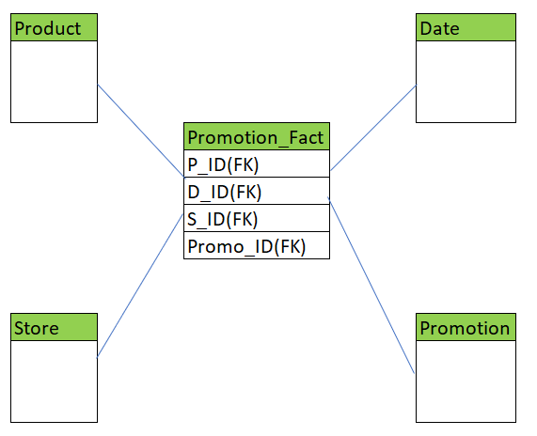
Data Schemas
A database schema defines its entities and relationships among them.
Database Schema is a descriptive detail of the database and which can be implemented by means of Schema diagram.
1.Star Schema
2.Snowflake Schema
3.Fact Constellation Schema.
1.Star Schema
Star Schema consists of fact table at the center and all the dimensions around it.
Fact table is usually a sum of all dimensions and dimension is single entity.
A primary key from dimension table is represented as foreign key in fact table.
Example:

2.Snowflake Schema
This is extension of star schema, where each point of start or dimension is divided into more granular level.
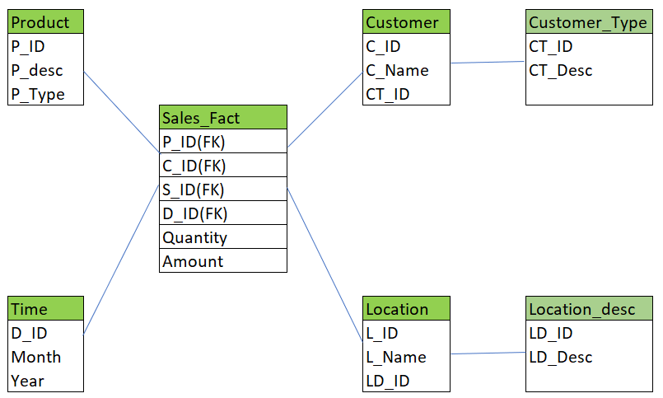
3.Fact Constellation (Galaxy) Schema
Fact Constellation is Schema for representing multidimensional model.
It is collection of multiple fact tables having common dimension tables.
It is collection of several start schemas and hence, it is also called as Galaxy schema.
It is one of the widely used schemas for Data warehouse designing and it is more complex than star and snowflake schema.
Example:
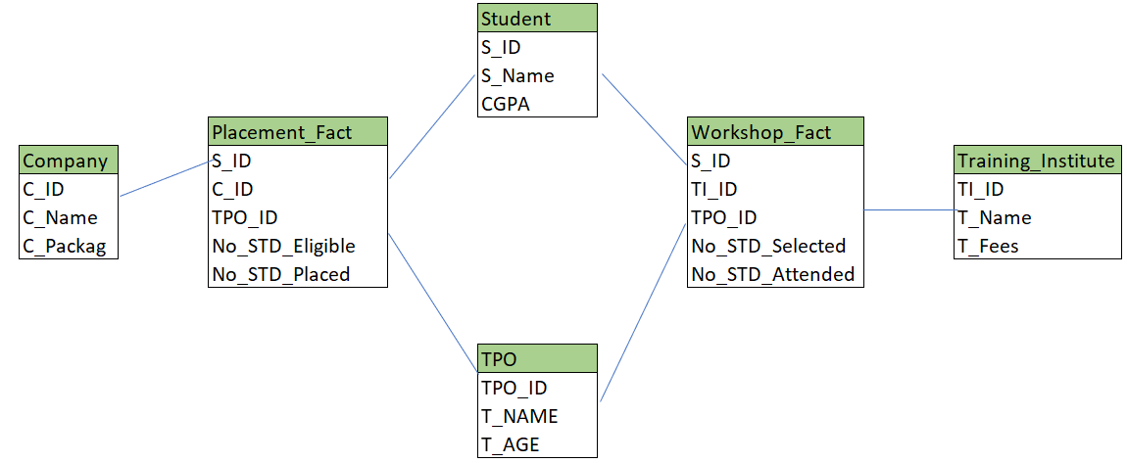

Normalization and Denormalization
Normalization is a process of eliminating or removing the redundant (Repetitive) data and storing the related information in a table.
The key points of Normalization are as below:

- Eliminating Redundant Data
- Faster Update
- Improve Performance
- Performance in Indexes

Below are the different Normal Forms

First Normal Form:

If the table is said to be in the 1st Normal Form it should follow the below rules
- Each cell must have one value. Eliminating Duplicate Columns
- Create separate table for the group of the related data and each row should be identified by Primary Key.

Let us take an example here:
Name | Department | Phone Number | Salary | TAX
Name 1 | Computers | 12354588, 6887890, 123456 | 4000 | 40
Name 2 | Electronics | 12345678 2345666,7896543333 | 5000 | 50
Name 3 | Civil | 4567890 | 3000 | 30

In the above table we see that there are different phone numbers for the single Name and we have to remove these duplicates by uniquely identifying each of them and giving a unique identification by giving them the Primary Key.
Now the below table is redesigned such that it is in the First Normal Form.
ID | Name | Department | Phone Number | Salary | TAX
1 | Name 1 | Computers | 12354588 | 4000 | 40
2 | Name 1 | Computers | 6887890 | 4000 | 40
3 | Name 1 | Computers | 123456 | 4000 | 40
4 | Name 2 | Electronics | 12345678 | 4000 | 40
5 | Name 2 | Electronics | 2345666 | 4000 | 40
6 | Name 2 | Electronics | 789654333 | 4000 | 40
7 | Name 3 | Civil | 4567890 | 3000 | 30
Second Normal Form:
If the table is said to be in the 2nd Normal Form it should follow the below rules
- It should satisfy the 1st Normal Form.
- Separate the Columns, values are duplicated in each row should be placed in the separate Table.
- Create the relationship between the tables.

Here in the above table, we see that the Name and the department columns are duplicated and in order to handle this we need to maintain the duplicates in the different table as below:
EMPID | Name | Department | Salary | TAX
1 | Name 1 | Computers | 4000 | 40
2 | Name 2 | Electronics | 4000 | 40
3 | Name 3 | Civil | 3000 | 30

ID | EMPID | Phone Number
1 | 1 | 12354588
2 | 1 | 6887890
3 | 1 | 123456
4 | 2 | 12345678
5 | 2 | 2345666
6 | 2 | 789654333
7 | 3 | 4567890

Here in these tables above EMPID is treated as the primary Key for the First Table and the Foreign Key for the Second Table.
Third Normal Form:
If the table is said to be in the 3rd Normal Form it should follow the below rules
- It should satisfy the 2nd Normal Form.
- Separate the Columns that are not dependent on the primary key of the table.

EMPID | Name | Department | Salary
1 | Name 1 | Computers | 4000
2 | Name 2 | Electronics | 4000
3 | Name 3 | Civil | 3000

ID | EMPID | Phone Number
1 | 1 | 12354588
2 | 1 | 6887890
3 | 1 | 123456
4 | 2 | 12345678
5 | 2 | 2345666
6 | 2 | 789654333
7 | 3 | 4567890

Salary | TAX
4000 | 40
3000 | 30

De-Normalization:
De-normalization is a database optimization technique in which we add redundant (repetitive) data to one or more tables. This can help us avoid costly joins in a relational database.
Note that de-normalization does not mean not doing normalization. It is an optimization technique that is applied after doing normalization.
Example:
We have two table students and branch after performing normalization.
The student table has the attributes Roll_no, stud-name, age, and Branch_id.

Roll_No | Student_Name | Age | Branch_ID
11 | Stevan | 23 | 1
12 | Mark | 22 | 2
13 | Nishem | 25 | 1
14 | Taylor | 21 | 3
15 | Kane | 26 | 4

Additionally,
the branch table is related to the student table with branch_id as the student table's foreign key.
Branch_ID | Branch_Name | Total_students
1 | EC | 150
2 | CSE | 100
3 | Civil | 60
4 | Mech | 80

A JOIN operation between these two tables is needed when we need to retrieve all student names as well as the branch name.
Suppose we want to change the student’s name only, then it is great if the table is small. The issue here is that if the tables are big, joins on tables can take an excessively long time.
In this case, we'll update the database with de-normalization, redundancy, and extra effort to maximize the efficiency benefits of fewer joins. Therefore, we can add the branch name's data from the Branch table to the student table and optimizing the database.

ETL Architecture
