**MainActivity.java:**

**package com.example.pr11;**

**import android.annotation.SuppressLint;**

**import android.os.Bundle;**

**import android.view.View;**

**import android.widget.CheckBox;**

**import android.widget.Toast;**

**import androidx.activity.EdgeToEdge;**

**import androidx.appcompat.app.AppCompatActivity;**

**import androidx.core.graphics.Insets;**

**import androidx.core.view.ViewCompat;**

**import androidx.core.view.WindowInsetsCompat;**

**public class MainActivity extends AppCompatActivity {**

**CheckBox c1,c2,c3,c4 ;**

**String s,s1,s2,s3;**

**String i="";**

**@SuppressLint("MissingInflatedId")**

**@Override**

**protected void onCreate(Bundle savedInstanceState) {**

**super.onCreate(savedInstanceState);**

**setContentView(R.layout.activity_main);**

**c1=(CheckBox) findViewById(R.id.cb1);**

**c2=(CheckBox) findViewById(R.id.cb2);**

**c3=(CheckBox) findViewById(R.id.cb3);**

**c4=(CheckBox) findViewById(R.id.cb4);**

**}**

**public void Click1(View view)**

**{**

**if(c1.isChecked())**

**{**

**s = c1.getText().toString();**

**}**

**else**

**{**

**s = i ;**

**}**

**if(c2.isChecked())**

**{**

**s1 = c2.getText().toString();**

**}**

**else**

**{**

**s1 = i ;**

**}**

**if(c3.isChecked())**

**{**

**s2 = c3.getText().toString();**

**}**

**else**

**{**

**s2 = i ;**

**}**

**if(c4.isChecked())**

**{**

**s3 = c4.getText().toString();**

**}**

**else**

**{**

**s3 = i ;**

**}**

**Toast.makeText(MainActivity.this,"Order is is:"+ s + s1 + s2 + s3 ,Toast.LENGTH_SHORT).show();**

**}**

**}**

**OutPut:**

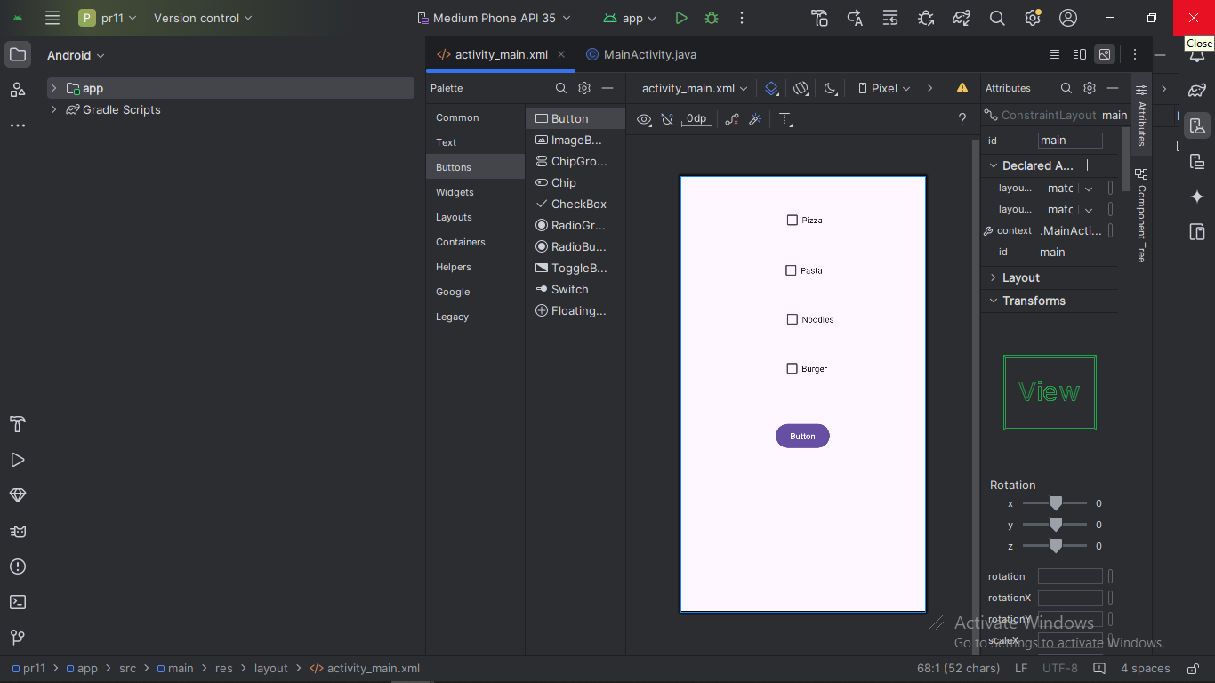

**<?xml version="1.0" encoding="utf-8"?>**

**<LinearLayout xmlns:android="http://schemas.android.com/apk/res/android"**

**xmlns:tools="http://schemas.android.com/tools"**

**android:id="@+id/linearLayout"**

**android:layout_width="match_parent"**

**android:layout_height="match_parent"**

**android:orientation="vertical"**

**android:padding="20dp"**

**tools:context=".MainActivity">**

**<CheckBox**

**android:id="@+id/cb1"**

**android:layout_width="wrap_content"**

**android:layout_height="wrap_content"**

**android:text="Pizza" />**

**<CheckBox**

**android:id="@+id/cb2"**

**android:layout_width="wrap_content"**

**android:layout_height="wrap_content"**

**android:text="Burger" />**

**<CheckBox**

**android:id="@+id/cb3"**

**android:layout_width="wrap_content"**

**android:layout_height="wrap_content"**

**android:text="Sandwich" />**

**<CheckBox**

**android:id="@+id/cb4"**

**android:layout_width="wrap_content"**

**android:layout_height="wrap_content"**

**android:text="Pasta" />**

**<Button**

**android**