# Activity_main.xml

<?xml version="1.0" encoding="utf8"?>

<RelativeLayout xmlns:android="http://schemas.android. com/apk/res/android"

xmlns:app="http://schemas.android.com

/apk/res-auto"

xmlns:tools="http://schemas.android.co m/tools" android:layout_width="match_parent" android:layout_height="match_parent" android:padding="15dp" tools:context=".MainActivity">

<TextView android:layout_width="match_parent" android:layout_height="wrap_content" android:id="@+id/texttitle" android:layout_marginTop="20dp" android:gravity="center" android:text="Enter the Details

Here"/>

<EditText android:layout_width="match_parent" android:id="@+id/name"

android:layout_height="wrap_content" android:textSize="20dp"

android:layout_below="@+id/texttitle" android:hint="Enter Name"/>

<EditText android:layout_width="match_parent" android:id="@+id/contact"

android:layout_height="wrap_content" android:textSize="20dp"

android:layout_below="@+id/name" android:hint="Enter Contact"/>

<EditText android:layout_width="match_parent" android:id="@+id/dob"

android:layout_height="wrap_content" android:textSize="20dp"

android:layout_below="@+id/contact" android:inputType="number" android:hint="Enter Date of

Birth"/>

<Button android:layout_width="match_parent" android:layout_height="wrap_content" android:id="@+id/insert" android:text="Enter New Data"

android:layout_below="@+id/dob"/>

<Button android:layout_width="match_parent" android:layout_height="wrap_content" android:id="@+id/update" android:text="Update the Data"

android:layout_below="@+id/insert"/>

<Button android:layout_width="match_parent" android:layout_height="wrap_content" android:id="@+id/delete" android:text="Delete Data"

android:layout_below="@+id/update"/>

<Button android:layout_width="match_parent" android:layout_height="wrap_content" android:id="@+id/view" android:text="View the Data"

android:layout_below="@+id/delete"/> </RelativeLayout>

# MainActivity.java

package com.example.bluetooth_19; import

androidx.appcompat.app.AppCompatAc tivity;

import android.app.AlertDialog; import android.database.Cursor; import android.os.Bundle; import android.view.View; import android.widget.Button; import android.widget.EditText; import android.widget.Toast; public class MainActivity extends

AppCompatActivity {

Button insert, update, delete,view;

EditText name, contact, dob;

DBHelper DB; @Override

protected void onCreate(Bundle savedInstanceState)

{ super.onCreate(savedInstanceState); setContentView(R.layout.activity_main); name=(EditText)findViewById(R.id.na me);

contact=(EditText)findViewById(R.id.c ontact); dob=(EditText)findViewById(R.id.dob);

insert=(Button)findViewById(R.id.inser

t);

update=(Button)findViewById(R.id.upd

ate);

delete=(Button)findViewById(R.id.delet e);

view=(Button)findViewById(R.id.view); DB=new DBHelper(this); insert.setOnClickListener(new

View.OnClickListener() { @Override public void onClick(View v) {

String nameTXT=name.getText().toString();

String contactTXT=contact.getText().toString();

String dobTXT=dob.getText().toString();

Boolean checkinsertdata= DB.insertuserdata(nameTXT, contactTXT, dobTXT);

if(checkinsertdata==true) Toast.makeText(MainActivity.this,

"New Data Inserted",

Toast.LENGTH_SHORT).show(); else

Toast.makeText(MainActivity.this,

"New Data NOt Inserted",

Toast.LENGTH_SHORT).show();

}

});

update.setOnClickListener(new

View.OnClickListener() { @Override public void onClick(View v) {

String nameTXT=name.getText().toString();

String contactTXT=contact.getText().toString();

String dobTXT=dob.getText().toString();

Boolean checkUpdatedata= DB.updateuserdata(nameTXT, contactTXT, dobTXT); if(checkUpdatedata==true)

Toast.makeText(MainActivity.this,

"Data Updated",

Toast.LENGTH_SHORT).show(); else

Toast.makeText(MainActivity.this,

"Data Not Updated",

Toast.LENGTH_SHORT).show();

}

});

delete.setOnClickListener(new

View.OnClickListener() { @Override public void onClick(View v) {

String nameTXT=name.getText().toString(); Boolean checkdeletedata=

DB.deletedata(nameTXT); if(checkdeletedata==true)

Toast.makeText(MainActivity.this,

"Data Deleted",

Toast.LENGTH_SHORT).show(); else

Toast.makeText(MainActivity.this,

"Data Not Deleted",

Toast.LENGTH_SHORT).show();

}

});

view.setOnClickListener(new

View.OnClickListener() { @Override public void onClick(View v) { Cursor res=DB.getdata();

if(res.getCount()==0){ Toast.

makeText(MainActivity.this, "No Entry

Exists",

Toast.LENGTH_SHORT).show();

return;

}

StringBuffer buffer=new

StringBuffer(); while (res.moveToNext()){

buffer.append("Name:

"+res.getString(0)+"\n"); buffer.append("Contact:

"+res.getString(1)+"\n"); buffer.append("Date of Birth: "+res.getString(2)+"\n\n"); }

AlertDialog.Builder builder=new

AlertDialog.Builder(MainActivity.this); builder.setCancelable(true); builder.setTitle("User Entries:\n"); builder.setMessage(buffer.toString()); builder.show();

}

});

}

}

**DBHelper Class** package com.example.bluetooth_19; import android.content.ContentValues; import android.content.Context; import android.database.Cursor; import

android.database.sqlite.SQLiteDatabase; import android.database.sqlite.SQLiteOpenHelp er;

public class DBHelper extends

SQLiteOpenHelper { public DBHelper( Context context) {

super(context, "userdata.db", null,

1);

} @Override public void onCreate(SQLiteDatabase

db) {

db.execSQL("create Table Userdetails(name TEXT primary key, contact TEXT, dob TEXT)");

} @Override public void

onUpgrade(SQLiteDatabase db, int oldVersion, int newVersion) {

db.execSQL("drop Table if exists

Userdetails"); } public Boolean insertuserdata(String

name, String contact, String dob){ SQLiteDatabase DB= this.getWritableDatabase();

ContentValues contentValues=new

ContentValues(); contentValues.put("name", name);

contentValues.put("contact",contact);

contentValues.put("dob", dob); long

result=DB.insert("Userdetails",null, contentValues); if (result==-1)

return false;

else

return true; } public Boolean updateuserdata(String

name, String contact, String dob){

SQLiteDatabase DB= this.getWritableDatabase();

ContentValues contentValues=new

ContentValues(); contentValues.put("contact",contact);

contentValues.put("dob", dob);

Cursor cursor=DB.rawQuery("Select * from

Userdetails where name = ?", new

String[] {name}); if (((Cursor) cursor).getCount()>0)

{ long result =

DB.update("Userdetails", contentValues, "name=?",

new String[]{name}); if (result == -1)

return false;

else return true;

}else return false; } public Boolean deletedata(String

name){

SQLiteDatabase DB= this.getWritableDatabase();

Cursor cursor=DB.rawQuery("Select * from

Userdetails where name = ?", new

String[] {name}); if (cursor.getCount()>0) {

long result = public Cursor getdata() {

SQLiteDatabase DB =

DB.delete("Userdetails","name=?", new this.getWritableDatabase();

String[]{name}); Cursor cursor =

if (result == -1) DB.rawQuery("Select * from

return false; Userdetails ", null);

else return cursor;

return true; }

}else } return false;

}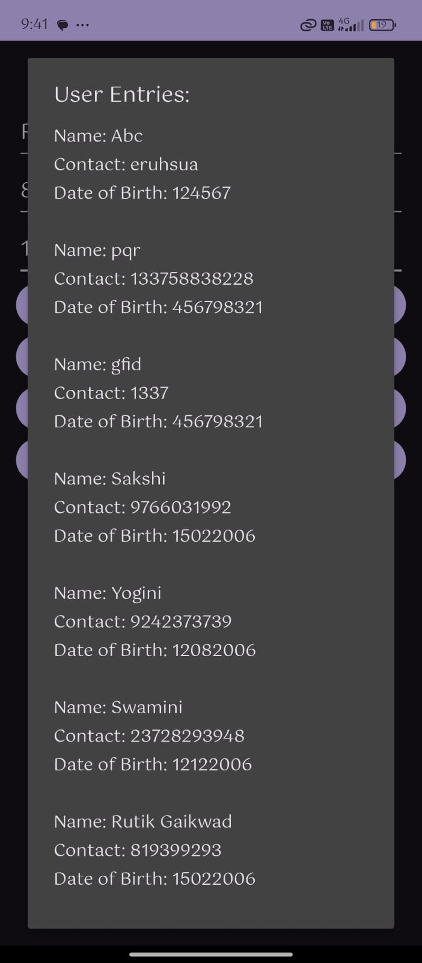

**Output:**