**package com.example.ptr12;  
import androidx.appcompat.app.AppCompatActivity;  
import android.os.Bundle;  
import android.view.View;  
import android.widget.*;  
  
public class MainActivity extends AppCompatActivity implements View.OnClickListener {  
  
 RadioButton r1, r2, r3, r4;  
 Button b1;  
  
 @Override  
 protected void onCreate(Bundle savedInstanceState) {  
 super.onCreate(savedInstanceState);  
 setContentView(R.layout.*activity_main*);  
  
 r1 = findViewById(R.id.*rb1*);  
 r2 = findViewById(R.id.*rb2*);  
 r3 = findViewById(R.id.*rb3*);  
 r4 = findViewById(R.id.*rb4*);  
 b1 = findViewById(R.id.*button*);  
  
  
 b1.setOnClickListener(this);  
  
 r1.setChecked(false);  
 r2.setChecked(false);  
 r3.setChecked(false);  
 r4.setChecked(false);  
 }  
  
 @Override  
 public void onClick(View v) {  
 if (r3.isChecked()) {  
 Toast.*makeText*(MainActivity.this, "Correct Answer!", Toast.*LENGTH_LONG*).show();  
 } else {  
 Toast.*makeText*(MainActivity.this, "Wrong Answer!", Toast.*LENGTH_LONG*).show();  
 }  
 b1.setEnabled(false);  
 }  
}**

**Output:**

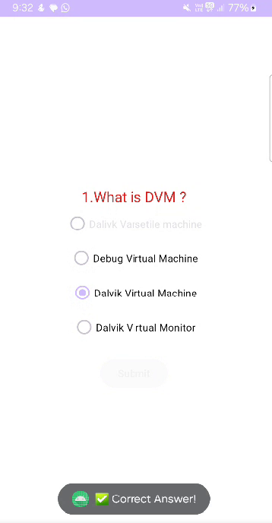

**<?xml version="1.0" encoding="utf-8"?>  
<LinearLayout  
 xmlns:android="http://schemas.android.com/apk/res/android"  
 android:layout_width="match_parent"  
 android:layout_height="match_parent"  
 android:orientation="vertical"  
 android:background="@color/white"  
 android:padding="16dp"  
 android:gravity="center">  
  
 <TextView  
 android:layout_width="wrap_content"  
 android:layout_height="wrap_content"  
 android:text="1.What is DVM ?"  
 android:textSize="20dp"  
 android:textColor="#D12222"  
 />  
  
 <RadioGroup  
 android:id="@+id/radioGroup"  
 android:layout_width="wrap_content"  
 android:layout_height="wrap_content"  
 android:gravity="center">  
  
 <RadioButton  
 android:id="@+id/rb1"  
 android:layout_width="wrap_content"  
 android:layout_height="wrap_content"  
 android:text="Dalivk Varsetile machine" />  
  
 <RadioButton  
 android:id="@+id/rb2"  
 android:layout_width="wrap_content"  
 android:layout_height="wrap_content"  
 android:text="Debug Virtual Machine"  
 android:textColor="@color/black"/>  
  
 <RadioButton  
 android:id="@+id/rb3"  
 android:layout_width="wrap_content"  
 android:layout_height="wrap_content"  
 android:text="Dalvik Virtual Machine"  
 android:textColor="@color/black"/>  
  
 <RadioButton  
 android:id="@+id/rb4"  
 android:layout_width="wrap_content"  
 android:layout_height="wrap_content"  
 android:textColor="@color/black"  
 android:text="Dalvik Virtual Monitor" />  
 </RadioGroup>  
  
 <Button  
 android:id="@+id/button"  
 android:layout_width="wrap_content"  
 android:layout_height="wrap_content"  
 android:text="Submit"  
 android:layout_marginTop="16dp" />  
  
</LinearLayout>**