

**Activity_Main.xml**

| <?xml version="1.0" encoding="utf-8"?>  <LinearLayout  xmlns:android="http://schemas.android.com/apk/r es/android"  xmlns:app="http://schemas.android.com/apk/resauto"  xmlns:tools="http://schemas.android.com/tools" android:id="@+id/main"  android:layout_width="match_parent" android:layout_height="match_parent" tools:context=".MainActivity" android:orientation="vertical" android:layout_marginLeft="100dp" android:layout_marginTop="40dp">  <TextView  android:layout_width="wrap_content" android:layout_height="wrap_content" android:text="Bluetooth" android:textSize="30dp" />  <Button  android:onClick="On" android:id="@+id/b1"  android:layout_width="wrap_content" android:layout_height="wrap_content" android:text="On" android:textSize="30dp"/>  <Button | android:onClick="Off" android:id="@+id/b2"  android:layout_width="wrap_content" android:layout_height="wrap_content" android:text="Off" android:textSize="30dp"/>  <Button  android:onClick="Visible" android:id="@+id/b3"  android:layout_width="wrap_content" android:layout_height="wrap_content" android:text="GetVisible" android:textSize="30dp"/>  <Button  android:onClick="Get_Device" android:id="@+id/b4"  android:layout_width="wrap_content" android:layout_height="wrap_content" android:text="List devices" android:textSize="30dp"/>  <ListView  android:layout_width="match_parent" android:layout_height="match_parent" android:id="@+id/l1"/>  </LinearLayout>  **Java Code –** |
| --- | --- |

package com.example.pr_23; import android.bluetooth.BluetoothAdapter; import android.bluetooth.BluetoothDevice; import android.content.Intent; import android.os.Bundle; import android.view.View; import android.widget.ArrayAdapter; import android.widget.Button; import android.widget.ListView; import android.widget.Toast; import androidx.activity.EdgeToEdge;

import androidx.appcompat.app.AppCompatActivity; import androidx.core.graphics.Insets; import androidx.core.view.ViewCompat; import androidx.core.view.WindowInsetsCompat; import java.util.ArrayList; import java.util.Set;

public class MainActivity extends AppCompatActivity {

Button b1,b2,b3,b4;

ListView l1; BluetoothAdapter BA; private Set<BluetoothDevice>pairedDevices;

@Override

protected void onCreate(Bundle savedInstanceState) { super.onCreate(savedInstanceState); setContentView(R.layout.activity_main); b1 = findViewById(R.id.b1); b2 = findViewById(R.id.b2); b3 = findViewById(R.id.b3);

b4 = findViewById(R.id.b4); l1 = findViewById(R.id.l1);

BA = BluetoothAdapter.getDefaultAdapter();

}

public void On(View view) { if(BA.isEnabled() {

Intent TurnOn=new

Intent(BluetoothAdapter.ACTION_REQUEST_E

NABLE);

startActivityForResult(TurnOn,0);

Toast.makeText(this, "Turn On",

Toast.LENGTH_SHORT).show() }

else {

Toast.makeText(this, "Already On", Toast.LENGTH_SHORT).show(); } } public void Off(View view) {

BA.disable();

Toast.makeText(this, "Turn Off",

Toast.LENGTH_SHORT).show() } public void Visible(View view) {

Intent vis=new

Intent(BluetoothAdapter.ACTION_REQUEST_D

ISCOVERABLE);

startActivityForResult(vis,0); } public void Get_Device(View view) { pairedDevices=BA.getBondedDevices(); ArrayList list=new ArrayList(); for (BluetoothDevice bt:pairedDevices) list.add((bt.getName()));

final ArrayAdapter ad=new ArrayAdapter(this,android.R.layout.simple_dropd own_item_1line,list); l1.setAdapter(ad);

Toast.makeText(this, "Showing paired device", Toast.LENGTH_SHORT).show(); } } **Android Manifest.xml –** <?xml version="1.0" encoding="utf-8"?> <manifest

xmlns:android="http://schemas.android.com/apk/r es/android"

xmlns:tools="http://schemas.android.com/tools">

<uses-permission

android:name="android.permission.BLUETOOT H_CONNECT"/>

<uses-permission

android:name="android.permission.BLUETOOT H_ADMIN"/>

<uses-permission

android:name="android.permission.BLUETOOT

<action

android:name="android.intent.action.MAIN" />

<category

android:name="android.intent.category.LAUNCH ER" />

</intent-filter>

</activity>

</application>

</manifest>

**Output** –

H_ADVERTISE"/> 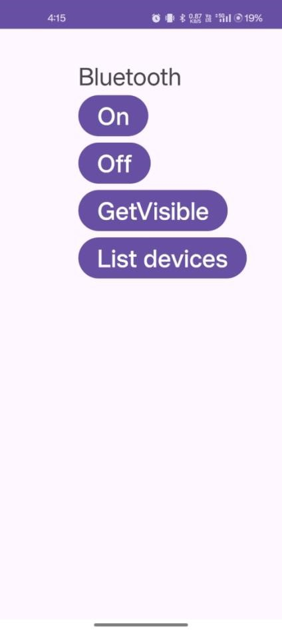

<uses-permission

android:name="android.permission.BLUETOOT H_PRIVILEGED_ADVERTISE"/>

<uses-permission

android:name="android.permission.BLUETOOT H_SCAN_ADVERTISE"/>

<application

android:allowBackup="true"

android:dataExtractionRules="@xml/data_extract ion_rules"

android:fullBackupContent="@xml/backup_rules

"

android:icon="@mipmap/ic_launcher" android:label="@string/app_name"

android:roundIcon="@mipmap/ic_launcher_roun

d" android:supportsRtl="true" android:theme="@style/Theme.Pr_23" tools:targetApi="31">

<activity

android:name=".MainActivity" android:exported="true">

<intent-filter>