Write a Servlet program to send username and password using html forms and authenticate the user

**1.Servlet:**

import java.io.IOException;

import java.io.PrintWriter;

import javax.servlet.ServletException;

import javax.servlet.http.HttpServlet;

import javax.servlet.http.HttpServletRequest;

import javax.servlet.http.HttpServletResponse;

public class NewServlet extends HttpServlet {

protected void doGet(HttpServletRequest req, HttpServletResponse rep)

throws ServletException, IOException {

rep.setContentType("text/html");

PrintWriter pw=rep.getWriter();

String item=req.getParameter("n1");

String item1=req.getParameter("n2");

pw.println("Username Is:"+item +"<br>");

pw.print("Password Is:"+item1);

if(item .equals("Vaishnavi") && item1.equals("vaishnavi@2024")){

pw.println("<h1>Successfully Login</h1>");

}

else{

pw.println("<h1>UnSuccessfully Login</h1>");

}

}

}

**2.Web:**

<html>

<head>

<title>Authentication</title>

<meta charset="UTF-8">

<meta name="viewport" content="width=device-width, initial-scale=1.0">

</head>

<body>

<form action="NewServlet" method="get">

<div>

Username: <input type="text" name="n1"><br><br>

Password: <input type="password" name="n2"><br><br>

<input type="Submit" value="Submit">

</div>

</form>

</body>

</html>

**Output:**

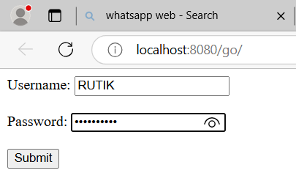

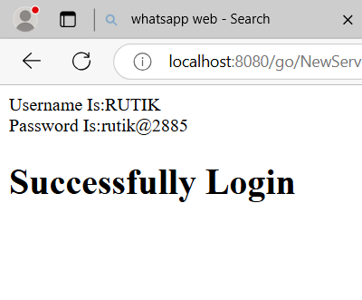

**Concatenation**

**1.Servlet:**

import java.io.IOException;

import java.io.PrintWriter;

import javax.servlet.ServletException;

import javax.servlet.http.HttpServlet;

import javax.servlet.http.HttpServletRequest;

import javax.servlet.http.HttpServletResponse;

public class NewServlet extends HttpServlet {

protected void doGet(HttpServletRequest request, HttpServletResponse response)

throws ServletException, IOException {

response.setContentType("text/html");

String str1 = request.getParameter("str1");

String str2 = request.getParameter("str2");

String concatenatedString = str1 + " " + str2;

PrintWriter out = response.getWriter();

out.println("<html><body>");

out.println("<h1>Concatenated String: " + concatenatedString + "</h1>");

out.println("</body></html>");

}

}

**2.Web:**

<html>

<head>

<title>supply a title</title>

<meta charset="UTF-8">

<meta name="viewport" content="width=device-width, initial-scale=1.0">

</head>

<body>

<form action="NewServlet" method="get">

String 1: <input type="text" name="str1">

String 2: <input type="text" name="str2">

<input type="submit" value="join">

</form>

</body>

</html>

**Output:**



